Nikolas Remley
Notes and Using TensorFlow

TensorFlow Basics

- TensorFlow is a Machine Learning library developed by Google made specifically for Deep Learning, but still applicable to a wide variety of data analysis
  - Deep learning can be defined as “A class of machine learning techniques that exploit many layers of non-linear information processing for supervised or unsupervised feature extraction and transformation, and for pattern analysis and classification” (Deng, Yu)
- Data is stored and computed in a C++ backend with a Python interface
  - In python, one build a graph (how data moves and is computed) by linking together different objects called tensors
    - Tensors can be in a few different categories, but one should note the difference between placeholders (data the user inputs) and variables (weights/biases, the values being optimized)
  - Once the graph is built the Variables should be initialized with a Session
    - A session is what allows the data to flow through the graph. One can write a session into a script or use an InteractiveSession for on the fly analysis/debugging
    - https://www.tensorflow.org/versions/r0.8/api_docs/python/client.html#Session
  - Once a Session is activated, one let's the data flow through the graph with sess.run and feed dictionaries
    - The feed dictionaries fill any placeholder tensors with the data of your choosing as long as the shapes are equal.
- This overview is very generalized, for more information visit the TensorFlow website. It is filled with tutorials and information for getting started.

Benefits of TensorFlow
- TensorFlow is very powerful and is used in many applications, particularly Google Applications
  - A lot of TensorFlow use comes in the form of image categorization, which uses very large data sets
- TensorFlow is very fast using a C++ backend
- TensorFlow is very customizable, one can make many different types of Neural Networks and Machine Learning algorithms

Issues with TensorFlow
- Location of the python scripts
  - Some people, including myself have run into issues with the placement of python scripts. A location that gives me no trouble is inside “tensorflow-master/tensorflow.” As a caution, there are some native files already present.
- Weight Initialization
  - When initializing weights some methods have bugs. “tf.truncated_normal” has not given any issues
- Data Normalization
  - If the data is not normalized, one runs the risk of the weights converging to 0, null, or inaccurate values. Personally, I use “preprocessing.normalize” from the sklearn library. There are a few options, my preference being a “max” normalization. (http://scikit-learn.org/stable/modules/preprocessing.html)
- Importing Data
  - Be sure the data is in the correct shape when importing. If the output variable is supposed to be a column vector, be sure it is a column vector.
- Debugging
  - In general, debugging can be difficult since TensorFlow does a lot of it's work in c++. Tensor's (objects that a part of the TensorFlow graph) do not store values. One must be comfortable knowing how to get desired values (initializing variables, activating the session, and running the feed dictionary)
- TensorBoard
  - Known to be buggy, the TensorBoard sometimes does not grab it's event file correctly. If it is not, navigate to the “logdir” (will be within the /tensorflow-master/tensorflow) directory and be sure an event file is inside. If so, restart the browser and terminal and try again. If not, then there is an issue with the script.

How to Run the Multilayer Perceptron script (Virtual Enviroment)

- Installation
  - Follow all the instructions online for installation
  - https://www.tensorflow.org/versions/r0.7/get_started/os_setup.html
    - The rest of this tutorial focuses on the Virtualenv installation. This prevents tensorflow from overriding any pre-existing Python packages
  - The rest of this document will show how to use Tensorflow after those instructions have been followed

- Getting Started with a Virtual Enviroment
  - It is recommended to use Tensorflow in a Virtual Enviroment, the steps for installation of virtualenv are below the steps for the pip installation.
  - In the terminal, navigate to the directory containing the tensorflow folder. This should be directly in the “tensorflow-master” directory.
    - $ cd …/tensorflow-master (… is the directory containg the tfmaster folder)
  - Before starting, activate the virtualenv in the tensorflow directory
    - $ virtualenv --system-site-packages ~/tensorflow
    - $ source ~/tensorflow/bin/activate)
  - Now navigate into the directory containing your python script ($ cd tensorflow/) folder. Your terminal should look like this:
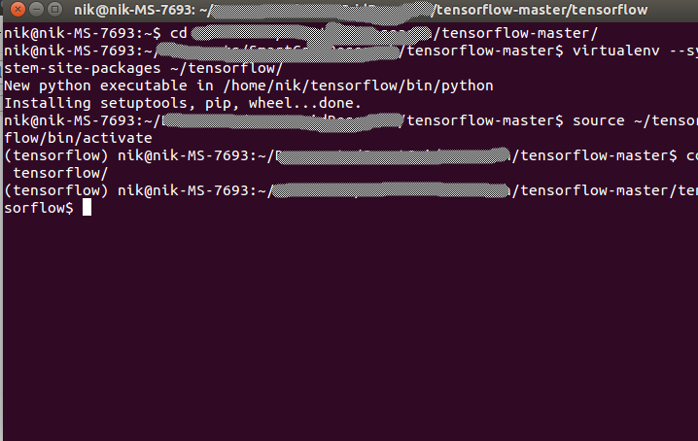
  - run the script ($ python Scipt.py)
    - The script should show a few different outputs related to the status and/or debugging
  - When one is done with the virtual enivroment use the command “$ deactivate”

- TensorBoard
  - The TensorBoard is a great way to visualize everything going on in script
  - In order to visualize certain elements with the TensorBoard, one needs to use SummaryWriters. The TensorFlow website has a great tutorial for making great TensorBoards
    - https://www.tensorflow.org/versions/r0.8/how_tos/summaries_and_tensorboard/index.html
  - To launch simply run your script enter ($ tensorboard –logdir=”./logdir'”). The script should prompt the user with the exact syntax
    - This will prompt to navigate to the localhost 6006, this is where you can look at the graphs and other ideas tensorflow has stored
    - The TAG warning is for debugging, not an issue
  - Here is the TensorBoard from the “TFMultilayerPerceptron.py” script
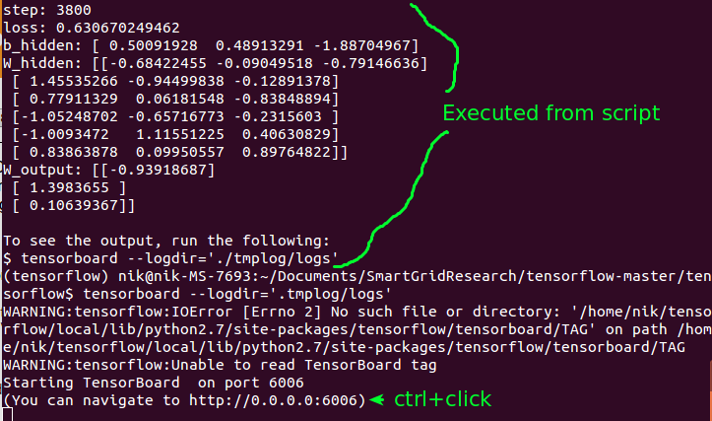
  - Ctrl+click on the link to open up the localhost on port 6006
  - If everything went smooth, your browser should look similar to this:
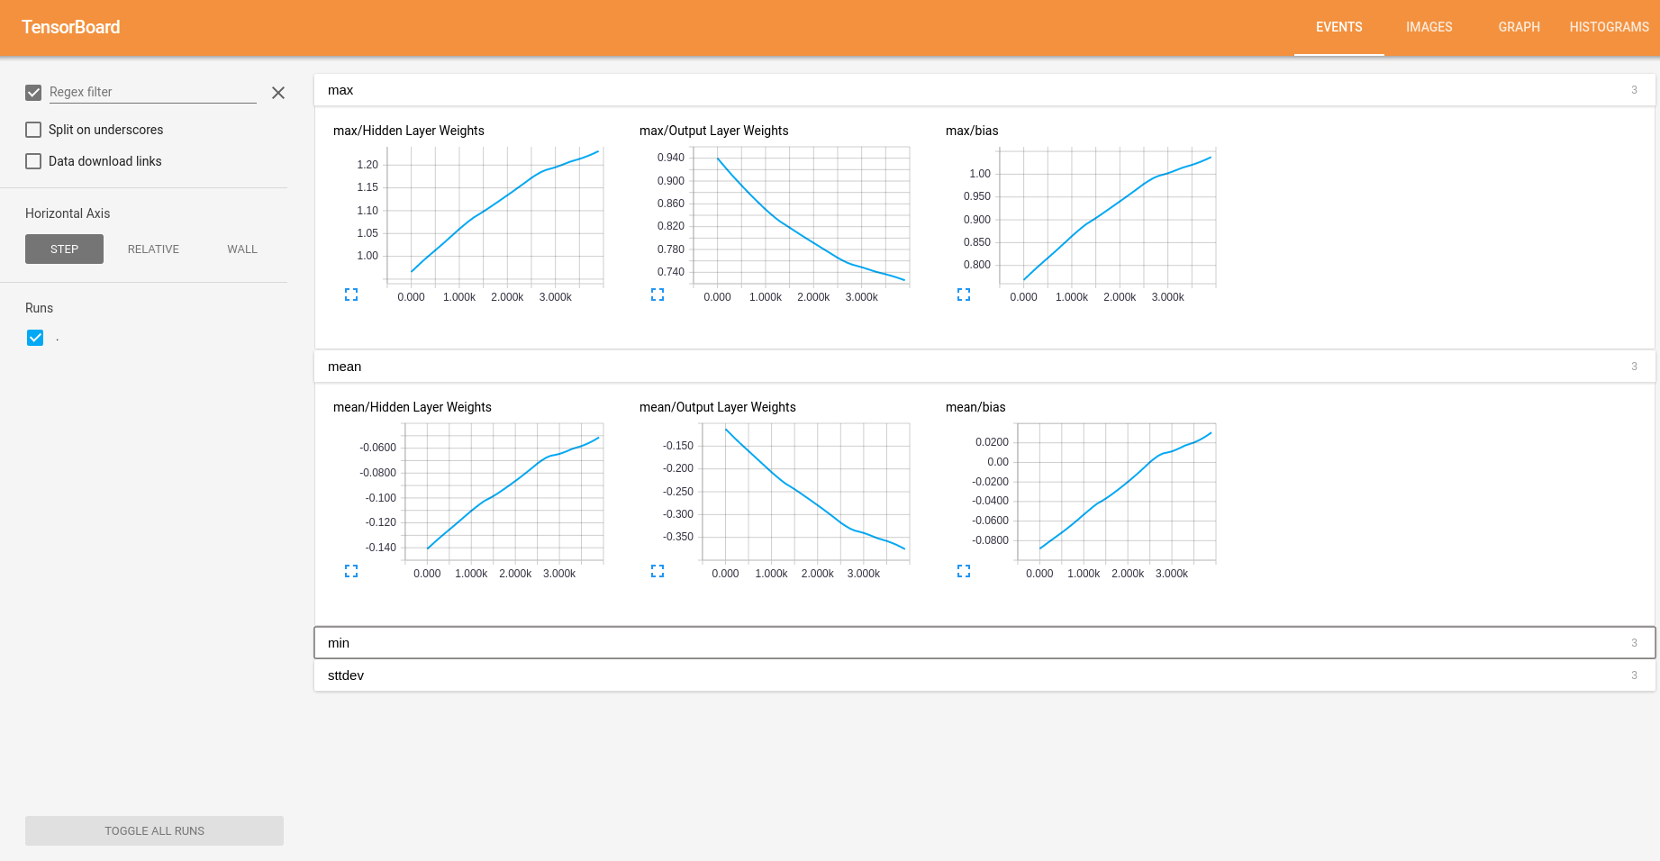
  - Check out the graph (the map for how data flows):
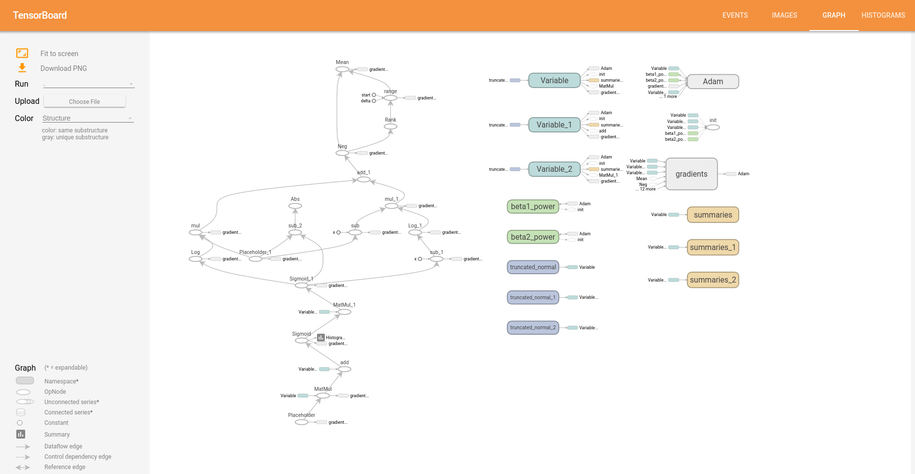
  - For a full interpretation of what everything means, visit: https://www.tensorflow.org/versions/r0.8/how_tos/graph_viz/index.html

Works Cited
- Deng, L.; Yu, D. (2014). “Deep Learning: Methods and Applications”. Foundations and Trends in Signal Processing 7:3-4. pg. 199

