Escaping Traps (Local Minima vs. Saddle Points):
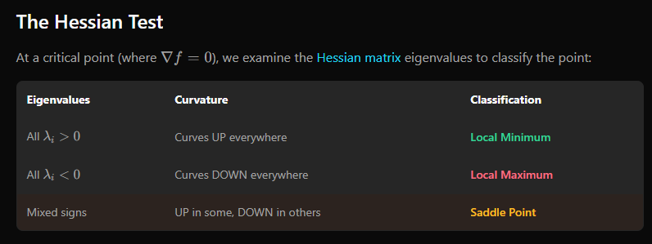
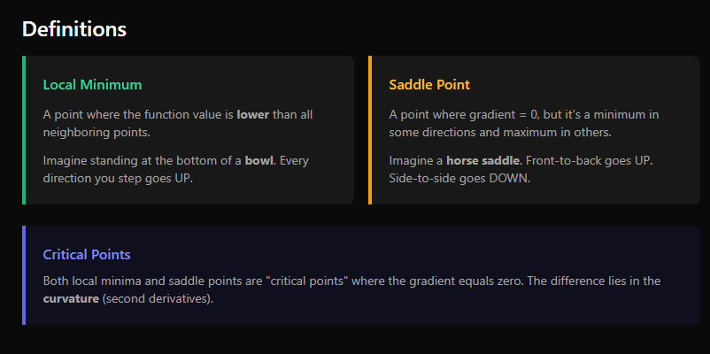
In deep learning local minima’s are rare the majority of stuck points are saddle points
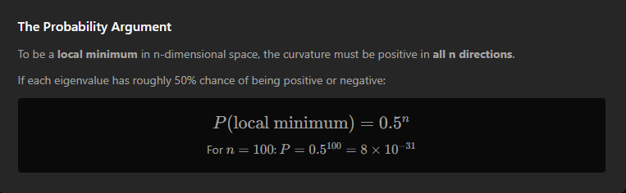
For examining and knowing what kind of point this, we do the Hessian test using eigenvalues
the high dimensional curse:
and here we have a 99-parameter model just as a simple example for what exponential decay of probability having a local minimum

mini batch noise:
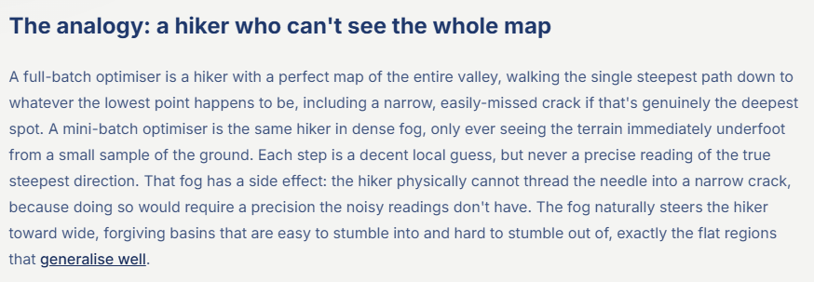
This analogy really sticked out to me
the normal gradient averages the whole of the training examples but SGD estimates average only on random batches of it so that makes a noise than the true average
Mini-Batch noise helps because it turns the optimizer from a purely deterministic downhill walker into something with a small random shove on every step. That shove matters most in places where the true gradient is weak or ambiguous, because then even a little randomness can move the parameters into a direction that gradient descent alone would not discover quickly.proceedings.mlr+3

