CURRICULUM VITAE

PERSONAL DETAILS

- Full Name : Samer Hasan AL-Khatib
- Address : Kuwait
- Mobile : 00965-94757228
- e-mail : samer_mail_2006@yahoo.com
- Facebook : http://www.facebook.com/samercs
- Skype : samercs1983
- Linkedin : https://www.linkedin.com/pub/samer-alkhatib/34/7/809
- Twitter : https://twitter.com/samercs
- Date of birth : 16/7/1983
- Nationality : Jordanian
- Marital Status : Married
- BO. Box : 283

EDUCATION AND QUALIFICATIONS

- 2001-2005 Bachelor degree in computer science from AL-ALbayt university Jordan with accumulative average 80.43 (very good)
- 2001 the general secondary education certificate examination with percentage average 86.8

Languages:

 | Write | Read | speaking
Arabic | Excellent | Excellent | Excellent
English | Very Good | Very Good | Good

EMPLOYMENT HISTORY

- From 1-3-2005 To 28-2-2008 as web developer in Epkss Company (Irbid –Jordan).
- From 1-3-2008 as web developer in computer center at Al al-Bayt University (Mafraq - Jordan).
- From 5-2010 as team leader in AIMstyle Company (Amman-Jordan).
- From 6/1/2015 As Software Engineer in Orange Jetpack Studio (Kuwait – Alardiya industry).

Training

- C# Course (1 Week)
- ASP.NET, ADO.NET,MVC (3 Weeks)
- SharePoint 2013 (administration & development) (2 weeks)

Experience

- 3 Year In Epkss Company Irbid –Jordan As .NET System Developer , Web Site Programming Using (ASP.NET , ASP , PHP) and Web Site Deployment And Configuration

- 7 Year's As web developer In Al al-Bayt University (asp.net,C#,VB.net , MVC , Entity Framework ,HTML5 & CSS3, JQuery ,Web API , Node.js , SQL Server , SharePoint,TFS , LINQ , JSON ,ADO.net )

- 5 year’s in aimstyle company as team leader (leads team that contains 4-10 developers) . working in many project that used ASP.NET, ADO.NET, C#, MVC, Web API , SQL Server , SharePoint , HTML5 & CSS3 , JQuery , Javascript ….)

Certification

- MCSD: Web Applications
  - Programming in HTML5 with JavaScript and CSS3 Exam No : 70-480
  - Developing ASP.NET MVC Web Applications Exam No : 70-486
  - Developing Microsoft Azure and Web Services Exam No : 70-487

- MCSD : Sharepoint Applications
  - Developing Microsoft SharePoint Server 2013 Core Solutions
  - Developing Microsoft SharePoint Server 2013 Advanced Solutions

- Developing Microsoft Azure Solutions
  - Exam No : 70-532

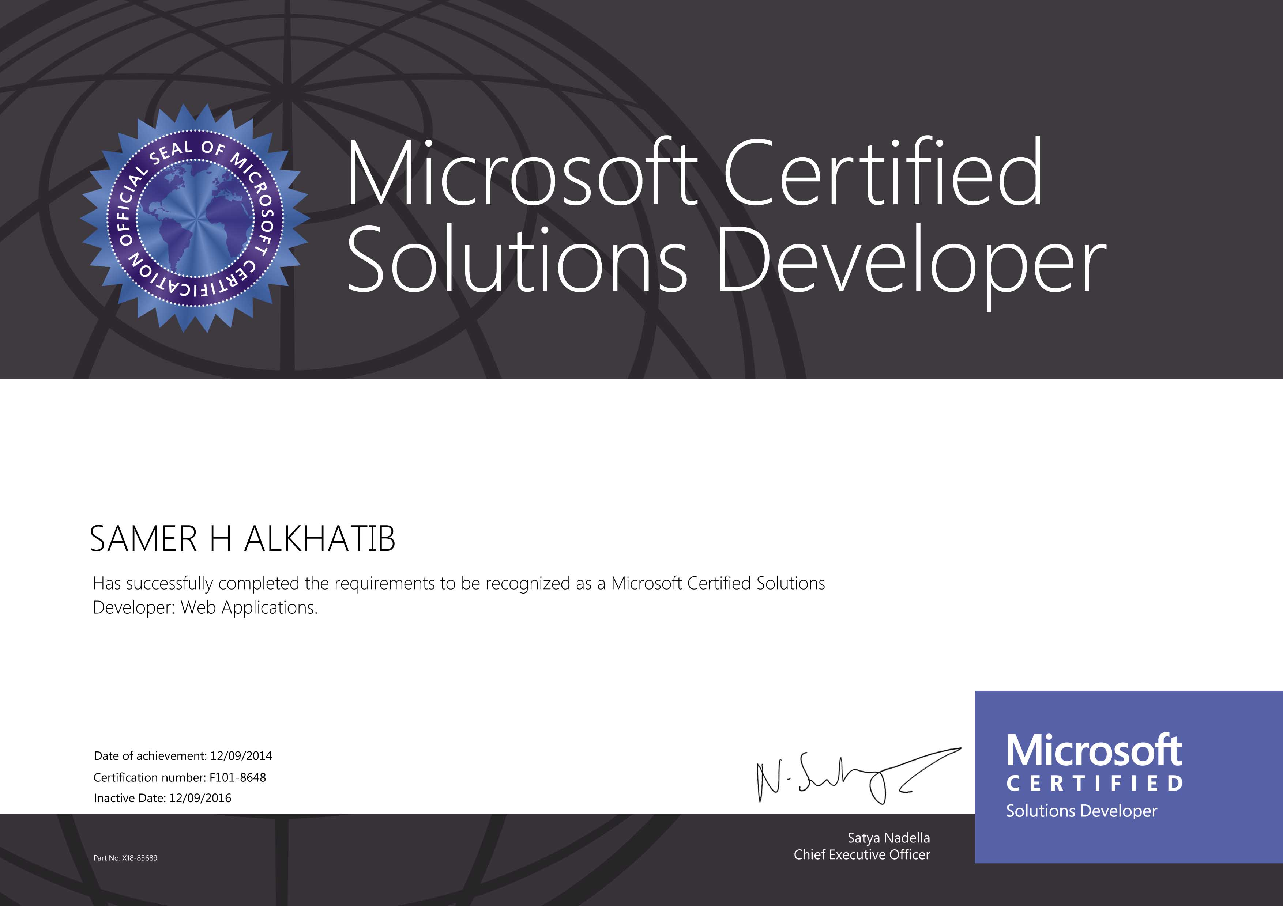

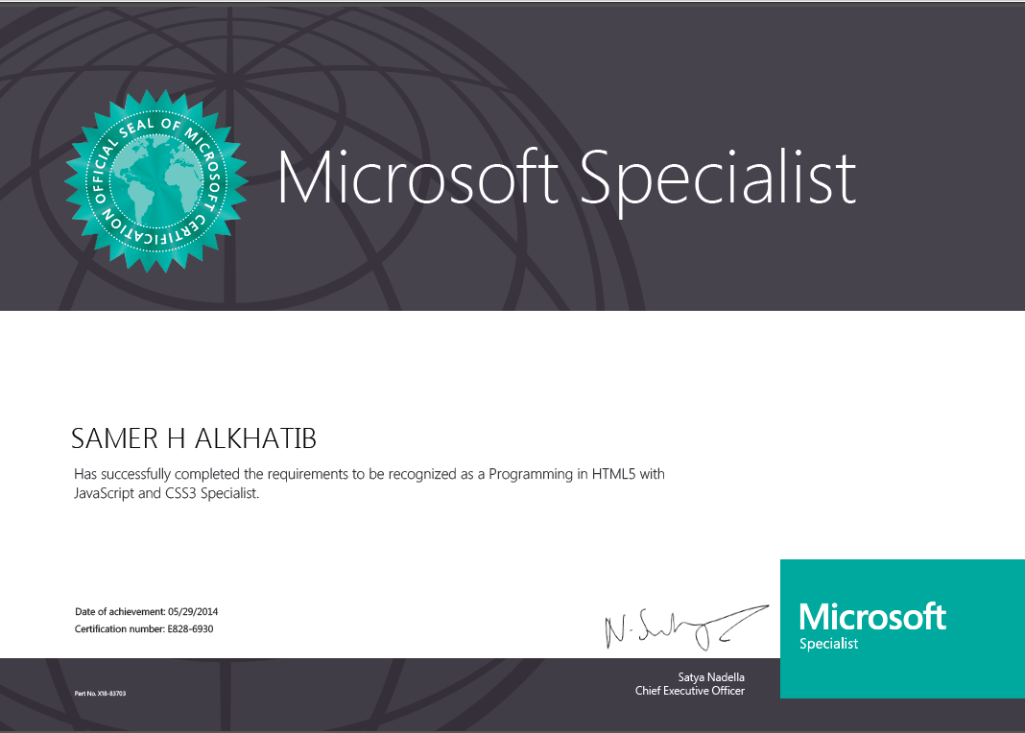
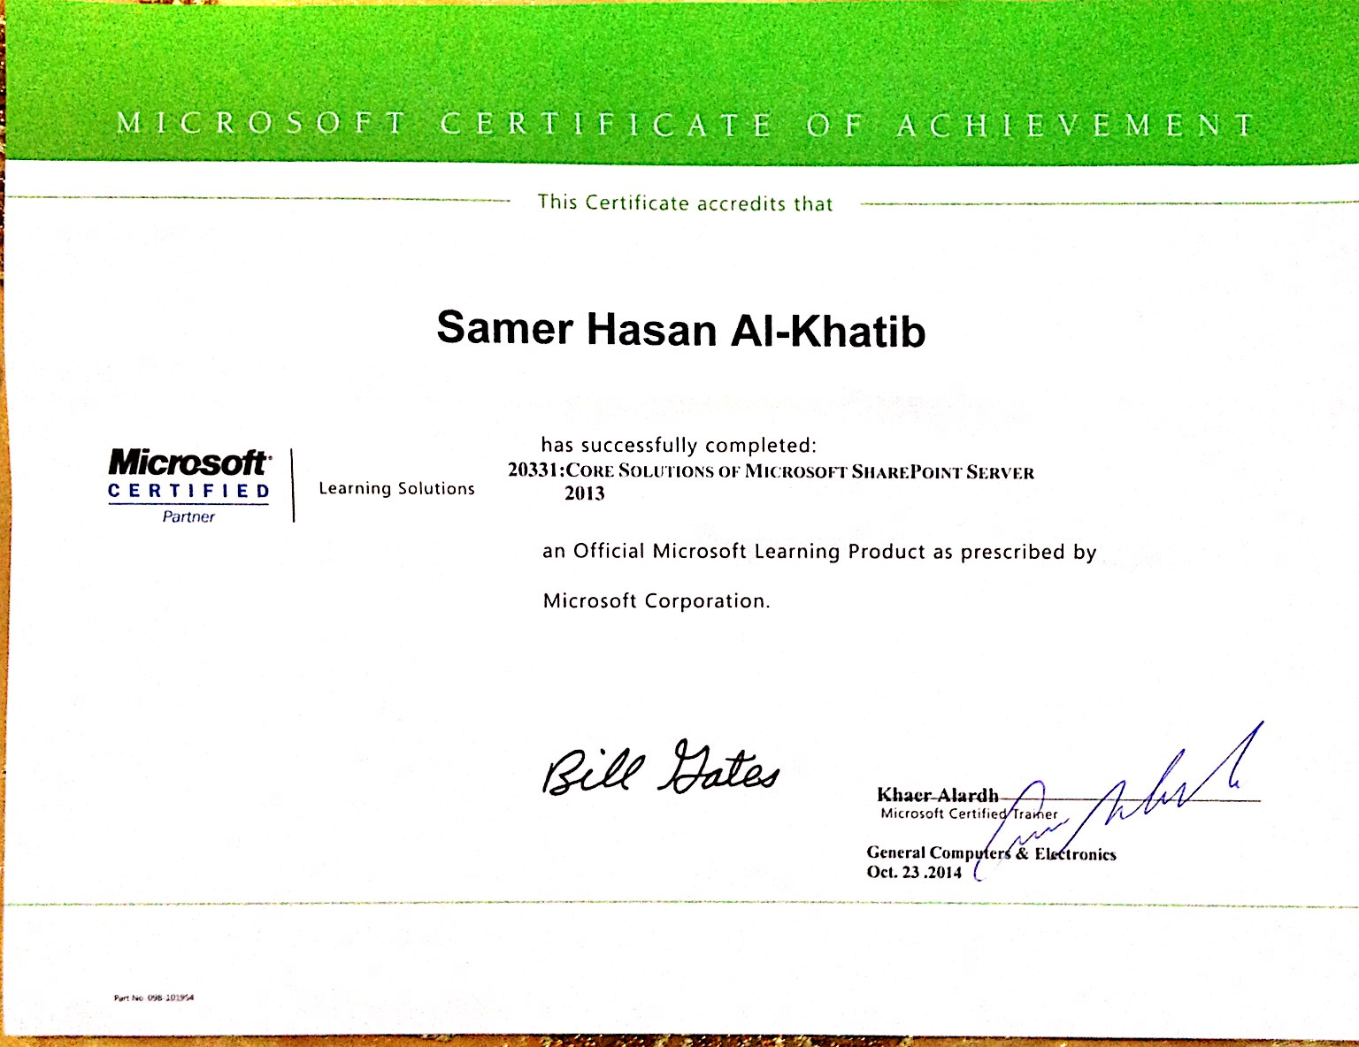
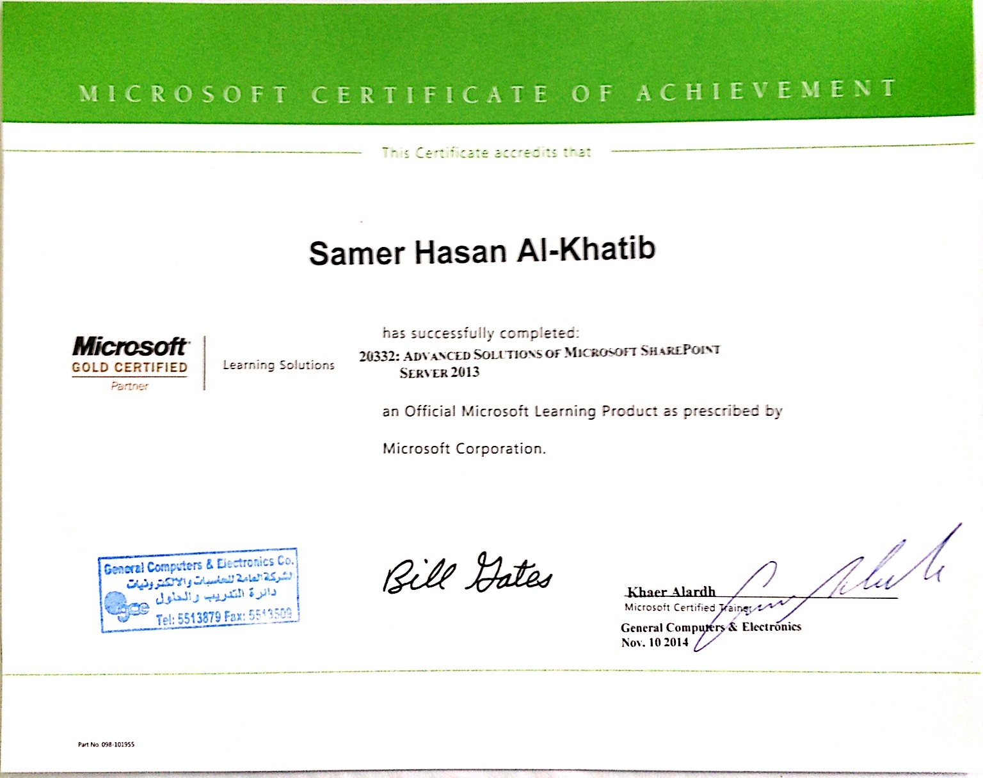
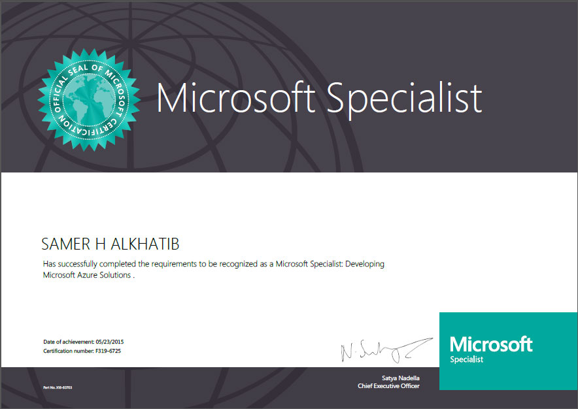

SKILLS

- C#
- ASP.NET
- MVC
- SharePoint 2013
- Web API
- VB.Net
- MS SQL Server
- ADO.NET
- LINQ To SQL
- T-SQL
- Ajax
- HTML 5 & CSS3
- Responsive Design
- SignalR
- JQuery
- JSON
- Node.js
- XML
- Web Services
- Java
- JSP & servlet
- JSF
- PHP and MySQL
- Adobe Photoshop
- .NET Nuke And PHP Nuke
- ISS (Installing and Configuration and web Site Configuration)
- Deployment Web Site On Server and Configuration The Web Site
- Network programming
- Multi thread programming

Some Of Web Projects That I Worked On It

Name | Url
Friday Bazaar | http://www.frbazaar.com/
Easy Shippings | https://www.easyshippings.com/
K7L | https://www.k7l.com
Seideh | http://www.seideh.com
Al ganem Group | http://www.alghanemgroup.com/
Aimstyle Company Website | http://www.aimstyle.com
Kalboard | http://kalboard.com/
Kalboard 360 | http://kalboard360.com/
Ritco Company | http://ritco.jo/
Green Apple Newspaper | http://greenapplejo.com/
IPark Jordan Website | http://ipark.jo/
Legend Pharma | http://legendpharma.com/
IKB Award | http://ikbaward.com/
Universal Civilizations Academy | http://www.uca.edu.jo/
Menatronix | http://menatronix.com/
شركة عدنان سعيد ابو ركبة | http://asarproperties.com/
الدكتور سليمان | http://drdabit.com/
نادي الجواد العربي | http://nadialjawad.com/
AMOR Cosmetics | http://amorjordan.com/
التنال العربي | http://attanalalarabi.com/
Jawsaq | http://jawsaq.com/
Vorsteljo | http://vorsteljo.com/
Let’s Learn | http://khalenanetalam.com/Ar/Default.aspx
Jibreel factories | http://jibreelfactories.com/
Shape shifters | http://www.shapeshiftersme.com/
طارق ابو شهاب للمقاولات | http://www.tascojo.com/
Aroma city group | http://www.aromacitygroup.com/

