Dell

**Online Car Parts Shop App**

[Date]



**Sparepart**

 contents

.introduction------------------------------------

. Software Requirements**-------------------------**

**.** sparepart scope**------------------------------------**

**.**use cases diagram**---------------------------------**

**.** context diagram**----------------------------------**

**.** quality attributes**---------------------------------**

**.**constrent**-----------------------------------------**

.

.

Sparepart

System(Sparepart)

Car Part

Customer

Manufacturer

Introduction

Sparepart is an online shop that allow the customer to buy car part for every car that is out there. At incredibly low costs, we provide the top manufacturers' brands right to consumers' hands. We can promise that drivers will be able to receive what they need, when they need it

Software Requirements

1. The system shall allow the user to login to the system

1.1 the user shall enter password and E-mail

1.2 the system shall verify login info

2. The user shall search for car parts

2.1 The user shall enter car model, year, manufacturer

3. the system shall display search results

3.1 if car parts not found the system shall ask the user to order from the manufacturer

4. the manufacturer shall ask for customer information from the system

4.1 the manufacturer shall prepare the order for shipping

5. the system shall ask user for payment method

5.1 the user shall pick payment method, visa or cash

5.1.1 the user shall enter his card details if he picked pay by visa

5.1.1.1 the bank shall verify user card information

6. The user must be able to into search the system within 1 second.

6.1 The front-page load time must be no more than 2 seconds for users that access the System

sparepart scope

First, the website must be arranged in terms of design, meaning that when entering the website, I know where to go to buy pieces and show the customer what he needs when he enters the site of parts or accessories that he needs to his car as well We must limit the number of existing pieces and when they run out Show a message to the buyer that the quantity has also been carried out Make some offers before or after the opening of the website You must also show a picture of the piece when the customer enters to buy it and the number of available quantity.

**.** quality attributes

# 1 the system shall verify login info

2 the user shall enter his card details if he picked pay by visa

3 the user shall enter password and E-mail

.constrent

# 1.The user shall enter car model, year, manufacturer

# 2 the system shall ask user for payment method

3 the manufacturer shall ask for customer information from the system

context diagram

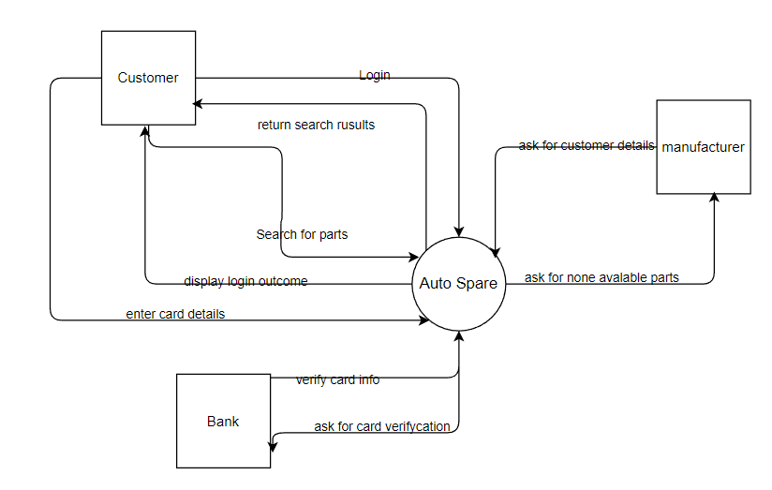

use cases diagram

