# Using Matlab

One way is to use Arduino’s regular serial port and create a serial port in Matlab.

A second way is to use also Arduino library but you need to download its support package.



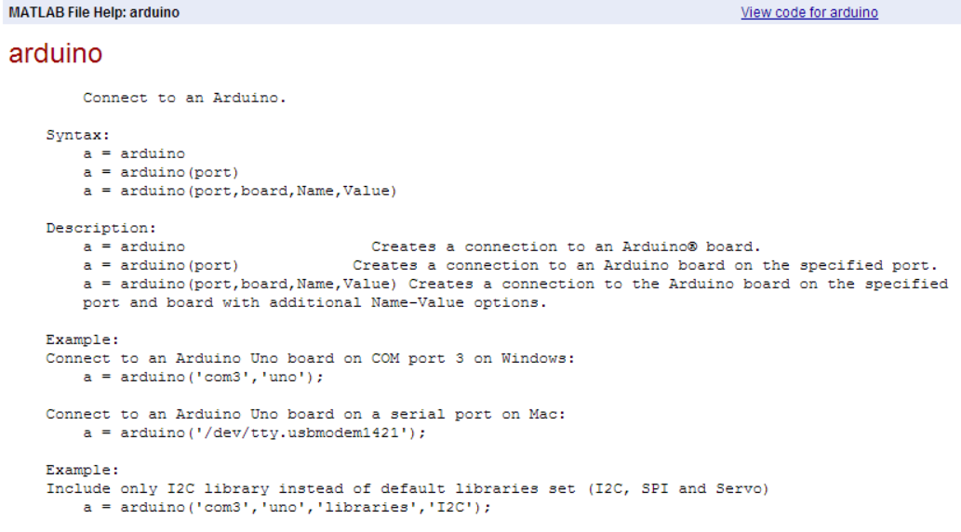

A third way is to use matlab’s I2C serial communication. Matlab allows reading serial I2C.

