Pert and Gantt charts
Activity | Description | Predecessors | Duration
A | System Request | - | 4 Days
B | Feasibility Study | - | 5 Days
C | Methodology | B | 3 Days
D | Time Estimation | A, C | 1 Day
E | Task Identification | C | 1 Day
F | PERT Chart | C | 3 Days
G | Gantt Chart | D, E, F | 3 Days
PERT Diagram
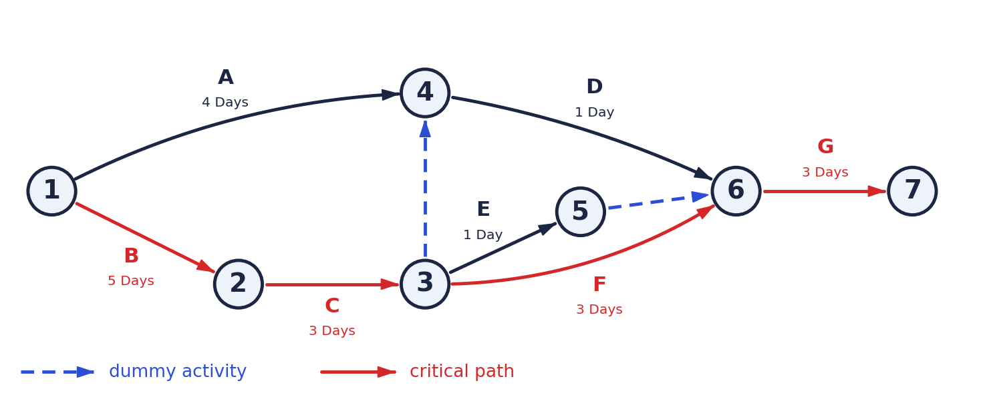
Gantt Chart
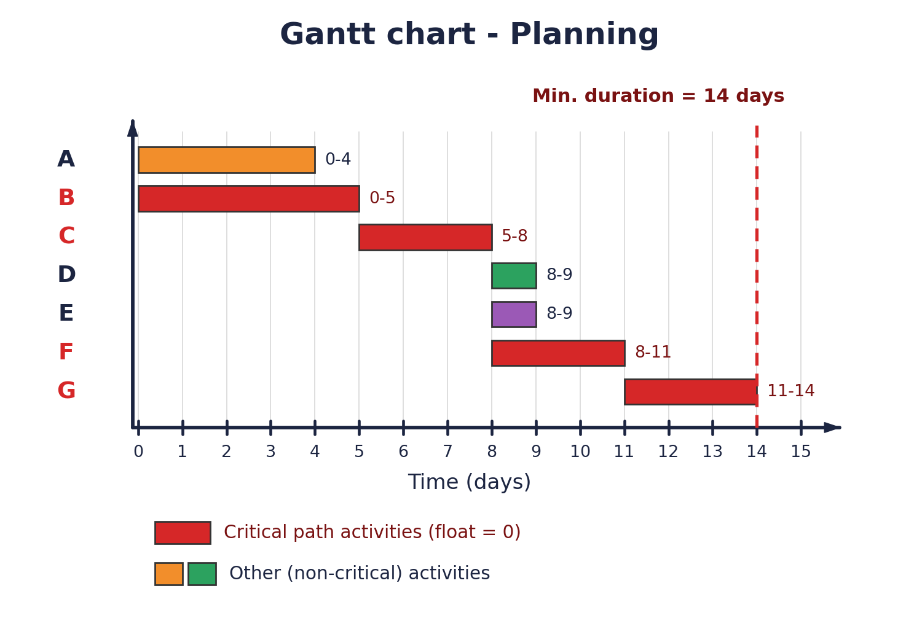
Minimum project duration = 14 days
Critical path: B → C → F → G

