Task 1
Draw the Pert chart for the following activities:
Activity | Predecessor
A | -
B | A
C | A
D | -
E | D
F | B, C, E
G | F
H | D
I | G, H
Answer
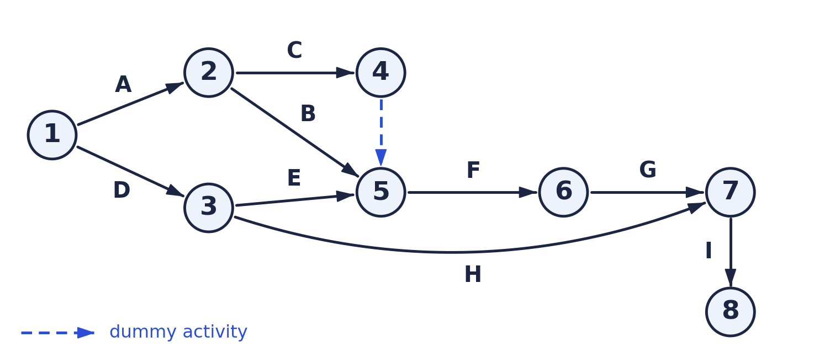
Task 2
Draw the Pert chart for the following activities:
Activity | Predecessor
A | -
B | -
C | -
D | A
E | C
F | B, D
G | B, D
H | E, F
I | A
J | G, H
K | E, F
Answer
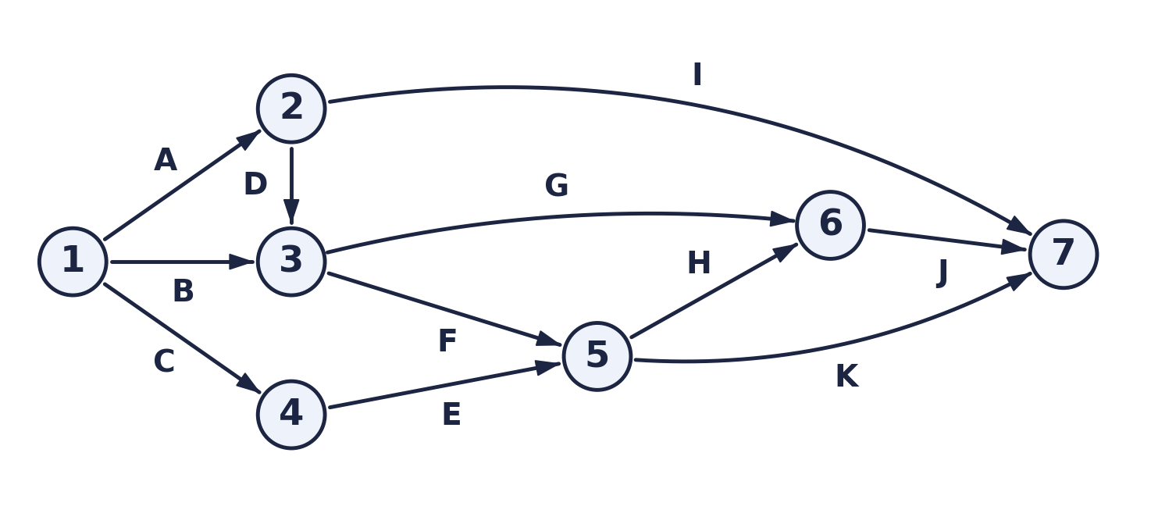
Task 3
For the following activities, draw the Pert and Gantt chart, then determine the minimum project duration and the critical path:
Activity | Duration (Days) | Predecessor
T1 | 8 | -
T2 | 15 | -
T3 | 15 | T1
T4 | 10 | -
T5 | 10 | T2, T4
T6 | 5 | T1, T2
T7 | 20 | T1
T8 | 25 | T4
T9 | 15 | T3, T6
T10 | 15 | T5, T7
T11 | 7 | T9
T12 | 10 | T11
Answer: Pert chart
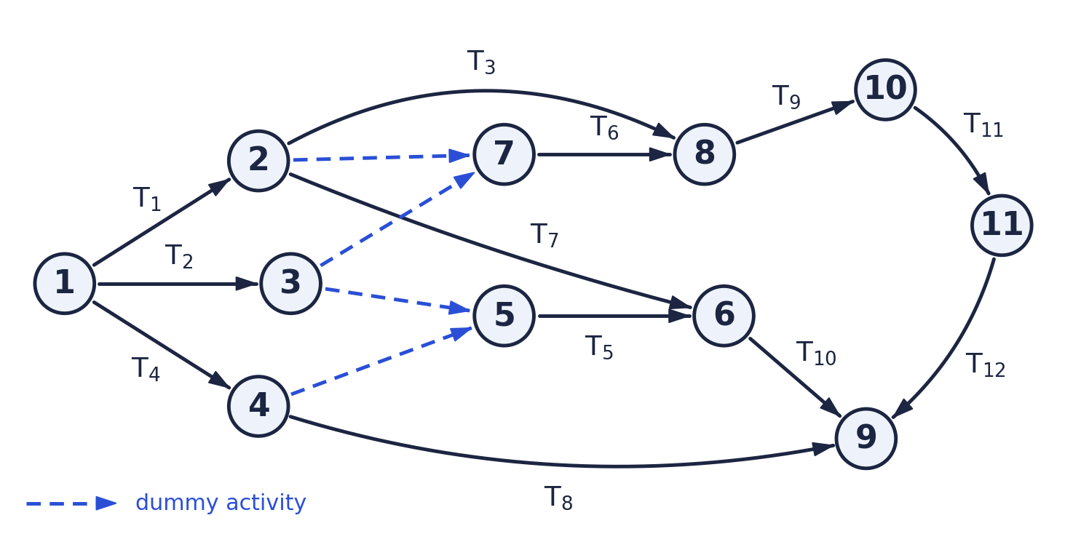
Minimum project duration & critical path

Minimum project duration = 55 days
Critical path: T1 → T3 → T9 → T11 → T12
8 + 15 + 15 + 7 + 10 = 55 days. These activities have zero float (ES = LS), so any delay in one of them delays the whole project. The other activities have float (T2 = 3, T4 = 20, T5 = 15, T6 = 3, T7 = 12, T8 = 20, T10 = 12 days) and can be delayed by that amount without affecting the finish date.
Answer: Gantt chart
