Parallel Programming Assignment Report Template

Students Information
Student Name: samer saad / Mena magdy / Abanoub hashmet / Bassem adel

Problem Information
Problem Title: Shared vs. Private Variables in OpenMP
Lecture Number:

Problem Description
Demonstrate the difference between shared and private variables in OpenMP. A loop computes j[i] = ifirst + i2 where i2 = 2*i. Without the private clause, all threads share the same i2 variable causing a race condition. With private(i2), each thread gets its own copy producing correct results.

Parallelization Approach
The loop is parallelized using #pragma omp parallel for. In the buggy version, i2 is shared among all threads, so one thread may overwrite i2 while another is still using it. In the corrected version, the private(i2) clause gives each thread its own independent copy of i2, eliminating the race condition.

Solution Explanation
private(i2) — creates a separate memory location for i2 on each thread. Each thread reads and writes only its own copy, preventing data conflicts.
shared (default) — all variables except the loop index are shared by default. Threads read and write the same memory location simultaneously, which causes incorrect results for i2.
#pragma omp parallel for — distributes loop iterations evenly across all available threads.
ifirst — remains shared intentionally because all threads only read it, never write it, so no race condition occurs.

Source Code
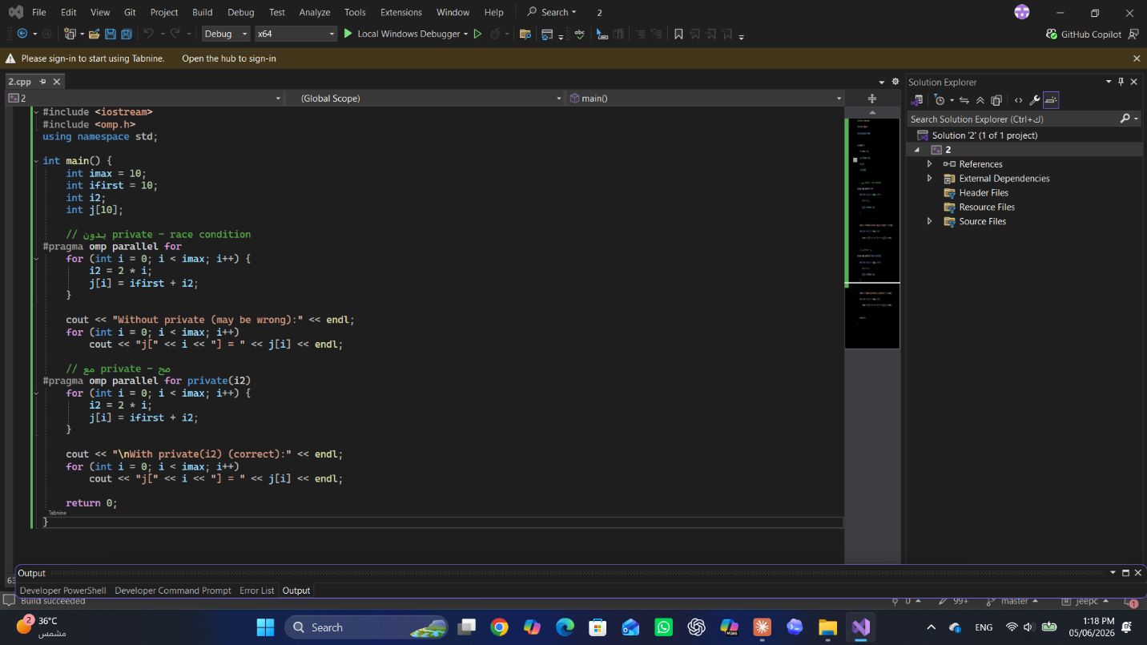

Execution Results
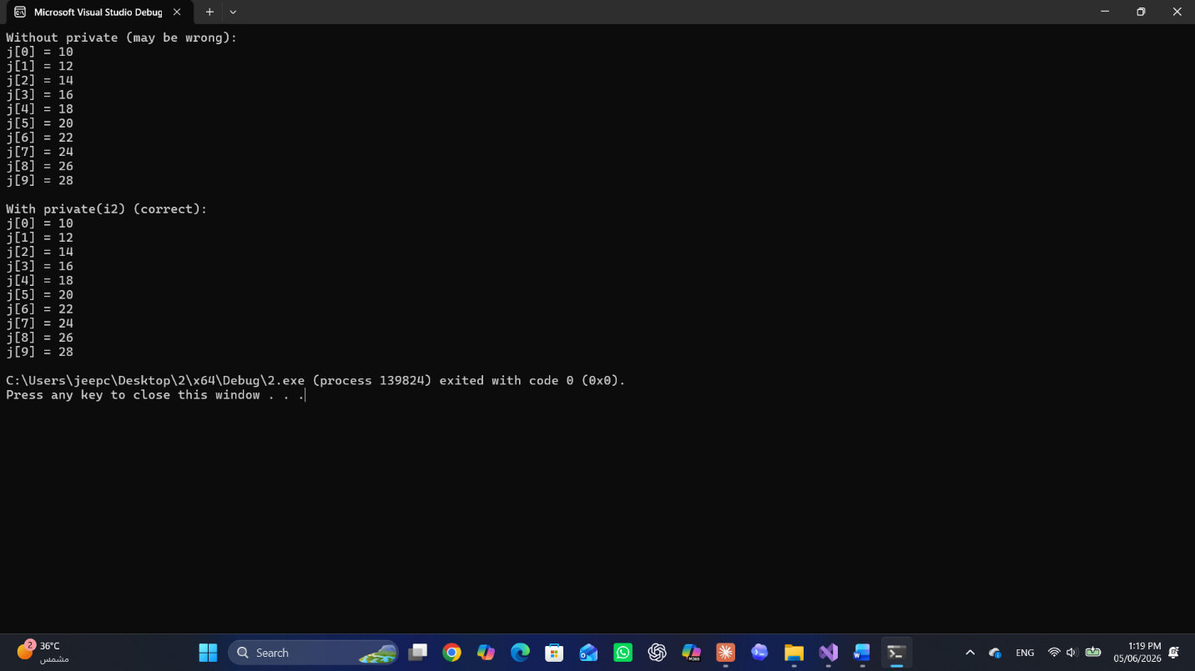

Conclusion
Without the private clause, multiple threads write to the same i2 memory location simultaneously, producing unpredictable and incorrect values in the j array. Declaring i2 as private ensures each thread computes its own value independently, giving the same correct result as the serial version. This demonstrates that variables used as intermediate values inside a parallel loop must be declared private.

