Parallel Programming Assignment Report Template

Students Information
Student Name: samer saad / Mena magdy / Abanoub hashmet / Bassem adel

Problem Information
Problem Title: OpenMP Basic - Parallel Region with Thread Info
Lecture Number:

Problem Description
Demonstrate basic OpenMP usage by retrieving thread information before and inside a parallel region. The program uses OpenMP functions to print the Master Thread ID, maximum available threads, current thread count, and thread IDs inside a parallel region with 6 threads.

Parallelization Approach
A parallel region is created using #pragma omp parallel num_threads(6), which spawns 6 threads. Each thread executes the block independently and prints its own thread ID and the total thread count inside the region.

Solution Explanation
omp_get_thread_num() — returns the ID of the current thread (0 for master).
omp_get_max_threads() — returns the maximum number of threads available on the system.
omp_get_num_threads() — returns the number of active threads in the current region (1 outside, N inside).
#pragma omp parallel num_threads(6) — creates a parallel region with exactly 6 threads.

Source Code

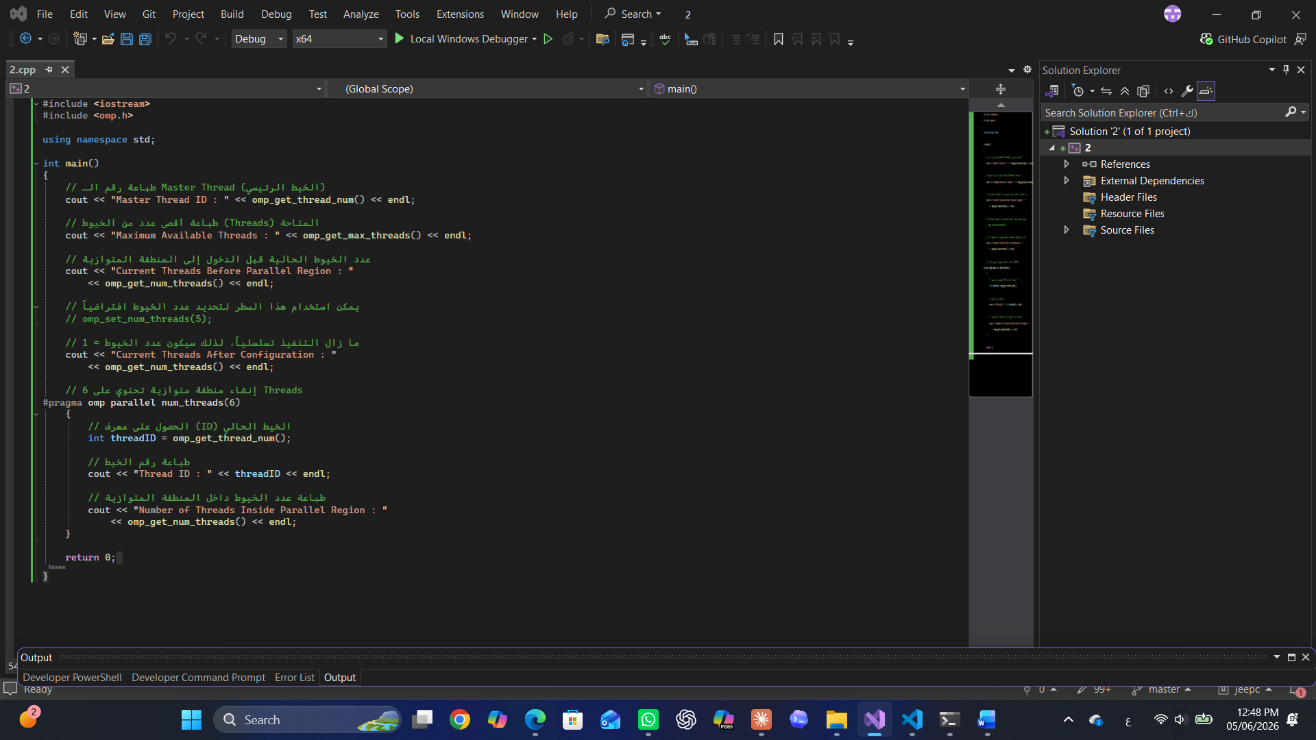

Execution Results
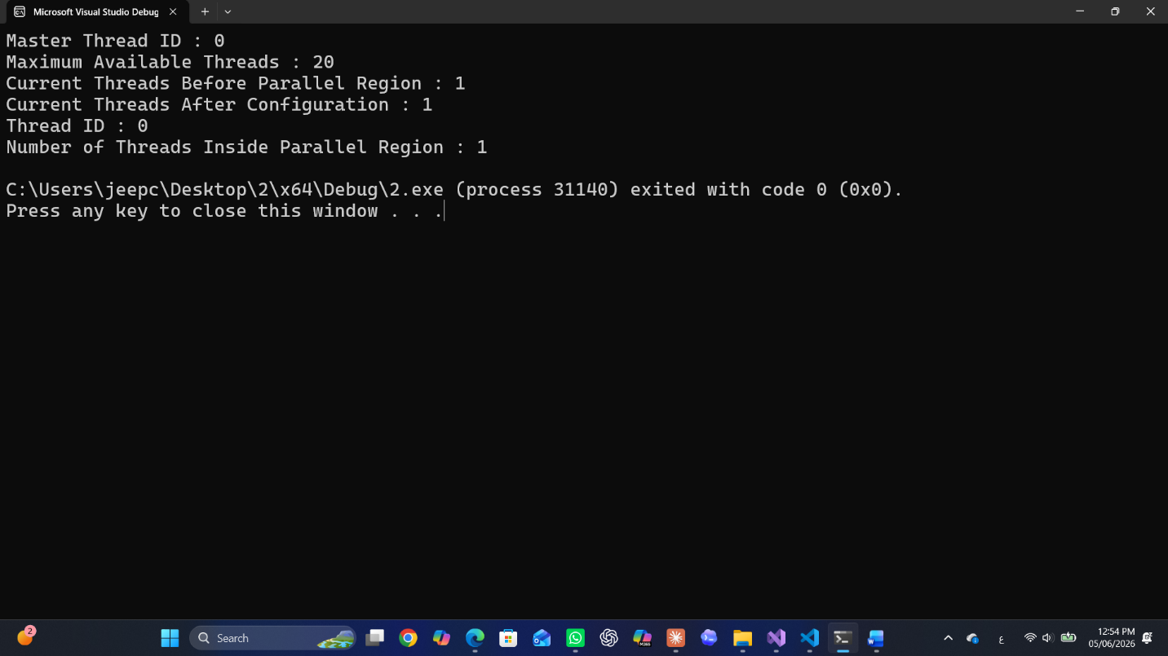

Conclusion
The program successfully demonstrates the use of OpenMP basic functions for thread management. Outside the parallel region, omp_get_num_threads() returns 1 (sequential execution). Inside the parallel region, all 6 threads execute concurrently, each reporting its own thread ID. The output confirms proper OpenMP initialization and thread spawning.

