Parallel Programming Assignment Report Template

Students Information
Student Name: samer saad / Mena magdy / Abanoub hashmet / Bassem adel

Problem Information
Problem Title: Array Sum using OpenMP Reduction Clause
Lecture Number:

Problem Description
Compute the sum of all elements in an array (sum1 = sum1 + a[i]) using multiple threads. Without synchronization, multiple threads writing to sum1 simultaneously produce incorrect results due to race conditions. The reduction clause solves this automatically.

Parallelization Approach
The loop is parallelized using #pragma omp parallel for with a reduction(+:sum1) clause. Each thread maintains its own private partial sum during the loop. At the end of the parallel region, OpenMP automatically adds all partial sums together into the final shared sum1 variable.

Solution Explanation
reduction(+:sum1) — tells OpenMP to create a private copy of sum1 for each thread initialized to 0, then sum all private copies into the shared sum1 at the end of the parallel region.
#pragma omp parallel for — distributes loop iterations across threads. Each thread processes a different subset of the array.
sum1 = 0.0 (before pragma) — the initial value must be set before the parallel region so the reduction starts correctly.
Supported operators — + * - / & ^ | && || MAX MIN can all be used with the reduction clause.
Roundoff note — due to floating-point non-associativity, the parallel result may differ very slightly from the serial result.

Source Code
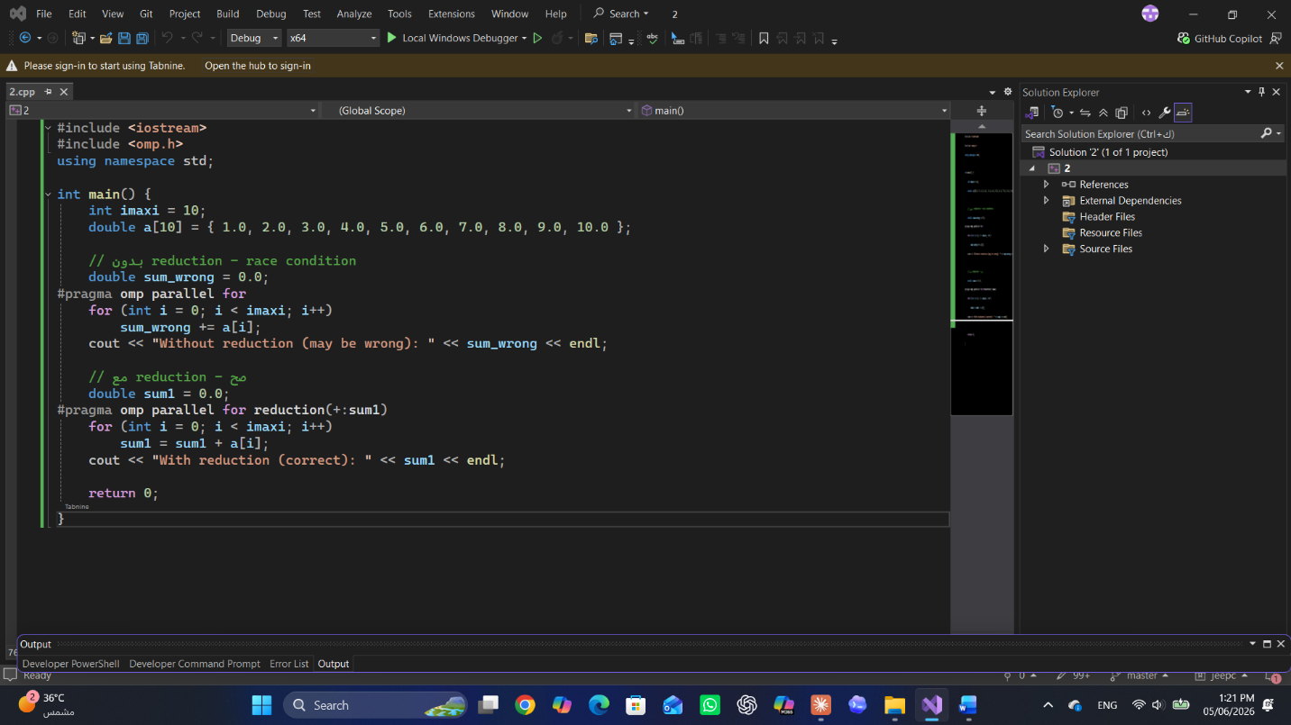

Execution Results
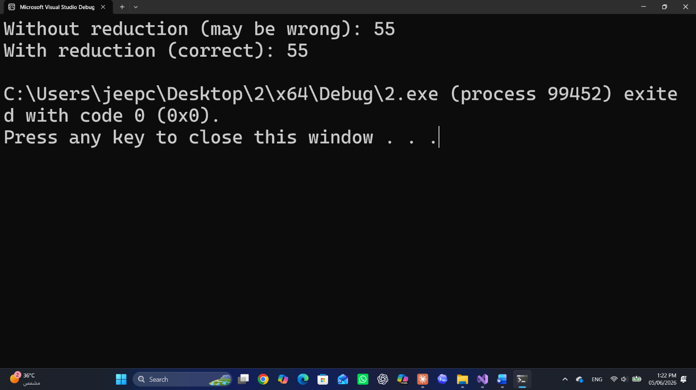

Conclusion
Without reduction, threads write to sum1 simultaneously, producing wrong and non-deterministic results. The reduction(+:sum1) clause handles this correctly and efficiently: each thread accumulates its own partial sum without synchronization overhead, and the final combination happens only once at the end. This pattern is ideal for any accumulation loop (sum, product, max, min) and is far more efficient than using a critical section.

