BLM 320 Class Work #10

* Decide if 3 colors are sufficient to color G₁ and G₂
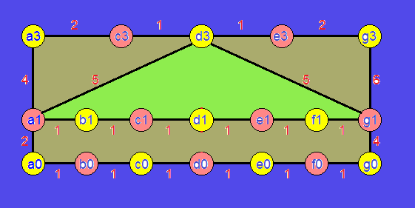
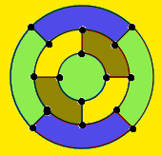

4 color Purple can be painted as green(Min 2 color)

* Find a minimum spanning tree in G₁ and G₂

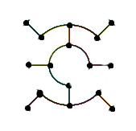
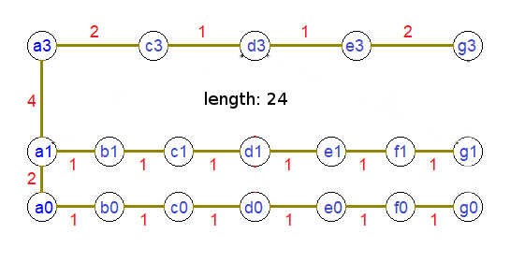

* Find a Hamiltonian circuit (cycle) in G₁ and G₂

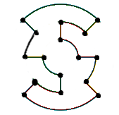
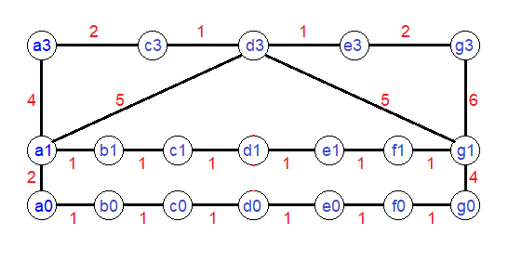
Does not include Hamiltonian cycle

* Decide if G₁ and G₂ contain an Eulerian circuit
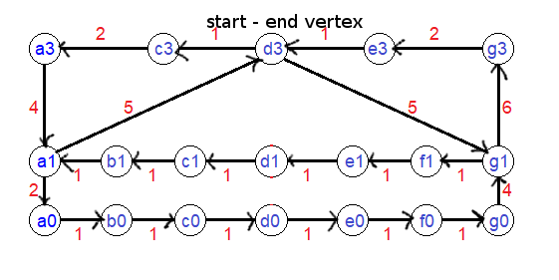

G1 does not contain

