Machine Learning

Term Project

Alpay Kurt 190303020 – Samet Şenol 190303013

In this project, the code uses a classifier trained using the MPG.csv (Miles Per Gallon).  
The goal is to estimate which features are important for car gas and how much important they are.

In this project, we are going to show the performance metric(such as, correlation coefficient, Interception, Confusion Matrix, Accuracy Score, Precision score, R2 Score) results and related graphics for every method.

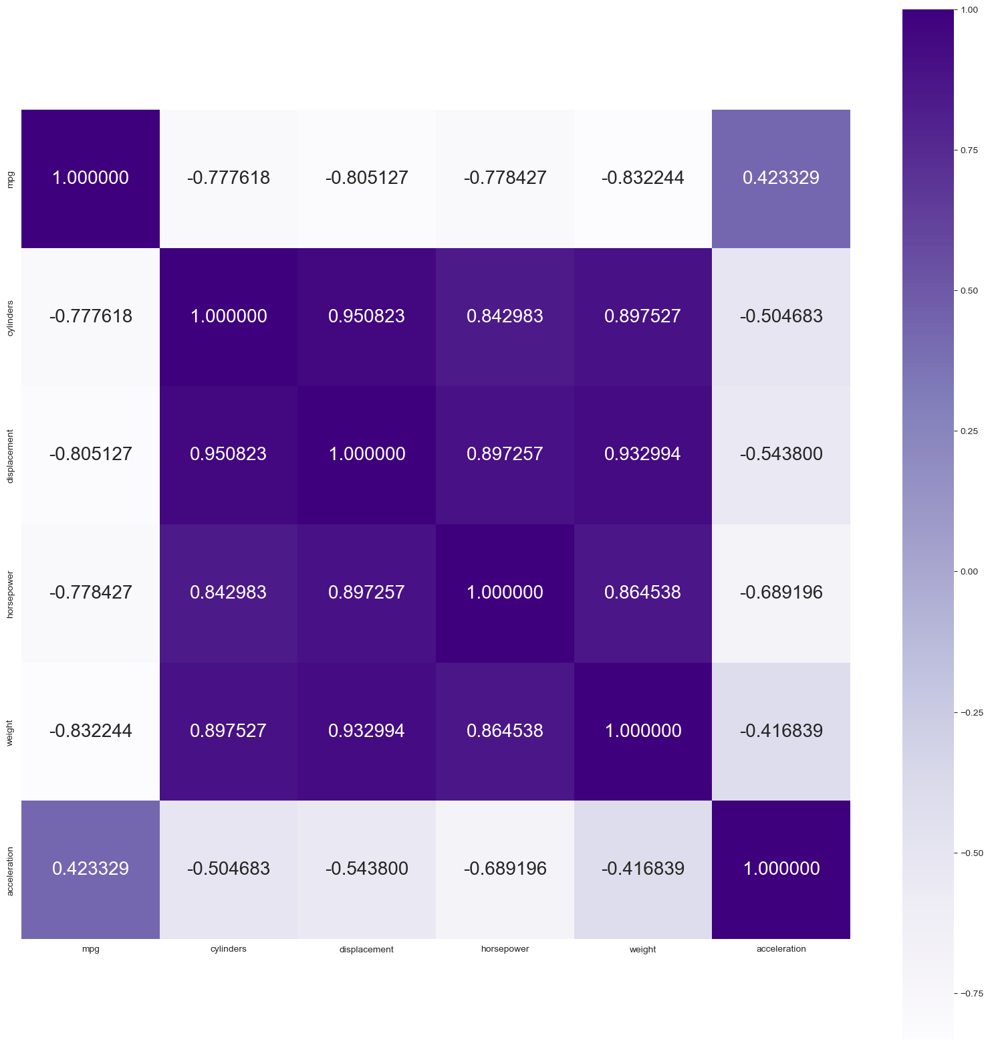**Correlation:**our correlationshape is (6,6) and our heat map is like:

|  |  |  |
| --- | --- | --- |
| **Method** | **Precision score** | **Accuracy Score** |
| Multiple Linear Regression | 78.57% | 74.63% |
| Logistic Regression | 84.69% | 81.78% |
| Polynomials Regression | 78.57% | 74.63% |
| K-NN | 84.69% | 81.69% |
| Naive Bayes | 72.44% | 72.87% |
| Decision Trees | 83.67% | 80.31% |
| Random Forest | 84.39% | 81.39% |
| Support Vector Machine | 83.67% | 80.69% |
| K-means clustering | 89.54% | 90.04% |
| Hierarchical clustering | 45.40% | 30.16% |

***Multiple Linear Regression:***

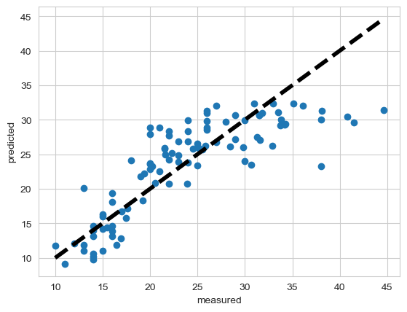

______________________________

coefficient:

[-0.31162377 -0.00470112 -0.02647071 -0.00552154 0.08056846]

______________________________

Interception:

43.94699577982187

______________________________

Confusion Matrix:

[[56 8]

[13 21]]

______________________________

Accuracy Score:

78.57142857142857 %

______________________________

Precision score:

74.63235294117648 %

______________________________

R2 Score:

-0.02848575712143897

***Logistic Regression:***

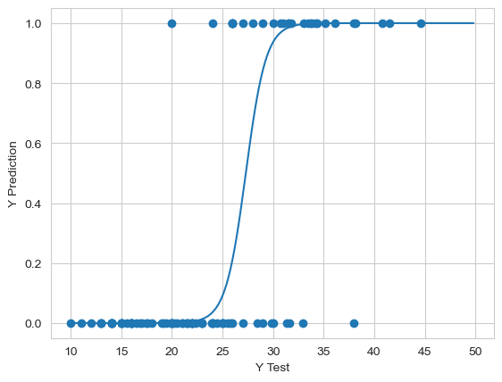

Confusion Matric:

[[62 7]

[ 8 21]]

______________________________

Accuracy Score:

84.6938775510204 %

______________________________

Precision score:

81.78571428571428 %

______________________________

R^2 Score:

0.2653673163418292

***Polynomial Regression:***

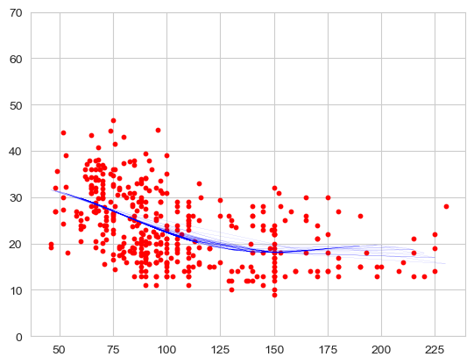

Confusion Metric:

[[56 13]

[ 8 21]]

______________________________

Accuracy Score:

78.57142857142857 %

______________________________

Precision score:

74.63235294117648 %

______________________________

R2 Score:

-0.02848575712143897

***K-NN:***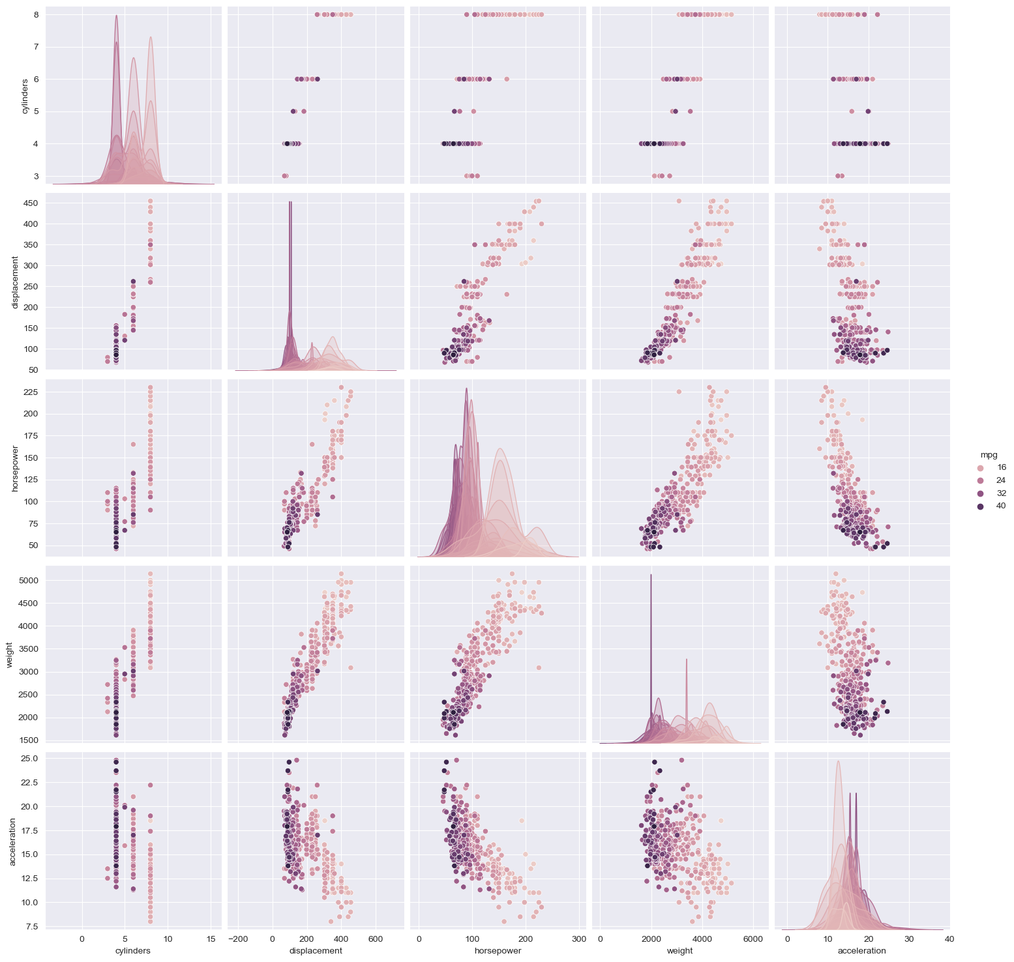

Confusion Matric:

[[45 24]

[ 3 26]]

______________________________

Accuracy Score:

72.44897959183673 %

______________________________

Precision score:

72.875 %

______________________________

R2 Score:

-0.32233883058470747

***Naïve-Bayes:***

Confusion Matric:

[[45 24]

[ 3 26]]

______________________________

Accuracy Score:

72.44897959183673 %

______________________________

Precision score:

72.875 %

______________________________

R2 Score:

-0.32233883058470747

***Decision Tree:***

Confusion Matric:

[[58 11]

[ 5 24]]

______________________________

Accuracy Score:

83.6734693877551 %

______________________________

Precision score:

80.31746031746032 %

______________________________

R2 Score:

0.21639180409795122

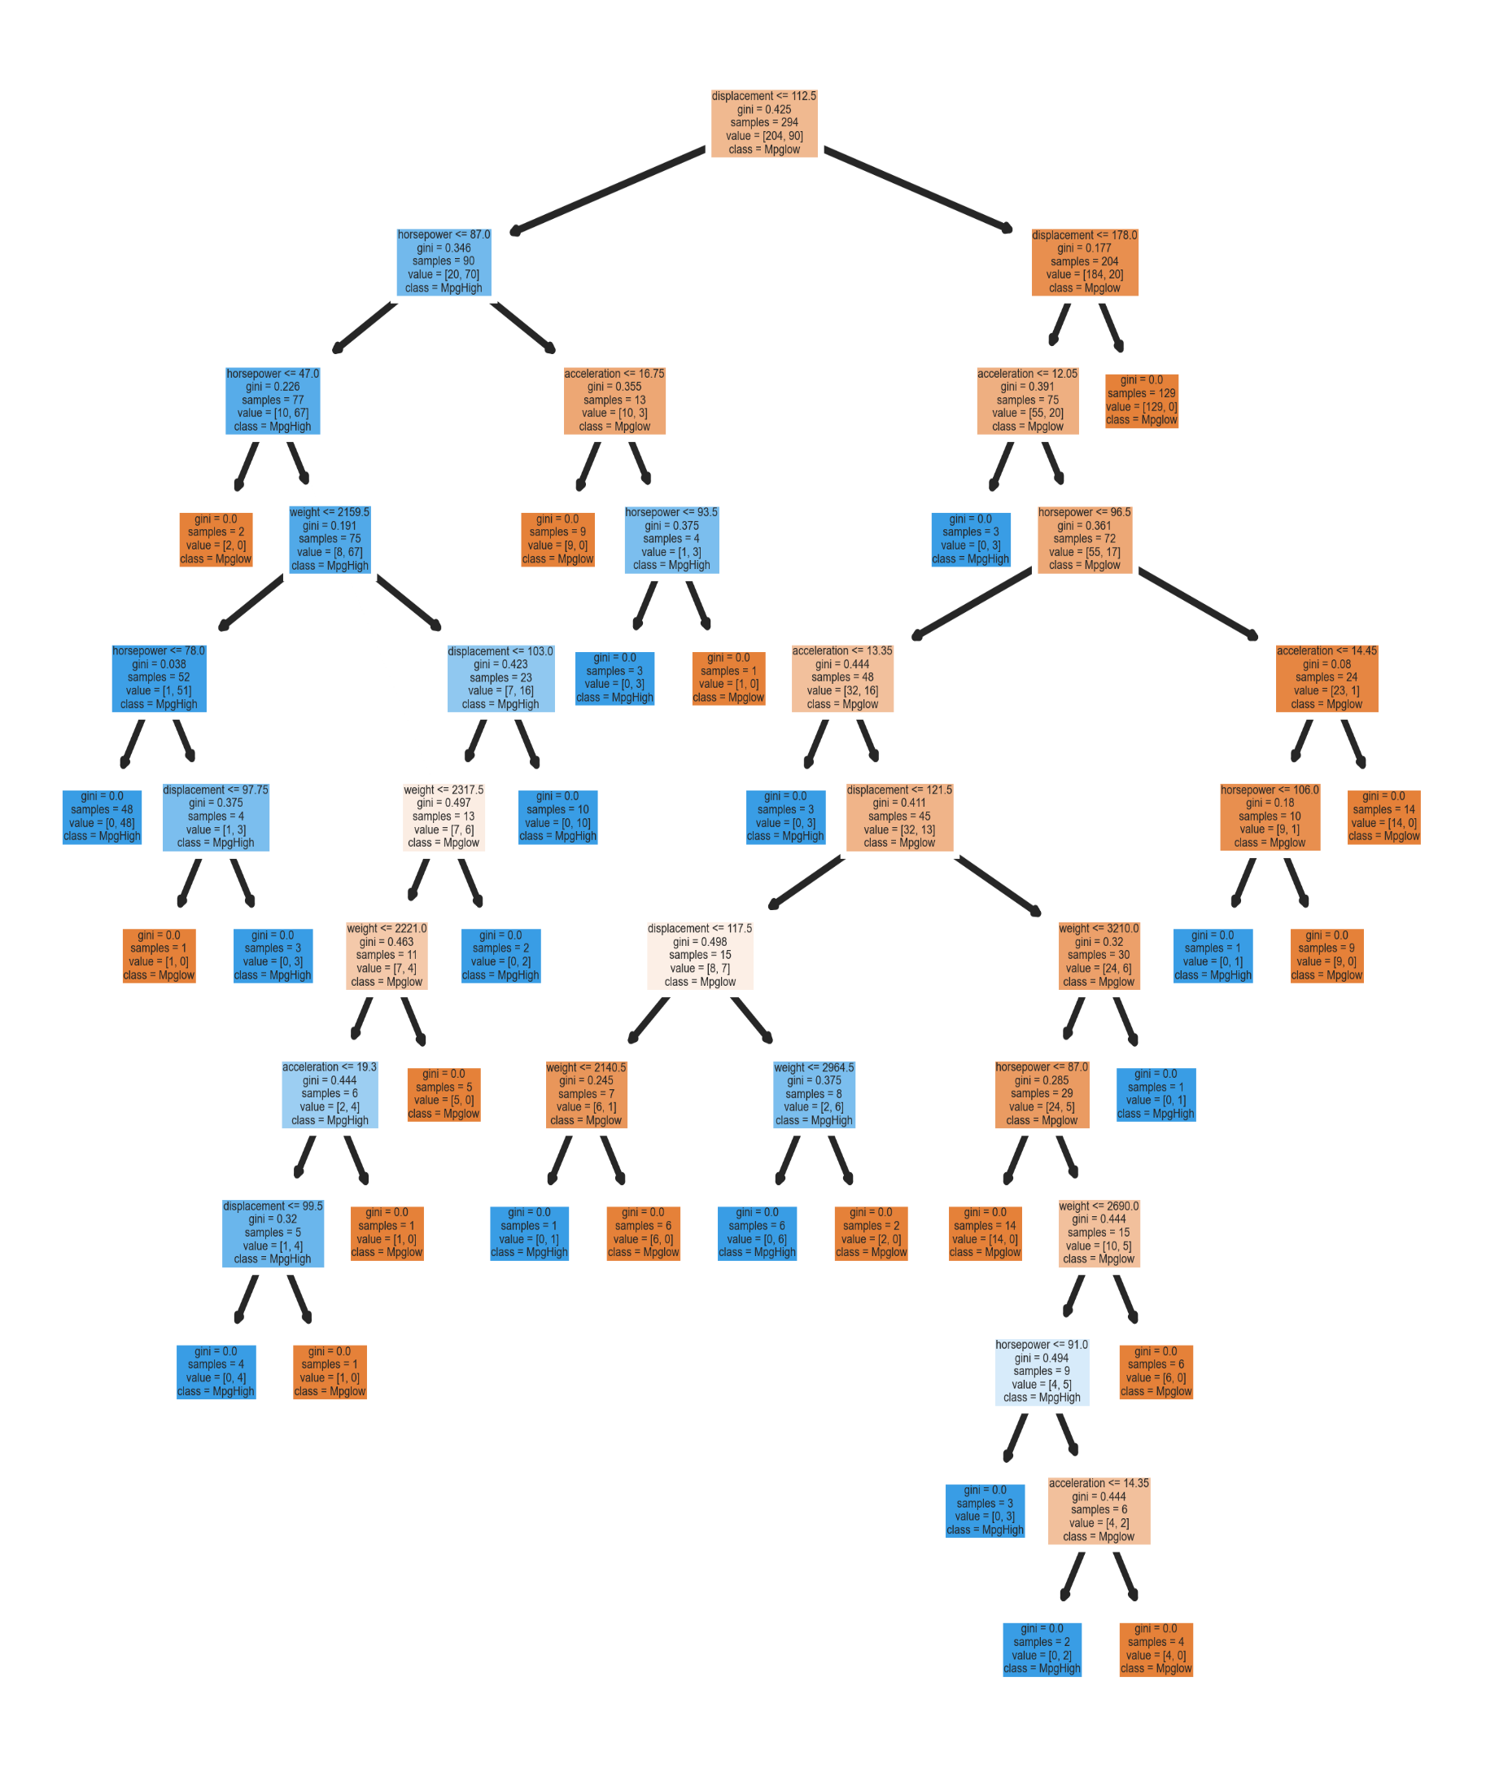

**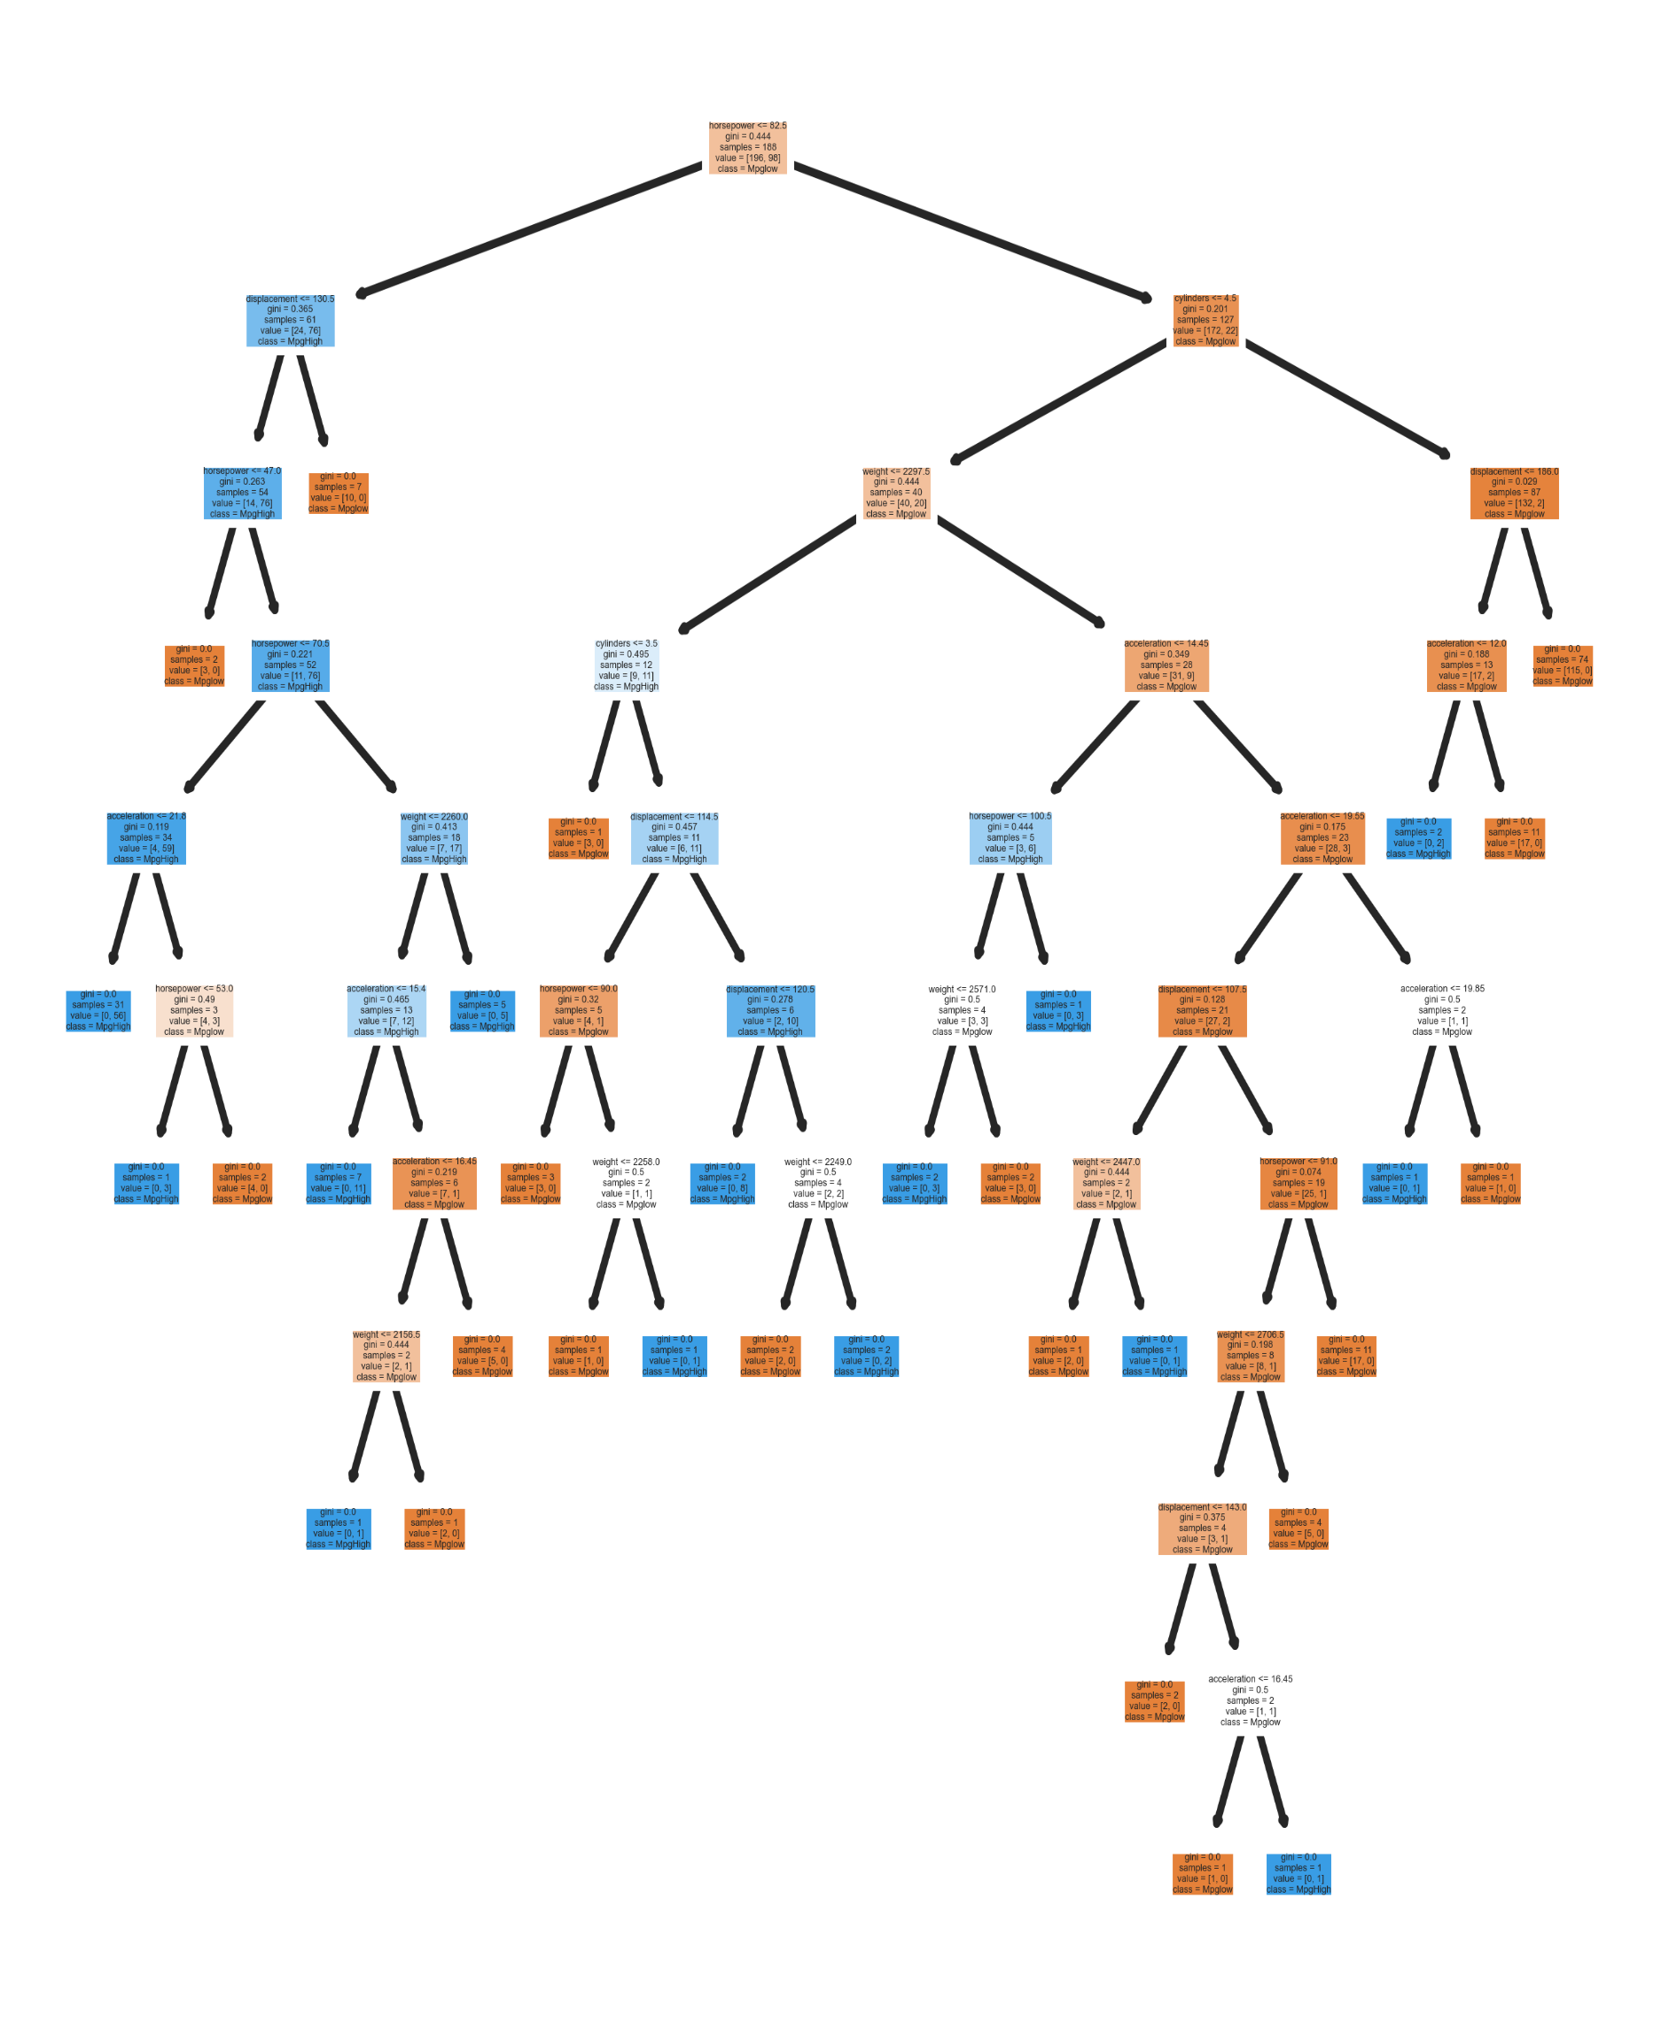*Random Forest:***

***SVM (Support Vector Machine):***

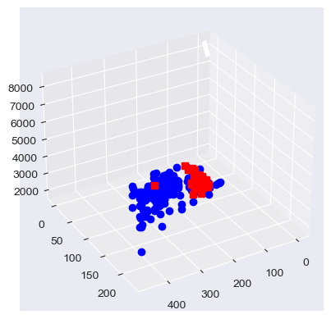

Confusion Metrics:

[[62 7]

[ 9 20]]

______________________________

Accuracy Score:

83.6734693877551 %

______________________________

Precision score:

80.69900886802294 %

______________________________

R2 Score:

0.21639180409795122

***K-Means Clustering:***

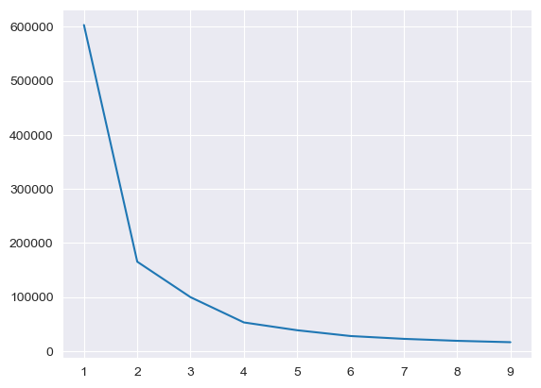

**As you can see from elbow, we definitely should use 2 clustering**

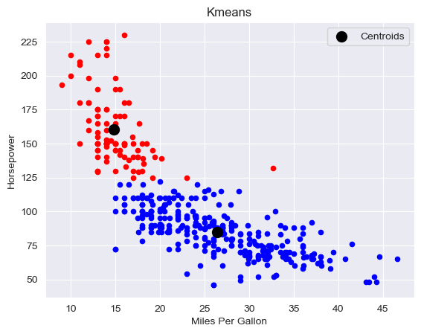

Confusion Metrics:

[[ 92 32]

[ 9 259]]

______________________________

Accuracy Score:

89.54081632653062 %

______________________________

Precision score:

90.04627266850396 %

______________________________

R2 Score:

0.5163697640828117

***Hierarchical Clustering:***

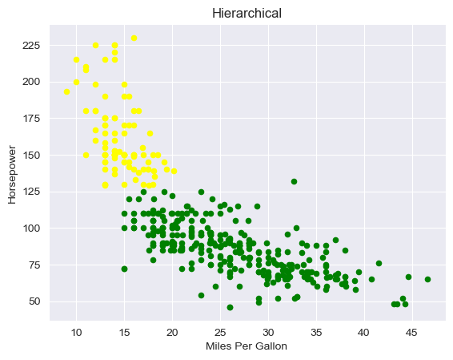

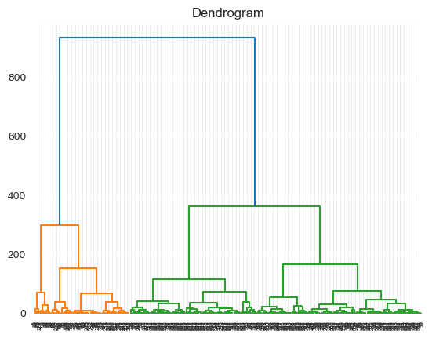

Confusion Metrics:

[[178 97]

[117 0]]

______________________________

Accuracy Score:

45.40816326530612 %

______________________________

Precision score:

30.16949152542373 %

______________________________

R2 Score:

-1.6072416472416475