# **THERMAL CALCULATIONS**

It is known that thermal calculation is necessary for providing suitable conditions for the temperature vulnerable circuit components. Otherwise, generally, because of the overheating components can be defected or can be harmed. The main reason of the heat increase in a circuit is power losses. These power losses occur as heat in the components so, doing power loss calculations before the thermal calculations is necessary.

## **Power Losses:**

Semiconductors can be heated to the high temperatures due to the losses inside of them. If the temperature exceeds the limit, semiconductor device can be broken. Hence, it must be considered the losses in the semiconductor devices:

* Switching losses
* Conduction losses

**-Switching Loss formula (Reverse Recovery Loss):**

**-Conduction Loss Formula**

### **Three-phase rectifier module VUO36-16NO8:**

From the simulation report, it was indicated that switching loss for this component was unsignificant. So, let’s check for the conduction loss:

(Maximum average current that passes through a diode in our design)



Figure 1:Thermal resistance of the three-phase rectifier module

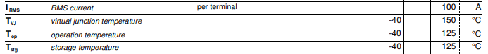

Figure 2:Temperature specifications of the three-phase rectifier module

Let’s assume Tambient = 40˚C. Then, calculate the temperature of the rectifier module.

Actually, this temperature is in the range of the device’s operation temperature. However, we were also decided to implement a heatsink to this device too. We planned to implement HBT254 to the rectifier.

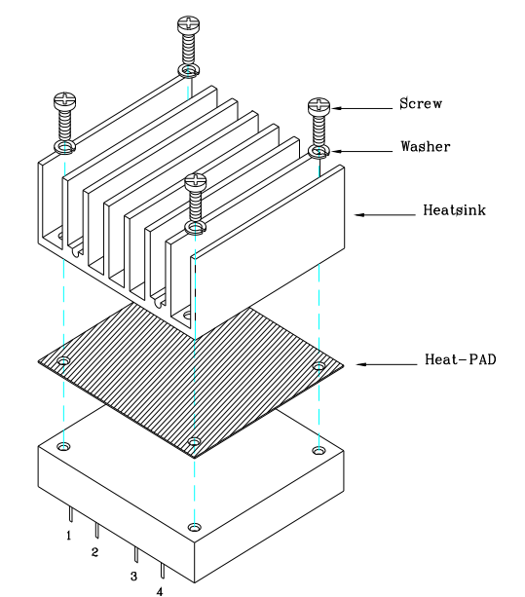

Figure :Possible implementation of the heatsink to the rectifier module

This heatsink has thermal resistance as RHA = 3 (. Hence, by using this heatsink,

### **Freewheeling Diode DSEP30-06B:**

Beside of the three-phase rectifier module, for the freewheeling diode, it was indicated that switching loss for this component was unsignificant in the simulation report. So, let’s check for the conduction loss:

(Current that passes through this diode in our design)

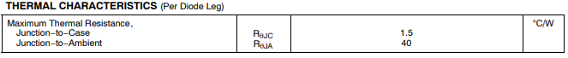

Figure :Thermal resistance of the diode



Figure :Operating temperature of the diode

Again, assume Tambient = 40˚C. Now, calculate the temperature of the diode.

As it can be observed, temperature of the diode exceeds the operating temperature range. Hence, heatsink and fan usage is necessary. For the heatsink, we have decided to use HBT254.

This heatsink has thermal resistance as RHA = 3 (. On the other hand, it will be used a 12V DC San Ace 80 fan.

Figure :Possible fan selection

Figure :DC fan specifications

It was planned to use 77−6020D12 and it has CFM = 22.43, which equal to LFM = 578.83. Besides, heatsink’s thermal resistance is 0.95 ( under 400 LFM. Hence, by using this heatsink and fan,

### 

### **IGBT IXGH24N60C4D1:**

The IGBT used as a switch in the buck converter is IXGH24N60C4D1. For this IGBT, let’s do the loss calculations:

(Switch on energy of the IGBT)

(Switch off energy of the IGBT)

(Collector-Emitter voltage in saturation)

(Current passes through this IGBT when it is conducting)

Hence,

Figure :Temperature specifications of the IGBT



Figure :Thermal resistance of the IGBT

We have decided to use the same fan and same heatsink that we planned to use for the diode. Hence, same calculations are valid for the IGBT.

Assume Tambient = 40˚C.

So, for the worst case, IGBT can stand and work properly.