# **EE463 STATIC POWER CONVERSION-I**

# **TERM PROJECT SIMULATION REPORT**



Musa Ulusoy 2305555

Muhammet Samet Yakut 2305647

Berna Corak 2304392

# **I. INTRODUCTION**

In our term project we are required to build a motor driver circuitry which will run a DC motor via AC grid. In this report, the topology we have chosen and the reason behind it will be discussed. Necessary analytical calculations will be given. Simulation of the circuitry will be talked upon, and component selection will be presented. Next, thermal calculations and the implementation we have done so far will be provided.

# **II. TOPOLOGY SELECTION**

Specifications of the project can be found in the [GitHub repository](https://github.com/odtu/ee463/tree/master/Term%20Project). For this project, basic topologies that we considered are as follows:

* *Center-tap transformer:* This topology turned out to be way expensive compared to others (~300 TL), therefore it is automatically eliminated. Besides this, in the small scale it has only one tap at the secondary, decreasing the flexibility of the output voltage, if used as a single component.
* *Single phase full bridge diode rectifier with buck converter:* This topology is comparably cheaper compared to others. However maximum output voltage that a single-phase diode rectifier can provide is 207 V, when variac is at 100%. That means for a maximum operational output of 180 V, duty cycle (DC) of the buck converter should be around 90%, which is not desired since as DC gets closer to the edges, its output becomes instable and non-reliable.
* *Single phase thyristor rectifier:* Similarly with the previous topology, maximum output this can provide is 207 V. For 180 V output, 30° of firing angle is required, which is reasonable. However, compared to the next topology especially, two gate driver circuitry is needed, complicating the matters. Even though pricewise being comparable with the three phase full bridge diode rectifier with buck converter, this topology is found to be more error-prone due to this multiple gate driver requirement and hence is not chosen.
* *Three phase full bridge diode rectifier with buck converter:* This topology is decided upon at the end, due to it being cheap and its ease of implementation. Since the motor acts like a capacitive load in addition with its series parasitic inductance, two components of the buck converter is not necessary, decreasing the cost even further and simplifying the circuitry. Only a gate driver is basically needed, which is doable.
* *Three phase thyristor rectifier:* Compared with the single phase case, cost and complexity is tripled, thus this topology is, too, eliminated.

# **III. SIMULATION RESULTS**

In order to obtain a quantitative result, a simulation model is constructed on Simulink software. In this simulation model, parasitic effects due to nonidealities of the components are included, such as on resistances of diodes and IGBT, forward voltage drops of diodes and IGBT. Only ESR value of the capacitor is not presented because its datasheet is not available on the internet. Note that this nonidealities are not added as discrete elements, i.e., they are already present in the fundamental blocks of the Simulink. Their values are taken from the datasheets of the components. Constructed simulation model is presented below in Fig. 1. For more detailed simulation model, which includes measurement and calculation elements, please refer to the [GitHub](https://github.com/sametyakut/EE463-TERM-PROJECT/tree/main/Simulation%20Models) repository.

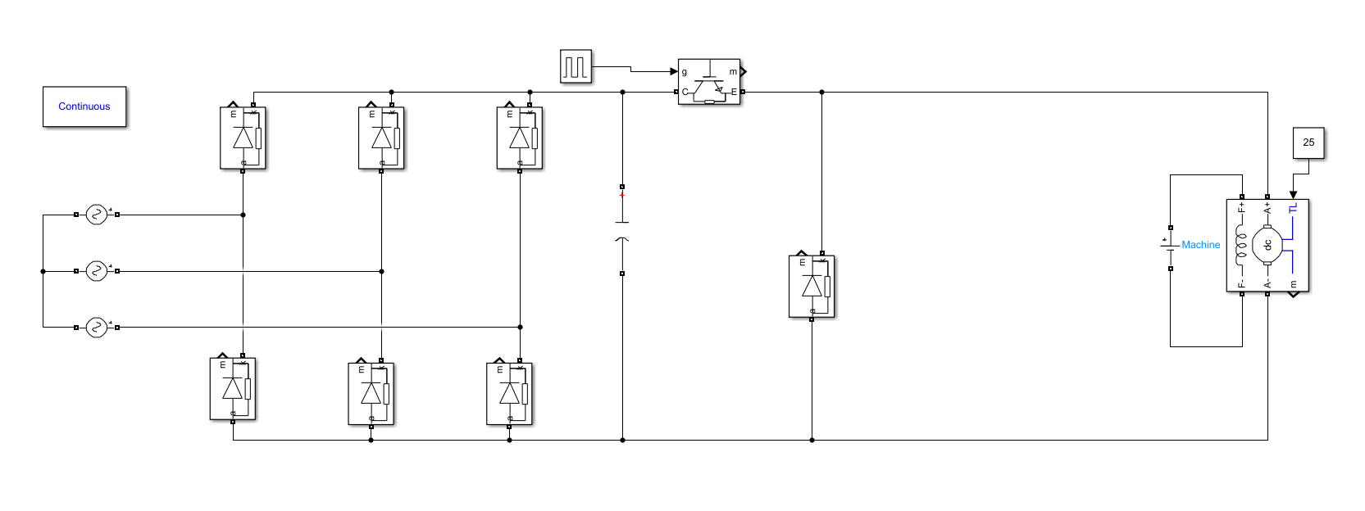

Figure 1. Simulation model of the selected topology

Simulation results of input voltage, output voltage and armature current with different duty cycle values are presented below in Figs. 2 to 7. For more detailed simulation results that covers each components voltage and current waveforms please refer to the [GitHub](https://github.com/sametyakut/EE463-TERM-PROJECT/tree/main/Figures) repository.

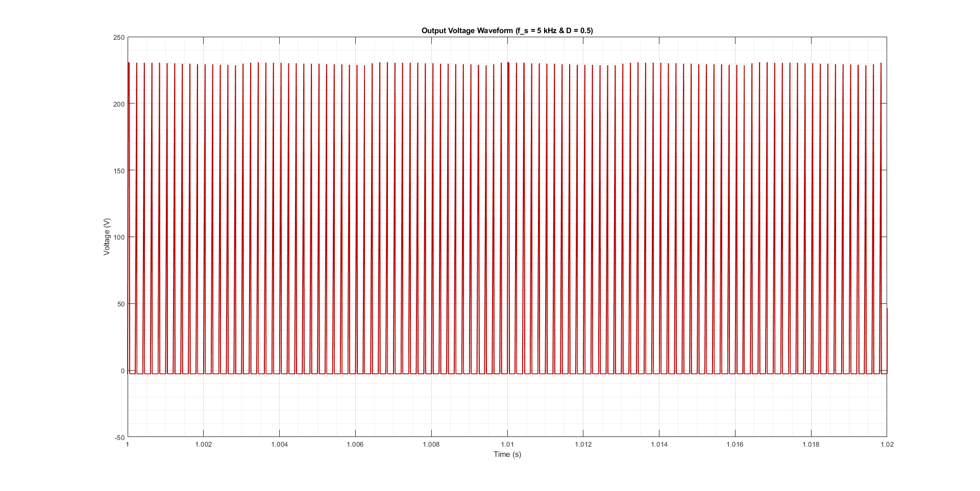

Figure 2. Output voltage waveform of the circuit when duty cycle is 20%

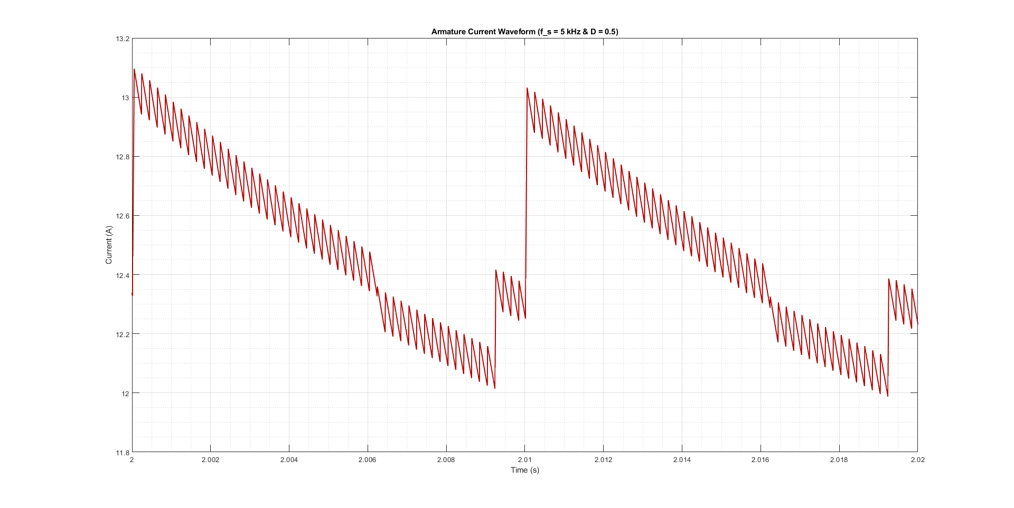

Figure 3. Armature current waveform when duty cycle is 20%

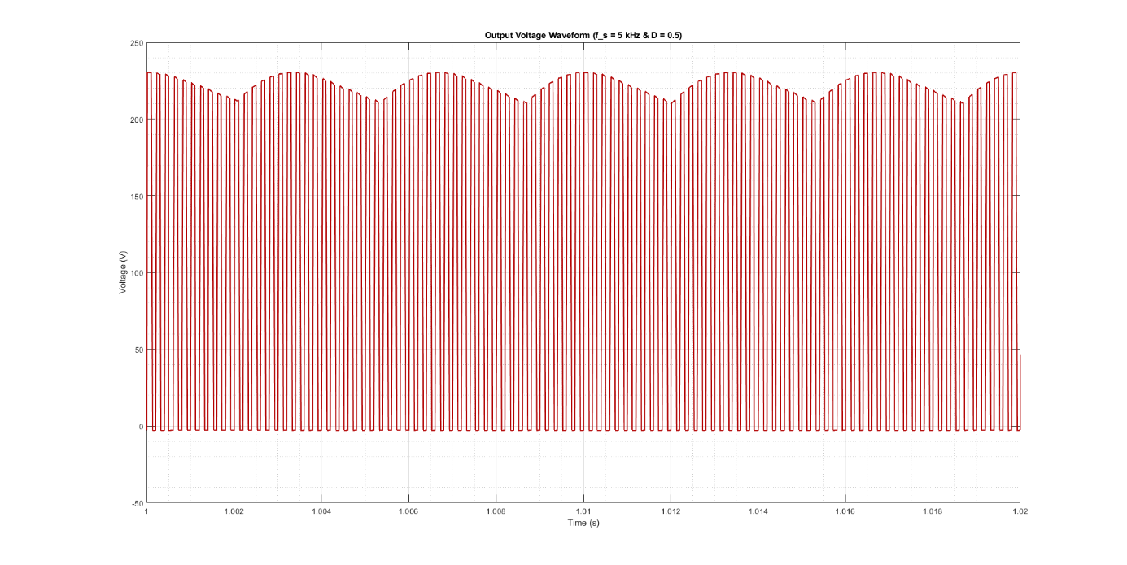

Figure 4. Output voltage waveform when duty cycle is 50%

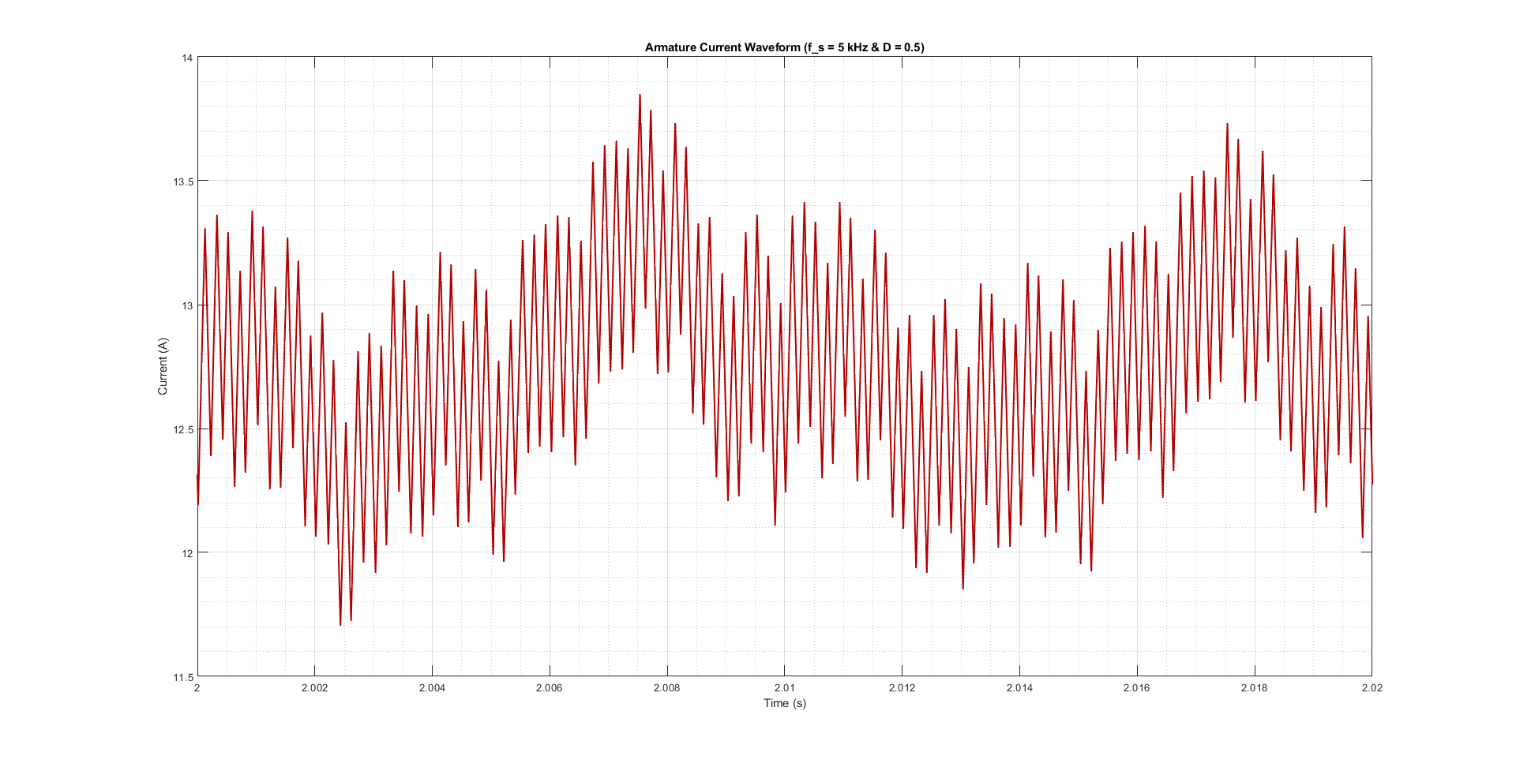

Figure 5. Armature current waveform when duty cycle is 50%

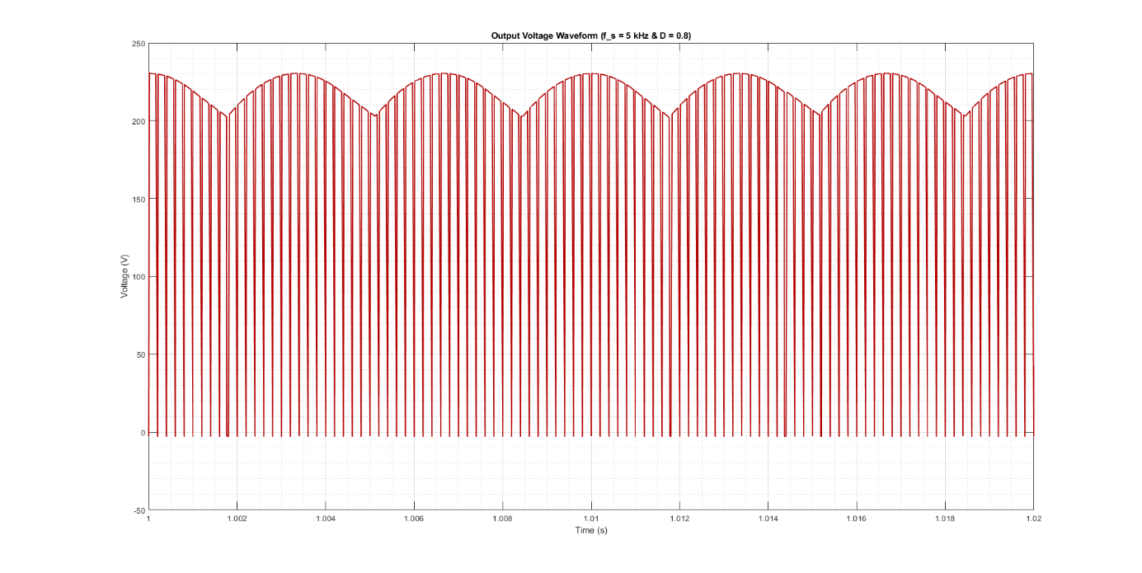

Figure 6. Output voltage waveform when duty cycle is 80%

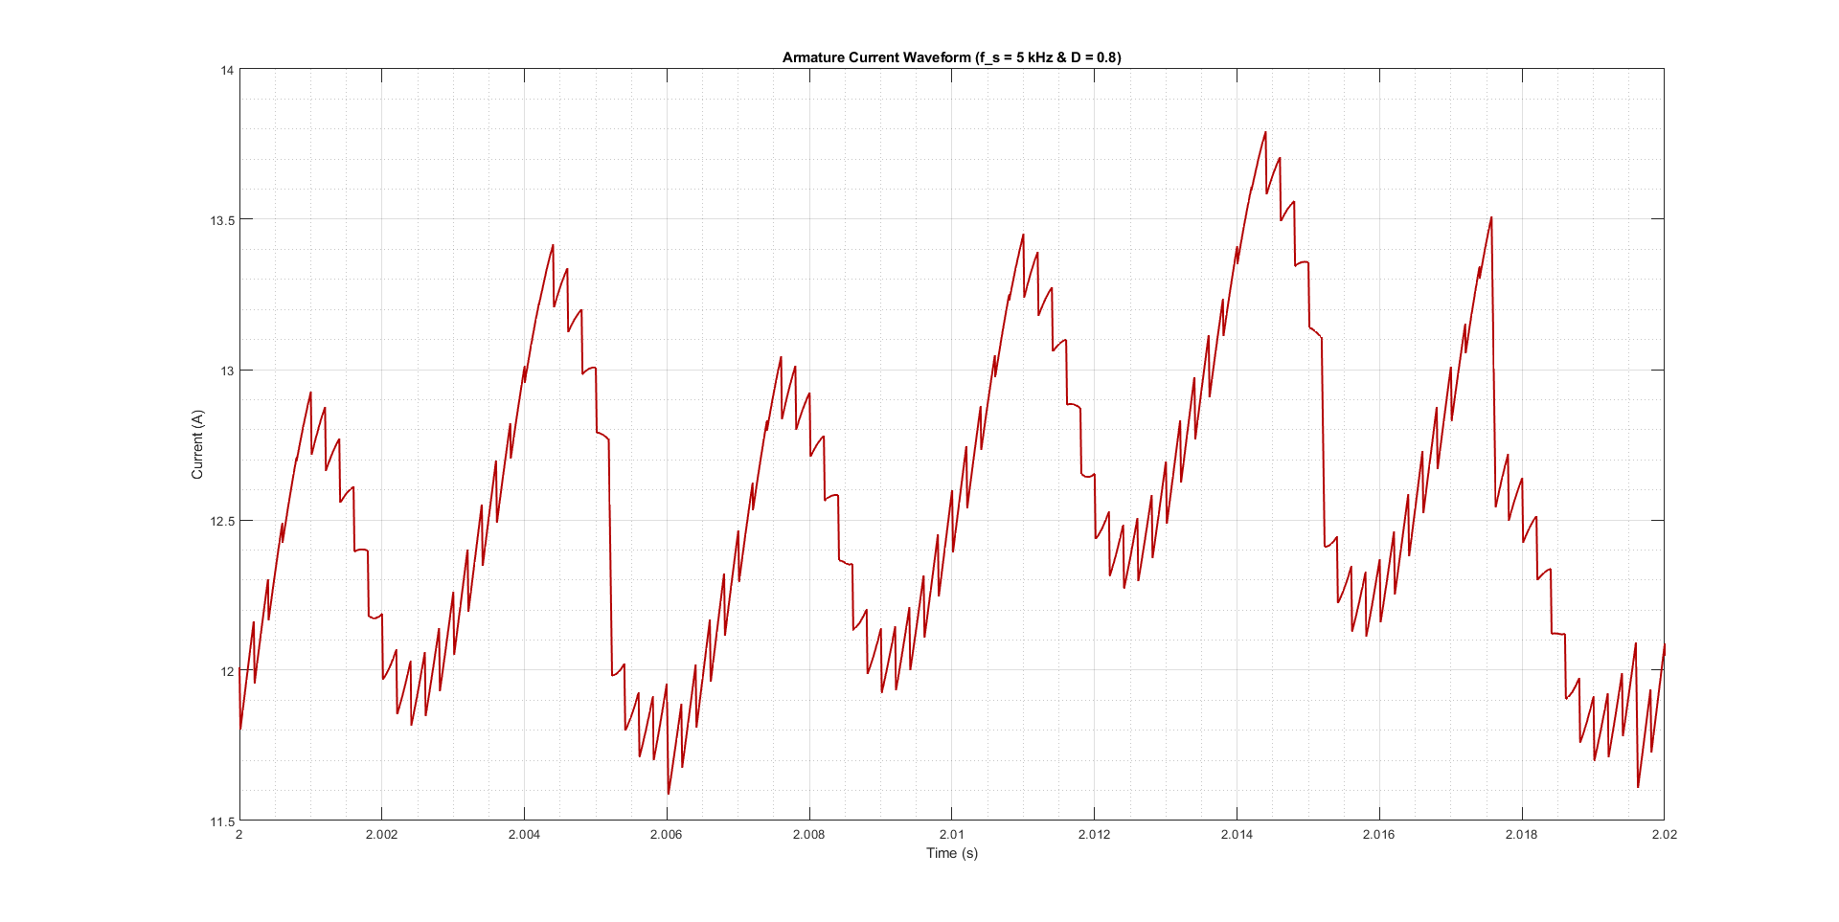

Figure 7. Output current waveform when duty cycle is 80%

**IV. COMPONENT SELECTION**

By utilizing the simulation results and analytical calculations, we will use three phase full-bridge rectifier, DC link capacitor, IGBT, freewheeling diode, analog controller and a gate driver. First of all, VUO36-16NO8 is selected as three phase full-bridge rectifier. Because it can carry an average current up to 27 A, and it can resist up to 1600 V. The reason for choosing this component is just for its current rating, i.e., although its voltage rating is too high, its current rating meets our requirements. Another reason for choosing this component is that finding the best suitable component is time consuming and expensive. So, we buy this rectifier module directly from an electronic store in Ankara. Moreover, as a DC link capacitor, two of the 330 µF and 400 V capacitor is chosen, we are expecting the average rectifier output voltage as roughly 222 V with a maximum value of 233 V. We chose 400 V capacitor because it is cheap, easy to find and gives us a safety margin. Since its datasheet is not available, we cannot include its ESR value in the simulation model. Furthermore, as an IGBT, we are planning to use the IXGH24N60C4D1, which is available in the laboratory. The reason for choosing this IGBT is that its current and voltage ratings meet our requirements, a maximum mean current of 20 A. Of course, there are more suitable transistors available, but we do not choose them because they are too expensive for us. Afterwards, as a freewheeling diode for buck converter, we chose the DSEP30-06B. The reason is quite simple, it is cheap and meets our requirements, i.e., its current rating is nearly double of the simulation results, but we already know that as the demand of the load increases, this current will also increase. We are expecting a maximum average current of 10 A in the freewheeling diode. So, it also gives us a safety margin. In addition, as can be seen from the simulation model that we do not use LC filter at the output of the buck converter because DC machine has a very large inductance which can filter the square wave so that it can rotate. Finally, since we are aiming to achieve an analog closed loop operation, we are planning to use TL494 controller for generating PWM according to feedback and send this PWM to IGBT via TLP250 optocoupler. They are both available in the laboratory.

# **V. Analytical Calculations**

Average output voltage of a three phase full bridge diode rectifier, ignoring the commutation:

For our purposes, reaching this high is not necessary, thus variac can be arranged such that DC does not go beyond 80%.

In other words, by setting the variac around 42-50%, we can operate the buck converter below 80% DC.

Operating the variac at 50%,

Duty cycle needed to achieve 180 V max. output:

This is within reasonable margins. Similarly, operating the DC at min. of the margin:

Min. output from the buck converter is then:

# **VI. Thermal Calculations**

## **Switching Losses and Conduction Losses:**

Our design consists of 7 diodes and 1 IGBT as semiconductors. 6 of the diodes is in the three-phase rectifier module, 1 of them is used as a freewheeling diode buck converter and also, IGBT is used as a switch in the buck converter.

**-Switching Loss formula (Reverse Recovery Loss):**

**-Conduction Loss Formula**

Three-phase rectifier module VUO36-16NO8 [1] consist of 6 diodes. For these diodes, let’s do the loss calculations:

(Maximum voltage that rectifier diodes will block)

(In our case, reverse current will be smaller since Vreverse = 235.15 V)

(Operation Frequency)

(Not written in the datasheet, but even for trr = 1s )

Hence, for these diodes, switching losses can be ignored.

(Maximum average current that passes through a diode in our design)

For the freewheeling diode, we are planning to implement DSEP30-06B [2] to the buck converter. For this diode, let’s do the loss calculations:

(Maximum voltage that diode will block)

(In our case, reverse current will be smaller since Vreverse = 230 V)

(Operation Frequency)

(Written in the datasheet)

We can say that switching loss is very low.

(Maximum average current that passes through this diode in our design)

The IGBT used as a switch in the buck converter is IXGH24N60C4D1 [3]. For this IGBT, let’s do the loss calculations:

(Switch on energy of the IGBT)

(Switch off energy of the IGBT)

(Collector-Emitter voltage in saturation)

(Current passes through this IGBT when it is conducting)

## **Capacitor and Inductor Losses:**

The remaining losses comes from the parasitic resistances of the inductor. We are not planning to use capacitor neither in the rectifier side nor in the buck converter side. Also, controller unit is working for logical operations hence, it does not consume significant amount of power. So, inductors cable resistance is enough for the loss calculation.

(Armature winding resistance)

13.6W

# **VII. Implementation**

So far, we have set 3 lab meeting to try some parts of the project. The tested parts are

* A close loop feedback topology
* Three-phase rectifier module.

For the close loop feedback topology, we worked on a topology which consist lots of LM741 op-amps. We initially tested the square wave generator part of the topology. The duty cycle of the square wave can be adjusted with a potentiometer. We have done it successfully, but afterwards, we decided that keeping all the op-amps in the linear region is hard to achieve. Hence, it is decided to search for another feedback topologies. After that, we decided to implement TL494 voltage reference chip into our circuit controller. It is thought that output voltage will be sampled by this chip, and it compares the sampled voltage with the reference voltage. Then, TL494 will arrange the duty cycle of the square wave and IGBT of the buck converter will switch accordingly.

For the three-phase rectifier module, we have bought one from the Konya Street. However, when we tested it, we realized that one pair of the diodes was not working. Hence, we go to Konya Street again and bought another one. This was working well. With this module, it can be said that rectification will be done successfully.

Of course, there are some challenges for us in this project. However, our biggest challenge is closed-loop controller design. We are not familiar with the TL494 chip and testing procedure of this chip is not easy for uninformed ones. By doing some research, it was found a test circuit for the TL494. However, the implementation of this circuit was hard and we could not observe any expected results. It would be nice to add some photos of the circuit or the results but taking photos did not come to our minds. Another problem is temperature of the IGBT. There will be losses in the IGBT, and this energy will pop up as heat. Hence, heatsink must be used to prevent heating problems.

**VIII. CONCLUSION**

In this report, our implementations, calculations and simulation results are given up to this point. Our main focus afterwards, is the gate driving circuitry as mentioned. Once we manage to generate the expected PWM waveform via that circuitry, we can say that the project is done.