Read Me

**TrajectoryVis**: a Visual Approach to Explore Movement Trajectories

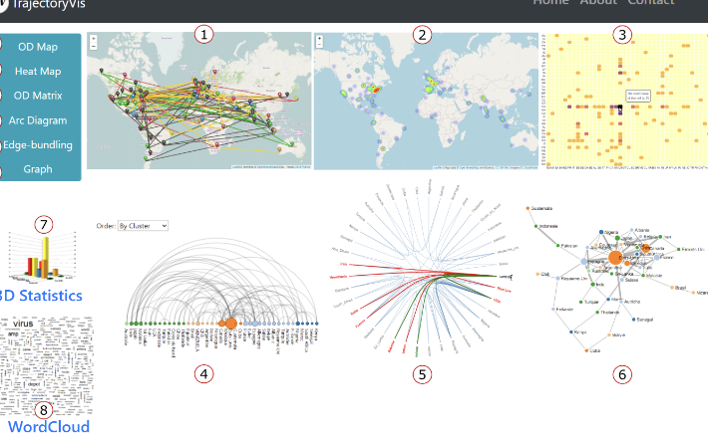

**Resume**

TrajectoryVis is a generic trajectory visualization tool to represent social network datasets (e.g. Twitter). Individual and aggregated trajectories can be visualized using different visual coding approaches. For example TrajectoryVis, allows you to visualize the trajectories of the hashtags # Covid19 and #Corona during the period May, June 2020 with several visualization techniques.

**Keywords**

Information visualization, Spatio-temporal visualization,Trajectory visualization, Social network data

**Getting the source cod**e

**Requirements**:

* Apache web server 2.4 or greater

**Deployment**:

1. Go to the Apache Web root directory (e.g., /var/www/html/ in ubuntu):

$ cd /var/www/html/

1. Clone this repository:

$ sudo git clone <https://github.com/samfad91/TrajectoryVis_V0.git>

1. Open a VS (Visual studio) and go to:

trajectoryvis/index.html

1. Lunch the VS code Live server from index.html

**Licence**

Attribution-NonCommercial-ShareAlike 4.0 International