Input Data

The data exists in a few formats, I believe the initial files were .csv files, but I could be wrong about that…it has been a minute! Here is representative sample:
The source file for this can be found here:
../cgan/dataset/3p6-selected-test.csv
Data types and other details:
- Ideally, x, y, and z should be stored as integers. This is not always done in the code, but is most appropriate. I’m sure that 16-bit precision is WAY more than we need, but 16-bit tensors aren’t really compatible with Apple Silicon’s GPUs…we should just do 32-bit everything…even though it isn’t efficient.
- The “px”, “py”, and “pz” columns are not used by our model, and for space saving purposes, these should normally be dropped.
- “vx”, “vy”, and “vz” should be stored as 32-bit precision floats
- “time” is also an integer, the range for this is 0-1200 in this dataset
- Distance is not currently used by the encoder, but is maintained for possible future use, this should probably be stored as an integer, but would have to check with Hesam.

Data normalization:

- The 3 velocity measurements (vx, vy, and vz) require a treatment, namely a linear transformation to rescale them between 0 and 1.
- To accomplish this, all (VELOCITY) values for all 12 experiments (3p6, 7p2, etc.) need to have their values scanned, looking for the highest value and lowest value.
This file:
/Users/kkreth/PycharmProjects/cgan/standalone/33_LearnTransformation.py

Was used to that end, and the logs kept show:
'''
For vx, here was the output:
/home/kkreth_umassd_edu/.virtualenvs/cgan/bin/python /home/kkreth_umassd_edu/cgan/standalone/33_LearnTransformation.py
Min values: tensor(-1.1100, device='cuda:0', dtype=torch.float64)
Max values: tensor(2.6400, device='cuda:0', dtype=torch.float64)
Process finished with exit code 0
Here it is for vy:
Min values: tensor(-1.9800, device='cuda:0', dtype=torch.float64)
Max values: tensor(2.2000, device='cuda:0', dtype=torch.float64)
For vx, vy, and vz:
Min values: tensor([-1.1100, -1.9800, -1.2200], device='cuda:0', dtype=torch.float64)
Max values: tensor([2.6400, 2.2000, 1.1000], device='cuda:0', dtype=torch.float64)
For the above, that should be for roughly 60M rows per file. ~10 files, so 600M rows.
There are 3 values per row, so 1.8B records were scanned approximately.
High of 2.6400
Low of -1.9800
'''
- Once the above was accomplished, any other files will most typically only reference the net-new fields called (keeping them around is convenient, but more likely to result in unforeseen error(s) --- this is a classic case of do as I recommend and not as I do ):
vx_norm, vy_norm, and vz_norm
As can be seen in this representative file:
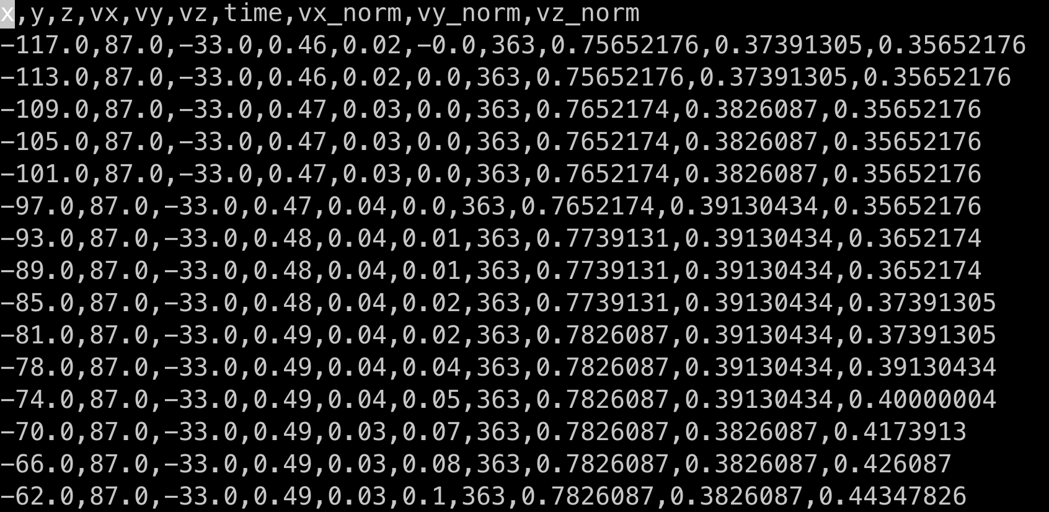

Training “sub sample”:
- In order to train the encoder, random samples are appropriate. This is really for several reasons:
  - We don’t want the encoder to be shown all data, unless that is necessary for some demonstrative reason not obvious to the author. Using more/most of the data could lead to “over training” and given the relatively low precision of the velocity vectors (e.g. <E-4), the variation of the data is not high given much fewer than 10⁴ values being present in any one column. If a reviewer were to ask this could be generated, but the argument for using “more data” has little value.
  - For reasons outlined in “parallel processing” section, each 60MM row file was further broken down into 1200 constituent files (one for each “time” count). This is fine to do for the purposes of the encoder, because the encoder has no knowledge of “time”, it only deals with representing velocity values. Now…it IS important that the encoder is only trained with data from the same time-step ( this is to say for EACH CUBE…not all permutations…that would be silly ), but that is helped by the “parallel processing” approach, not hindered.
- Approximately 1.2MM rows were randomly selected from each experiment, so, using roughly speaking 1/60th of the data for training. This was accomplished by randomly sampling ~1,000 rows from each of the 1200 constituent files (see next section) that are broken down by time step.
- When creating the “constellation” of 125 values shown here:
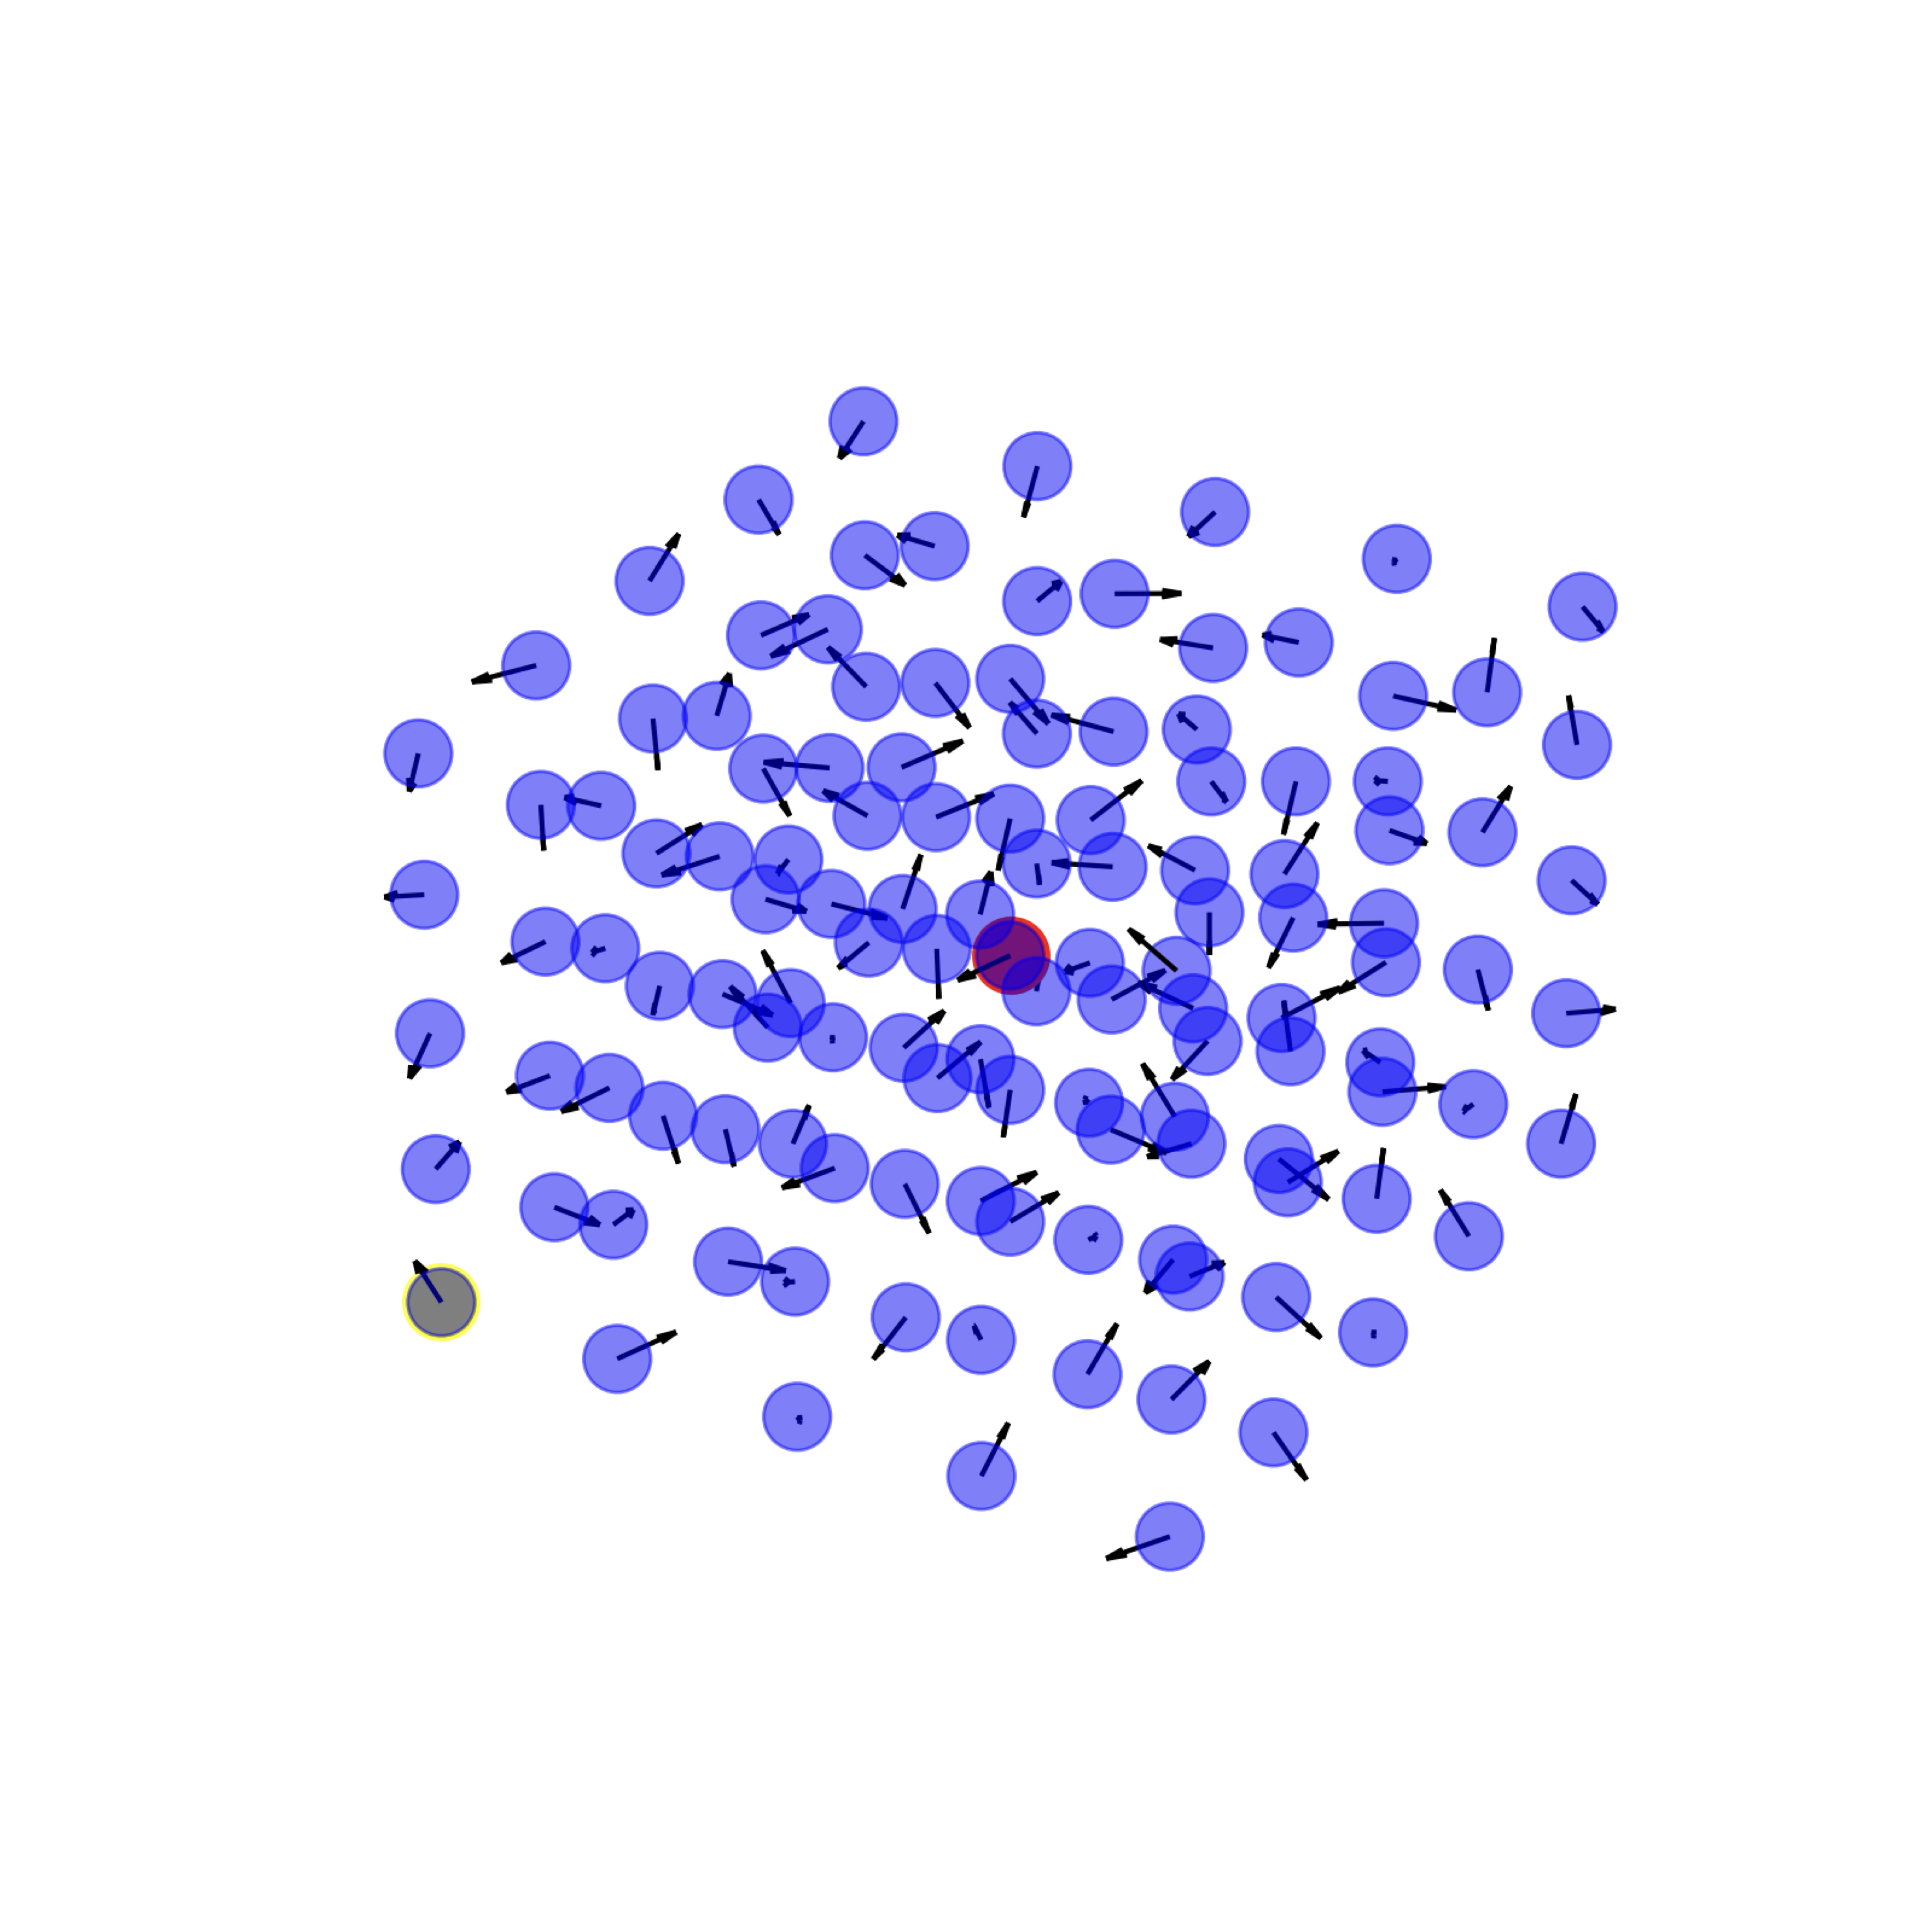
each of the “random samples” (which would only be the red dot) mentioned “fills in” the rest of the values (in blue) from the same time t.
- The reason that the number of rows/samples is a little “approximate” is that because if a randomly selected value has an x,y,z coordinate that is within 2 values of the “edge” of the data…we discard this as a candidate. Part of our “exclusion criteria” are any data points that do not allow for us to create a uniform cube, which only happens in two situations:
  - Edge case as mentioned above
  - Missing data or error in the underlying source file(s).
Regarding “b” above, I believe that there may be 1 or 2 places in the many GB of source data that meet this criteria. I did not track this well, but regardless this should be a separate exception that is logged/counted distinctly. This would amount to an enhancement if implemented.

Parallel Processing:
- The unity cluster allows for >100 jobs to be run simultaneously, and you can request GPUs, but submitting these to the scheduler “all at once” or even a few a second will cause problems where some number(s) of jobs will fail as no more jobs are accepted.
- A solution for this is to have effectively “one job” per experiment, that can take as a parameter the “array” parameter. This way, especially for items like “normalizing values” this can be done using 1200 jobs. Now…might there be matrix operations that can handle this…yes, but that was not done here. I’m trying to show functionally what is required, not how it was finally solved. Trust me, as you can see from the previous branches (if you seek boredom that is), many other approaches were tried and abandoned…so, basically, research.

#!/bin/bash
#SBATCH -c 1
#SBATCH --mem=32gb
#SBATCH --job-name=11p4
#SBATCH -t 21:55:00 # Job time limit
#SBATCH --array=1-1200
#SBATCH --nodes=1
#SBATCH --ntasks-per-node=4
#SBATCH -o /home/kkreth_umassd_edu/logs/%x.%A.%a.out

source /home/kkreth_umassd_edu/_virtual_python_2/bin/activate

# Set the directory path
export PYTHONPATH="${PYTHONPATH}:/home/kkreth_umassd_edu/cgan/production/:/home/kkreth_umassd_edu/cgan/:/home/kkreth_umassd_edu/cgan/production/encoder/"
cd /home/kkreth_umassd_edu/cgan/production/

# Set the directory path using job name
directory_path="/home/kkreth_umassd_edu/DL-PTV/${SLURM_JOB_NAME}"

# Calculate the file number from the task ID
file_number=$SLURM_ARRAY_TASK_ID

# Construct the input file path
file_1="${directory_path}/${file_number}.hdf"

# Define the log file path with the job name (you can provide this as a parameter)
file_2="/home/kkreth_umassd_edu/cgan/saved_models/WAE_0043_Latent_model_at_epoch_100.pth"

# Our third file
file_3="/home/kkreth_umassd_edu/cgan/configs/Umass_experiments.txt"

# Pass the input file as an argument to the Python script
/home/kkreth_umassd_edu/_virtual_python_2/bin/python /home/kkreth_umassd_edu/cgan/production/encode_all_possible_input.py \
--input_hd5_file "$file_1" \
--model_path "$file_2" \
--meta_project_data_JSON "$file_3"

Config File:

- This is a file here:
/Users/kkreth/PycharmProjects/cgan/configs/Umass_experiments.txt
That contains a compilation of useful meta-data about each experiment file (before breaking it down into time steps).
- This is a JSON style file (although poorly named…) that contains:
X_min = minimum x value found
X_max = maximum x value found
x_4th_min = The most minimum useful (for our cube) coordinate
x_4th_max = The most maximum useful (for our cube) coordinate
x_enumerated = All values for x (as an array)
The above are repeated for y as well as z
- Additionally there is a “time_enumerated” field here as well…this was originally done to validate that the data in all experiments was consistent. Once the experiments were all shown to have the identical number of time-steps, this was never used. This is never referenced in any code for the auto-encoder, so could/should be dropped.
- This file currently uses float values and looks like this:
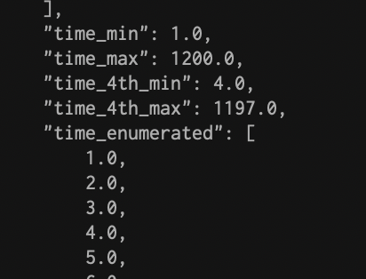
This is not ideal, and should be integer instead.

Training the “final” model on the cluster (another version can be found in cgan/production/encoder/WAE_Unity_Cluster.sbatch within git):
#!/bin/bash
#SBATCH -c 2
#SBATCH -p gpu
#SBATCH --gpus=1
#SBATCH --constraint=sm_75&vram32
#SBATCH --mem=94gb
#SBATCH --job-name=v0037
#SBATCH -t 24:00:00 # Job time limit
#SBATCH --nodes=1
#SBATCH --ntasks-per-node=1
#SBATCH --output=/home/kkreth_umassd_edu/logs/WAE4_out.log
#SBATCH --error=/home/kkreth_umassd_edu/logs/WAE4_err.log

source /home/kkreth_umassd_edu/_virtual_python_2/bin/activate

# Set the directory path
directory_path="/home/kkreth_umassd_edu/cgan/production/encoder"

# Pass the input file as an argument to the Python script
/home/kkreth_umassd_edu/_virtual_python_2/bin/python /home/kkreth_umassd_edu/cgan/production/encoder/train.py

For reasons that I could never determine…the model does not leverage more than one GPU, even when given access to multiple GPUs. In that sense, it is a good idea to request a relatively new/fast GPU, hence the “constraint” above.

Additionally, no job can functionally exceed 24 hours, so doing an hourly checkpoint or one based on “epochs” etc. is recommended. This is always hard to know how to do…because one Epoch might take 2 hours for some models. For this model, the batches/Epochs are very fast, I think 24 hours got me something like 10E⁹….ah…the days of the GPU have finally arrived!

How the cube is put together:

- Not very well!
- This code converts a csv to a pickle (as we were running out of space, this type of compression becomes more common):
foundational/csv_to_pickle.py
This file was put together in such a way that one row could be used to train…as to make this trivial for a dataloader etc. So, if you peak in the file it is literally:
head -n 1 /Users/kkreth/PycharmProjects/data/DL-PTV/combined_data_for_training_AE.csv
- DatasetName,Coordinate_1_X,Coordinate_1_Y,Coordinate_1_Z,Coordinate_2_X,Coordinate_2_Y,Coordinate_2_Z,Coordinate_3_X,Coordinate_3_Y,Coordinate_3_Z,Coordinate_4_X,Coordinate_4_Y,Coordinate_4_Z,Coordinate_5_X,Coordinate_5_Y,Coordinate_5_Z,Coordinate_6_X,Coordinate_6_Y,Coordinate_6_Z,Coordinate_7_X
…
X,Coordinate_122_Y,Coordinate_122_Z,Coordinate_123_X,Coordinate_123_Y,Coordinate_123_Z,Coordinate_124_X,Coordinate_124_Y,Coordinate_124_Z,Coordinate_125_X,Coordinate_125_Y,Coordinate_125_Z
With the “DatasetName” being a key that indicates the experiment, the timestep, and the centroid coordinate (x,y,z --- which you might note CAN be negative do that is a -10, -12, 11 x,y,z below). Having this as a string that has to be tediously pulled apart looking for the “_” separator is not a recommendation, that is just what bad coders do…
Here is the first row which can be seen using floats for the coordinate, which is sloppy and should be fixed/refactored:
10p4_1000_-10.0_-12.0_11.0,0.7619047536478414,0.4437229437874509,0.3441558472521893,0.7835497804534384,0.4567099556778416,0.3506493475530055,0.7900432807542545,0.4458874455004027,0.35714285430454074,0.7835497804534384,0.4155844158746979,0.3593073608555319,0.7683982797515341,0.3787878778847781,0.3593073608555319,0.7835497804534384,0.43073593068755034,0.3484848474527334,0.7965368068579471,0.43722943703591566,0.35497835420426865,0.7965368068579471,0.42207792222306323,0.357142

- There are two “driver files” used to create the cubes. These are meant to be created with a sort order of x, y, then z…so always lowest x values first, then the lowest y, then the lowest z. The order shouldn’t actually be important…but DOES have to be consistent.
  - foundational/AdjacentCoordinateFinder.py
  - foundational/AnalyzerOfCoordinates.py
These are…spaghetti, my apologies. You will see however that they contain unit tests because I was paranoid about how the cube was setup, and that the coordinates were mapped correctly. This is also just called proper unit testing; that must have been pride talking.

The actual model:

- Found (in the v1 branch) under “production/encoder”.
  - production/encoder/model.py
Has the model proper, which is not overly complicated. This was the result (and some of it is still in the code) of attempting many different loss functions and topologies. The “gritty details” should not matter, only how the loss is computed, which seemed to indicate a good fit and that learning was occurring.
As you can see here:
https://wandb.ai/pvl-data/Log%20Cosh%20Further%20Refinement%200043?nw=nwuserkekreth
The model is creating a latent space that is (oddly) between ~-0.3 and 0.3. I point this out for two reasons, one…because there are negative values in the latent space that I never (properly) corrected for, and two that if the model hasn’t had a need to “stretch” further in the latent space, this is most likely because it just doesn’t need to…this is indicative of a model that is working.
That is probably an over-statement, it is more appropriate to say that if the model wasn’t working (e.g. learning really well with a good CI) it would randomly “thrash around” in the latent space trying to find purchase (as it were) on the underlying multidimensional problem it is trying to optimize.

Pre-processing (from Hesam’s perspective… this is what makes this entire process an ‘ensemble’ model):

- In order to help make the two different code-bases more “independent” and not requiring anyone to run my code besides me…I provided the precomputed “input” of all (valid) possible input cubes for all experiments, all times (t), given all possible centroids. This is a non-trivial amount of computation. This took the cluster (e.g. running 100+ jobs simultaneously) about a week to do. This is why I have leveraged SLURM arrays so much (and ultimately whey I put the files into 1200 pieces), it occurred to me that this would be unavoidable.
- For the Transformer to compute loss however, “going back” is required as the Transformer works completely in the latent space we have created (just like how ChatGPT works). This requires really two parts:
    - Running the model to “decode” the latent space
    - De-normalizing (reversing the linear transformation we used when we looked for the largest vx, vy, and vz):
These two files:
production/LatentDecoderRing.py
production/LatentDecoderRingTest.py
Is a unit test (I’m not consistent…sometimes the unit test is a separate file, sometimes it is embedded, sometimes I’m just a bad coder and there IS no unit test).

Just a note that “DecoderRing” is for taking a latent representation (so an input of 47 floats also the output from Hesam’s work) and “converting” back to 475 floats. This is in fact, just running the trained model in “.eval()” mode (do NOT forget this…it is easy to miss) rather than “.train()” mode. Last but not least, to get the most accurate (and with no need for conversion(s) loss measurement we want to be in the same value space/range as the original input data, that is why we reverse all of these steps. Because, once done, the MSE is just simply the MSE.

We seem to have run into a relatively intractable problem, which is causing these errors:

There appear to be issues like the following:
Current hostname: Skirt
WARNING:__main__:Found 0 matches for coordinate (-125, 87, -33) at time 262
WARNING:__main__:Found 0 matches for coordinate (-121, 87, -33) at time 262
This happens for different times and/or coordinates on different files.
The above was for:
INFO:__main__:Processing 5 rows from 10p4.pkl
INFO:__main__:Processing row 1/5 in 10p4.pkl
or there is:
DEBUG:CoordinateSpace:Point 125/125: (-105, 87, -17)
WARNING:__main__:Found 0 matches for coordinate (-121, 87, -33) at time 135
Which was for:
INFO:__main__:Processed 5 rows from 8p4.pkl in 44.87s
Going to try "more rows" LOL first though...
Or this nonsense:
2025-04-20 23:30:45,102 - __main__ - INFO - Processing row 1/5000 in 7p2.pkl
2025-04-20 23:30:45,129 - __main__ - WARNING - Found 0 matches for coordinate (-125, 87, -33) at time 561
2025-04-20 23:30:45,134 - __main__ - WARNING - Found 0 matches for coordinate (-121, 87, -33) at time 561
2025-04-20 23:30:45,168 - __main__ - WARNING - Found 0 matches for coordinate (-121, 87, -33) at time 561
or this one:
2025-04-20 22:53:31,340 - __main__ - INFO - Processing row 1/5000 in 7p8.pkl
2025-04-20 22:53:31,369 - __main__ - WARNING - Found 0 matches for coordinate (-125, 87, -33) at time 397
2025-04-20 22:53:31,374 - __main__ - WARNING - Found 0 matches for coordinate (-121, 87, -33) at time 397
2025-04-20 22:53:31,407 - __main__ - WARNING - Found 0 matches for coordinate (-121, 87, -33) at time 397
Seems like this particular location has "random" missing coordinates, but even more oddly only three at some random time and given the same x,y,z.

I’m not 100% sure on how to handle this… First things first, I’m going to run something to interrogate the initial input files, to ensure that this problem was actually in that data. I’ll write a class:

PreProcessingValidate.py

That will look at the number of combinations of x,y,z per time slice and see if they are consistent.

Seems that even in the “source” data which in my computer is:
/Users/kkreth/PycharmProjects/data/all_data_cleaned_dtype_correct

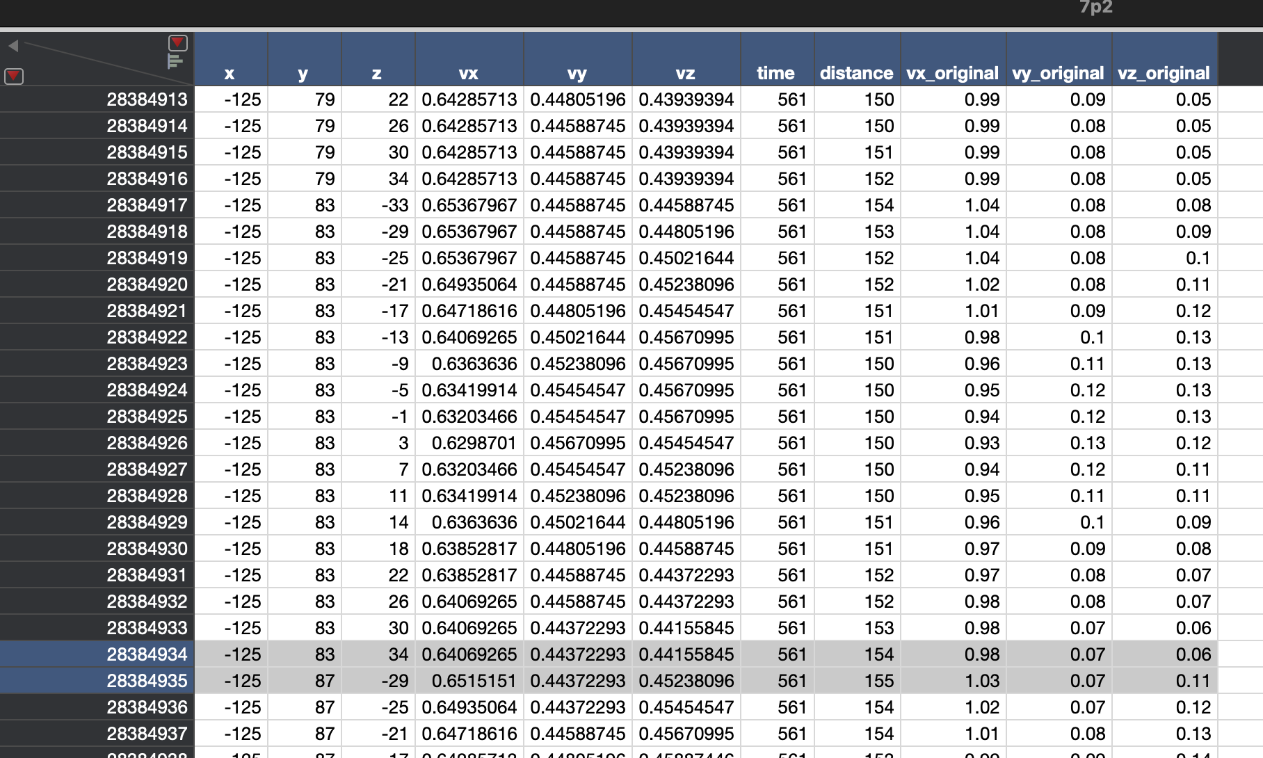

You can see that yes…indeed there SHOULD be an entry that would explain this error log:
Or this nonsense:
2025-04-20 23:30:45,102 - __main__ - INFO - Processing row 1/5000 in 7p2.pkl
2025-04-20 23:30:45,129 - __main__ - WARNING - Found 0 matches for coordinate (-125, 87, -33) at time 561

OK, so we need to perform a “unit test”…we have one that will be formal, once we have generated all data, but we need a manual one for now.

Let’s look at 10p4, time 262
X,y,z coordinates of -42,75,-21

Here are the relative x_enumerated:
-50,
-46,
-42,
-38,
-34,

Y:
67,
71,
75,
79,
83,

Z:
-29,
-25,
-21,
-17,
-13,

So, the CORRECT next two velocity “sets” would be from:
(-50,67,-29)
(-50,67,-25)

These velocities (for this time of 262) are above.

We should also verify the centroid is the same! This should be the very same vx, vy, and vz for the “x,y,z”. This is point 63:
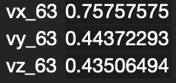

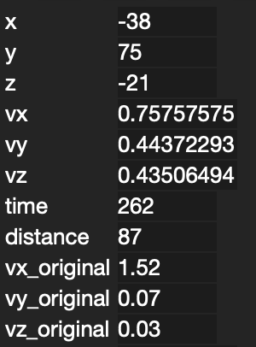

Vx,vy,vz (original) of well…here is all the data:
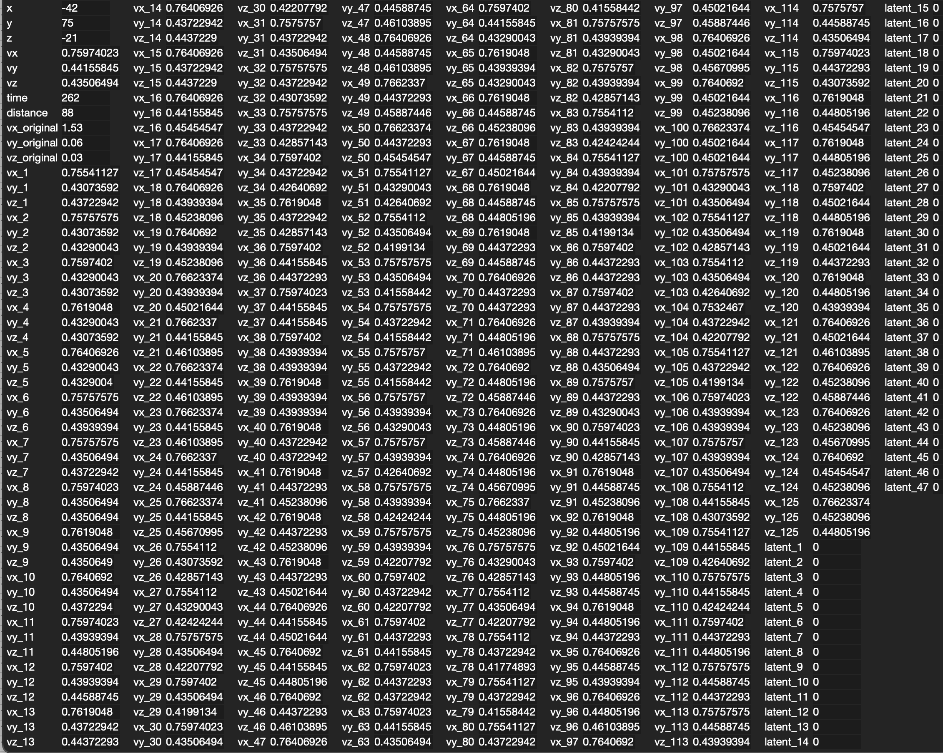

We shouldn’t have to check “all” the values, just a few spot checks. Let’s first try the first two sets of vx_1, vx_2, and vx_3 as well as vx_4, vx_5, and vx_6

If these are the x,y,z coordinates IN ORDER that we expect, we need to know what these neighbors should be (in coordinate space).

As far as a “manual” unit test, this seems to pass with flying colors!

The Kolmogorov barrier refers to a fundamental theoretical limit on how much a smooth signal (such as a physical system's state or a fluid's velocity field) can be compressed without unacceptable loss of accuracy.
At its core, the idea is:
- In many real-world systems (like turbulence, fluid flow, weather, etc.), the amount of truly compressible information is fundamentally limited by the inherent complexity and unpredictability (entropy) of the system.
- Andrey Kolmogorov, in the mid-20th century, helped formalize these ideas with concepts like Kolmogorov complexity (how short a program can be that generates a given object) and Kolmogorov entropy (how quickly a system's information becomes unpredictable over time).
- The Kolmogorov barrier arises when you try to encode or compress signals that are governed by chaotic or highly entropic dynamics: you can't compress beyond a certain point without losing critical details.
In other words:
If a system has high intrinsic entropy or complexity, no amount of clever compression can reduce its information content below a certain threshold without fundamentally misrepresenting it.

In practical terms, the Kolmogorov barrier shows up in areas like:
- Data compression (limits how well you can compress chaotic signals like weather or turbulence).
- Reduced-order modeling (limits how low you can go in dimension reduction for complex physical systems without unacceptable loss).
- Autoencoders (especially for chaotic or highly dynamic data — you eventually can't make the latent space smaller without catastrophic reconstruction errors).

A more mathematical flavor:
- Suppose you have a smooth function (e.g., velocity field) sampled at some resolution.
- Kolmogorov's work implies that the number of degrees of freedom required to describe it grows depending on the rate of decay of its spectrum (Fourier modes, singular values, etc.).
- If the decay is slow (as it is in turbulence, chaotic flows, etc.), then even with the best methods, you can't reduce the data much without missing important structures.
If you try to force more compression beyond the "Kolmogorov barrier," you'll get:
- Unrealistic reconstructions,
- Loss of small-scale but important features,
- Degradation in predictive or physical accuracy.

Example:
In turbulent fluid dynamics:
- The Kolmogorov microscales describe the smallest scales where energy is dissipated.
- If your model/compression ignores these scales, it will miss critical dissipation dynamics and be wrong.
In reduced-order modeling:
- The Kolmogorov nn-width gives a formal measure of how well a set of functions can be approximated by an nn-dimensional space.
- A small Kolmogorov width means good compression is possible; a large width means the Kolmogorov barrier is high.

Quick Summary
Aspect | Kolmogorov Barrier
What it is | A theoretical limit on compressibility or dimension reduction of complex systems
Why it matters | Crossing it leads to loss of essential information
Related concepts | Kolmogorov complexity, Kolmogorov entropy, Kolmogorov nn-width
Shows up in | Fluid dynamics, machine learning, reduced-order modeling, turbulence
Practical consequence | There’s a hard minimum for how much you can compress chaotic or complex systems without losing important behavior

Would you also like me to show you a diagram or a small code example that visually shows a signal being compressed and where the "barrier" kicks in? 🚀
It makes the concept even clearer!

