10-11-19

**Final Year Project Log 1 by Samuel Feerick**

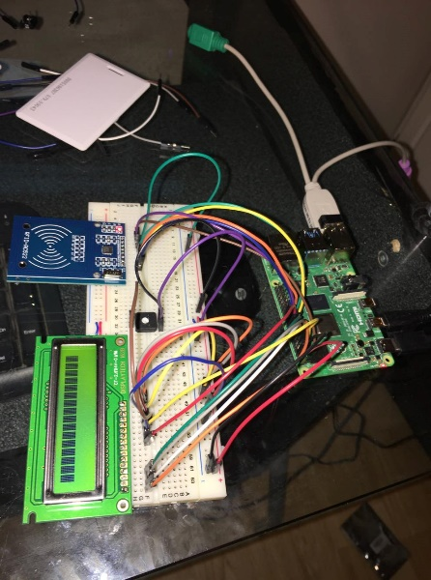

Up to now I have my hardware circuit more or less set up. As seen above. The past few weeks I’ve been waiting on parts and couldn’t do much until I got them. I’ve been following a Tutorial online on designing this sort of system. I am running command in the terminal and running bash scripts through to get up RFID system. I only have one RFID card at present so I’m also waiting on more of them. Hopefully I’ll have them by next week. At present I am having a problem with my LCD display as it is not running as it should be but I think the problem is the DisplayTech 16b2 model LCD display hasn’t the correct drivers to be run by a Raspberry PI, so I have ordered a different Type of LCD display via Amazon which I should have in a week so hopefully this one can be run on a PI.

# Tasks

* Tasks for the upcoming days will be held up until I get the parts needed to finish off the Hardware side of my Project.

# Reflection

* Learning a lot everyday from using the Raspberry Pi as I have never used this before.
* Learned that I still have the skills to solder as I hadn’t soldered in a very long time.