17-11-19

**Final Year Project Log 2 by Samuel Feerick**

New LCD display arrived so I swapped it in for the other one.

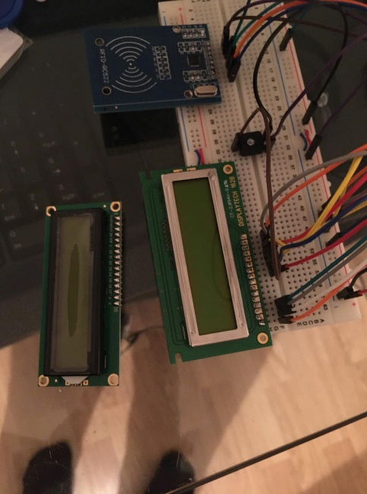 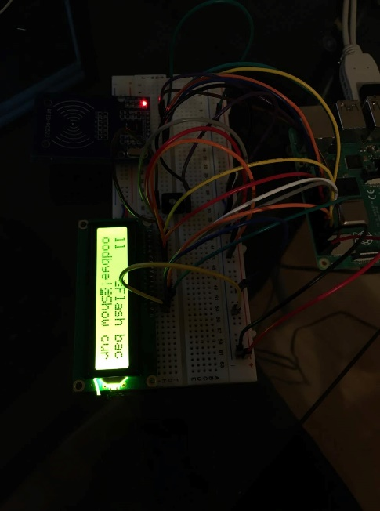

The new display works perfectly, and it has allowed me to make progress with my project.

The next step is to build the database to store the data that will be inputted from the RFID scanner.