10-02-20

**Log 6 by Samuel Feerick**

I got a good bit done on my project this week.

I got the finger print scanner up and running. So I am trying to link it up to the rest of the project at the moment. Will hope to have that done by the end of the week.

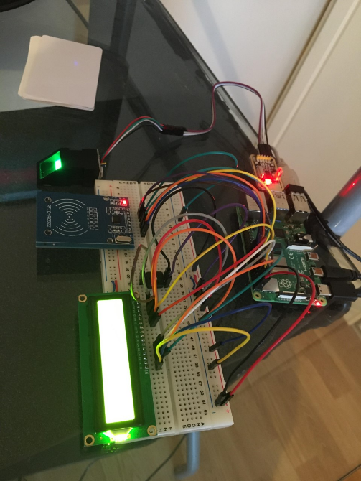

Also, I started work on the Apache Tomcat server which Michael Murray suggested I should add to my project.

This will take a small bit of time as I am trying to figure out how integrate it into my project through watching tutorials.

