
Final Year Project Proposal
Samuel Feerick
G00319993
B.Eng. Software and Electronic Engineering L8

Employee Attendance Tracker

Project Description
My proposal is to build a system to track an employee’s attendance for my father’s construction business. I plan to implement this by manufacturing an RFID scanner that the employee flashes his sign in card over a scanner which will write data to a Raspberry Pi and the Raspberry Pi will produce data to a LCD display to say if the employee is early or late for work. It will then produce information to a web server to show the employees hours worked in the week and what times the employee is signing in and out on a daily basis. This website will be available to view by the employee and the employer.

Software programming languages to be used
The software language I will be using will be C++ and Python.

Hardware requirements
- Raspberry Pi
- LCD Displays
- RFID Scanner
- RFID Cards
Architecture Diagram
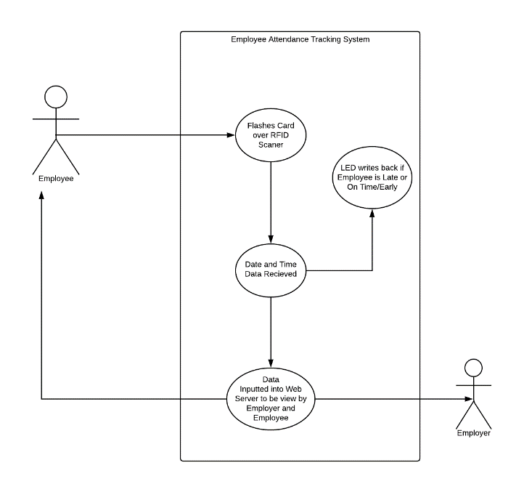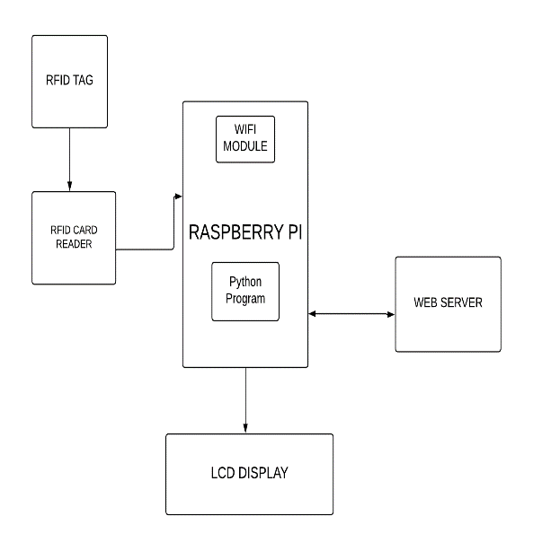
Timeline for deliverables
By Oct, I expect to have all my research completed
By Nov, I expect to start the build of the hardware side of my project
By Dec, I expect to start work on my web server
By Jan, I expect to start on the Raspberry Pi program side of my project
By Feb, I expect to link all parts of my project together
By April, I will be in final test

