S2 Text. Experiment B: temporal forecasting against naive persistence
Supporting information for: Kaya-guided hybrid deep learning for leave-country-out estimation of national CO₂ emissions: a 112-country benchmark with country-clustered inference, conformal uncertainty, and explainable AI.

Purpose
The main experiments estimate the emissions of countries that are absent from training, a task in which no naive forecast from a country’s own history can be formed. Most published studies address a different task: forecasting the future emissions of a country whose history is known. Experiment B applies that conventional task to the same panel, in order to show how the learners compare with naive persistence when persistence is available as a benchmark.

Methods
The panel of 112 countries was used for forecasting $h$ years ahead, with $h$ = 1, 3 and 5. The predictors are the eight-year window of the six covariates of the article together with the country’s own lagged values of $y=lnc$ (56 columns in total), where $c$ is per-capita CO₂ emissions. The lagged emissions were included because withholding them would handicap the learners relative to persistence and make the comparison uninformative. Two formulations of the target were used: a level formulation, which predicts $y_{t+h}$ directly, and a log-growth formulation, which predicts $y_{t+h}−y_{t}$.
Models were trained on all pairs of window and target with a target year up to 2017 and tested on the target years 2021 to 2023. A replication trained through 2012 and tested on 2015 to 2019 was run to check whether the results hold in a period before the COVID-19 pandemic. Two naive baselines were used. Persistence predicts that emissions stay at their last observed value, ${\hat{c}}_{t+h}=c_{t}$. Drift extrapolates recent growth, ${\hat{y}}_{t+h}=y_{t}+h {\overset{‾}{Δ}}_{3}$, where ${\overset{‾}{Δ}}_{3}$ is the mean of the last three annual changes in $y$. AUTHORS: the submitted text states that six learners were evaluated under each formulation, whereas the table reports four (ridge, random forest, XGBoost and LightGBM); please state which learners were evaluated and how the reported formulation was chosen for each. Table A reports ridge regression, random forest, XGBoost and LightGBM, each in the formulation named in the table.
Accuracy was measured by the mean absolute error (MAE, in t CO₂ per person) and by the mean absolute scaled error (MASE) for horizon $h$,
$${MASE}_{h}=\frac{\frac{1}{N}\sum_{n=1}^{N}{\left|c_{n}−{\hat{c}}_{n}\right|}}{\frac{1}{T_{tr}−h}\sum_{t=h+1}^{T_{tr}}{\left|c_{t}−c_{t−h}\right|}}, \left(B1\right)$$
where the numerator is the MAE of the model over the $N$ test observations and the denominator is the MAE of the naive $h$-step forecast within the training period of $T_{tr}$ years, computed for each country, so that the errors of every country are scaled by that country’s own naive difficulty. A value below 1 means that the model is more accurate out of sample than the naive forecast was in sample. Because the denominator is computed in the training period and the numerator in the test period, persistence itself need not have a MASE of exactly 1: it is 1.198 for $h$ = 1 in the 2021–2023 test period, when emissions were more volatile than before 2020, and 0.995 in the replication.
Each learner was compared with persistence by a cluster bootstrap that resamples countries, as in the article.

Results
When the country’s own history is available, naive persistence is a strong benchmark (Table A; Fig A).
In the test period 2021–2023, one year ahead, persistence has an MAE of 0.317 t per person. Only XGBoost improves on it, by a small and marginally significant margin (level formulation, MAE 0.296, difference −0.021, cluster-bootstrap p = 0.045). Three and five years ahead, more learners improve on persistence: random forest in the log-growth formulation reaches an MAE of 0.481 for $h$ = 3 (p = 0.031) and 0.621 for $h$ = 5 (p = 0.039), and XGBoost reaches 0.599 for $h$ = 5 (p = 0.0001). Several learners have a MASE below 1 at the longer horizons; the lowest is 0.867 for ridge regression in the log-growth formulation at $h$ = 5.
Two qualifications are more important than these gains. First, the margins are small: the largest improvement over persistence at any horizon is 19% of the MAE. The drift baseline is less accurate than persistence at every horizon in both periods. Second, the ranking of the learners does not replicate. In the period 2015–2019, no learner is significantly more accurate than persistence for $h$ = 1 or $h$ = 3, and only random forest in the log-growth formulation is for $h$ = 5 (p = 0.047). Ridge regression in the log-growth formulation has a MASE of 0.945 for $h$ = 1, but its advantage over persistence is not significant when countries are treated as clusters. The learner that is most accurate in one period is generally not the most accurate in the other.

Interpretation
Annual national per-capita CO₂ emissions are close to a random walk. Persistence should therefore always be reported when emissions are forecast; in this experiment the significant margins of the learners over persistence are 7% to 19% of the MAE, depend on the horizon and are not stable between evaluation periods. A high coefficient of determination for a temporal forecast that is reported without a naive baseline largely reflects persistence and does not demonstrate skill. The leave-country-out task of the article is not affected by this problem, because the history of the target country is withheld.
Table A. Mean absolute error (MAE, t CO₂ per person) and mean absolute scaled error (MASE) by forecast horizon in Experiment B.
Model | MAE, h = 1 | MAE, h = 3 | MAE, h = 5 | MASE, h = 1 | MASE, h = 3 | MASE, h = 5
Test period 2021–2023
Persistence | 0.317 | 0.531 | 0.738 | 1.198 | 1.030 | 1.101
Drift | 0.380 | 0.680 | 0.933 | 1.425 | 1.363 | 1.424
Ridge regression (log-growth) | 0.339 | 0.542 | 0.678 | 1.193 | 0.926 | 0.867
Random forest (log-growth) | 0.307 | 0.481 | 0.621 | 1.145 | 0.950 | 0.939
XGBoost (level) | 0.296 | 0.506 | 0.599 | 1.188 | 0.983 | 0.963
LightGBM (log-growth) | 0.307 | 0.528 | 0.621 | 1.202 | 1.014 | 0.971
Replication period 2015–2019
Persistence | 0.247 | 0.468 | 0.682 | 0.995 | 1.084 | 1.241
Drift | 0.285 | 0.683 | 1.043 | 1.154 | 1.531 | 1.920
Ridge regression (log-growth) | 0.239 | 0.429 | 0.598 | 0.945 | 0.990 | 1.108
Random forest (log-growth) | 0.246 | 0.453 | 0.567 | 0.976 | 1.028 | 1.088
XGBoost (level) | 0.302 | 0.457 | 0.642 | 1.213 | 1.155 | 1.114
LightGBM (log-growth) | 0.269 | 0.516 | 0.647 | 1.141 | 1.204 | 1.238
Bold marks an MAE that is significantly lower than that of persistence in a cluster bootstrap over countries (p < 0.05). h, forecast horizon in years.
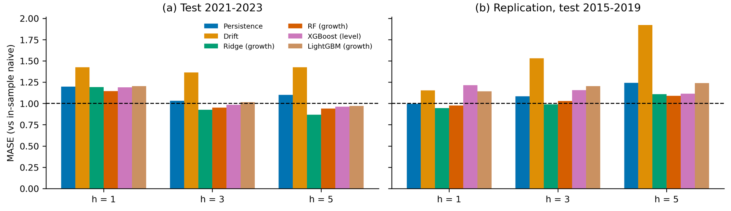
Fig A. Mean absolute scaled error (MASE) by forecast horizon in Experiment B. (a) Test period 2021–2023. (b) Replication period 2015–2019. Values below the dashed line indicate that a model is more accurate out of sample than the naive forecast was within the training period. RF, random forest; h, forecast horizon in years.

