The Algorithmic Frontier: Teaching C and Arduino at Discovery World
On October 11, I spent the day at Discovery World with the MSOE Lunabotics team for a community outreach event. As the team’s Programming Lead, my goal was to take the complex world of embedded systems and make it something forty local students could actually get their hands on333. We used mini-rovers powered by Arduino boards to teach the basics of coding in C. While it’s easy to think of "servant leadership" as just showing up to help, I saw this as a way to use my technical background to lower the barrier to entry for kids who might not otherwise see themselves as engineers.
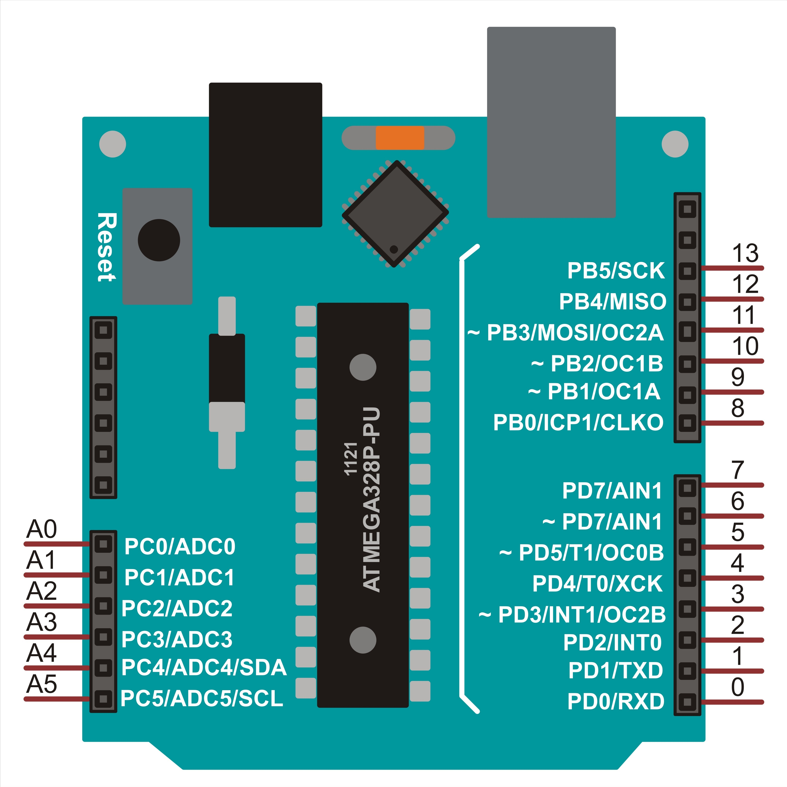
Figure 1: Shutterstock
Before the event, I spent time architecting the codebase to ensure it was "malleable” to ensure that it would be easy for students to work with. I designed modular functions for motor control and differential steering so students could focus on the logic without getting bogged down in syntax errors. During the sessions, we walked through how to use while and for loops to automate rover movements. The biggest challenge was the range of ages; explaining a logic gate or a delay function to a third-grader requires a completely different approach than talking to a high schooler. I had to constantly adjust my communication style to keep everyone engaged, ensuring that the "technical frontier" remained accessible to everyone in the room.
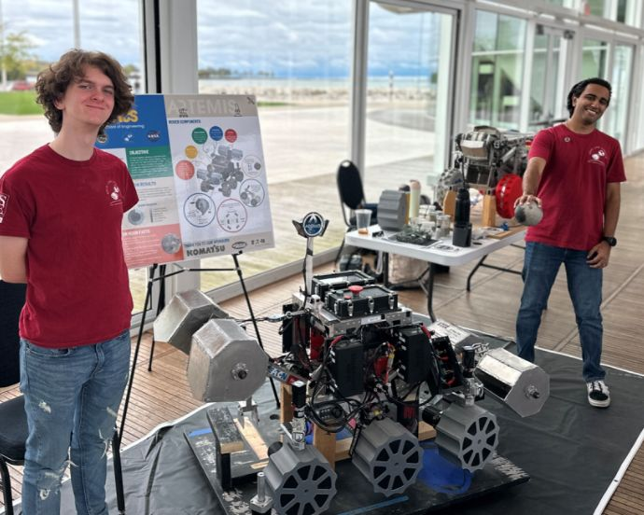
This work connects directly to the systemic gaps discussed in The Color of Law by Richard Rothstein. Rothstein breaks down how government-backed segregation didn't just affect housing; it built an architecture of exclusion that still limits who gets access to high-end educational resources today (Rothstein). By bringing these rovers and our expertise into a public space, we’re trying to disrupt that pattern. We aren't just teaching a programming language; we’re providing technical "property" to a generation of Milwaukee students who have been historically sidelined by the policies Rothstein describes.

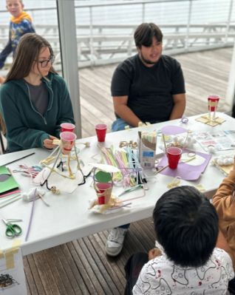

The setting of the event is also significant. In The Selma of the North, Patrick D. Jones details Milwaukee’s long fight for civil rights and the struggle against being shut out of the city's progress (Jones). For me, servant leadership in this context means recognizing that technical knowledge is power. When we show a student how to manipulate a rover with a few lines of C code, we’re giving them a sense of agency. It’s a small way to push back against the legacy of exclusion that Jones writes about, replacing it with a sense of "I can build this".
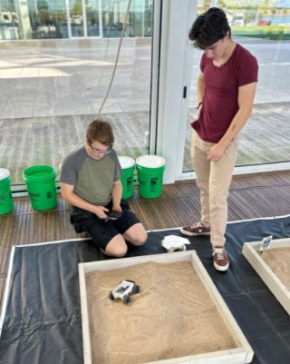
Ultimately, this experience taught me that being a leader in a technical field isn't just about how well you can optimize an algorithm; it’s about how well you can translate that knowledge for others. Seeing the students move from being intimidated by the hardware to successfully debugging their own loops was the most rewarding part of the day. Moving forward, I want to keep using my role as a programmer to serve as a bridge, making sure the "frontier" of technology is a place where everyone has a chance to participate.
