Breaking Down Barriers: Placemaking for an Accessible STEM Future at MSOE
A Placemaking Proposal for Enhanced Accessibility at the We Energies STEM Center

Introduction: The Promise and the Gap
The We Energies STEM Center at MSOE creates and supports inclusive experiences for K-12 students to explore their future possibilities, serving nearly 6,000 students annually from across Milwaukee. Yet despite this mission of inclusion, significant accessibility barriers prevent many students from fully participating in STEM education. Individuals with disabilities remain underrepresented in STEM fields, and barriers including socioeconomic, self-perception, physical, institutional, and societal constructs significantly impact underrepresented communities.
Research Question: How can placemaking strategies transform the We Energies STEM Center into a model of universal accessibility, ensuring that all students—regardless of physical ability, socioeconomic status, learning differences, or cultural background—have equal opportunities to engage with STEM education and envision themselves in STEM careers?
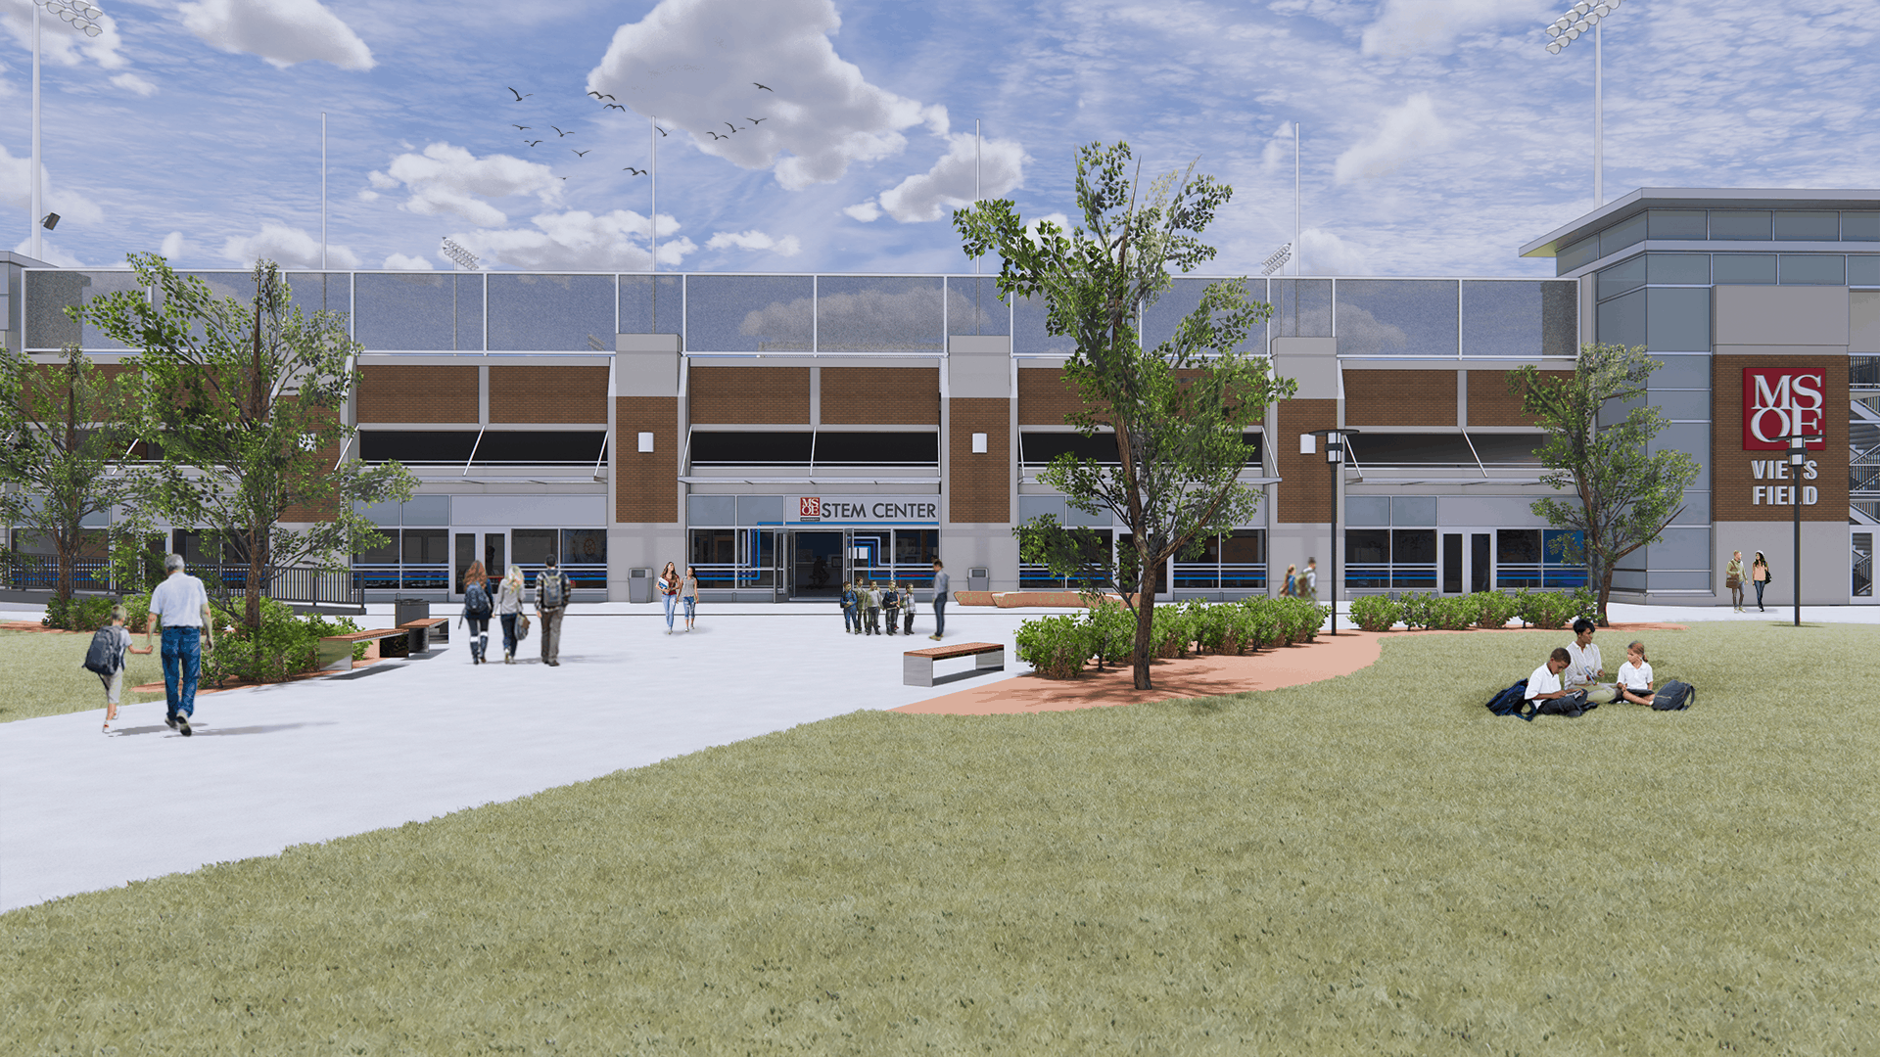Figure 1: MSOE Stem Center Outside Rendering

The Challenge: Understanding Barriers to STEM Access
Milwaukee's STEM education landscape reveals troubling disparities. While the STEM Center has reached over 10,000 students from 150 K-12 schools and 87% of schools attending programming indicate it's the only out-of-school STEM experience their students have, accessibility challenges persist on multiple fronts.
Physical Accessibility Barriers include laboratory spaces designed primarily for students without mobility limitations, equipment requiring fine motor skills, extended session durations that challenge students with physical or cognitive disabilities, and wayfinding systems that don't accommodate diverse sensory needs.
Economic Barriers manifest through transportation costs that prevent high-need schools from accessing programs, equipment and material fees that exclude low-income families, and the digital divide limiting access to virtual programming for students without reliable internet or devices.
Cognitive and Learning Barriers emerge from instruction formats that privilege certain learning styles, limited alternative instruction methods, language-heavy content without multimodal support, and classroom cultures that don't normalize diverse learning needs.
Cultural and Social Barriers appear through lack of role models from diverse backgrounds in STEM fields, programming that doesn't reflect students' cultural contexts, implicit biases affecting who feels welcome in STEM spaces, and gender disparities in STEM participation.

The Opportunity: A Vision for Universal Access
The STEM Center's physical location at 1444 N. Water Street, combined with its partnerships with major corporations and community organizations, creates a unique opportunity for transformative placemaking. Public spaces can be optimized for maximum accessibility through features like tactile strips, accessible restrooms, color contrast applications, and more. Beyond meeting ADA requirements, inclusive design goes deeper to consider social, cultural, and physiological barriers that prevent people from fully engaging with a space.
This proposal envisions the STEM Center as Milwaukee's premier model of accessible STEM education—a space where every student can see themselves as a scientist, engineer, or innovator regardless of their starting point.

Design Elements: Building Accessibility from the Ground Up

1. Sensory-Inclusive Wayfinding System
Implement a comprehensive wayfinding system using multiple sensory modalities: tactile pathways with textured floor surfaces indicating routes to different lab areas, color-coded zones with high-contrast visual markers for different activity types, audio beacons providing verbal directions and descriptions of spaces, and braille signage paired with large-print, plain-language descriptions at decision points.

2. Flexible Learning Zones
Redesign laboratory and activity spaces with barrier-free routes, tactile paving, sensory elements, and low-complexity wayfinding: adjustable-height workbenches accommodating wheelchair users and students of different heights, modular furniture arrangements supporting individual work, small groups, or large collaborative projects, quiet focus zones with reduced sensory stimulation for students who need it, and sensory-rich exploration areas with hands-on materials for kinesthetic learners.
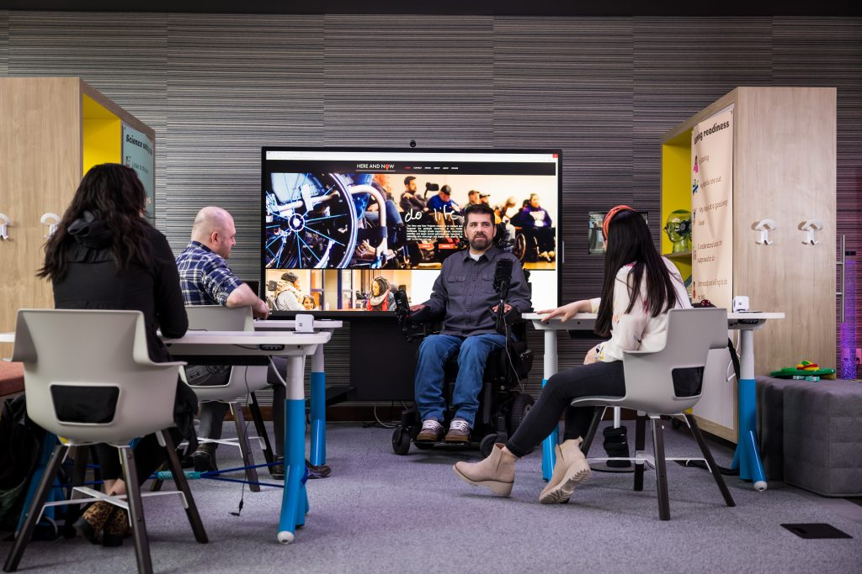Figure 2: Microsoft Inclusive Tech Lab, 2023

3. Universal Design Equipment Station
Create an equipment library featuring assistive technologies and universally designed tools: large-grip tools and adaptive equipment for students with motor challenges, screen readers and magnification software for visually impaired students, noise-canceling headphones for students with sensory sensitivities, alternative input devices including adaptive keyboards and switches, and visual timers and graphic organizers supporting executive function.

4. Welcome Plaza Transformation
Transform the existing outdoor collaboration area into an inclusive community gathering space: sensory garden elements incorporating plants with diverse textures, scents, and visual interest, flexible seating including benches with backs and armrests, movable chairs, and ground-level seating areas, shade structures and covered zones protecting from weather and providing visual rest, and interactive installations demonstrating STEM concepts through multiple modalities. This would replace empty lawns, which provide no practical value to the STEM center’s mission.
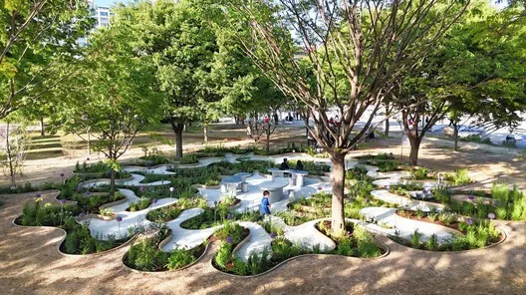Figure 3: Accessible Outside Space

5. Digital Accessibility Hub
Establish a dedicated space supporting equitable technology access: high-speed internet workstations with accessibility features enabled, loaner laptop program for students needing devices at home, assistive technology demonstration area where students can try different tools, and virtual participation station enabling remote engagement for students unable to attend in person.

Programming Initiatives: Access Through Experience

Accessibility Ambassadors Program
Diverse representation matters, and seeing individuals who look like them succeeding in STEM can inspire students from underrepresented backgrounds. Train MSOE student volunteers as Accessibility Ambassadors who understand inclusive teaching practices, can operate assistive technologies, serve as peer mentors from diverse backgrounds, and actively welcome and support all participants.

Family STEM Nights with Transportation
Address transportation barriers by providing support for high-need schools through partnerships with Milwaukee County Transit System for shuttle services, flexible evening and weekend programming accommodating family schedules, childcare for siblings enabling parents to focus on their participating child, and dinner provided removing food insecurity as a barrier.

Adaptive STEM Challenge Series
Design monthly challenges using universal design for learning principles ensuring all learners have robust STEM experiences: multiple ways to demonstrate understanding beyond written tests, collaborative team structures pairing students with complementary strengths, scaffolded difficulty levels allowing entry points for different skill levels, and celebration of diverse problem-solving approaches rather than single "correct" solutions.

Mentorship Connections Initiative
Partner with Milwaukee professionals with disabilities in STEM careers, creating: virtual mentor sessions bringing role models directly to students, career pathway discussions highlighting diverse routes into STEM, disability pride celebrations normalizing disability as part of human diversity, and networking events connecting students with potential future opportunities.
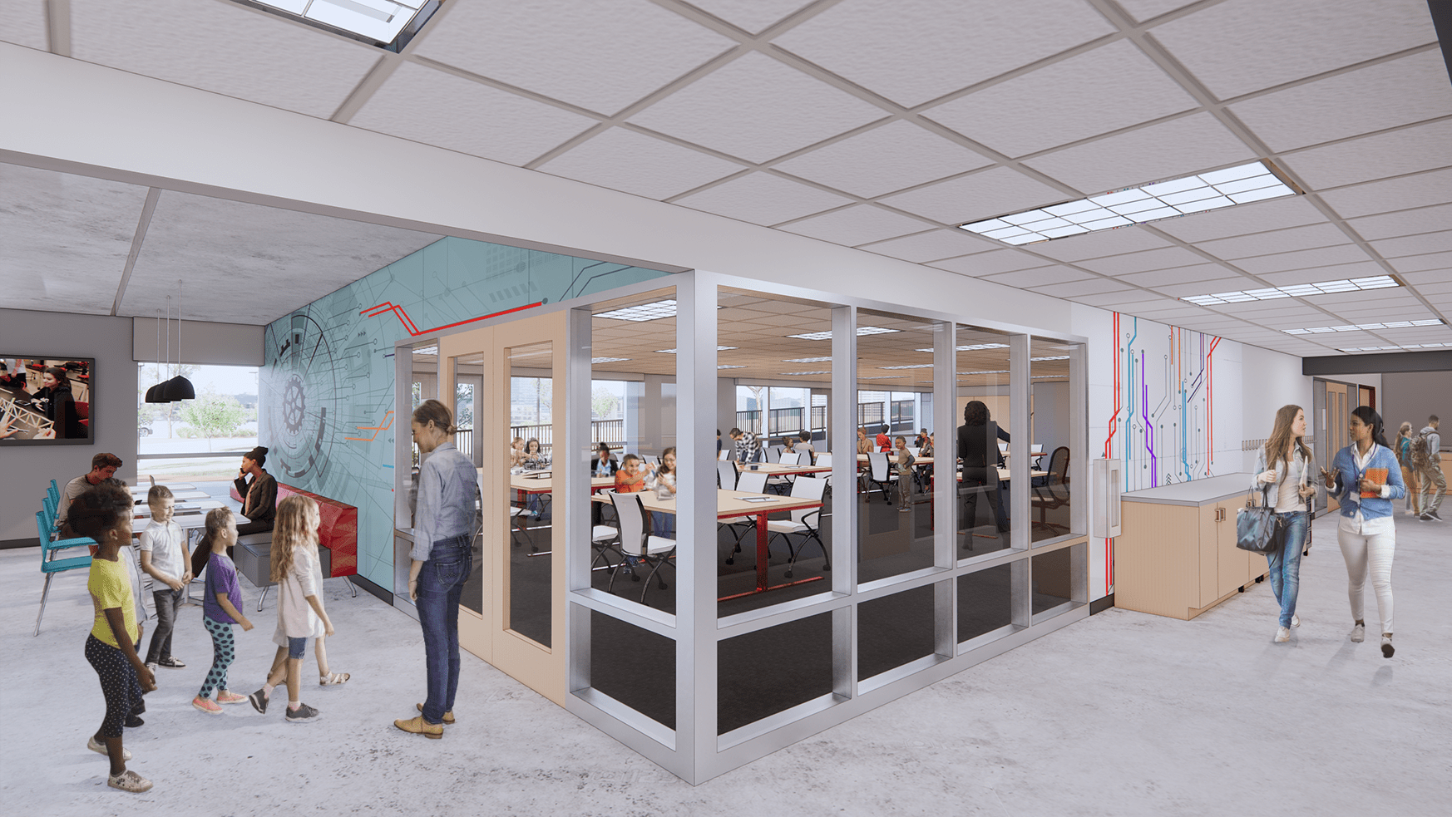Figure 4: MSOE Stem Center Classrooms

Community Impact: Transforming Lives and Systems

Immediate Benefits
Students with disabilities gain access to laboratory settings where engagement is enhanced through thoughtful environmental design, experiencing STEM as a field where they belong. Low-income families access high-quality STEM programming without financial burden, breaking cycles of limited opportunity. English language learners engage through visual, hands-on, and collaborative activities reducing language barriers. Neurodiverse students find learning environments matching their needs rather than forcing conformity.

Ripple Effects
Milwaukee schools adopt universal design practices modeled at the STEM Center. Corporate partners recognize the value of decreasing barriers and giving students access to resources they need, extending support to their own workplace accessibility. MSOE students develop inclusive design mindsets carrying into their engineering careers. The community witnesses disability inclusion as strength rather than accommodation, shifting cultural narratives.

Long-Term Transformation
A more diverse workforce emerges, benefiting employers and creating a healthier economy. Students who might have abandoned STEM persist to become the engineers, scientists, and innovators Milwaukee needs. The STEM Center becomes a national model for accessible informal STEM education, with other cities replicating the approach. Milwaukee's reputation as an inclusive, innovative city strengthens, attracting talent and investment.
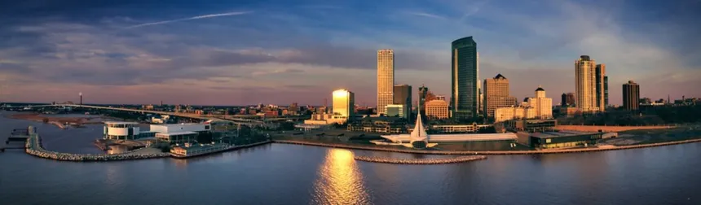Figure 5: Milwaukee Skyline

Implementation Strategy: Making it Real

Phase 1: Foundation (Months 1-6)
Conduct comprehensive accessibility audit with input from disability community members, establish Accessibility Advisory Committee including people with lived disability experience, secure additional funding through grants focused on accessibility in STEM, train all STEM Center staff in inclusive practices and disability awareness, and pilot test redesigned spaces with diverse student groups.

Phase 2: Physical Transformation (Months 7-12)
Install wayfinding system and sensory elements, reconfigure laboratory spaces with adjustable furniture and equipment, establish equipment library with assistive technologies, redesign outdoor plaza with accessible features, and launch digital accessibility hub.

Phase 3: Program Launch (Months 13-18)
Recruit and train Accessibility Ambassadors, implement transportation support system, debut Adaptive STEM Challenge Series, establish mentor connections with STEM professionals, and develop family engagement programming.

Phase 4: Evaluation and Expansion (Months 19-24)
Gather data on participation rates from previously underserved groups, assess student learning outcomes across diverse populations, document successes and challenges through case studies, share best practices with Milwaukee schools and other STEM centers, and refine approaches based on community feedback.

Precedent: Learning from Leaders

Smithsonian Science Education Center - Zero Barriers Initiative
The Zero Barriers in STEM Education program offered teachers professional learning opportunities and high-quality science content to strengthen inclusive strategies, ensuring all learners have robust STEM experiences. Their workbook provides nine universal design strategies applicable to any STEM setting, demonstrating that accessibility requires intentional planning but yields universal benefits.

Manchester Community College - UDL Mechatronics
By drawing on Universal Design for Learning principles, educators revamped laboratory materials and environments to optimize learning for all students. The "plus-one" approach—adding just one more way for students to interact with content—proved manageable and transformative, showing that accessibility doesn't require complete overhauls but thoughtful incremental changes.

Portland Community Gardens
Portland's community garden initiative designated specific land plots and developed scholarship assistance to ensure socioeconomically disadvantaged residents weren't excluded, bridging gaps in access to public space. This model demonstrates how proactive removal of financial barriers creates truly inclusive community spaces.

Measuring Success: Accountability Through Data
Track quantitative metrics including percentage increase in participation from students with documented disabilities, participation rates from Title I schools compared to baseline, diversity of student demographics engaged in programming, repeat participation rates indicating sustained engagement, and student performance on STEM learning assessments across groups.
Gather qualitative feedback through student voice surveys using multiple response formats, family experience interviews capturing parent perspectives, teacher observations of student engagement and confidence, Accessibility Ambassador reflections on program impact, and case studies documenting individual student journeys.
Monitor systems change via number of Milwaukee schools adopting universal design practices, corporate partners expanding accessibility in their workplaces, MSOE curriculum changes influenced by STEM Center model, policy recommendations developed from lessons learned, and media coverage raising awareness of accessible STEM education.

Conclusion: A STEM Future for Everyone
The We Energies STEM Center stands at a critical juncture. With a vision to empower all students to see the world through an engineering mindset, the Center plays a critical role in advancing STEM opportunities. Yet vision without accessibility remains merely aspiration. This placemaking proposal offers a roadmap for transforming that vision into reality—creating not just a STEM education facility, but a community cornerstone where every young person, regardless of circumstance, can discover their potential.
Inclusive design in public spaces lays a foundation for civic life that builds attachment and belonging for everyone. When we design STEM spaces with the most marginalized students in mind, we create environments where all students thrive. The accommodations supporting a student with a mobility disability—adjustable workbenches, flexible layouts—also benefit a student recovering from injury or a parent bringing a toddler to Family STEM Night. The visual supports helping an English language learner—graphic organizers, demonstration videos—enhance understanding for every participant.
Milwaukee's future depends on cultivating diverse STEM talent. Every child should have equal opportunity to access the educational material they seek. The innovations Milwaukee needs will come from students currently excluded from STEM pathways—the brilliant mind experiencing the world differently through autism, the creative problem-solver navigating poverty, the natural engineer whose first language isn't English, the computational thinker using a wheelchair.
This proposal recognizes that accessibility isn't charity—it's justice. It's not about doing favors for "those students"—it's about removing barriers that never should have existed. It's not lowering standards—it's raising the bar for what inclusive excellence looks like.
The We Energies STEM Center has the infrastructure, partnerships, expertise, and community trust to become a national model. With intentional placemaking centering accessibility, Milwaukee can demonstrate that STEM education truly is for everyone. The question isn't whether we can afford to make these changes—it's whether we can afford not to.
Every student lost to STEM because of inaccessible design represents unrealized potential, unsolved problems, uninvented solutions. Milwaukee's transformation begins with ensuring the STEM Center's doors—and everything beyond them—open equally for all.

Works Cited
Anthropic API Research on STEM Center accessibility, December 2024.
Burgstahler, S. (2008). "Universal Design in Higher Education: From Principles to Practice." Harvard Education Press.
CAST. (2022). "Universal Design for Learning Guidelines." Center for Applied Special Technology.
Holmes, K. (2020). "Mismatch: How Inclusion Shapes Design." MIT Press.
Milwaukee School of Engineering. (2024). "We Energies STEM Center Mission and Programs." Retrieved from msoe.edu.
National Science Foundation. (2019). "Women, Minorities, and Persons with Disabilities in Science and Engineering." NSF 19-304.
Project for Public Spaces. (2023). "Inclusive by Design: Laying a Foundation for Diversity in Public Space."
Smithsonian Science Education Center. (2024). "Zero Barriers in STEM Education: Accessibility and Inclusion Initiative."
Universal Design Project. (2023). "Accessible and Inclusive Public Spaces: Foundations for Thriving Communities." URBACT.
U.S. Department of Education. (2024). "Breaking Barriers: Creating Inclusive STEM Education for All Students."
Anderson, Lauren (2020). “MSOE to build STEM education center”. https://biztimes.com/msoe-to-build-stem-education-center/

