Diagram 1: Trade Worker BPM Display

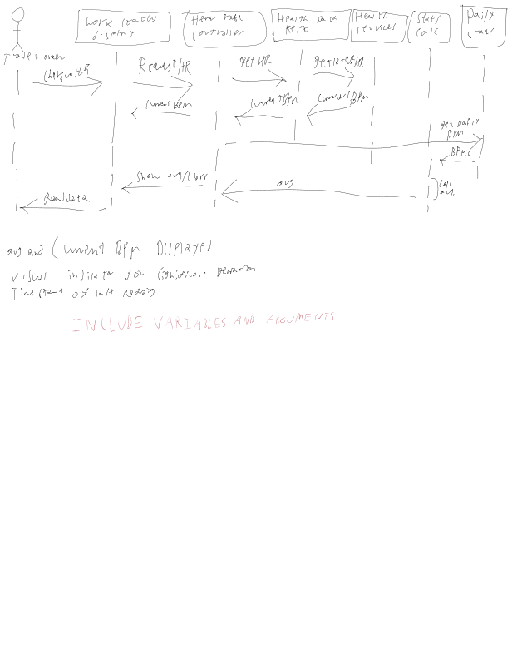

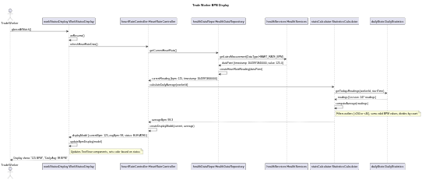
Purpose
Models the interaction flow when a trade worker glances at their smartwatch to view their current heart rate and daily average BPM.

Preconditions
- Trade worker has WearOS watch powered on and worn correctly
- HeartRate monitoring app is running and has been active since start of workday
- HealthServices permissions granted (BODY_SENSORS)
- At least 5 BPM readings collected during current workday
- Current time is during work hours (e.g., 10:34 AM)

Postconditions

What the Actor Sees:
- Primary display: Current BPM "125" in large, bold font (32sp)
- Secondary display: "Daily Avg: 98 BPM" in smaller font (18sp)
- Status indicator: Yellow/orange color indicating ELEVATED status
- Timestamp: "Updated 10:34 AM" in small gray text
- Visual feedback: Subtle haptic feedback confirming display update

Data State Changes:
- healthDataRepo internal cache updated with latest HeartRateReading object
- No persistent storage writes (read-only operation for display)
- workStatusDisplay.currentModel updated with new BpmDisplayModel
- dailyStats object maintains in-memory collection (no new data added)
- View rendering state refreshed in WearOS display buffer

System State:
- Background HealthServices monitoring continues
- Next automatic refresh scheduled in 60 seconds
- Battery-efficient passive monitoring remains active
- App lifecycle in RESUMED state

Diagram 2: Health & Safety Officer Alert

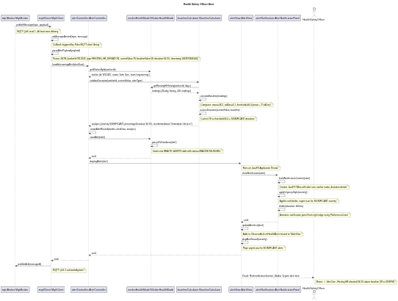
Purpose
Models the interaction flow when the Manager Portal (JavaFX application) receives and displays a health alert from a worker's smartwatch via MQTT, notifying the Health & Safety Officer of a significant biometric deviation.

Preconditions
- Health & Safety Officer is logged into Manager Portal (JavaFX application)
- Manager Portal is connected to MQTT broker at mqtt://alerts.company.com:1883
- Officer is subscribed to topic health/alerts/team/{teamId}
- Worker baseline data exists in system (minimum 30 days of resting HR data)
- Worker's smartwatch has detected anomalous resting heart rate and published alert
- Officer has Manager Portal window in focus or running in background

Postconditions

What the Actor Sees:
- Primary Alert Banner (top-right of screen):
  - Red urgent border with warning icon ⚠
  - Worker name: "John Doe"
  - Alert message: "Resting HR elevated 34.5% above baseline"
  - Metrics: "Current: 78 BPM | Baseline: 58 BPM"
  - Timestamp: "2 minutes ago"
  - Two buttons: [Acknowledge] [View Details]
- Alert Table Update:
  - New row added to alerts TableView
  - Status column shows "UNACKNOWLEDGED" in red
  - Severity column shows "SIGNIFICANT" with urgent icon
- Audio Feedback:
  - Urgent alert tone played once (if sound enabled)
- System Tray (if minimized):
  - Badge count incremented
  - Desktop notification shown

