Virtual Museum for Texiguat, Honduras: Honoring Francisco Morazán

Introduction
Francisco Morazán (1792-1842) stands as Central America's greatest champion of unity, democracy, and liberal reform. Born and raised in Texiguat, a small municipality in Honduras founded in 1606, Morazán rose from humble origins to become president of the Federal Republic of Central America, fighting tirelessly to keep the region united against conservative forces that sought to fragment it into separate nations. Yet despite his towering significance in Central American history, Morazán's legacy remains inadequately preserved and inaccessible to many who could benefit from understanding his vision of democratic governance and regional cooperation. This servant leadership project aims to create a virtual museum based in Texiguat that honors Morazán's life and ideals while making his story accessible to local community members, Honduran students, and the broader global audience interested in Latin American independence movements. To inform this initiative, I researched successful virtual museums dedicated to historical figures, examining how they balance scholarly rigor with emotional resonance, connect personal biography to broader historical movements, and leverage digital technology to serve both preservation and education goals. This research focused on two complementary examples from Milwaukee—the Jewish Museum Milwaukee's Golda Meir virtual exhibition and the University of Wisconsin-Milwaukee's "Picturing Golda Meir" digital photo collection—alongside the international Nelson Mandela digital heritage initiatives in South Africa.

Milwaukee Example: Jewish Museum Milwaukee's Golda Meir Virtual Exhibition
The Jewish Museum Milwaukee's virtual exhibition dedicated to Golda Meir (1898-1978) demonstrates how digital storytelling can transform a historical figure from distant icon into relatable human being while preserving the gravitas of their achievements. Meir, who served as Israel's Prime Minister from 1969-1974, spent her formative years in Milwaukee after immigrating from Kiev in 1906. The virtual exhibition brilliantly employs first-person narrative, telling Meir's story in her own voice as she reflects on her life during a 1969 airplane journey back to Milwaukee—her first visit to her American hometown as Prime Minister.
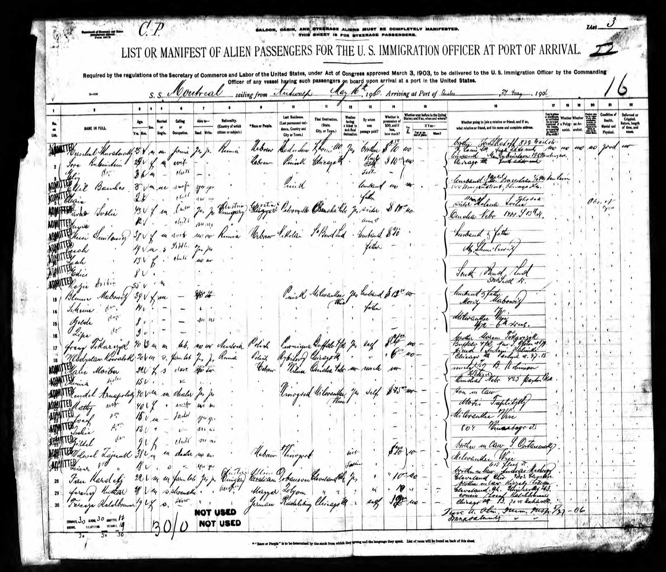
This narrative approach creates immediate emotional connection. Rather than presenting dry biographical facts, the exhibition places readers inside Meir's consciousness as she remembers her family's desperate flight from Russian pogroms, the harrowing fourteen-day ship journey to America traveling under false papers, and her first glimpse of Milwaukee's "colorful and bright" streets. The exhibition integrates primary source documents—including the ship manifest showing where her family's names appear on lines 13-16—transforming archival materials into tangible evidence of lived experience. By centering Milwaukee as the crucible where young Golda Mabovitch became the leader who would help establish and guide Israel, the exhibition accomplishes multiple goals simultaneously: it honors a world leader, strengthens Milwaukee's cultural identity, and demonstrates how local communities shape global history.
The exhibition's structure around thematic connections rather than pure chronology reflects sophisticated understanding of human-centered design principles from our course readings. Hyperlinks invite deeper exploration of themes like "Immigration and Finding Home," "Tikkun Olam" (the Jewish concept of repairing the world), and "Members of the Tribe," allowing users to follow their interests rather than being forced through a predetermined path. This approach recognizes that different audiences come with different needs—some seeking comprehensive biography, others interested in specific aspects of Meir's activism, students researching particular historical periods, or Milwaukee residents curious about local connections.
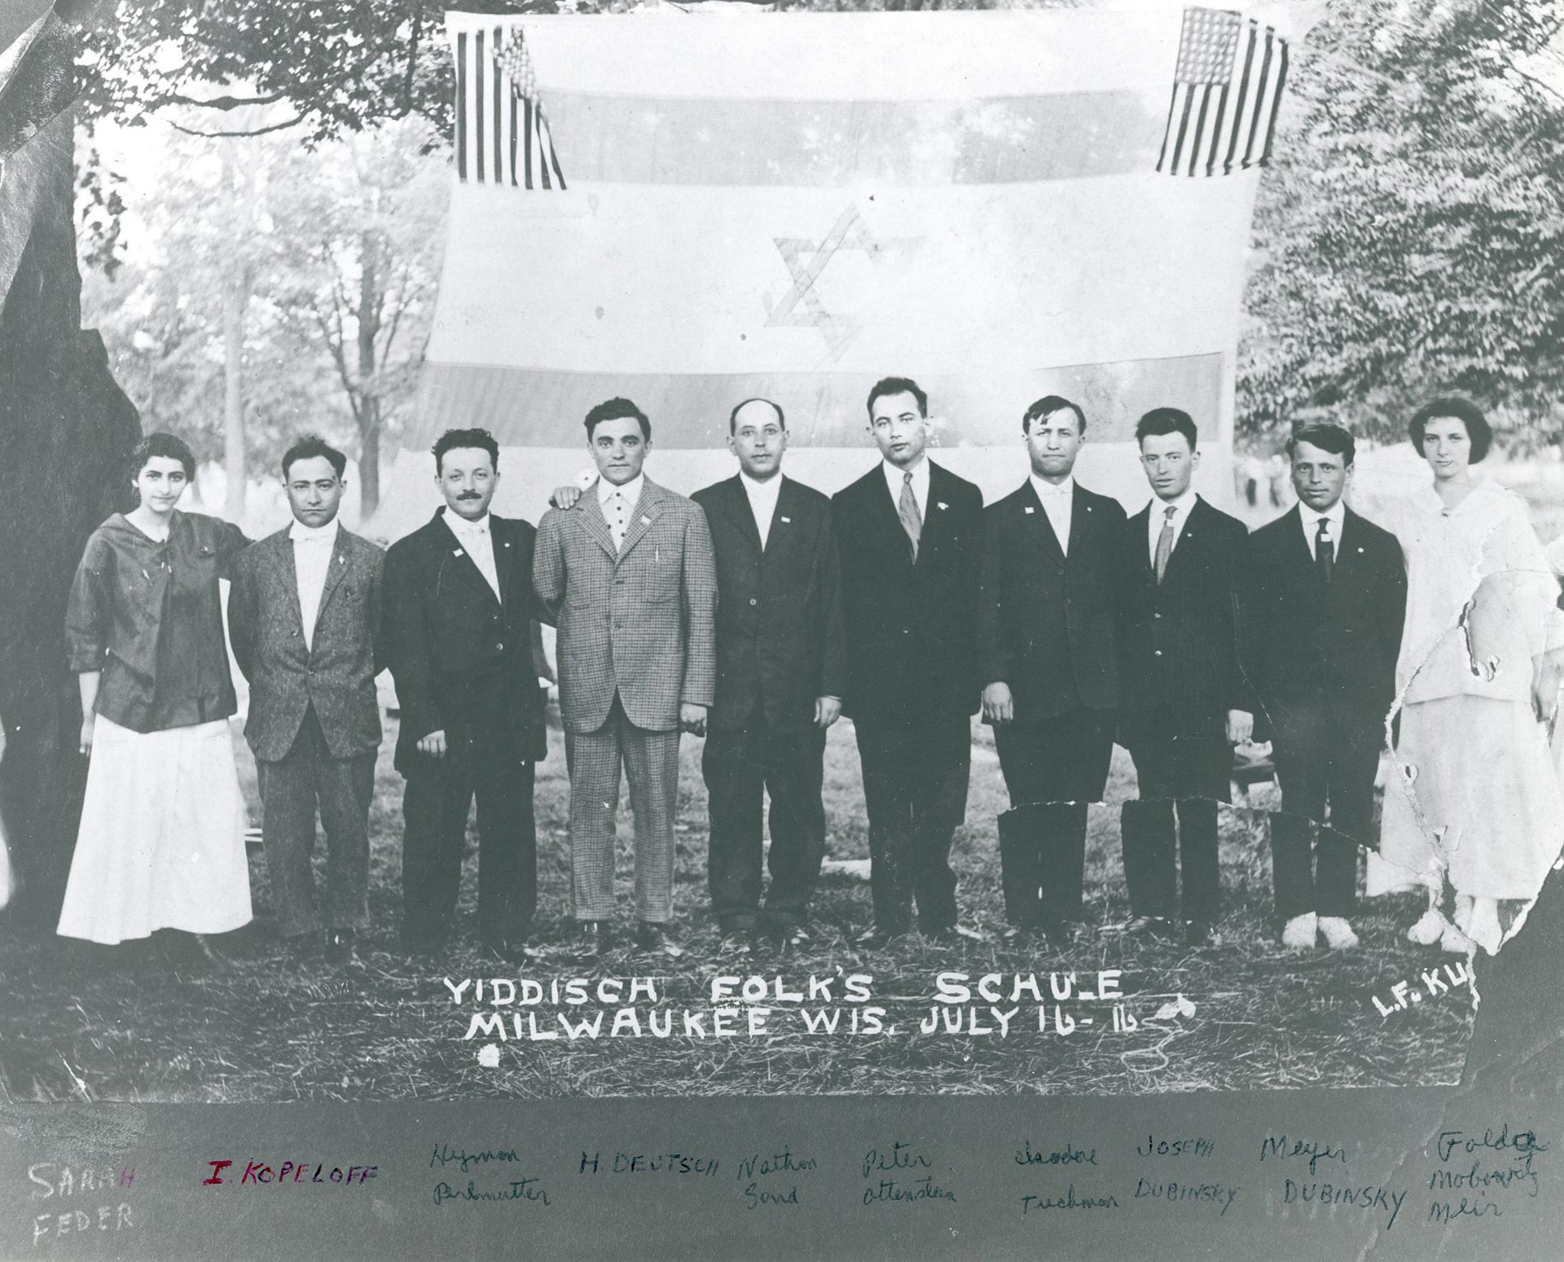
Most powerfully, the exhibition highlights how Milwaukee's institutions shaped Meir's trajectory. Her years at Fourth Street School (now Golda Meir School), where at age eleven she organized the American Young Sisters Society to raise money for classmates' textbooks, reveal early leadership and commitment to educational access. Her time at North Division High School, teaching at the Yiddish Folk Shule, and organizing for Poalei Zion in Milwaukee provided the training ground for international statesmanship. For the Texiguat virtual museum, this model suggests profound possibilities: telling Francisco Morazán's story through his Texiguat roots—his childhood experiences, education, family connections, and the landscape that shaped his vision—could transform him from distant historical figure into hometown hero whose values remain relevant today.

Milwaukee Example: UWM's "Picturing Golda Meir" Digital Photo Collection
Complementing the Jewish Museum's narrative exhibition, the University of Wisconsin-Milwaukee Libraries' "Picturing Golda Meir" collection takes a different but equally valuable approach: comprehensive visual documentation of an entire life. This digital collection presents 157 images spanning 1904 to 1987, housed in the Archives Department and made freely accessible through UWM's Digital Collections platform. The collection methodology demonstrates how systematic visual archiving can preserve multiple dimensions of a historical figure's life and impact.
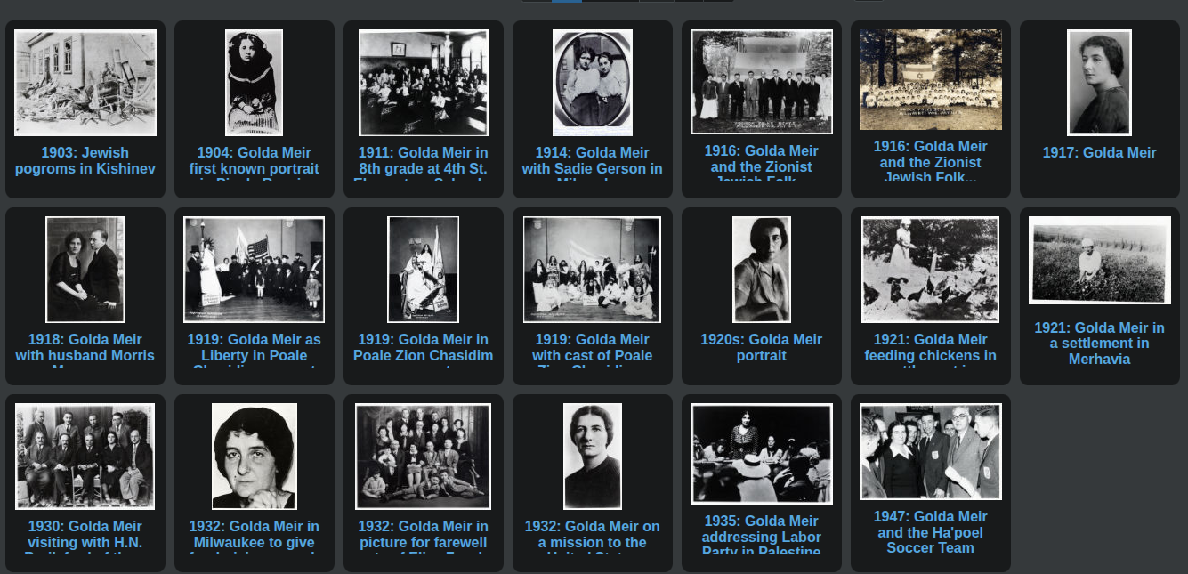
What distinguishes this collection is its integration into broader university infrastructure. The Golda Meir Library at UWM bears her name, a historical marker on campus commemorates her education there at Milwaukee Normal School (1916-17), and the photo collection connects to the university's mission of accessible scholarship. This multi-layered recognition—physical space, commemorative marker, and digital archive—creates what our placemaking readings describe as "layered memory," where history becomes embedded in place through multiple reinforcing elements. The physical library serves daily users, the marker educates campus visitors, and the digital collection extends access globally while preserving fragile original photographs.
The collection's temporal breadth proves particularly instructive for the Texiguat project. By documenting Meir's entire life span rather than focusing only on her political career, the collection humanizes her trajectory—showing the young girl who arrived in Milwaukee, the teenage activist organizing on street corners, the young wife departing for Palestine in 1921, and the elder stateswoman. For Morazán, similarly comprehensive visual documentation would be invaluable: portraits from different life stages, images of locations significant to his biography, maps showing his military campaigns, documents in his hand, and photographs of sites associated with his legacy. While original photographs of Morazán himself don't exist (he lived before widespread photography), the collection could include historical illustrations, modern photographs of relevant sites, digitized documents, and visual materials documenting how Morazán has been remembered and commemorated over the nearly two centuries since his death.
The UWM collection also demonstrates tactical urbanism's principle of starting with available resources and expanding over time. The collection currently contains 157 images—substantial but not overwhelming—suggesting a manageable scope for initial development. For Texiguat's museum, this implies beginning with core visual materials (perhaps 50-100 carefully selected and documented images) rather than attempting exhaustive coverage from the outset. Quality curation and clear documentation matter more than sheer quantity, especially when building trust with communities who may be skeptical of external projects.
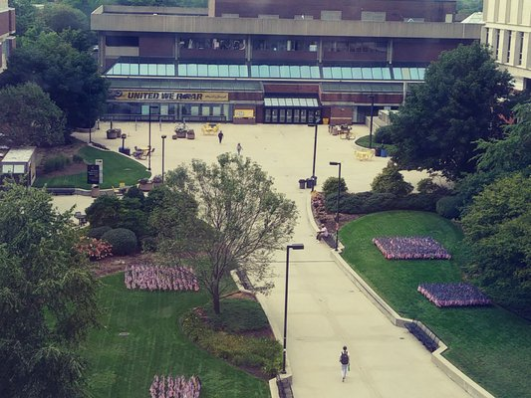

Global Example: Nelson Mandela Digital Heritage Initiatives
While the Milwaukee examples demonstrate how smaller-scale, focused digital projects can effectively honor historical figures, the Nelson Mandela digital heritage initiatives illustrate what becomes possible with greater resources, institutional backing, and sustained commitment. The Mandela digital ecosystem includes multiple interconnected entities: the Nelson Mandela Foundation (which houses the Centre of Memory and extensive archives), the Nelson Mandela Museum (with physical sites in Mthatha and Qunu), the Nelson Mandela Capture Site (commemorating his 1962 arrest), and numerous partnerships with international platforms like Google Arts & Culture. Together, these initiatives create comprehensive digital access to Mandela's life, legacy, and the anti-apartheid struggle.
The Google Arts & Culture partnership proves particularly significant. The platform hosts over twenty digital exhibitions about Mandela in multiple languages, including "A Virtual Exhibition on the Life and Times of Nelson Mandela," which offers perspective on his life within the contexts of colonialism, apartheid, and democracy. This virtual exhibition includes church membership cards from 1931, photographs of Mandela with his law class at the University of the Witwatersrand in 1944, images from his underground organizing in the 1950s, documentation of his twenty-seven years imprisonment on Robben Island, and materials from his presidency and elder statesman years. The exhibition also provides behind-the-scenes tours of the archive repository itself, demystifying how historical memory is preserved and making the research process visible to users.
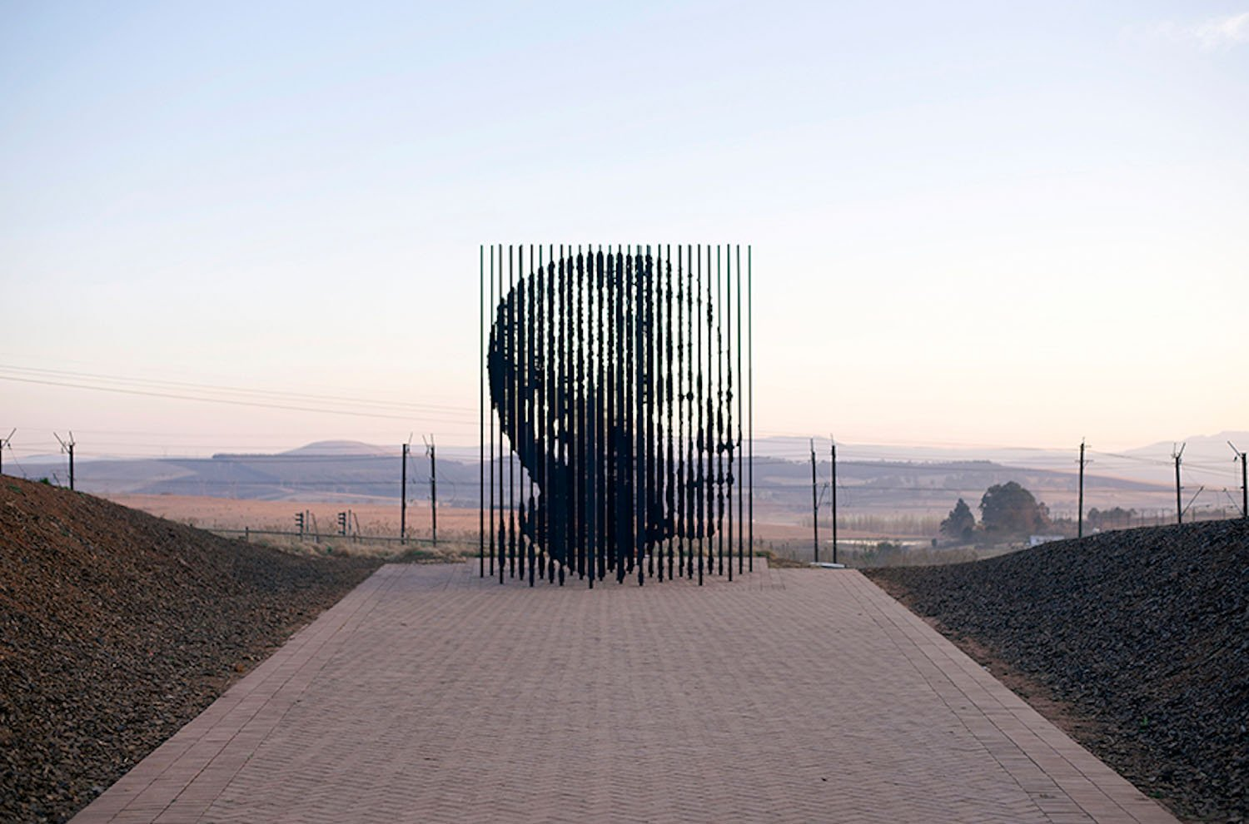
What makes the Mandela initiatives especially relevant to Texiguat's context is their explicit commitment to community development alongside heritage preservation. The Nelson Mandela Museum Youth and Heritage Centre in Qunu was established in 2006 specifically to serve as "a catalyst for youth and community development," not merely as tribute to Mandela. The Centre employs over thirty-five staff, welcomes approximately five hundred visitors daily (pre-pandemic), hosts school groups and education programs, trains twenty-five young adults for hospitality and tourism careers, and supports local businesses through construction and upgrade projects. Mandela himself insisted that the museum should not be a tribute dedicated to him but should serve as "a catalyst and springboard for the upliftment and development of the local community."
This philosophy directly addresses concerns raised in our human-centered design readings about projects that extract community stories without providing reciprocal benefit. The Mandela model demonstrates how heritage preservation can function as economic development engine, creating sustainable employment, supporting local businesses, providing educational resources, and strengthening community pride. For Texiguat, this suggests that a virtual museum about Francisco Morazán should include components that benefit the community beyond pure historical preservation—perhaps training programs in digital literacy, tourism infrastructure development, or educational partnerships with Honduran schools that use the museum as curriculum resource.
The Nelson Mandela Capture Site's virtual tour, launched during COVID-19 lockdowns in March 2020, showcases how quickly institutions can pivot to digital access when necessary. Using drone footage, the virtual experience allows users to explore the site's immersive exhibition with its historical artifacts, rare video and audio footage, and 360-degree views of the iconic steel sculpture commemorating Mandela. The Site offered virtual visits free of charge while encouraging supporters to pre-purchase tickets, buy memberships, or make donations to sustain operations—demonstrating how digital access can complement rather than replace physical visits while creating additional revenue streams.
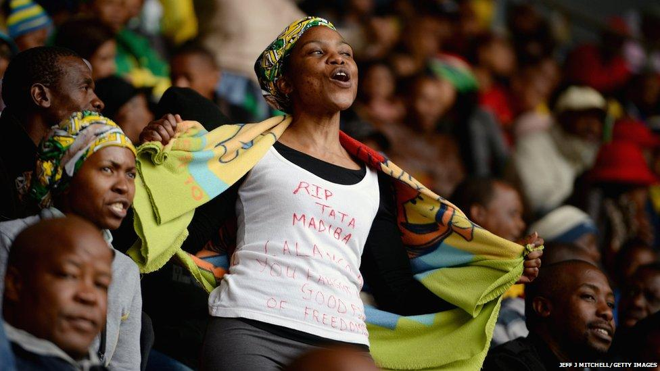

Connecting to Course Concepts
These precedent projects illuminate several key concepts from our course readings, starting with placemaking. The Golda Meir exhibitions demonstrate how digital spaces can function as "places" in the fullest sense—not mere information repositories but environments where community members gather, share stories, and maintain connections to heritage. The Jewish Museum Milwaukee's first-person narrative creates an intimate digital space that invites reflection and identification, while UWM's photo collection provides a different kind of place: an archive where researchers, students, and curious visitors can encounter primary sources directly. Both complement physical places (the Fourth Street School renamed in Meir's honor, the UWM library bearing her name) while extending their reach globally.
The Nelson Mandela initiatives take placemaking further by creating an entire ecosystem of interconnected physical and digital places. Robben Island exists as both UNESCO World Heritage Site and Google Street View destination. The Capture Site sculpture stands on the roadside where Mandela was arrested while virtual tours bring it to screens worldwide. Qunu's Youth and Heritage Centre serves local community daily while Google Arts & Culture exhibitions reach international audiences. This multiplicity of places—each serving distinct purposes while reinforcing a unified narrative—suggests that Texiguat's virtual museum might eventually connect to multiple physical sites (Morazán's birthplace, the military headquarters building, locations of significant events in his life) while also existing as digital destination accessible to anyone with internet connection.
Human-centered design principles appear consistently across successful historical figure museums. The Golda Meir exhibition's first-person narrative prioritizes emotional engagement over encyclopedic completeness, recognizing that connection precedes learning. The thematic organization respects different users' entry points and interests rather than imposing a single "correct" path through the material. The Nelson Mandela initiatives' multilingual approach acknowledges that heritage belongs to diverse audiences with different linguistic backgrounds. For Texiguat, this suggests extensive consultation with local community members about how they understand Morazán's significance, what stories matter most to them, and how they would want his legacy presented to their children and to external visitors.
Tactical urbanism's emphasis on incremental, adaptable interventions resonates with how these digital projects developed over time. The UWM photo collection began as archival digitization project and evolved into publicly accessible resource. The Jewish Museum Milwaukee's virtual exhibitions launched as pandemic response and became permanent offerings. The Mandela initiatives grew from single institution (the Foundation) to interconnected ecosystem of museums, memorials, and digital platforms. This evolutionary approach—starting with manageable scope, learning from users, adding features based on demonstrated need—proves more sustainable than attempting comprehensive perfection from the beginning. For Texiguat, this suggests launching with core content (perhaps biographical timeline, key documents, significant locations, educational resources for schools) and expanding based on community feedback and identified needs.

Challenges and Strategies for Success
My research revealed common challenges these projects navigated successfully. Content development in first-person voice, as the Golda Meir exhibition demonstrates, requires careful research and thoughtful writing. The exhibition team clearly studied Meir's autobiography, speeches, and interviews to capture her voice authentically. For Morazán, this would mean deep engagement with his letters, proclamations, and the limited personal writing that survives, likely requiring collaboration with historians who have studied his life extensively. The authenticity of voice matters enormously—poorly executed first-person narrative rings false and damages credibility.
Visual materials present different challenges. While the UWM collection benefits from preserved photographs spanning Meir's entire life, Morazán lived before widespread photography, and Texiguat may have limited visual archives. However, the Mandela initiatives demonstrate how to work with mixed media: historical illustrations, modern photographs of relevant sites, digitized documents, maps, and commemorative materials can combine to create rich visual environment even without abundant original photographs. Partnerships with Honduran national archives, universities, and museums could provide access to relevant historical images and documents.
Sustainable funding and institutional support emerge as critical success factors. The UWM collection benefits from university library infrastructure and expertise. The Jewish Museum Milwaukee operates as established nonprofit with donor base and community support. The Mandela initiatives receive support from South African government, international foundations, and revenue from physical site visits. For Texiguat, identifying funding sources will be essential—potentially through Honduran Ministry of Culture grants, educational foundations interested in Latin American history, partnerships with universities studying Central American independence movements, or crowdfunding campaigns targeting Honduran diaspora communities worldwide. Creating compelling case for impact—emphasizing educational benefits, cultural preservation, community economic development, and tourism potential—will be crucial for securing support.
Technical capacity represents another significant consideration. The Milwaukee examples benefit from university expertise and museum professionals with digital experience. Texiguat's virtual museum will likely need partnerships with technical experts—perhaps through collaboration with Honduran universities like Universidad Nacional Autónoma de Honduras (UNAH), international NGOs working on cultural preservation, or even MSOE students as part of ongoing Honors Program engagement. Starting with proven, user-friendly platforms (WordPress, Omeka for museums, or even well-organized Google Sites) makes more sense than attempting custom development requiring ongoing technical maintenance the community may struggle to provide.

Conclusion: Advancing the Texiguat Project
This research demonstrates that virtual museums can powerfully honor historical figures while serving multiple community goals: education, cultural preservation, identity strengthening, economic development, and global connection. The Jewish Museum Milwaukee's Golda Meir exhibition proves that first-person narrative can transform distant historical figure into relatable human being whose struggles and triumphs resonate across time and culture. The UWM digital photo collection shows how systematic visual documentation, even of modest scale, provides invaluable resource for researchers, educators, and curious learners. The Nelson Mandela initiatives illustrate how heritage preservation can function as community development catalyst, creating employment, supporting local business, providing educational resources, and strengthening cultural pride.
For Texiguat's virtual museum honoring Francisco Morazán, these precedents suggest a clear path forward that balances ambition with pragmatism. The museum should begin with core content focused on telling Morazán's story through his Texiguat roots—his childhood and family background, education and formative influences, emergence as military and political leader, vision for Central American unity, and tragic death in 1842 at age fifty. This biographical foundation should employ first-person narrative where possible, drawing on Morazán's letters and proclamations to let him speak in his own voice about his ideals and struggles.
The museum should integrate multiple content types: historical illustrations and portraits; modern photographs of Texiguat locations connected to Morazán's life; digitized historical documents, maps, and letters; timeline showing his life in context of Central American independence movements; thematic sections exploring concepts like democracy, regional unity, liberal reform, and military leadership; educational resources designed for Honduran school curriculum; and oral histories from Texiguat elders about local memories and traditions connected to Morazán. This multi-modal approach serves different learning styles and allows users to engage at various levels of depth.
Bilingual presentation in Spanish and English proves essential. Spanish serves the primary audience—Texiguat residents, Honduran students, Central American communities throughout the region—while English extends reach to international scholars, tourists, and diaspora communities. Following the Mandela model of prioritizing accessibility, the museum should work across different devices and connection speeds, recognizing that many potential users may access it via mobile phones with limited bandwidth.
Partnership development will determine long-term sustainability. Collaboration with Honduran universities could provide scholarly expertise, technical support, and student researchers. Partnership with Honduras Ministry of Culture or similar entities might offer funding and official recognition. Connection to Google Arts & Culture or similar platforms would dramatically expand reach and provide tested infrastructure. Engagement with Honduran diaspora communities worldwide could generate both financial support and content contributions. Most critically, deep ongoing collaboration with Texiguat community members ensures the museum reflects local values, preserves stories elders hold, and serves needs identified by residents rather than imposed by outsiders.
The museum should explicitly incorporate community development components inspired by the Mandela Youth and Heritage Centre model. This might include training programs in digital literacy, content creation, or heritage tourism for local youth; partnerships with Texiguat schools using the museum for history education; infrastructure supporting cultural tourism (information materials, local guide training, small business development); and employment for community members in museum maintenance, content development, and visitor services if physical component develops alongside digital presence.
Most fundamentally, these successful examples demonstrate that honoring a historical figure means more than cataloging their achievements. It means understanding how place shaped the person, how their values remain relevant to contemporary challenges, and how their story can inspire and educate future generations. Francisco Morazán fought for Central American unity, democratic governance, secular education, and social reform. His vision, though ultimately defeated by the conservative forces that fragmented the Federal Republic, speaks powerfully to contemporary challenges of regional cooperation, democratic resilience, and inclusive development. By creating a virtual museum that makes Morazán's life and ideals accessible to new generations, Texiguat can strengthen its own cultural identity, educate youth about their heritage, contribute to broader Central American historical consciousness, and demonstrate how small communities can preserve and share the legacies of their greatest citizens with the world.

Works Cited

"Exhibitions." Nelson Mandela Foundation, www.nelsonmandela.org/exhibitions. Accessed 2 Nov. 2025.
"Golda Meir." Jewish Museum Milwaukee Virtual Exhibitions, virtual.jewishmuseummilwaukee.org/golda-meir/. Accessed 2 Nov. 2025.
"Golda Meir." Wisconsin Historical Society, 3 Aug. 2012, wisconsinhistory.org/Records/Article/CS533.
"Golda Meir Historical Marker." Historical Marker Database, www.hmdb.org/m.asp?m=32664. Accessed 2 Nov. 2025.
"Google Street View of Robben Island." Nelson Mandela Foundation, www.nelsonmandela.org/publications/entry/google-street-view-of-robben-island. Accessed 2 Nov. 2025.
"Home - UWM Libraries Digital Collections." University of Wisconsin-Milwaukee, 18 June 2025, uwm.edu/lib-collections/.
"Nelson Mandela: The Official Exhibition Virtual Experience." Milwaukee Public Museum, www.mpm.edu/plan-visit/exhibitions/special-exhibitions/nelson-mandela-official-exhibition/education-programs-resources/virtual-exhibit-experience. Accessed 2 Nov. 2025.
"Nelson Mandela Museum." Nelson Mandela Museum Official Website, www.nelsonmandelamuseum.org.za/. Accessed 2 Nov. 2025.
"Take a Virtual Tour of The Nelson Mandela Capture Site." Good News Daily, 4 June 2020, goodnewsdaily.co.za/2020/06/04/take-a-virtual-tour-of-the-nelson-mandela-capture-site/.
"Texiguat, El Paraíso, Honduras Genealogy." FamilySearch Wiki, 29 Dec. 2021, www.familysearch.org/en/wiki/index.php?title=Texiguat,_El_Para%C3%ADso,_Honduras_Genealogy.
"A Virtual Exhibition on the Life and Times of Nelson Mandela." Google Arts & Culture, artsandculture.google.com/story/a-virtual-exhibition-on-the-life-and-times-of-nelson-mandela/0gISCwoZmy8vJw. Accessed 2 Nov. 2025.
"Virtual Tour." Nelson Mandela Museum, www.nelsonmandelamuseum.org.za/virtual-tour/. Accessed 2 Nov. 2025.

