AI Tools Lab 9 – ANNs

Name: Sam Freund

Exercise 1
Complete the two functions in the notebook, then fill in the following information:
- Accuracy of “my_classifier” on low variance data: 1.0
- Accuracy of “my_classifier” on high variance data: 0.794
- Accuracy of the MLP on the low variance data: 0.632

Exercise 2
Add your plot of accuracy vs epochs here for the MLP on the low variance data. Note that you should be able to achieve a very high accuracy – be sure to test large enough values for your epochs! Then answer the question below.

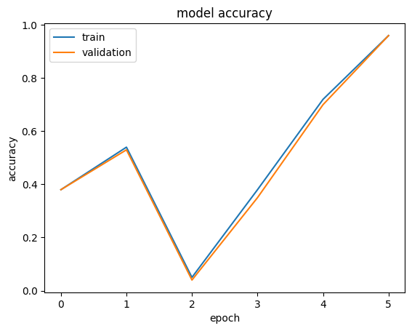

- What is the relationship between the number of epochs and the accuracy?
As epochs increase, so does accuracy.

Exercise 3
Complete the table below. Feel free to add more rows to the table if you ran additional experiments. Answer the discussion question below.
Neurons in hidden layer | Epochs | Train Accuracy | Test Accuracy | Low/high variance data?
4 | 5 | 0.06 | 0.04 | low
8 | 5 | 0.5 | 0.51 | low
12 | 5 | 0.65 | 0.65 | low
16 | 5 | 0.91 | 0.91 | low
20 | 5 | 0.77 | 0.77 | low

- What can you observe about the relationship between neurons in the hidden layer and the resulting accuracy?
More neurons typically results in higher accuracy, but not always.

Exercise 4
Complete the table below. Feel free to add more rows to the table if you ran additional experiments. Answer the discussion question below.

Neurons in hidden layer | Epochs | Train Accuracy | Test Accuracy | Low/high variance data?
4 | 5 | 0.14 | 0.1 | high
8 | 10 | 0.58 | 0.59 | high
8 | 5 | 0.2 | 0.2 | high
16 | 20 | 0.73 | 0.72 | high
0 | 5 | 0.25 | 0.23 | high

- Was the MLP able to achieve a higher accuracy than “my_classifier” was on the higher variance data? Why/why not?
It was not, I presume this is because it did not train for long enough. If trained for longer, I expect that it would have been able to exceed the values of `my_classifier`.

Exercise 5
Complete the table below – do not include runs that got “stuck” at 57%. Feel free to add more rows to the table if you ran additional experiments. Answer the discussion question below.

Neurons in hidden layer | Epochs | Training Accuracy | Testing Accuracy | Total # of model parameters
16 | 10 | 0.85 | 0.82 | 118282
8 | 10 | 0.85 | 0.8 | 118282
16 | 100 | 0.68 | 0.64 | 118282
32 | 10 | 0.82 | 0.79 | 118282
64 | 10 | 0.83 | 0.79 | 118282

- What do you think contributed to your experiment with the highest testing accuracy being the best? Why?

Most of it was fairly similar, I think the largest contributor was a reasonable number of epochs, as when I tested with more epochs it ended up overfitting.

Exercise 6
Place the output plot from your run (after adding a dense and a dropout layer). Answer the following discussion questions.

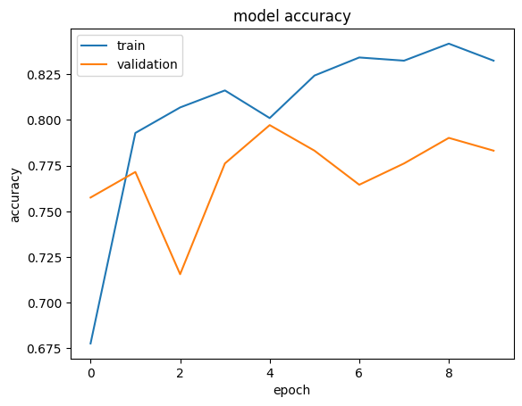

- Did more layers help? Somewhat, but results were not significantly different than my prior result.

- Did dropout affect overfitting? It seems to have somewhat increased overfitting, contrary to what I would effect.

- Did the total number of parameters correlate with changes in accuracy across your experiments? More or less, we didn’t see a significant change, but there were no significant changes observed in prior experiments either.

Exercise 7
Complete the table below.
Activation Function | Training Accuracy | Testing Accuracy
Softmax | 0.57 | 0.57
Elu | 0.84 | 0.8
Swish | 0.84 | 0.81

Exercise 8
Complete the table below. Feel free to add more rows to the table if you ran additional experiments. If you altered the data augmentation, you should add columns to the table and document the augmentation you did. Complete the reflection below.

Deepness | Epochs | Training Accuracy | Testing Accuracy
10 | 1 | 0.91 | 0.89
20 | 1 | 0.97 | 0.90
20 | 2 | 0.97 | 0.94
5 | 1 | 0.87 | 0.84
5 | 2 | 0.87 | 0.84

- What model alterations seemed to have the largest effect? Why might this be? Did your model ever become overfit to the training set?

Increasing the number of epochs helped significantly, and decreasing the number of epochs proved to be significantly detrimental. Of further note is the fact that depth has a larger effect the more epochs are run. My model did not become overfit.

Which model (CNN or DNN) achieved the best test accuracy?
Hint: it is possible to achieve better than 95% accuracy on the test set?

The CNN model achieved a higher test accuracy.

Which model trained faster? What is the performance difference between running the slower model on a CPU vs GPU?

The model with a bigger layer trained slower, and vice versa. Performance difference from the smaller model is fairly significant, but not as significant as I’ve seen on bigger models.
Which model was larger (had the most parameters)? How many parameters did each model have? Is the number of parameters related to the time it takes to train the model?

The CNN model was larger and had more parameters. The number of parameters is related to the amount of time it takes to train the model, but if a GPU is used it can parallelize the training resulting in a similar time across models.

Based on your confusion matrices, which class was the most difficult to accurately predict? Was it consistently difficult among different models?

The most difficult to predict seems to have been classes 1 and 2. This is consistent across the DNN and CNN models, although there were differences with some of the other classes they struggled with.

How can you use the results from the confusion matrix to inform how you would test the mobile app for accuracy?

I would choose the characters that performed the worst, and test those. These characters would likely provide the best baseline, as I can guarantee that all other characters will perform as well, or better.

What affect did data augmentation have on the CNN and DNN models?

Data augmentation was not experimented with for the CNN model. For the DNN model, we found that it was helpful, but only in moderation. After extending the data augmentation too far, it proved detrimental to the accuracy.

