|  |
| --- |
| http://scifi.usask.ca/images/logos/SCI-FI%20Logo_Blue.jpg |
| **CODEMAKERS Love 2D Project Manual** |
| 2018 |

**Table of Contents**

README ……………………………………………………………………………………………………………………………………………….3

Camp Schedule …………………..………………………………………………………………………………………………………………..4

ACTIVITY: Intro Programming …………………………………………………………………………………………………………….…6

ACTIVITY: First Game ………….………………………………………………………………………………………………………………10

ACTIVITY: Digital Citizenship …………………………………………………………………………………………………………….…14

ACTIVITY: Quidditch ……………………………………………………………………………………………………………………………18

ACTIVITY: Love hertz ……………………………………….……………………………………………..…………………………………..24

ACTIVITY: Pinball ………………………………………..………..…………………………………………………………………………….26

Tricks that will make your game better ………..………………………………………………………………………………….…31

ACTIVITY: Liner Rider ………………………………………………………………………………………………………………………….37

ACTIVITY: Line Rider Eraser ………………………………………………………………………………………………………………...41

ACTIVITY: Game’s To Usb’s/Line Rider Comparison………………………………………………..…………………………...44



**README**

Make sure the campers have the folder Files_For_Campers on their computer by the afternoon of the first day. There are many code templates that the campers will build code from in this folder. There is one file called Give_at_ending/Game_tricks.pdf that should not be given until after the Game_tricks/Game_design workshop.

Have fun!

**Camp Schedule**

**5 day**

|  |  |  |  |  |  |
| --- | --- | --- | --- | --- | --- |
| **Codemaker - Love 2D (2017)** | | | | | |
| **Time** | **Monday** | **Tuesday** | **Wednesday** | **Thursday** | **Friday** |
| **9:00 AM** | **Welcome/ Tours** | **First Game** | **Pinball** | **Line rider** | **Finishing Touches** |
| **9:30 AM** |
| **10:00 AM** | **Digital Citizenship** |
| **10:30 AM** |  | | | |
| **11:00 AM** | **Basic Coding** | **Quidditch** | **Pinball** | **Line rider** | **Games to USBs / Line Rider Comp** |
| **11:30 AM** |
| **12:00 PM** | **Lunch** | | | | |
| **12:30 PM** |
| **1:00 PM** | **Basic Coding** | **Quidditch** | **Game Design Tricks** | **Line Rider** | **water fight** |
| **1:30 PM** |
| **2:00 PM** |
| **2:30 PM** | **Snack** | | | |
| **3:00 PM** | **First Game** | **Love Hertz** | **Line Rider** | **Science Show 2:30** |
| **3:30 PM** |
| **4:00 PM** | **Home Time** | | | | |

**4 day**

|  |  |  |  |  |
| --- | --- | --- | --- | --- |
| **Codemakers - Love 2D Short Week (2017)** | | | | |
| **Time** | **Tuesday** | **Wednesday** | **Thursday** | **Friday** |
| **9:00 AM** | **Welcome/ Tours** | **First Game** | **Line rider** | **Finishing Touches** |
| **9:30 AM** |
| **10:00 AM** | **Digital Citizenship** |
| **10:30 AM** |  | | |
| **11:00 AM** | **Basic Coding** | **Pinball** | **Line rider** | **Games to USBs / Line rider Comp** |
| **11:30 AM** |
| **12:00 PM** | **Lunch** | | | |
| **12:30 PM** |
| **1:00 PM** | **Basic Coding** | **Pinball** | **Line rider** | **SUPER FUN TIMES** |
| **1:30 PM** |
| **2:00 PM** |
| **2:30 PM** | **Snack** | | |
| **3:00 PM** | **First Game** | **Game Design Tricks** | **Science Show 2:30** |
| **3:30 PM** |
| **4:00 PM** | **Home Time** | | | |

**ACTIVITY: Intro Programming**

BY: Sam Germain adapted from Carter Hill

GRADE and CAMP: Grade 7-9, Codemakers (Love 2D)

TOPIC(s): Game Design, binary

|  |
| --- |
| TIME: 120 mins |

OBJECTIVE: Learning the basics of programming in Lua

**MATERIALS:**

* ヽ(ຈل͜ຈ)ﾉ︵ ┻━┻

**SCIENTIFIC BASIS (learning outcomes - teach this):**

**What is syntax?** All coding languages are unique in how they operate, and the word syntax is used to describe them. For example the “syntax” for writing something to the console in Python or Lua is “print(“something”)” whereas with c++ it’s more like: cout << “something” << endl; In the same way, one could say the “syntax” for saying hello in French is bonjour.

**Variables:** Variables, put simply, are placeholders for data. They have an assigned name and a value that can be changed at almost any time. Variables in coding are not very different from variables in math. If we say that x – 3 = 1, we know that x = 4, x would be its name, and 4 would be its value. In Lua, variables can be assigned really easy, just by typing name = value. If there is already a variable called name, its value would be changed, and if not, it would simple create a value for it.

Variables can hold the values of all kinds of different data types. The most obvious answer would be numbers. What other types of data can be used in computer code? If you want a string (a string of characters, like a sentence) you would say myString = “Your sentence in quotes”. The quotations make the computer know that it’s a string variable type. Another important data type is Boolean, which can only have two values, can you guess what they are? (It’s True and False). myBoolean = True

**Conditionals:** Are bits of code that are only executed if a given condition is true. This is where computer and human language are most comparable. Let’s say you’re about to go get groceries you check your fridge and see that you’re out of milk, so you add it to your list. The next time you go to get groceries you still have some left, so you decide not to get milk. Next, somebody else in your house is going shopping, so you tell them “If we’re out of milk buy some!” which is very close to how conditionals are written in computer science. Let’s say we have a variable that is true if the milk jug is empty, so “outOfMilk = True”. Then, our if statement would look like: “if outOfMilk then // end” or “if outOfMilk == True”. Or we could have a variable that is true if we have milk, so: “if milkNotEmpty == False then // end”.

You can also use numbers in conditionals. For example, if 4 == 4 would always turn true, and thus the code in that block will always execute. Or you could have a variable that shows how much milk is left, like milkAmount = 10. You could say that if the milk is almost gone, you should buy more. You can do that by using < and > which mean less than or greater than. So “if milkAmount < 3 then” would execute if your “milkAmount” is two or less.

**Functions:** Functions, or procedures, are kind of like variables but for code. Let’s say we want a function that adds four to a given number. It would look like:

function add(x, y)

z = x + y

return z

end

And then if I wanted to add two numbers together and assign it to a variable I would simply type myVariable = add(4, 3). Functions can have as many arguments as you want them to, or they could have 0 arguments at all. If they have no arguments, you have to remember to use the brackets anyway, there just won’t be anything between them.

**Objects**

Objects behave like a container that can have variables(called attributes) and functions(called methods) attached to them. Lets use the analogy of a bike as our object. If we refer to samsbike.height we are referring to the height of sams bike, and if we refer to samsbike.speed we are referring to the speed of sams bike. If we say mattsbike.speed we are referring to the speed of matts bike.

**Loops**

Our for loops are only going to loop through objects, because of this, they don’t have to really learn what for loops are, just how to loop through an object. In looping through an object we repeat the same series of instructions for each attribute of the objects. We LOOP through each of the attributes of the object and perform some code using each attribute

**PROCEDURE:**

Get the kids to watch this video <https://www.youtube.com/watch?v=l26oaHV7D40&index=13&list=PL8dPuuaLjXtNlUrzyH5r6jN9ulIgZBpdo> on crash course programming.

The following exercises will take place on <https://repl.it/repls/GloomyGummyGenericsoftware>. Get the kids to visit this site

Write each of the following examples on the board and get the kids to try to code their own example

Write this example of variable’s on the board and get them to try to code their own example

**Variables**

x = 3

print(x) -- should print 3

y = 4 + x

print(y) --should print 7

**Conditional**

x = 3

if (x<5) then

print("less than 5")

elseif (x<10) then

print("less than 10")

else

print("greater than 10")

end

**Functions**  
function add(x, y)

z = x + y

return z

end

x = 2

y = 3

w = add(x,y)

print(w) --Should print 5

**Objects**

mattsbike = {}

samsbike = {}

samsbike.height = 172

mattsbike.height = 184

print(samsbike.height) --Should print 172

print(mattsbike.height) --Should print 184

--If the kids are too confused, you can skip this next part on methods

function samsbike.setheight(x)

samsbike.height = x

end

samsbike.setheight(150)

print(samsbike.height) --Should print 150

**For Loop**

We are going to create an object that has 3 string variables. We are then going to loop through each variable and print the string.

**Pseudocode**

bike = {}

bike.height = "1.2 m"

bike.speed = "20 km/hr"

bike.terrain = "Mountain"

for each variable in objects

print the variable

end for loop

**Lua Code**

strings = {}

bike.height = "1.2 m"

bike.speed = "20 km/hr"

bike.terrain = "Mountain"

for _, item in pairs(objects) do

print(item)

end

--Should print

--1.2 m

--20 km/hr

--bike.terrain

**ACTIVITY: First Game**

BY: Sam Germain

GRADE and CAMP: Grade 7-9, Codemakers (Love 2D)

TOPIC(s): Game Developement

|  |
| --- |
| TIME: 120 mins |

OBJECTIVE: To create our first game

MATERIALS:

* ᕙ(░ಥ╭͜ʖ╮ಥ░)━☆ﾟ.*･｡ﾟ

SCIENTIFIC BASIS (learning outcomes - teach this):

Games in love2d have 3 main functions. Love.load, love.update, and love.draw. Love.load is the function that operates when the game starts, it puts everything into the game that is there at the beginning.  
Love.update records input from the user and determines what changes are to be made to the game.

Love.draw gives the output of the game to the user, it shows the display.

Love.physics: Love.physics is used to create objects that can interact with eachother. Objects can be static(fixated on the screen), or dynamic(move around). When a dynamic object hits a static object, it deflects off of it, in this way, collision detection is taken care of for us.

We will give the kids a template for the world that the game exists in. The template sets the   
Each object has a minimum of 3 attributes

* Body: Determines where the object exists within the frame and whether the object is static or dynamic.
  + Ex: objects.ball.body = love.physics.newBody(world, 1700/2, 1000/2, "dynamic")
* Shape: Determines the shape of the object
  + Ex: objects.ball.shape = love.physics.newCircleShape(20)
* Fixture: Puts the object in the game world
  + objects.ball.fixture = love.physics.newFixture(objects.ball.body, objects.ball.shape, 1)

Objects: Objects are nothing more than a simple way of organising information. We are going to create 3 objects. 1 object is already created.  
  
PROCEDURE:

**Love.load**

1. Get the kids to open their template for the first game. If they drag it over love.exe as is it should display a blue screen.
2. The first thing you’ll do is change the width of the ground from 200 to 1700.  
   *objects.ground.shape = love.physics.newRectangleShape(1700, 50)*

At 1700 if the ball falls off the screen then it falls infinitely, because there is no ground that exists outside the screen. If you change it to 25000, the ball still has something to fall on if it rolls off the screen, even though you can’t see it. They can open **tutorials/Ground_width.pdf** to view the photo’s below.

**Ground Width: 200**

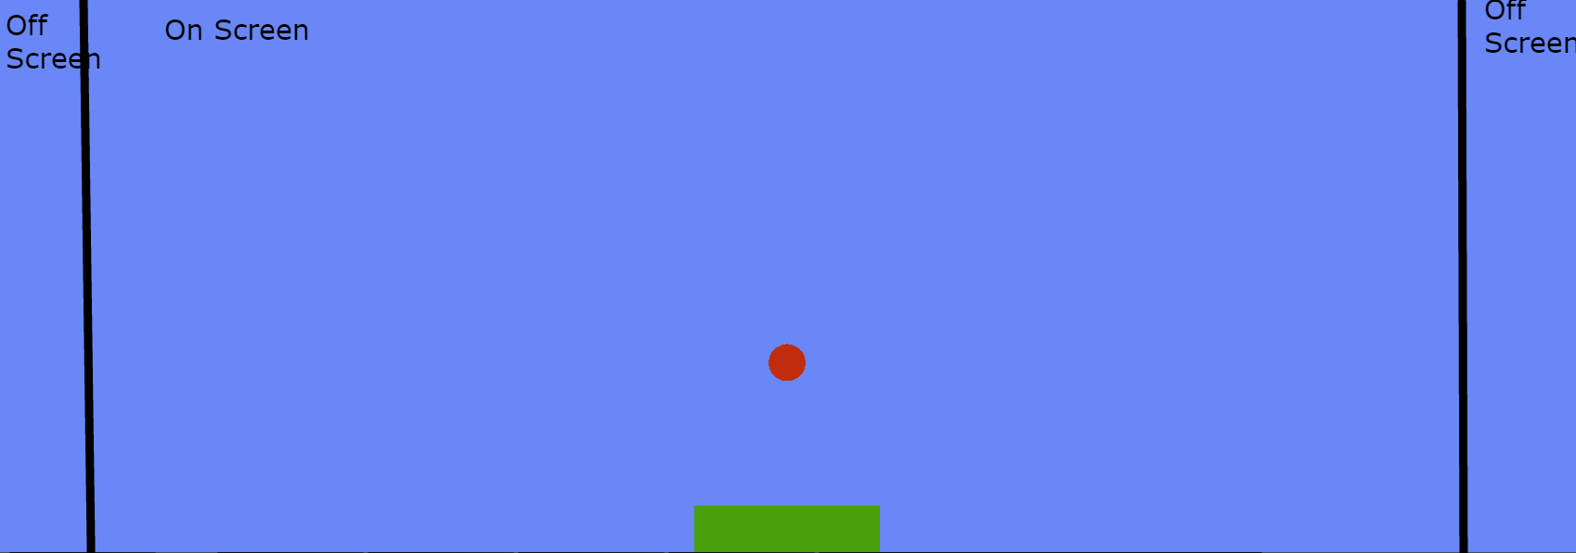

**Ground Width: 1700**

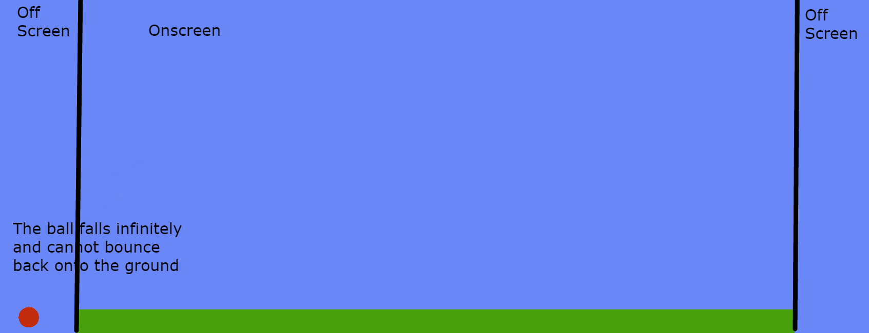

**Ground Width: 25000**

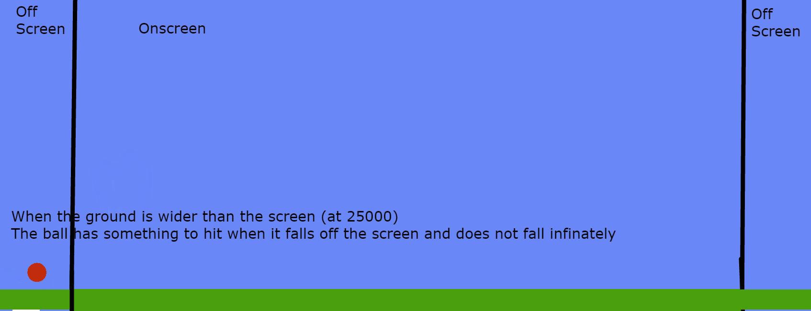

1. Fill in the right hand values for the ball object. The template should match the complete version by the end. The comments specify what the values should be for the ball. They should be able to use the code for how the ground was made as a reference for how to code the ball.
2. Code the left and right hand sides for the blocks that the ball will bounce against. The code is almost identical to the two objects created before and the comments specify what to do.

**Love.update**

1. Code instructions for the ball to move when the left arrow key is hit, the right arrow key is already coded

**Love.draw**

1. Uncomment the lines in love.draw that draw the shapes on the screen
2. Change the color of the ball to red. There is a commented out line for love.graphics.setcolor. They will have to uncomment this line and fill in the values specified in the comments. A few lines above they can see the code that was used to do this earlier.

**Template**

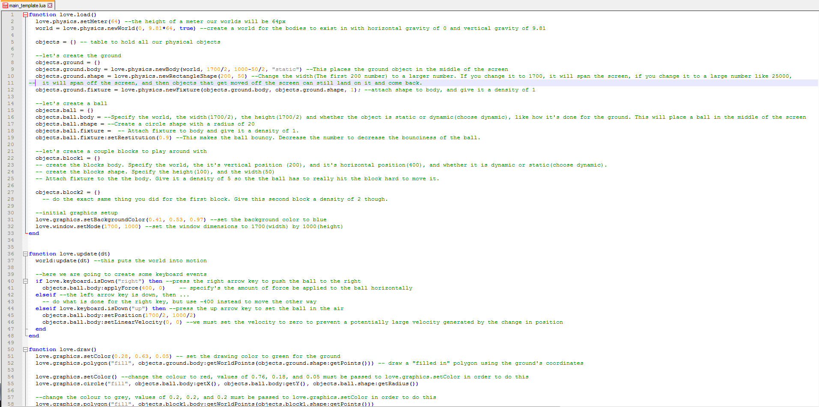

**Complete Code**

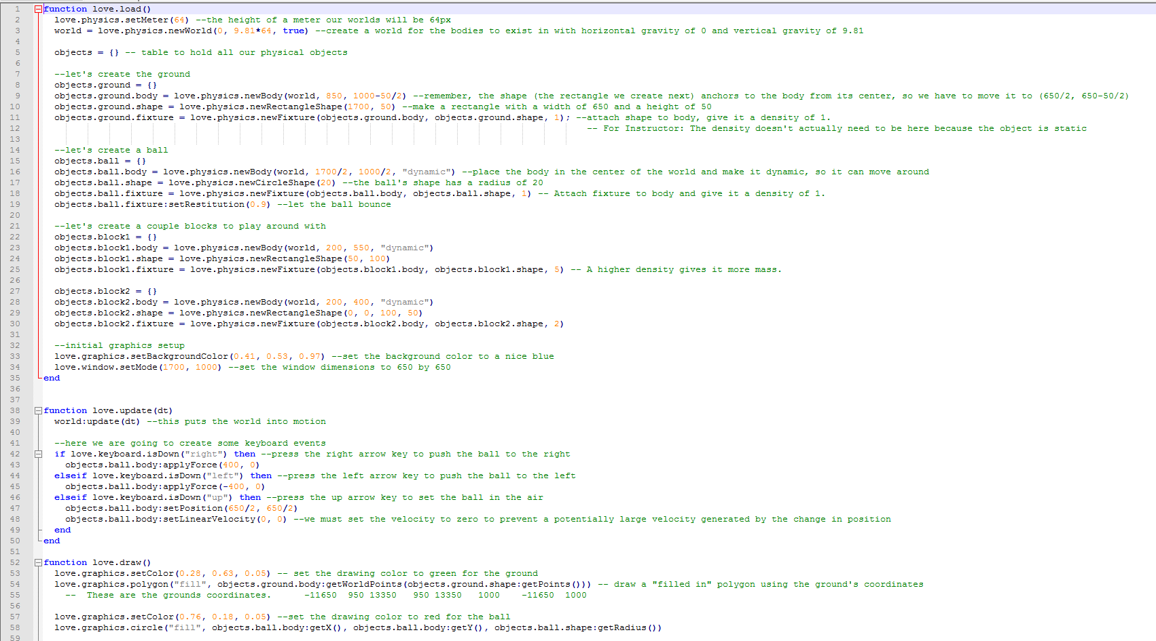

**Digital Citizenship: Searching and Security**

BY: Dominik Pytlak, Stephen and Jamie

GRADE and CAMP: 7+

TOPIC(s):

|  |
| --- |
| TIME: 30 mins |
| Set Up & Intro = Show some video’s on a screen |

**MATERIALS (what you’ll need for one week of camp):**

* **The internet and a screen to show videos on**

**What is Digital Citizenship?**

Digital citizenship refers to the norms of appropriate, responsible, and healthy behaviour in technology use. This includes ethics, etiquette, digital literacy, safety and security. Your behaviour online is sourced back to you in real life so it is important to always represent yourself on the internet as you would in real life. Your words and actions on the internet will have an impact on you just as they would in the real world.

**Content online never goes away**

There are websites that save old versions of websites

Video on why you should care about privacy

<https://www.youtube.com/watch?v=85mu9PLWCuI>

If you post something online, and then delete it, someone might have saved a copy, or the site you posted it on didn’t delete it

**How to tell if information is legit**

https://www.youtube.com/watch?v=FxyKHp47EnQ

**Website evaluation methods**

Author

* Who wrote this?
* What is their background?
* Is the author an individual or group?
* Is the author an expert on the topic
* Sharing opinions or facts?
* How does all of this shape what the author wrote?
* Click on Info/About if you can’t find the authors name

Motivation

* Is the webpage considered by a group organization or company
* What does the group stand to gain by convincing others of its points
* Was the information reviewed by others before it was published
* Is the information from a personal site (blog, etc.)
* .edu and .gov are more likely to be objective

Evidence

* Are there citations and links to other sources?
  + Are the citations accurate
* Can you verify the evidence from the site
* Are there many sources or just a couple

Timeliness

* When was the information published or last updated

BE SKEPTICAL

**Security**

Don’t just use things you’ve gotten online without checking them

* If an “antivirus” that you didn’t install is telling you that you have a virus… chances are, it’s a virus.

* Check the website at https://safeweb.norton.com/

Or google yourwebsite.com scam and if you get search results of people reporting it’s a scam, that’s a red flag

**SECURITY**

* Key loggers can record your key’s entered in

Fake Wap

* + Software that shows a fake wireless access point
  + Who owns it
  + Who’s using your data
  + Beware if free wifi doesn’t require a password or terms of use page
* Phishing
  + Replicates a legit looking site
  + A legit message that is actually fake
  + Anybody who’s asking for your password over email is a red flag
* Malware
  + Something that gets into your computer and messes things up
  + Comes in from a sketchy source
  + Don’t download programs and files from websites you don’t trust

Hacking techniques

* Bait and Switch
  + Buys ad space on a website and lures people to clicking on it
* Virus’s and Trojans
  + Send data from your computer continuously back to the hacker
* Keyloggers
  + Record your key strokes
  + Banks let you use their virtual keyboards to avoid this

**Efficient Use of Google**

https://www.youtube.com/watch?v=LTJygQwYV84

Boolean operators

* AND – results with both criteria
* OR – results with one or more of the criteria met
* NOT – results that don’t contain something
  + Can also use the minus sign

Asterisk at the end of a word give different endings

* Ex: Canad* returns results for Canada, Canadian, and Canadians

https://www.youtube.com/watch?v=R0DQfwc72PM

Quotation marks

* Assures the words show up in the order they are within the quotation marks

Can upload an image to google images and search for similar images that way

* Finds the origin of a specific image

Related:url

* Finds similar websites

Filetype:pdf

* Finds specific file types

Intitle: your search term

* Displays sites that have the search term in their title

Startpage.com

* Google search results without your ip address

**Procedure**

Watch this video on why you should care about privacy

<https://www.youtube.com/watch?v=85mu9PLWCuI>

Watch This video on privacy

\\rhubarb\admin\Outreach\SF-Instructors\Staff 2018\Camps\Codemakers- Gamedev\Videos_For_Digital_CitizenShip\privacy

Watch this video on how to tell how reliable information is.  
<https://www.youtube.com/watch?v=FxyKHp47EnQ>

Go over the types of Scam’s people try to pull as described under security

Watch this video on Scam Baiting: \\rhubarb\admin\Outreach\SF-Instructors\Staff 2018\Camps\Codemakers- Gamedev\Videos_For_Digital_CitizenShip\Ted_Talk_On_Scambaiting.mp4

Watch this video on googling better

https://www.youtube.com/watch?v=LTJygQwYV84

Give each kid a copy of Google_tips.pdf

**Bonus:** Watch this video on lunch, a break, or if there’s extra time if people are interested:

(A Ted Talk on why online privacy is important)  
 \\rhubarb\admin\Outreach\SF-Instructors\Staff 2018\Camps\Codemakers- Gamedev\Videos_For_Digital_CitizenShip\Glen_Greenwald_Why_Privacy_Matters.mp4

**ACTIVITY: Quidditch**

BY: Sam Germain

GRADE and CAMP: Grade 7-9, Codemakers (Love 2D)

TOPIC(s): Game Developement

|  |
| --- |
| TIME: 150 mins |

OBJECTIVE: To learn how to manipulate the camera

MATERIALS:

* 😐

SCIENTIFIC BASIS (learning outcomes - teach this):

Love.physics: We perform camera movment in love2d by creating a camera object that has 2 attributes, an x and a y coordinate

*Camera = {*

*x = 0,*

*y = 0*

*}*

We can set these values to change when we press an arrow key

*if love.keyboard.isDown("right") then --RIGHT ARROW BUTTON IS DOWN then*

*Camera.x = Camera.x + 5*

*end*

We then subtract these x and y coordinates from each of the objects within the game to look like things are moving.

*love.graphics.polygon('fill', ramp.x - Camera.x, ramp.y - Camera.y, ramp.x2 - Camera.x, ramp.y - Camera.y, ramp.x2 - Camera.x, ramp.y2 - Camera.y)*

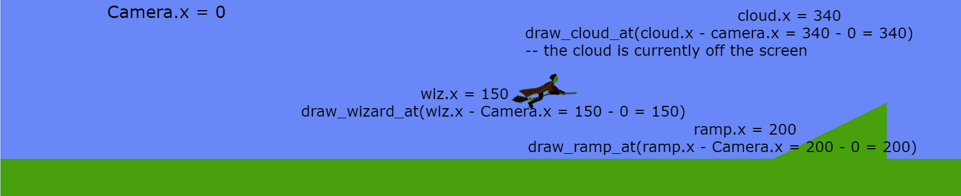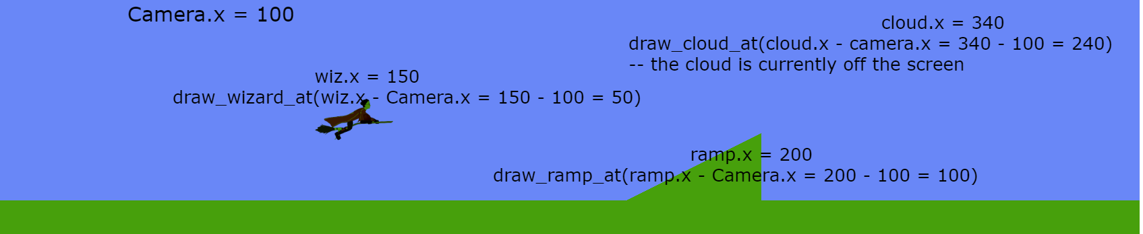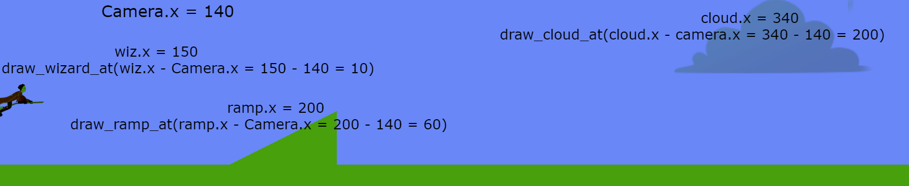

Here we change the position that we draw each of the objects at, the screen does not actually move, all the objects on the screen are just continually redrawn at a position that is further to the left.

Or we can set them to be locked on to a particular object

*Camera.x = wizard.body:getX() - love.graphics.getWidth()/2 --The subtraction is done so that the camera is centered on the wizard, instead of the wizard being at the side of the screen*

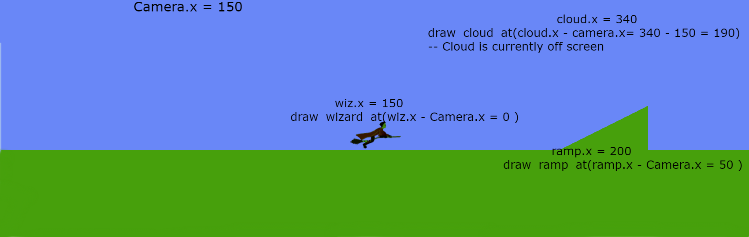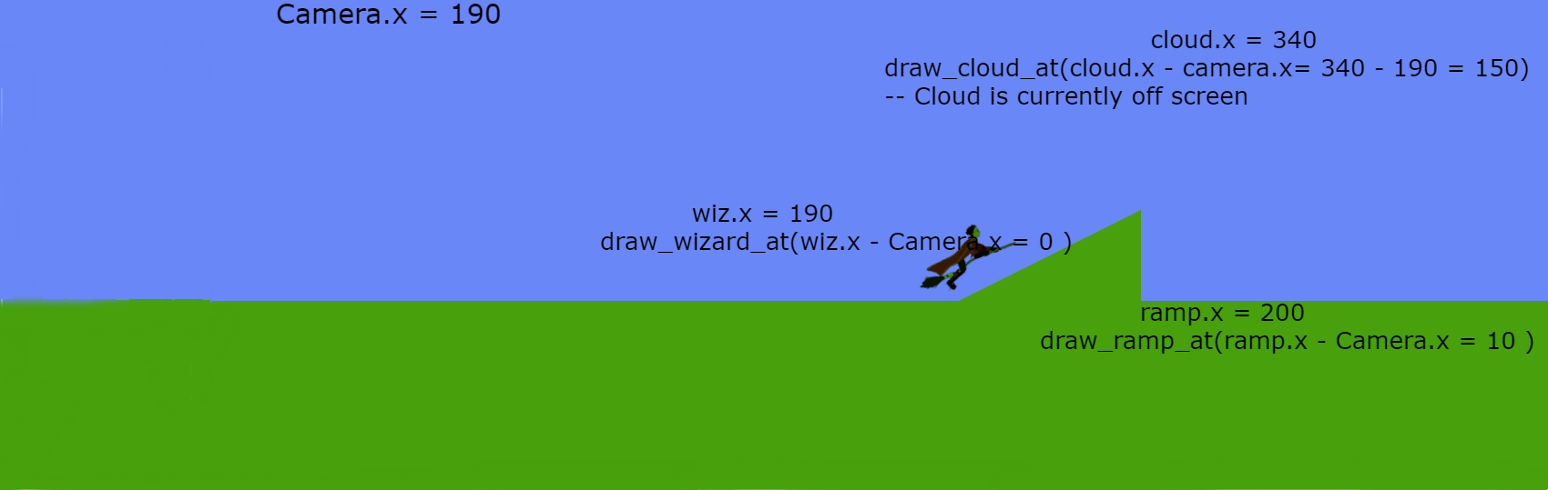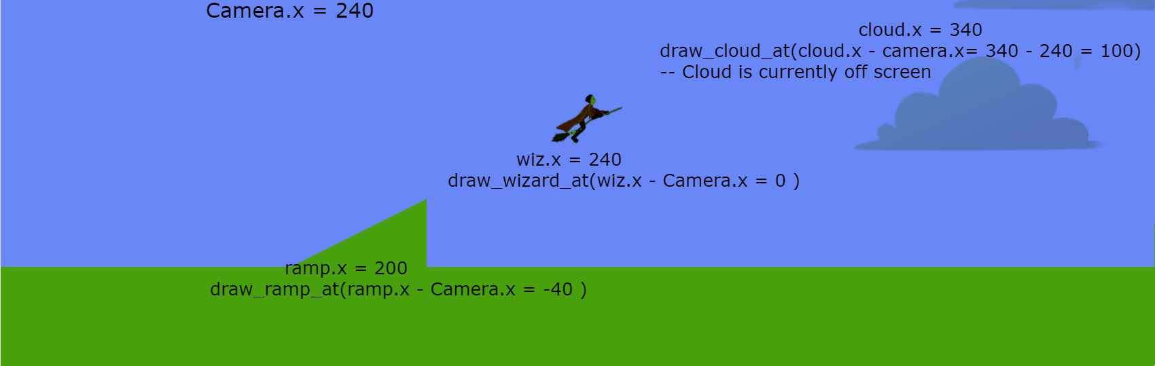

The game is set up to show the first type of movement when the game is paused, and the second type of movement when the game is not paused.

PROCEDURE:

Get the kids to open the tutorials/Camera_movement.pdf file and explain camera movment to them.

Get the kids to open the main.lua and Camer.lua files within their Quidditch folder.

**Camera Template**

The kids must edit the template so that the Camera.update function includes functionality for moving to the Camera right and down, the adjustments are specified in the comments.

They must also update the Camera:follow function so that the camera also follows the wizard vertically, the adjustments are specified in the comments.

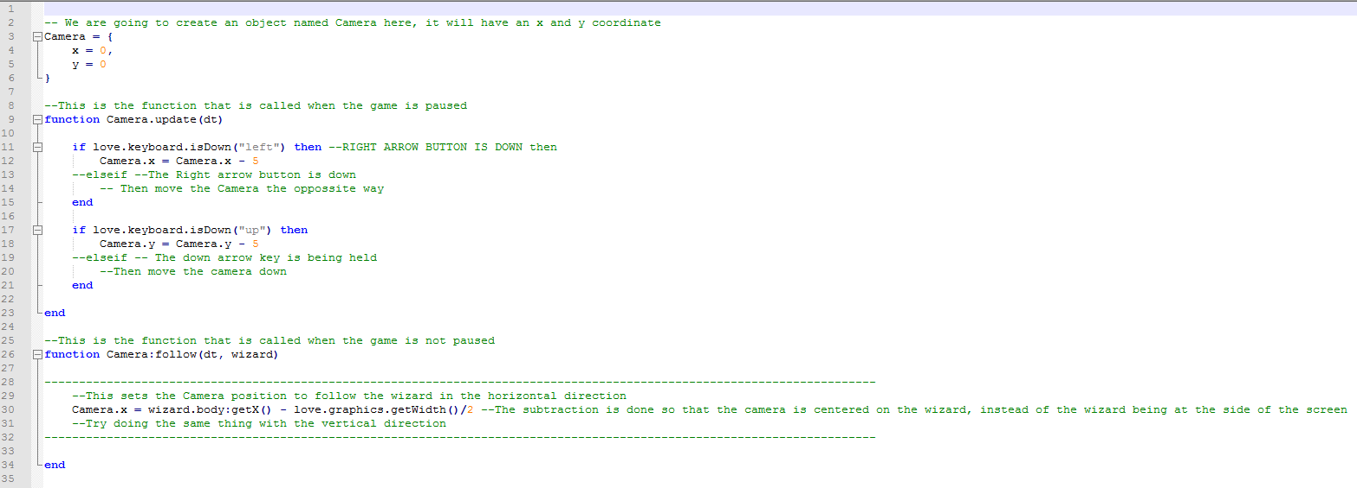

**Complete Camera Code**

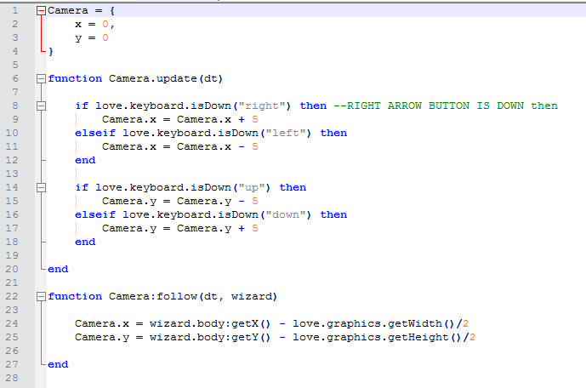

**Love.update Template**

The kids must edit the code so that a force is applied on the wizard to move right, up and down with the right, up and down arrow keys. The wizard will only move when the game is not paused.

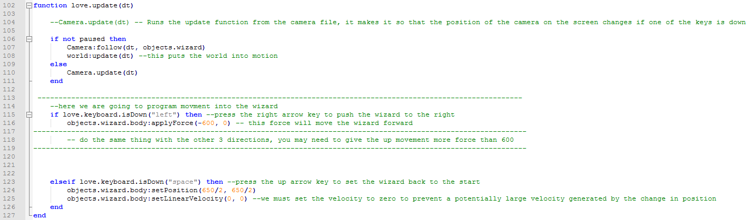

**Love.update completed code**

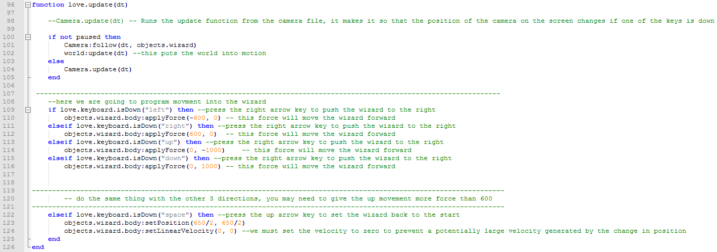

**Love.draw template**

The kids must subtract Camera.x from all the objects x coordinates, and subtract Camera.y from all the objects y coordinates. The objects include the ramps, the ground, the wizard, and the hoops. Have them test out the code after each subtraction and let them see what happens.

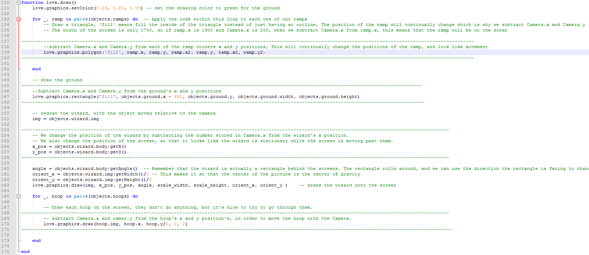

**Love.draw completed code**

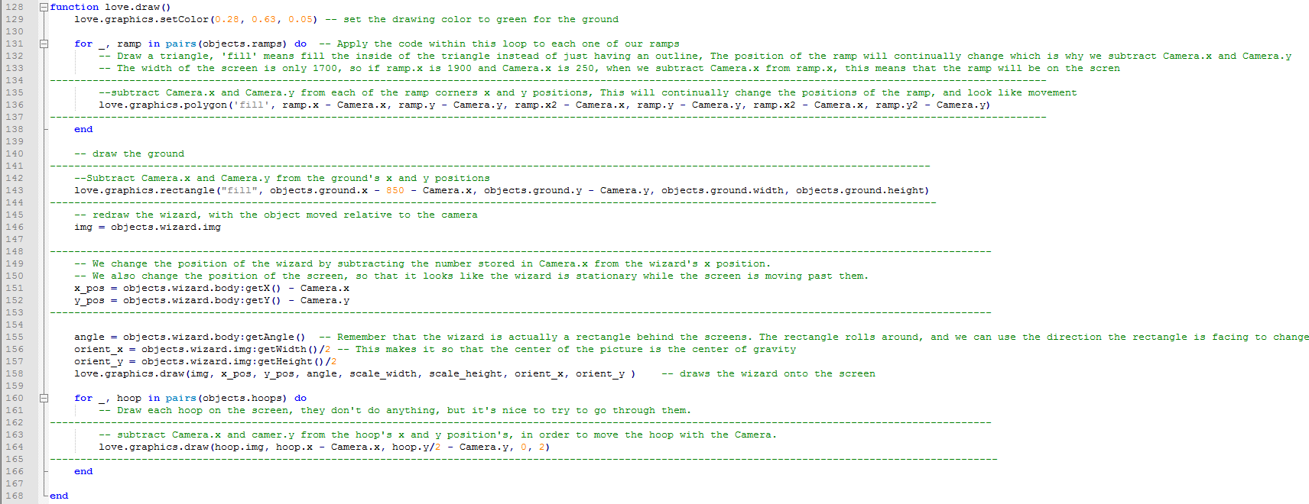

**How to use the “Love Hertz 2.0” Game Engine**

BY: Carter Hill

GRADE and CAMP: 7+

TOPIC(s):

|  |
| --- |
| TIME: 1 hour |
| Set Up & Intro = |
| Testing Substances = |
| Identify Mystery Substance = |

**MATERIALS (what you’ll need for one week of camp):**

* **One Golden Coelacanth**

**SCIENTIFIC BASIS (learning outcomes - teach this):**

Love Hertz 2.0 is a new version of the Love Hertz game engine used in last year’s Codemaker’s. It has been recoded from the ground up to dynamically use its own in-game level editor. How it works is, when the game starts up, it loops through certain image folders, and automatically creates a placeable object within the game based off its image. The image will then follow the mouse, and other placeable objects can be selected by using the scroll wheel. They can then be set into the level by clicking the primary (left) mouse button, or deleted after being placed with the secondary (right) mouse button.

This means that the kids will be able to create their own tiles and objects for the game. Once they’re shown how it works, all children will be able to easily create and play their own games. Editing the code for this game engine is not recommended, as it’s already in a working and robust state. However, they will be given two copies, so if they want to fiddle with the code, they can still have an untouched (and working) copy. We will, however, be coding our own (more basic) version over the week, and so make sure they know that more coding will be coming if they are really wanting to do that.

**PROCEDURE:**

1. On their USB stick, there will be a folder titled “LoveHertz2.0-FINAL”. Open this folder and take a look inside.
2. Within the game folder, there will be another folder called “images”. Open this folder as well. Inside, you will see, yet again, more folders. Each of these folders with create an object in the game with certain properties. Images in the “tiles” folder will need to be 64x64 pixels in size and will be placed in a grid pattern. Images place in the “static” folder will have no special properties, but can also be placed on the screen. We will worry about enemies later.

**ACTIVITY: Pinball**

BY: Sam Germain

GRADE and CAMP: Grade 7-9, Codemakers (Love 2D)

TOPIC(s): Game Developement

|  |
| --- |
| TIME: 120 mins |

OBJECTIVE: To learn how to program a pencil tool on the screen

MATERIALS:

* 😐

SCIENTIFIC BASIS (learning outcomes - teach this):

Drawing is done on the screen by connecting many lines together.

When a shape is drawn like this



It is done so by putting multiple straight lines onto the screen. Each line has 2 x coordinates and 2 y coordinates.

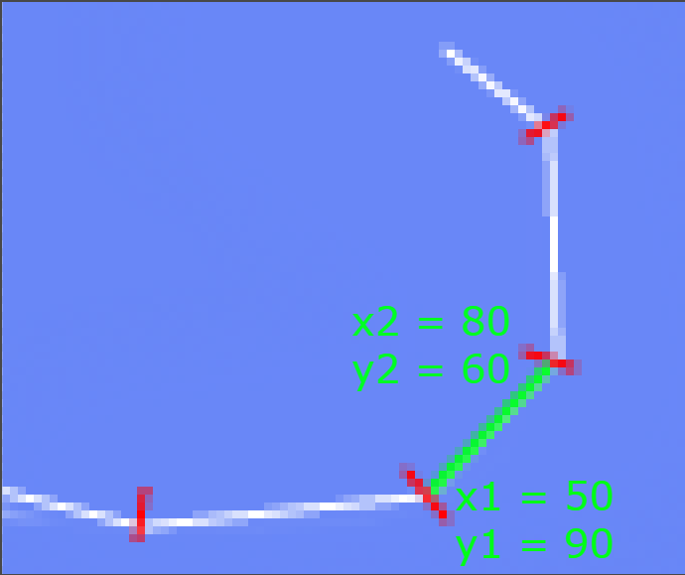

There is an example of how to draw a line within main.lua in the pinball folder. It draws a line by default within the game.

*line = {}*

*line.x1 = 1675*

*line.x2 = 1625*

*line.y1 = 100*

*line.y2 = 100*

*line.body = love.physics.newBody(world, 0, 0, "static")*

*line.shape = love.physics.newEdgeShape(line.x2, line.y2, line.x1, line.y1)*

*line.fixture = love.physics.newFixture(line.body, line.shape, 5)*

*table.insert(objects.lines,line)*

We want to draw lines only when the mouse is down. We do this with an if statement

*if love.mouse.isDown(1) then*

And obtain the x and y coordinates with functions like the following

*drawn_x = love.mouse.getX()*

But we need to have 2 x and y coordinates in order to draw a line. Because of this we have the variables *oldx* and *oldy* originally set to nil.  
After calling *love.mouse.getX()* check if oldx is set to nil

*if oldx then*

If oldx is not nil then draw a new line with drawn_x and drawn_y as the x1 and y1 coordinates, and oldx and oldy as the y1 and y2 coordinates. After the if statement set oldx and oldy to be equal to drawn_x and drawn_y, this is so you will have continuous lines.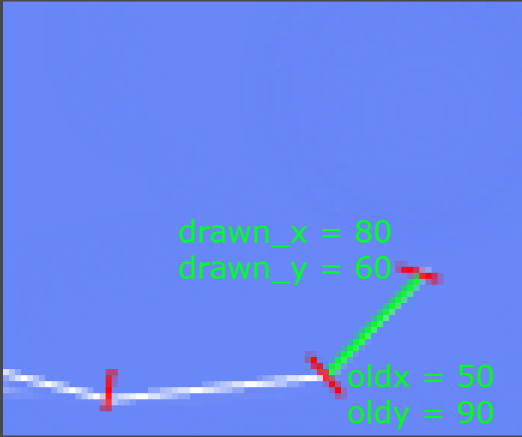

Notice how drawn_x and drawn_y in the picture above become old_x and old  
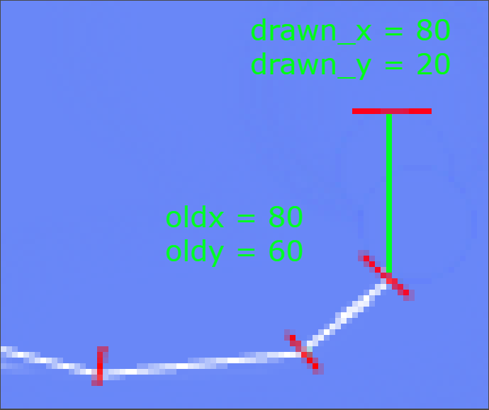

**Setting oldx and oldy to nil**

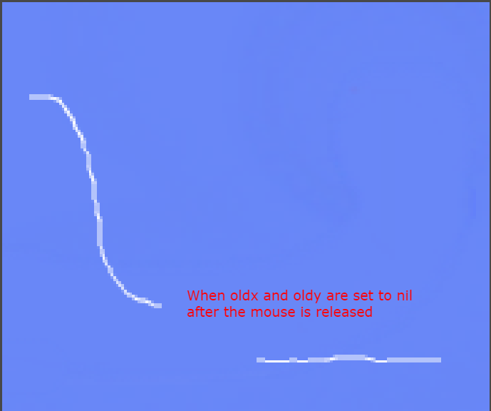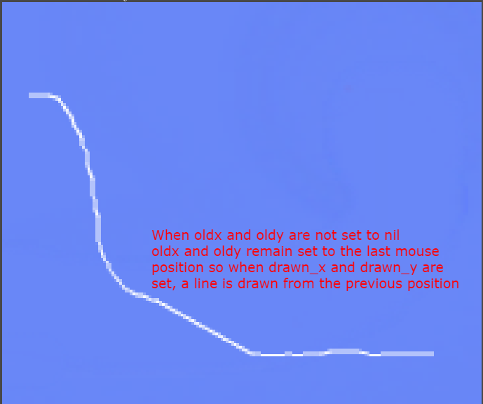

Procedure

Get the kids to open their tutorial/Drawing_Line_Objects.pdf file and explain drawing lines to them

Get the kids to open the main.lua file stored within their folder.

**Love.draw**

The kids must code a for loop that draws all the lines from objects.lines onto the screen. They can refer to the quidditch game for reference on how to draw things in a loop. There is already one line programmed in objects.lines so a line should show when you draw this.

**Love.update**

The if statement ‘*if love.mouse.isDown(1) then’* is already in the template that will be given to the kids. All of the code within the update function will be within this if statment

The variable *drawn_x* is already set to the mouses x coordinate. The kids must **set the variable drawn_y to be the y coordinate to be the mouses y coordinate.**

There is a nested if statement checking if oldx is not nil. Within this if statement there is a line object with its x coordinates set. The kids must **set the y coordinates of the line.** They must also **create a body, a shape, and a fixture** for the line, and **add the line to the list objects.lines.** They can refer to the first ball game for reference on how to do this.

Outside the nested if statement the variables oldx and oldy are set to 0. The kids must set these variable to drawn_x and drawn_y.

**ACTIVITY: Tricks that will make your game better**

BY: Sam Germain

GRADE and CAMP: Grade 7-9, Codemakers (Love 2D)

TOPIC(s): Game Developement

|  |
| --- |
| TIME: 60 mins |
| Intro = 20 mins |
| Challenges = 60 mins |
| Conclusion = 5 mins |

OBJECTIVE: To teach tricks that will make your game better

MATERIALS:

* An ethic that permits Tom Foolery

SCIENTIFIC BASIS (learning outcomes - teach this):

1. **Crucial Components of Game Design.**
2. A clear goal, or incentive to carry on.
   * In Mario we know that we have to reach the flag pole at the end of the level. In open world exploration games, we’re given a big world and a means to explore it.
3. Every game has rules, it’s literally what makes games what they are
   * A sport like hockey would be a game with tons of rules, such as getting a penalty for tripping. Another rule could even be that a team gets a point if the puck enters the opponents net. Ask the group what kind of rules Mario, or any other video game, has (things like “it is game over when you run out of lives”, or “you get hurt if you get hit by an enemy or a trap”).
4. Conveyance: how well information is communicated. What could a designer of a video game do to explain rules. Tutorials? Sometimes, but In most cases, a player should be able to understand the rules without being explicitly told much at all
   * In Mario, you know that the blocks with question marks on them have prizes. If you were the first person to play Mario ever, you would figure this out very quickly because the stand out and look very unique from the other blocks.
5. A balance in challenge. If a game is too difficult to play or understand, players will get frustrated and not enjoy it. If a game is too easy, players may get bored of it quickly, unless there is a sort of creative component to it. (The Sims would be horribly boring with only one type of floor tile or wallpaper, also Assassin’s Creed 3). Once you find that perfect balance of challenge, it’s also important to give players a sort of “break” once in a while. Having no change of pace will often begin to bore or tire players as well, so a section of easier play every half an hour or so will keep the players engaged and wondering what will come next.
   * Games will often do this by adding quick story heavy sections, or action games will often give you a puzzle to solve. That may not apply to us because we won’t be making very long games, but it’s a good knowledge to have.

PROCEDURE:

The folder \\rhubarb\admin\Outreach\SF-Instructors\Staff 2018\Camps\Codemakers- Gamedev\Destroyer_Executables contains 14 versions of the same game, each with a slight modification to it. Get the kids to open up destroyer_1 and tell them they should place their mouse behind their keyboard and that they will need the extra desk space(They actually can’t play the game without the mouse). After a minute ask “Who’s having fun!” and they’ll most likely say they don’t know what to do. Explain the first 3 principles of game design and that this game wasn’t fun because the rules and goal weren’t conveyed to you. Now tell them they actually need to use the mouse to blast the emoji. The goal of the game should be pretty clearly conveyed once they start playing with the mouse.

The first level of the game is pretty hard, and I almost gave up on it because it was so hard. I’m assuming the kids will have equal frustration but I could be wrong. Explain the 4th crucial component of Game Design and that if a game is too difficult people will get frustrated and not want to play it. Labelled on the next picture is a location of where the first shot needs to be to win the level, the game is regular difficulty after that.

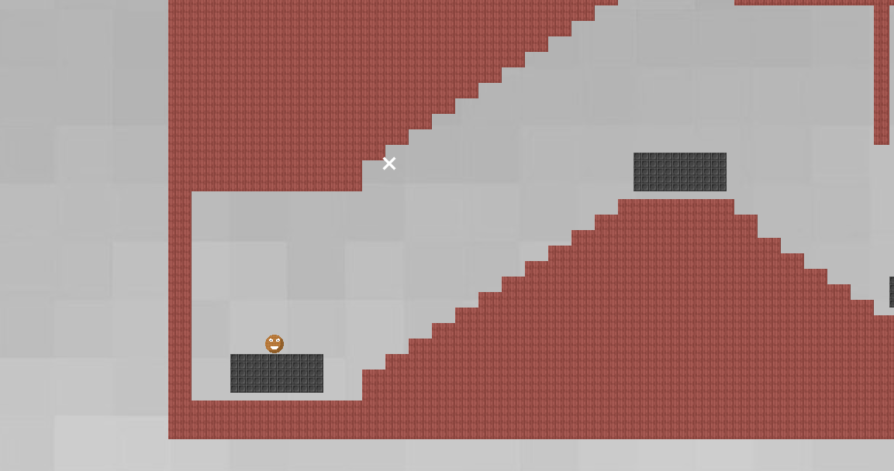

After playing with the first game for a bit, get them to open the second game, then the third, the fourth…. All of these games are the same with a small adjustment added to each one that is intended to make the game more fun. Let them play around with each game for a little bit until they understand the concept of each change. Below is an explanation of each of the changes

Destroyer_1: Basic

* The most simplified version of the destroyer game

Destroyer_2:Simple sounds effects

* When the player jumps or hits a wall you hear small sounds

Destroyer_3: Object Particles

* Shows permanence, things happen to the world when you do something to them
  + Other examples of Permanence
    1. When bullets miss you can see bullet holes in the wall
    2. Bullet Shells
    3. Smoke

Destroyer_4:Player Particles

* Shows the effect that impact has on the player with some hit animation

Destroyer_5: Explosions

* Blocks go flying and the game feels more exciting

Destroyer_6: Bigger Explosions

* There’s even more blocks and they go flying further! Why did we even have those small explosions to begin with?

Destroyer_7: Background Lag/Camera Lerp

* The Background is animated to lag slightly behind the animation of the player.

Destroyer_8: Screen shake

* The screen shakes when the player blasts. This makes the blast feel much more powerful

Destroyer_9: Motion blur

Destroyer_10: Color

* When the platforms explode the blocks from the platforms are a range of colors

Destroyer_11: More Bass

* The sound effect from the player blasting is much more bassy and the blast feels more powerful.
  + This sound effect is actually the result of 5 different blast sounds playing simultaneously.

Destroyer_12: Slow Motion

* There is a slower framerate when you lose the game.
  + Feels more epic.
  + Gives some meaning to the game.

Destroyer_13: Huge explosions

* Let’s just make the platform blocks fly all over the place!

Destroyer_14: Music

**Bonus (Some extra info if it’s wanted, but you don’t have to teach this)**

Based off this video (<https://www.youtube.com/watch?v=AJdEqssNZ-U&feature=youtu.be>)

* Contains swears, don’t show to campers

Some other tricks that will make your game better

1. Basic animations
2. Low enemy Hp
3. High rate of fire

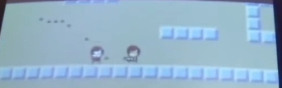

1. More enemies

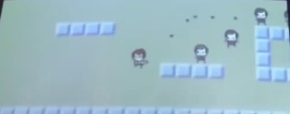

1. Bigger bullets

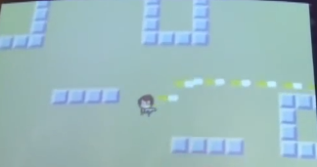

1. Muzzle Flash
   1. There is a small yellow circle around the gun when the player shoots

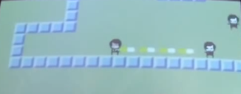

1. Faster Bullets
2. Less accuracy

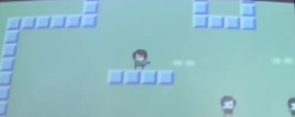

1. Impact effects
   1. That cloud is from an enemy being hit

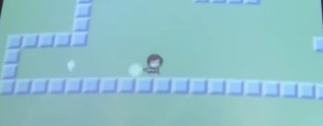

1. Hit animation
   1. That white part is the same shape as an enemy and shows them being hit.

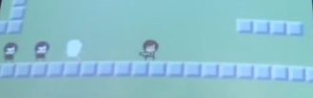

1. Enemy knockback
   1. Enemies move back when you hit them
2. Camera Position
3. Player Knockback
   1. Player moves back when shooting
4. Sleep
   1. Slight delay on impact
      1. Brain has more time to process the game when something important happens
5. Gun delay
   1. Gun lags behind character and looks like the character is carrying it
   2. Gun kicks back
6. Strafing
   1. the technique of moving the player's character from side to side, rather than forward or backward
7. Shoot multiple bullets at a time

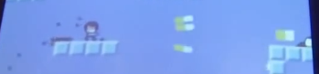

**ACTIVITY: Line Rider**

BY: Sam Germain

GRADE and CAMP: Grade 7-9, Codemakers (Love 2D)

TOPIC(s): Game Developement

|  |
| --- |
| TIME: 60 mins |
| Intro = 20 mins |
| Challenges = 60 mins |
| Conclusion = 5 mins |

OBJECTIVE: To combine the skills learned into a final project

MATERIALS:

* 😐

SCIENTIFIC BASIS (learning outcomes - teach this):

All the necessary skills have already been taught to the kids, they must use their previous code to figure out how to make this project

PROCEDURE

Get them to visit [www.linerider.com](http://www.linerider.com) and play line rider for 5 minutes or so, so they have an idea of the game that they are trying to make.

Get the kids to open the main.lua, and camera.lua files within the line_rider folder, they DO NOT need to open the eraser file(that comes later).

**Love.load()**

The 4 variables drawn_x, drawn_y, oldx and oldy must be created and initialized to 0 or nil

*drawn_x = 0 --position to be drawn on when the mouse is pressed*

*drawn_y = 0 --position to be drawn on when the mouse is pressed*

*oldx = 0*

*oldy = 0*

The Rider must be created and put into the world. The rider is actually just a rectangle, with the toboggan rider drawn overtop of the rectangle, this was coded for the kids in the quidditch game, although the kids did not code it themselves. Friction should be set to 0, so that the rider can do loops and stuff. The kids have not learned how to do this, but it’s in the comments.

*objects.rider = {}*

*objects.rider.body = love.physics.newBody(world, 650/2, 0, "dynamic")*

*objects.rider.width = 40*

*objects.rider.height = 30*

*objects.rider.shape = love.physics.newRectangleShape(objects.rider.width, objects.rider.height)*

*objects.rider.fixture = love.physics.newFixture(objects.rider.body, objects.rider.shape) objects.rider.fixture:setFriction(0.0)*

*objects.rider.img = love.graphics.newImage("images/tobboggan.png")*

**love.update()**

The if not pause if statement must be modified to include both of the Camera functions

*if not pause then*

*world:update(dt) --this puts the world into motion*

*Camera:follow(dt,objects.rider)*

*else*

*Camera.update(dt)*

*End*

Code must be put in to draw a line if the mouse is down. This can basically just be copied from the pinball game, but Camera.x and Camera.y must be subtracted from drawn_x and drawn_y

*if love.mouse.isDown(1) then*

*drawn_x = love.mouse.getX() + Camera.x --x coordinate of the mouse*

*drawn_y = love.mouse.getY() + Camera.y --y coordinate of the mouse*

*if oldx ~= nil then*

*line = {}*

*line.x1 = oldx*

*line.x2 = drawn_x*

*line.y1 = oldy*

*line.y2 = drawn_y*

*line.body = love.physics.newBody(world, 0, 0, "static")*

*line.shape = love.physics.newEdgeShape(drawn_x, drawn_y, oldx, oldy)*

*line.fixture = love.physics.newFixture(line.body, line.shape, 5)*

*table.insert(objects.lines, line)*

*end*

*oldx = drawn_x*

*oldy = drawn_y*

*else*

*oldx = nil*

*oldy = nil*

*end*

**love.draw()**

The rider must be drawn. The angle variable makes it so that the rider image turns in accordance with the way the rectangle is facing, so when the top of the rectangle is facing down, the top of the rider image is facing down. Orient_x and Orient_y set the center of rotation for the image. When Orient_x and Orient_y are set to the top left corner, the image does not touch the surface it’s resting on when upside down.

*rider_img = objects.rider.img*

*rider_x = objects.rider.body:getX() - Camera.x*

*rider_y = objects.rider.body:getY() - Camera.y*

*rider_angle = objects.rider.body:getAngle()*

*orient_x = objects.rider.img:getWidth()/2*

*orient_y = objects.rider.img:getHeight()/2*

*love.graphics.draw(rider_img, rider_x, rider_y, rider_angle, 1, 1, orient_x, orient_y )*

They must draw the lines that are drawn on the screen. This is done exactly like the pinball game but Camera.x and Camera.y must be subtracted from the lines x and y coordinates

*for _, line in pairs(objects.lines) do*

*love.graphics.line( line.x1 - Camera.x, line.y1 - Camera.y, line.x2 - Camera.x, line.y2 - Camera.y)*

*end*

**Camera.lua**

**For the four day camp, they did not do the quidditch exercise, so the camera is coded for them mostly. They will have to subtract Camera.x and Camera.y from their other objects however, so explain a little bit about the camera, just so they kind of understand why they have to subtract it.

The Camera object exists as an empty object

*Camera = {}*

X and y coordinates for camera must be created and set to 0

*Camera = {*

*x = 0,*

*y = 0*

*}*

**Camera.update**

The actions for the arrow keys must be coded into camera.update. This includes adding and subtracting from Camera.x and Camera.y if an arrow is being pressed. This function only operates when the game is paused.

*if love.keyboard.isDown("right") then --RIGHT ARROW BUTTON IS DOWN then*

*Camera.x = Camera.x + 5*

*elseif love.keyboard.isDown("left") then*

*Camera.x = Camera.x - 5*

*end*

*if love.keyboard.isDown("up") then*

*Camera.y = Camera.y - 5*

*elseif love.keyboard.isDown("down") then*

*Camera.y = Camera.y + 5*

*end*

**Camera.follow**

When the game is not paused, the camera.follow function is used to set Camera.x and Camera.y to the coordinates of the rider.

*Camera.x = rider.body:getX() - love.graphics.getWidth()/2*

*Camera.y = rider.body:getY() - love.graphics.getHeight()/2*

**The eraser can be coded after this, or just given to the kids if there is no more time. There is a separate write up for the eraser, with what to do if there is more time or if there is no more time.**

**ACTIVITY: Line Rider Eraser**

BY: Sam Germain

GRADE and CAMP: Grade 7-9, Codemakers (Love 2D)

TOPIC(s): Game Developement

|  |
| --- |
| TIME: 60 mins |

OBJECTIVE: To put the eraser into line rider

MATERIALS:

* 😐

SCIENTIFIC BASIS (learning outcomes - teach this):

The eraser will be coded in the work on the right click of the mouse. A variable, which we will call erase_x and erase_y will be assigned to the x and y coordinates of the mouse we the mouse is held down. We need to loop through each of our lines and check if the line spans over the spot we are trying to erase. The pictures below explain the four scenario’s where a line would span over the spot we are trying to erase.

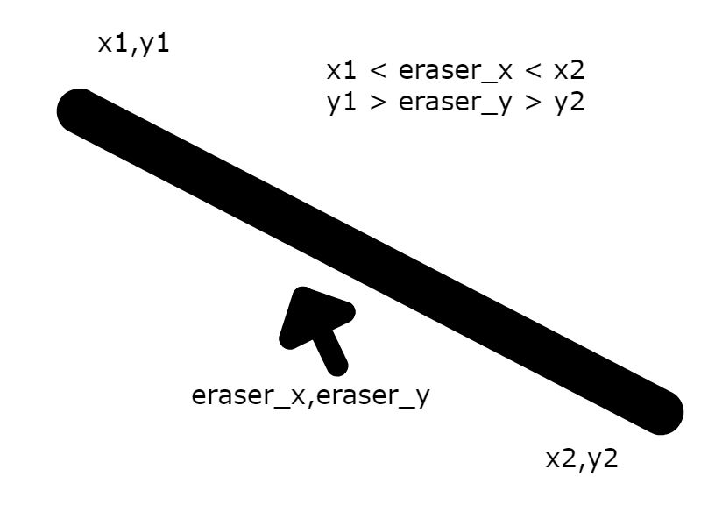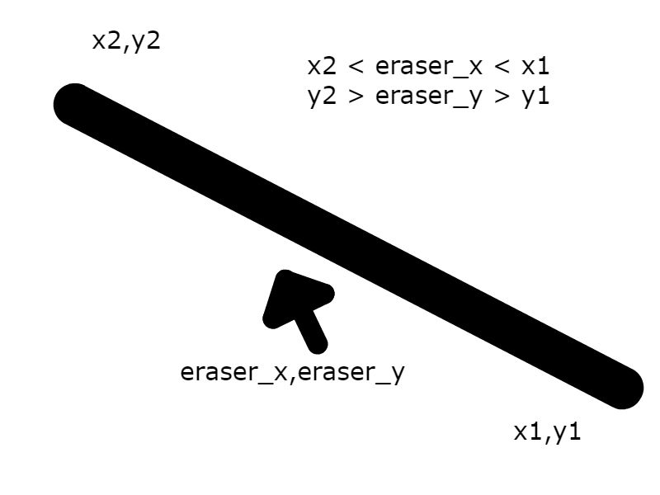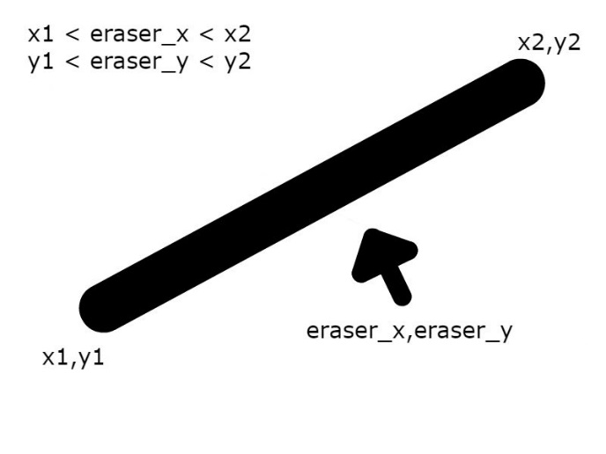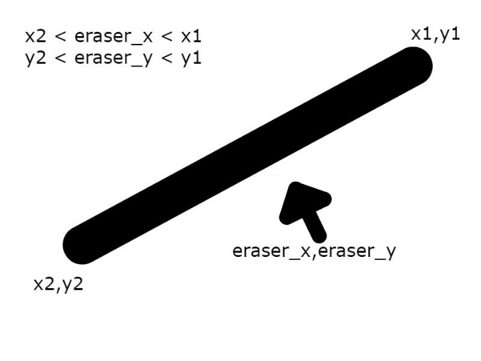

**Indices**

The code is in there for them, but here’s an explanation of whats going on.  
Each line also has an index in a table. The first line segment is the first one in the table, and the second line segement is the second line in the table. If we set a line_counter to 0, loop through objects.lines, and increase line_counter by 1 every time we execute the loop, then line_counter is always the index of the line we’re looking at.

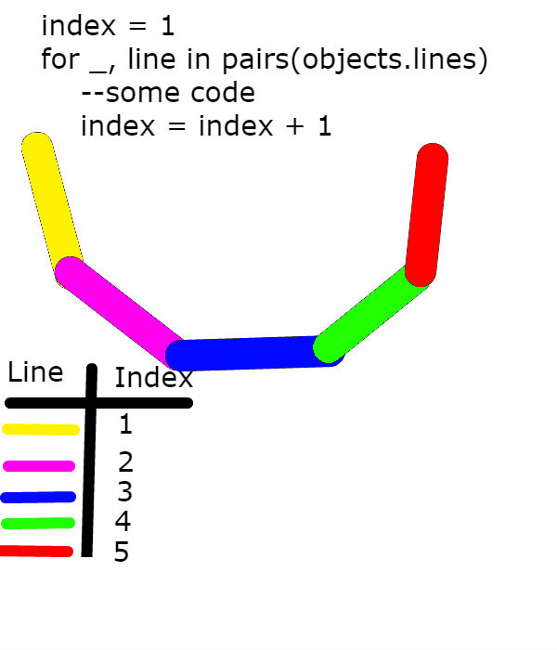

From this image, we can see that when looping through all our lines, when we are on our first line, the index is equal to 1, when we are on our second line, the index is equal to 2, so if we delete the line with index 2, we are deleting the purple line.

PROCEDURE

If there is no more time

* give the kids the eraser.lua file
* put require(“eraser”) at the top of main.lua
* put erase() into draw.update()

Otherwise

* they must edit their eraser.lua file so that it works as an actual eraser
* if the eraser is within the range of the line, I use line.body:setType("dynamic") to make the line fall, this doesn’t actual delete the line, but the line won’t interfere with the game anymore
* Using table.remove(objects.lines, Line_index) is a comment in the file. If they uncomment this and place it in the correct nest, then the line should no longer be drawn.
* put require(“eraser”) at the top of main.lua
* put erase() into draw.update()

**ACTIVITY: Game’s To Usb’s/Line Rider Comparison**

BY: Sam Germain

GRADE and CAMP: Grade 7-9, Codemakers (Love 2D)

TOPIC(s): Game Developement

|  |
| --- |
| TIME: 60 mins |

OBJECTIVE: To get games onto usb. Also to compare the line rider they built to the official line rider and try to get the kids thinking about how they would put the extra features in.

MATERIALS:

* | (• ◡•)| (❍ᴥ❍ʋ)

SCIENTIFIC BASIS (learning outcomes - teach this):

PROCEDURE:

* Get the kids to open their How_to_put_games_onto_usb_sticks.pdf file. They can follow the instructions within this pdf to get their games onto usbs.
* If there is time get them to visit [www.linerider.com](http://www.linerider.com) and see the differences in this line rider. Try to get them to figure out what kind of programming they could do to achieve these distances.
  + For the red lines some code could be written that would be something like, if the rider is on the line, applyForce to the rider
  + For the green lines, you could have an if statement checking if green is true, and if it is, exclude creating a fixture for those line objects
  + When the line rider falls off the sled, you could have an if that checks the angle and position of the rider and if the angle is a certain value when the rider hits the line, then you create 2 objects(one rider and one sled) to replace the previous object and sled.
  + For the arms and legs, you can create multiple rectangles that must stay attached to eachother, but each will have their own center of gravity…