**ACTIVITY: First Game**

BY: Sam Germain

GRADE and CAMP: Grade 7-9, Codemakers (Love 2D)

TOPIC(s): Game Developement

|  |
| --- |
| TIME: 120 mins |

OBJECTIVE: To create our first game

MATERIALS:

* ᕙ(░ಥ╭͜ʖ╮ಥ░)━☆ﾟ.*･｡ﾟ

SCIENTIFIC BASIS (learning outcomes - teach this):

Games in love2d have 3 main functions. Love.load, love.update, and love.draw. Love.load is the function that operates when the game starts, it puts everything into the game that is there at the beginning.  
Love.update records input from the user and determines what changes are to be made to the game.

Love.draw gives the output of the game to the user, it shows the display.

Love.physics: Love.physics is used to create objects that can interact with eachother. Objects can be static(fixated on the screen), or dynamic(move around). When a dynamic object hits a static object, it deflects off of it, in this way, collision detection is taken care of for us.

We will give the kids a template for the world that the game exists in. The template sets the   
Each object has a minimum of 3 attributes

* Body: Determines where the object exists within the frame and whether the object is static or dynamic.
  + Ex: objects.ball.body = love.physics.newBody(world, 1700/2, 1000/2, "dynamic")
* Shape: Determines the shape of the object
  + Ex: objects.ball.shape = love.physics.newCircleShape(20)
* Fixture: Puts the object in the game world
  + objects.ball.fixture = love.physics.newFixture(objects.ball.body, objects.ball.shape, 1)

Objects: Objects are nothing more than a simple way of organising information. We are going to create 3 objects. 1 object is already created.  
  
PROCEDURE:

**Love.load**

1. Get the kids to open their template for the first game. If they drag it over love.exe as is it should display a blue screen.
2. The first thing you’ll do is change the width of the ground from 200 to 1700.  
   *objects.ground.shape = love.physics.newRectangleShape(1700, 50)*

At 1700 if the ball falls off the screen then it falls infinitely, because there is no ground that exists outside the screen. If you change it to 25000, the ball still has something to fall on if it rolls off the screen, even though you can’t see it. They can open **tutorials/Ground_width.pdf** to view the photo’s below.

**Ground Width: 200**

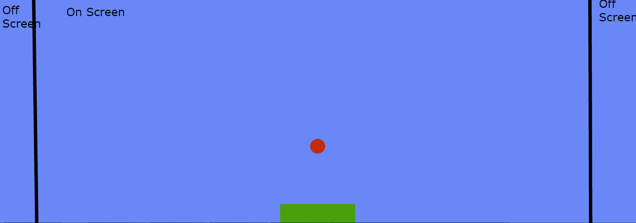

**Ground Width: 1700**

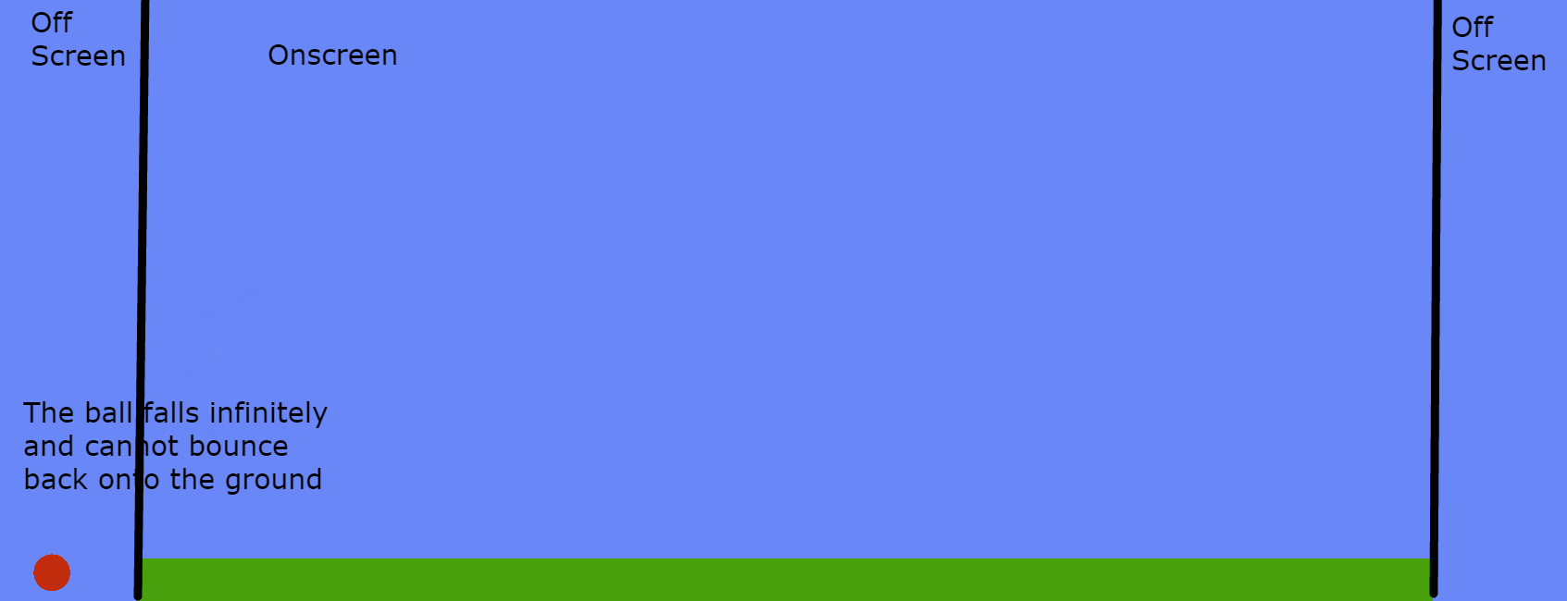

**Ground Width: 25000**

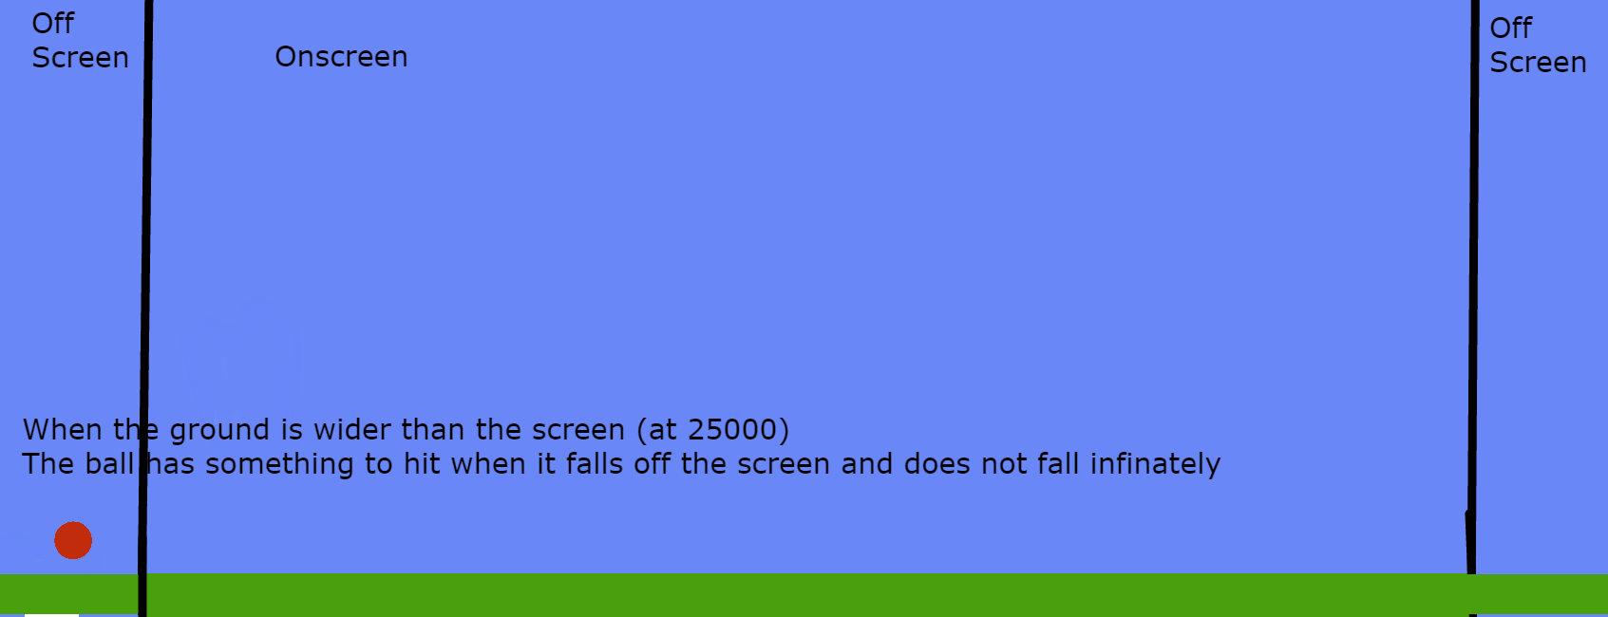

1. Fill in the right hand values for the ball object. The template should match the complete version by the end. The comments specify what the values should be for the ball. They should be able to use the code for how the ground was made as a reference for how to code the ball.
2. Code the left and right hand sides for the blocks that the ball will bounce against. The code is almost identical to the two objects created before and the comments specify what to do.

**Love.update**

1. Code instructions for the ball to move when the left arrow key is hit, the right arrow key is already coded

**Love.draw**

1. Uncomment the lines in love.draw that draw the shapes on the screen
2. Change the color of the ball to red. There is a commented out line for love.graphics.setcolor. They will have to uncomment this line and fill in the values specified in the comments. A few lines above they can see the code that was used to do this earlier.

**Template**

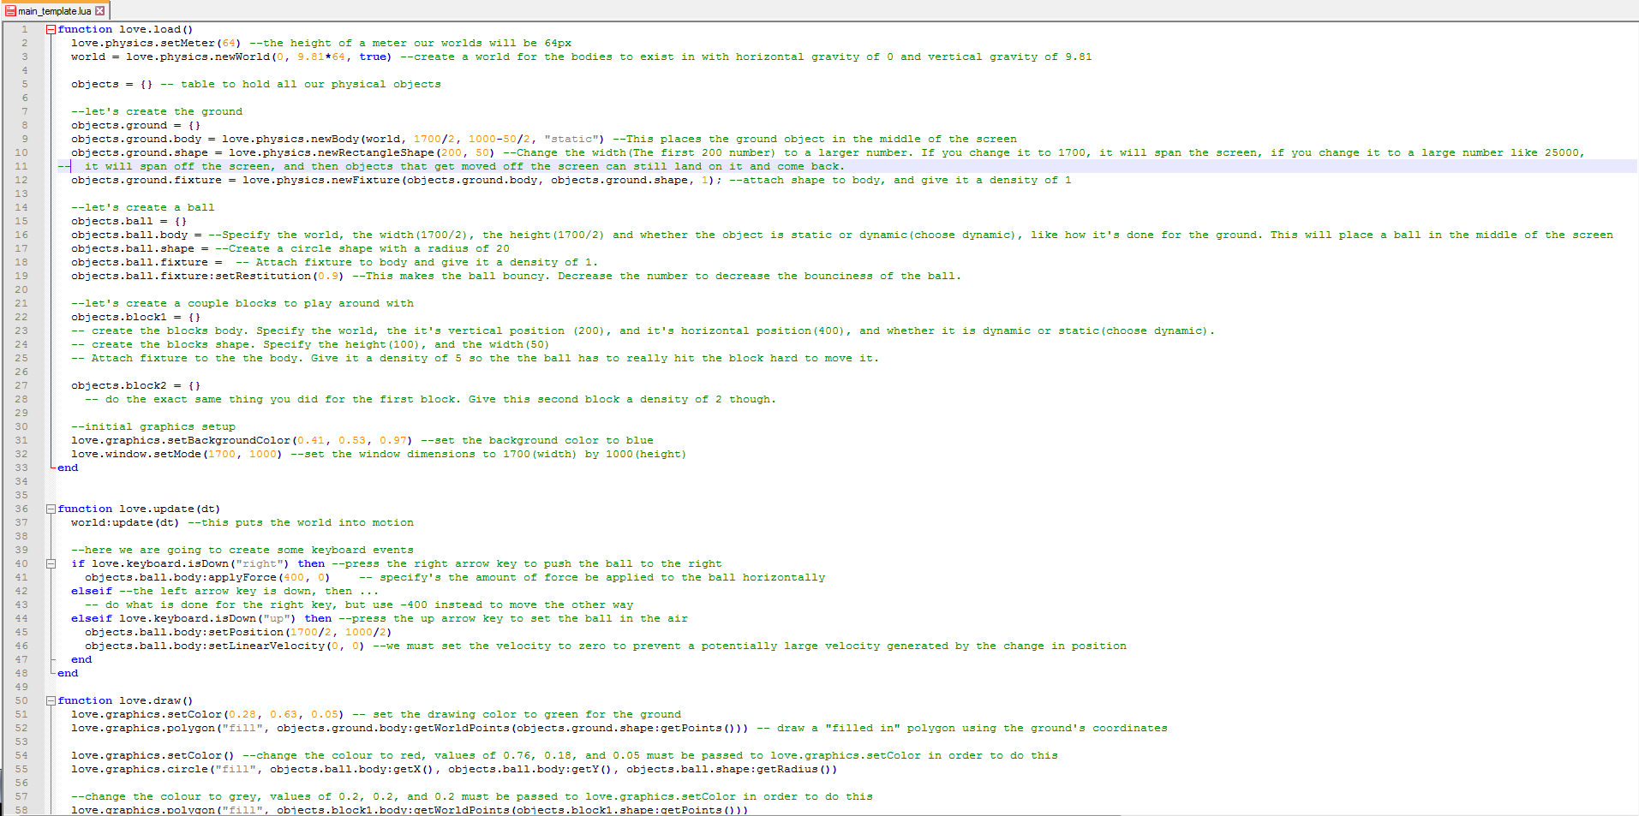

**Complete Code**

