**ACTIVITY: Tricks that will make your game better**

BY: Sam Germain

GRADE and CAMP: Grade 7-9, Codemakers (Love 2D)

TOPIC(s): Game Developement

|  |
| --- |
| TIME: 60 mins |
| Intro = 20 mins |
| Challenges = 60 mins |
| Conclusion = 5 mins |

OBJECTIVE: To teach tricks that will make your game better

MATERIALS:

* An ethic that permits Tom Foolery

SCIENTIFIC BASIS (learning outcomes - teach this):

1. **Crucial Components of Game Design.**
2. A clear goal, or incentive to carry on.
   * In Mario we know that we have to reach the flag pole at the end of the level. In open world exploration games, we’re given a big world and a means to explore it.
3. Every game has rules, it’s literally what makes games what they are
   * A sport like hockey would be a game with tons of rules, such as getting a penalty for tripping. Another rule could even be that a team gets a point if the puck enters the opponents net. Ask the group what kind of rules Mario, or any other video game, has (things like “it is game over when you run out of lives”, or “you get hurt if you get hit by an enemy or a trap”).
4. Conveyance: how well information is communicated. What could a designer of a video game do to explain rules. Tutorials? Sometimes, but In most cases, a player should be able to understand the rules without being explicitly told much at all
   * In Mario, you know that the blocks with question marks on them have prizes. If you were the first person to play Mario ever, you would figure this out very quickly because the stand out and look very unique from the other blocks.
5. A balance in challenge. If a game is too difficult to play or understand, players will get frustrated and not enjoy it. If a game is too easy, players may get bored of it quickly, unless there is a sort of creative component to it. (The Sims would be horribly boring with only one type of floor tile or wallpaper, also Assassin’s Creed 3). Once you find that perfect balance of challenge, it’s also important to give players a sort of “break” once in a while. Having no change of pace will often begin to bore or tire players as well, so a section of easier play every half an hour or so will keep the players engaged and wondering what will come next.
   * Games will often do this by adding quick story heavy sections, or action games will often give you a puzzle to solve. That may not apply to us because we won’t be making very long games, but it’s a good knowledge to have.

PROCEDURE:

The folder \\rhubarb\admin\Outreach\SF-Instructors\Staff 2018\Camps\Codemakers- Gamedev\Destroyer_Executables contains 14 versions of the same game, each with a slight modification to it. Get the kids to open up destroyer_1 and tell them they should place their mouse behind their keyboard and that they will need the extra desk space(They actually can’t play the game without the mouse). After a minute ask “Who’s having fun!” and they’ll most likely say they don’t know what to do. Explain the first 3 principles of game design and that this game wasn’t fun because the rules and goal weren’t conveyed to you. Now tell them they actually need to use the mouse to blast the emoji. The goal of the game should be pretty clearly conveyed once they start playing with the mouse.

The first level of the game is pretty hard, and I almost gave up on it because it was so hard. I’m assuming the kids will have equal frustration but I could be wrong. Explain the 4th crucial component of Game Design and that if a game is too difficult people will get frustrated and not want to play it. Labelled on the next picture is a location of where the first shot needs to be to win the level, the game is regular difficulty after that.

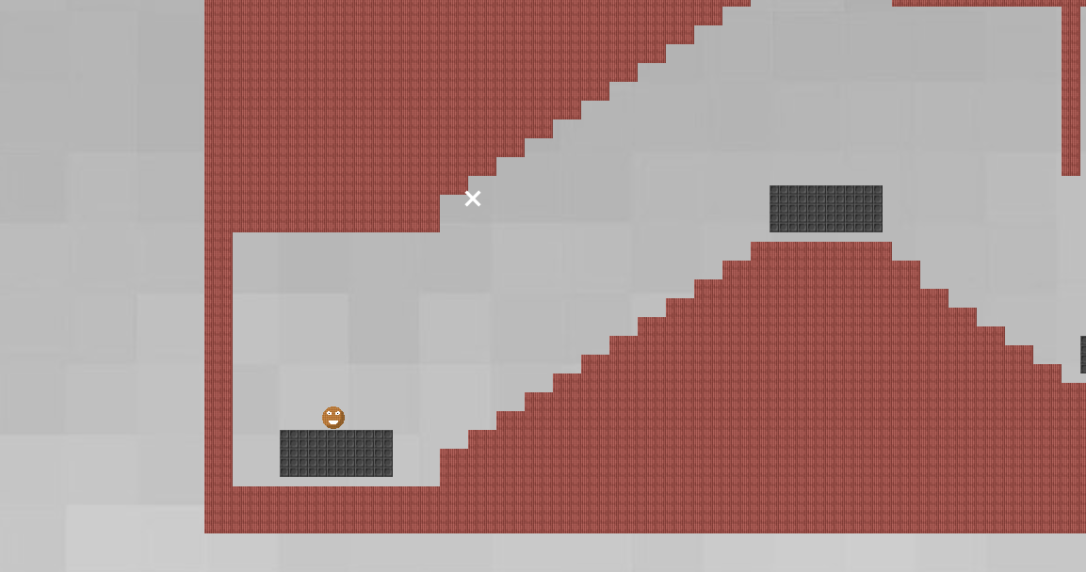

After playing with the first game for a bit, get them to open the second game, then the third, the fourth…. All of these games are the same with a small adjustment added to each one that is intended to make the game more fun. Let them play around with each game for a little bit until they understand the concept of each change. Below is an explanation of each of the changes

Destroyer_1: Basic

* The most simplified version of the destroyer game

Destroyer_2:Simple sounds effects

* When the player jumps or hits a wall you hear small sounds

Destroyer_3: Object Particles

* Shows permanence, things happen to the world when you do something to them
  + Other examples of Permanence
    1. When bullets miss you can see bullet holes in the wall
    2. Bullet Shells
    3. Smoke

Destroyer_4:Player Particles

* Shows the effect that impact has on the player with some hit animation

Destroyer_5: Explosions

* Blocks go flying and the game feels more exciting

Destroyer_6: Bigger Explosions

* There’s even more blocks and they go flying further! Why did we even have those small explosions to begin with?

Destroyer_7: Background Lag/Camera Lerp

* The Background is animated to lag slightly behind the animation of the player.

Destroyer_8: Screen shake

* The screen shakes when the player blasts. This makes the blast feel much more powerful

Destroyer_9: Motion blur

Destroyer_10: Color

* When the platforms explode the blocks from the platforms are a range of colors

Destroyer_11: More Bass

* The sound effect from the player blasting is much more bassy and the blast feels more powerful.
  + This sound effect is actually the result of 5 different blast sounds playing simultaneously.

Destroyer_12: Slow Motion

* There is a slower framerate when you lose the game.
  + Feels more epic.
  + Gives some meaning to the game.

Destroyer_13: Huge explosions

* Let’s just make the platform blocks fly all over the place!

Destroyer_14: Music

**Bonus (Some extra info if it’s wanted, but you don’t have to teach this)**

Based off this video (<https://www.youtube.com/watch?v=AJdEqssNZ-U&feature=youtu.be>)

* Contains swears, don’t show to campers

Some other tricks that will make your game better

1. Basic animations
2. Low enemy Hp
3. High rate of fire

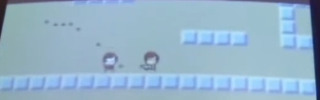

1. More enemies

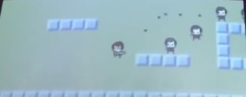

1. Bigger bullets

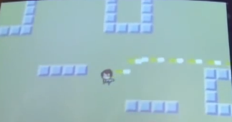

1. Muzzle Flash
   1. There is a small yellow circle around the gun when the player shoots

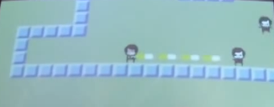

1. Faster Bullets
2. Less accuracy

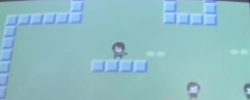

1. Impact effects
   1. That cloud is from an enemy being hit

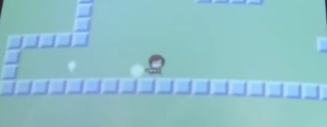

1. Hit animation
   1. That white part is the same shape as an enemy and shows them being hit.

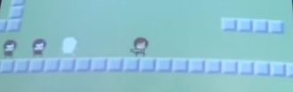

1. Enemy knockback
   1. Enemies move back when you hit them
2. Camera Position
3. Player Knockback
   1. Player moves back when shooting
4. Sleep
   1. Slight delay on impact
      1. Brain has more time to process the game when something important happens
5. Gun delay
   1. Gun lags behind character and looks like the character is carrying it
   2. Gun kicks back
6. Strafing
   1. the technique of moving the player's character from side to side, rather than forward or backward
7. Shoot multiple bullets at a time

