**ACTIVITY: Line Rider Eraser**

BY: Sam Germain

GRADE and CAMP: Grade 7-9, Codemakers (Love 2D)

TOPIC(s): Game Developement

|  |
| --- |
| TIME: 60 mins |

OBJECTIVE: To put the eraser into line rider

MATERIALS:

* 😐

SCIENTIFIC BASIS (learning outcomes - teach this):

The eraser will be coded in the work on the right click of the mouse. A variable, which we will call erase_x and erase_y will be assigned to the x and y coordinates of the mouse we the mouse is held down. We need to loop through each of our lines and check if the line spans over the spot we are trying to erase. The pictures below explain the four scenario’s where a line would span over the spot we are trying to erase.

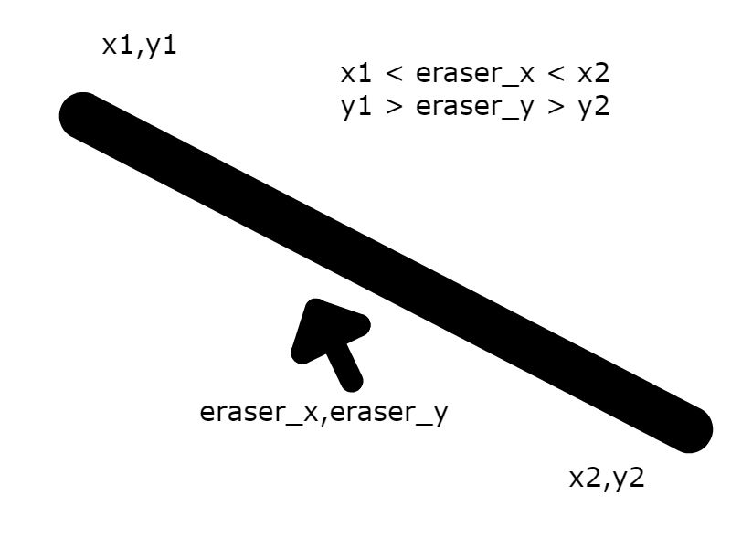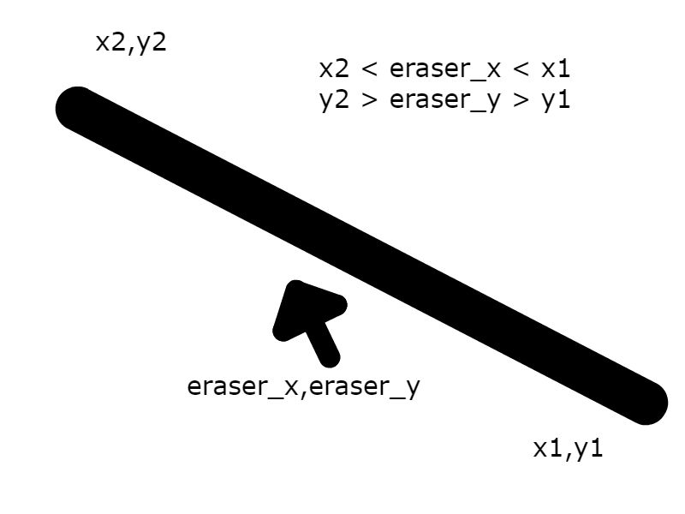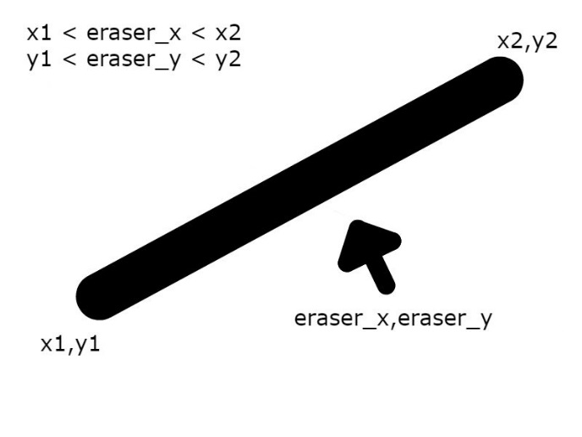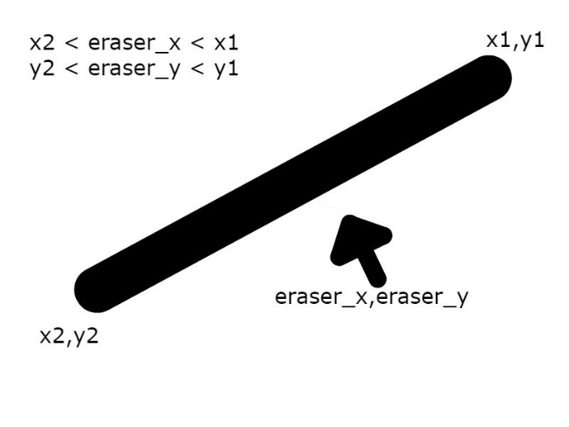

**Indices**

The code is in there for them, but here’s an explanation of whats going on.  
Each line also has an index in a table. The first line segment is the first one in the table, and the second line segement is the second line in the table. If we set a line_counter to 0, loop through objects.lines, and increase line_counter by 1 every time we execute the loop, then line_counter is always the index of the line we’re looking at.

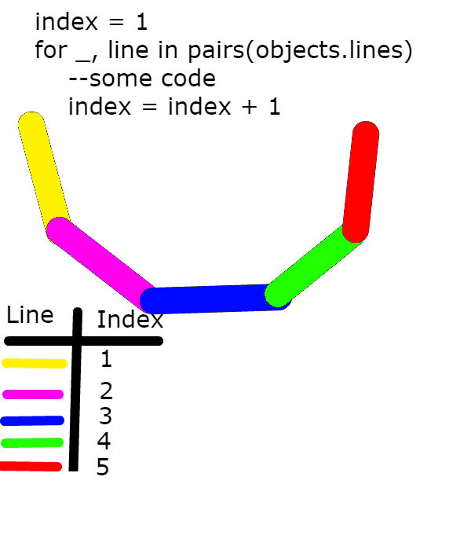

From this image, we can see that when looping through all our lines, when we are on our first line, the index is equal to 1, when we are on our second line, the index is equal to 2, so if we delete the line with index 2, we are deleting the purple line.

PROCEDURE

If there is no more time

* give the kids the eraser.lua file
* put require(“eraser”) at the top of main.lua
* put erase() into draw.update()

Otherwise

* they must edit their eraser.lua file so that it works as an actual eraser
* if the eraser is within the range of the line, I use line.body:setType("dynamic") to make the line fall, this doesn’t actual delete the line, but the line won’t interfere with the game anymore
* Using table.remove(objects.lines, Line_index) is a comment in the file. If they uncomment this and place it in the correct nest, then the line should no longer be drawn.
* put require(“eraser”) at the top of main.lua
* put erase() into draw.update()