**ACTIVITY: Pinball**

BY: Sam Germain

GRADE and CAMP: Grade 7-9, Codemakers (Love 2D)

TOPIC(s): Game Developement

|  |
| --- |
| TIME: 60 mins |
| Intro = 20 mins |
| Challenges = 60 mins |
| Conclusion = 5 mins |

OBJECTIVE: To learn how to program a pencil tool on the screen

MATERIALS:

* 😐

SCIENTIFIC BASIS (learning outcomes - teach this):

Drawing is done on the screen by connecting many lines together.

When a shape is drawn like this



It is done so by putting multiple straight lines onto the screen. Each line has 2 x coordinates and 2 y coordinates.

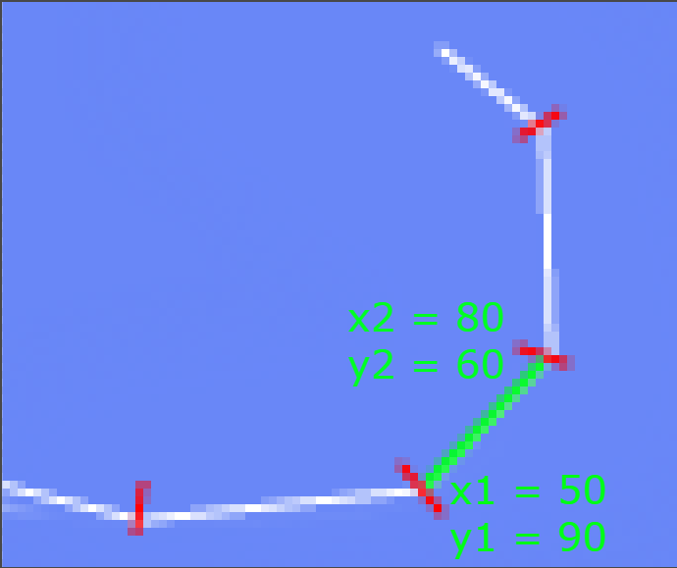

There is an example of how to draw a line within main.lua in the pinball folder. It draws a line by default within the game.

*line = {}*

*line.x1 = 1675*

*line.x2 = 1625*

*line.y1 = 100*

*line.y2 = 100*

*line.body = love.physics.newBody(world, 0, 0, "static")*

*line.shape = love.physics.newEdgeShape(line.x2, line.y2, line.x1, line.y1)*

*line.fixture = love.physics.newFixture(line.body, line.shape, 5)*

*table.insert(objects.lines,line)*

We want to draw lines only when the mouse is down. We do this with an if statement

*if love.mouse.isDown(1) then*

And obtain the x and y coordinates with functions like the following

*drawn_x = love.mouse.getX()*

But we need to have 2 x and y coordinates in order to draw a line. Because of this we have the variables *oldx* and *oldy* originally set to nil.  
After calling *love.mouse.getX()* check if oldx is set to nil

*if oldx then*

If oldx is not nil then draw a new line with drawn_x and drawn_y as the x1 and y1 coordinates, and oldx and oldy as the y1 and y2 coordinates. After the if statement set oldx and oldy to be equal to drawn_x and drawn_y, this is so you will have continuous lines.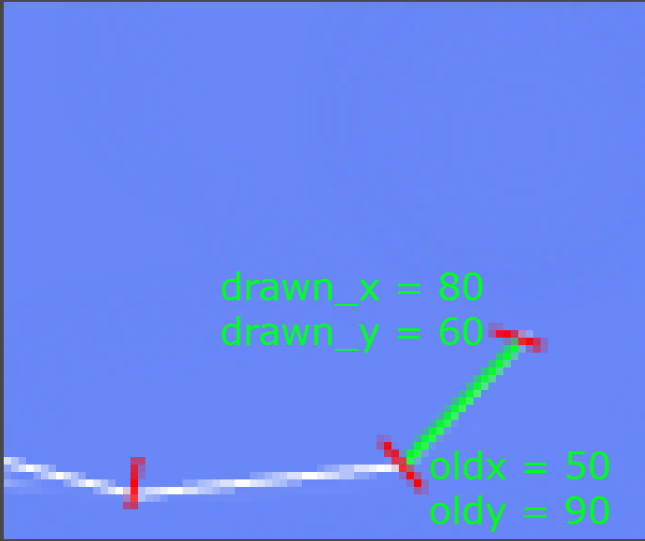

Notice how drawn_x and drawn_y in the picture above become old_x and old  
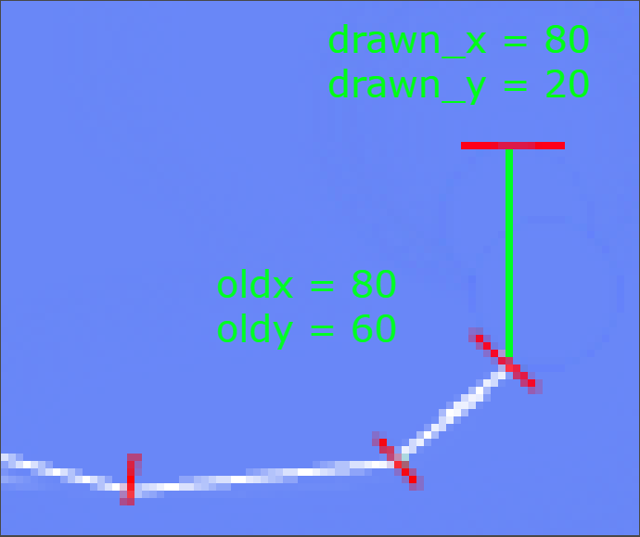

**Setting oldx and oldy to nil**

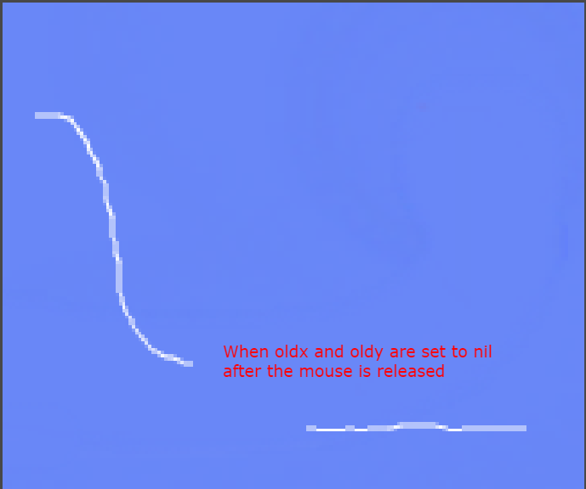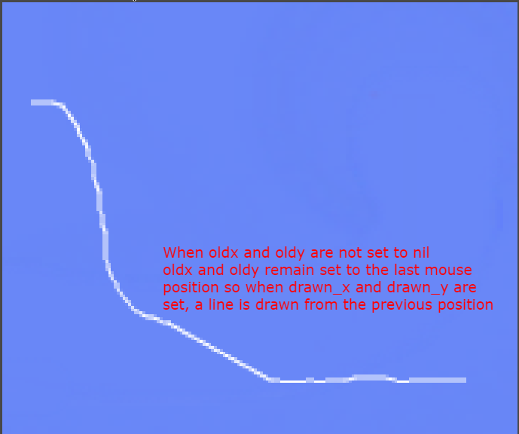

Procedure

Get the kids to open their tutorial/Drawing_Line_Objects.pdf file and explain drawing lines to them

Get the kids to open the main.lua file stored within their folder.

**Love.draw**

The kids must code a for loop that draws all the lines from objects.lines onto the screen. They can refer to the quidditch game for reference on how to draw things in a loop. There is already one line programmed in objects.lines so a line should show when you draw this.

**Love.update**

The if statement ‘*if love.mouse.isDown(1) then’* is already in the template that will be given to the kids. All of the code within the update function will be within this if statment

The variable *drawn_x* is already set to the mouses x coordinate. The kids must **set the variable drawn_y to be the y coordinate to be the mouses y coordinate.**

There is a nested if statement checking if oldx is not nil. Within this if statement there is a line object with its x coordinates set. The kids must **set the y coordinates of the line.** They must also **create a body, a shape, and a fixture** for the line, and **add the line to the list objects.lines.** They can refer to the first ball game for reference on how to do this.

Outside the nested if statement the variables oldx and oldy are set to 0. The kids must set these variable to drawn_x and drawn_y.