**ACTIVITY: First Game**

BY: Sam Germain

GRADE and CAMP: Grade 7-9, Codemakers (Love 2D)

TOPIC(s): Game Developement

|  |
| --- |
| TIME: 150 mins |

OBJECTIVE: To learn how to manipulate the camera

MATERIALS:

* 😐

SCIENTIFIC BASIS (learning outcomes - teach this):

Love.physics: We perform camera movment in love2d by creating a camera object that has 2 attributes, an x and a y coordinate

*Camera = {*

*x = 0,*

*y = 0*

*}*

We can set these values to change when we press an arrow key

*if love.keyboard.isDown("right") then --RIGHT ARROW BUTTON IS DOWN then*

*Camera.x = Camera.x + 5*

*end*

We then subtract these x and y coordinates from each of the objects within the game to look like things are moving.

*love.graphics.polygon('fill', ramp.x - Camera.x, ramp.y - Camera.y, ramp.x2 - Camera.x, ramp.y - Camera.y, ramp.x2 - Camera.x, ramp.y2 - Camera.y)*

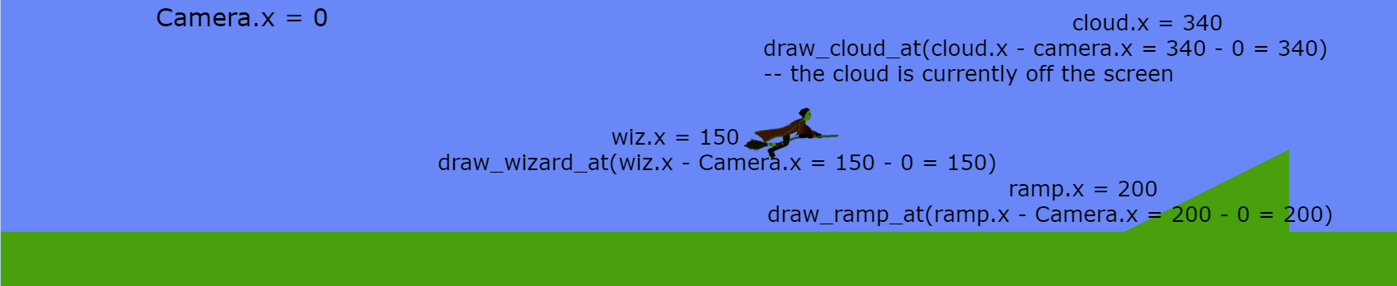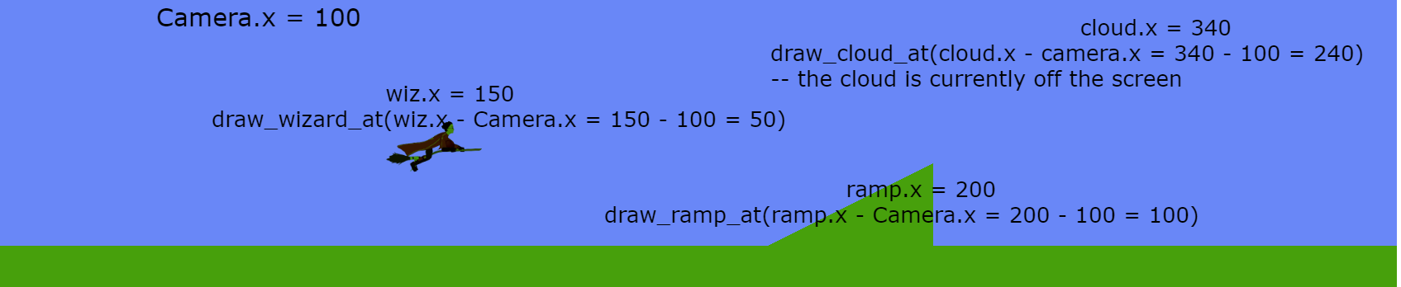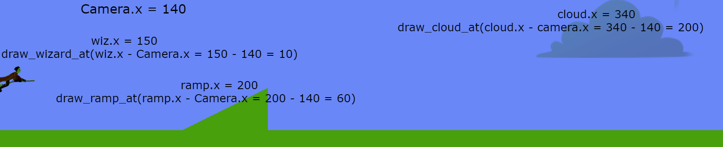

Here we change the position that we draw each of the objects at, the screen does not actually move, all the objects on the screen are just continually redrawn at a position that is further to the left.

Or we can set them to be locked on to a particular object

*Camera.x = wizard.body:getX() - love.graphics.getWidth()/2 --The subtraction is done so that the camera is centered on the wizard, instead of the wizard being at the side of the screen*

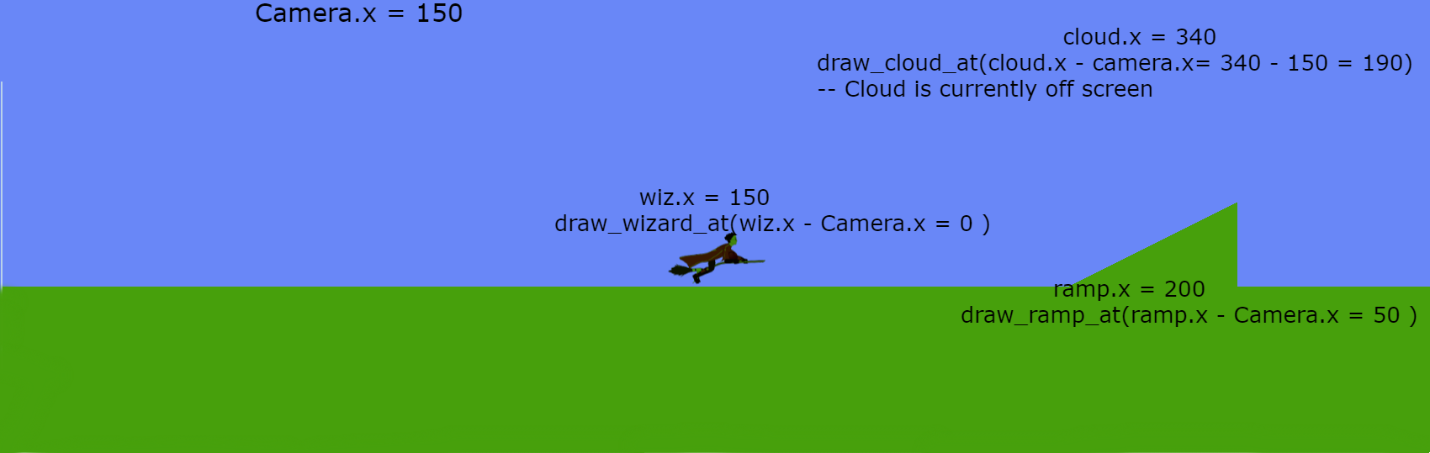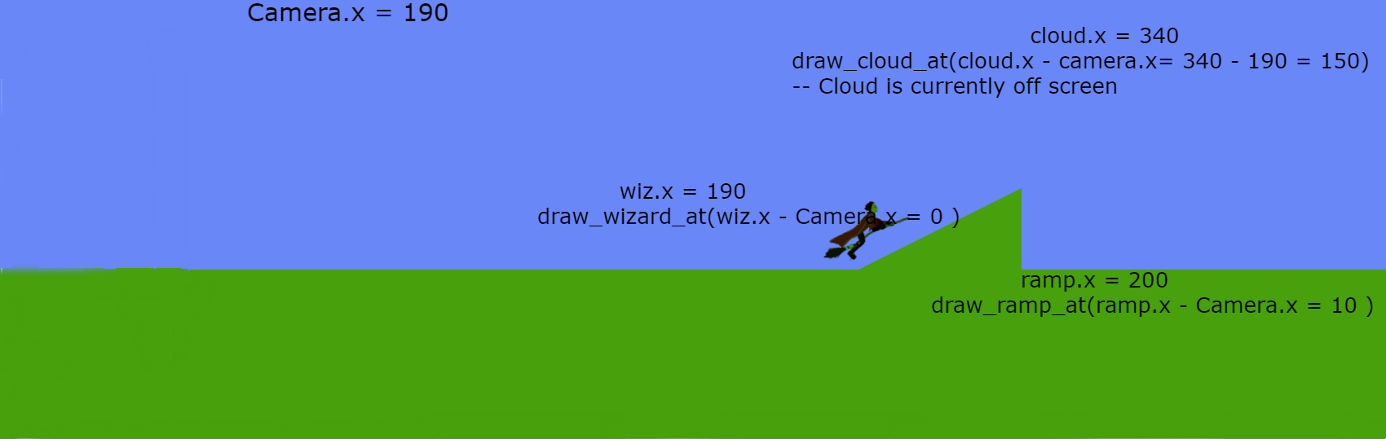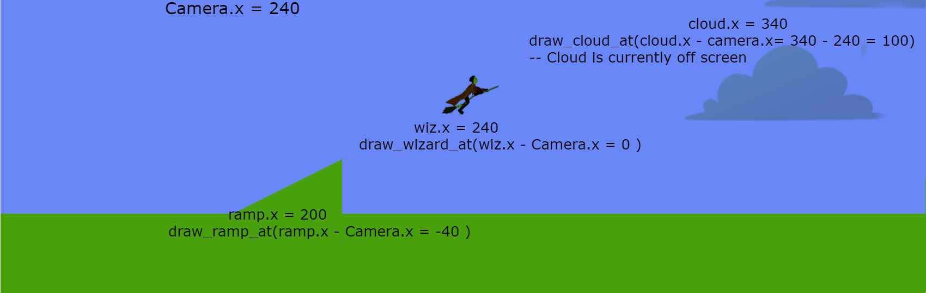

The game is set up to show the first type of movement when the game is paused, and the second type of movement when the game is not paused.

PROCEDURE:

Get the kids to open the tutorials/Camera_movement.pdf file and explain camera movment to them.

Get the kids to open the main.lua and Camer.lua files within their Quidditch folder.

**Camera Template**

The kids must edit the template so that the Camera.update function includes functionality for moving to the Camera right and down, the adjustments are specified in the comments.

They must also update the Camera:follow function so that the camera also follows the wizard vertically, the adjustments are specified in the comments.

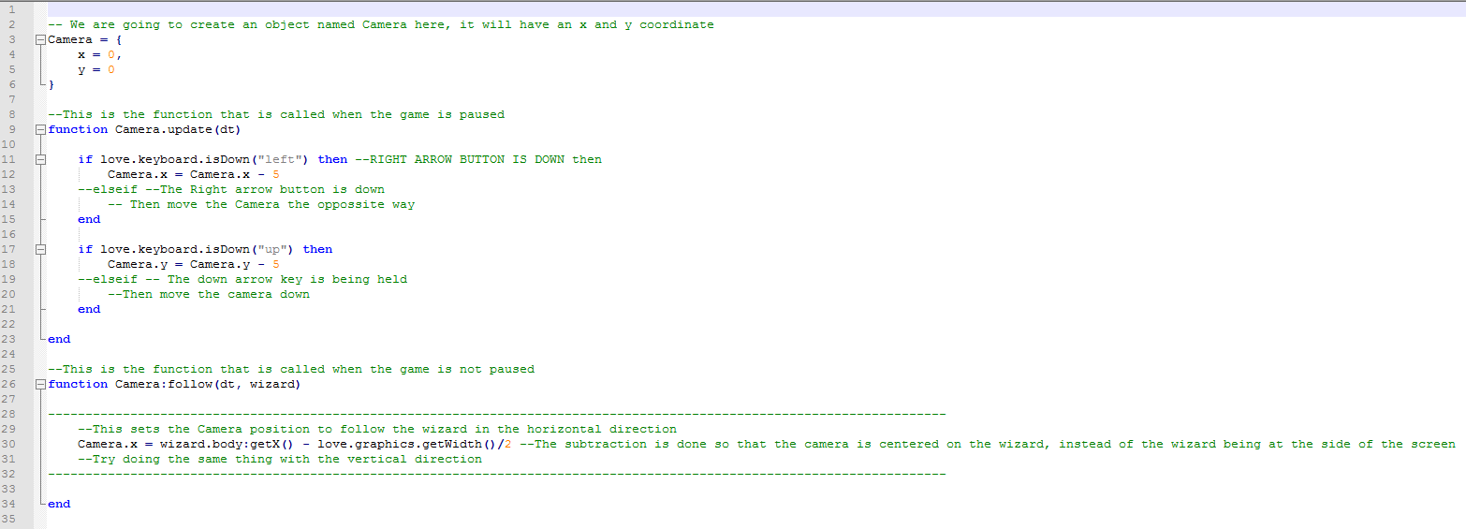

**Complete Camera Code**

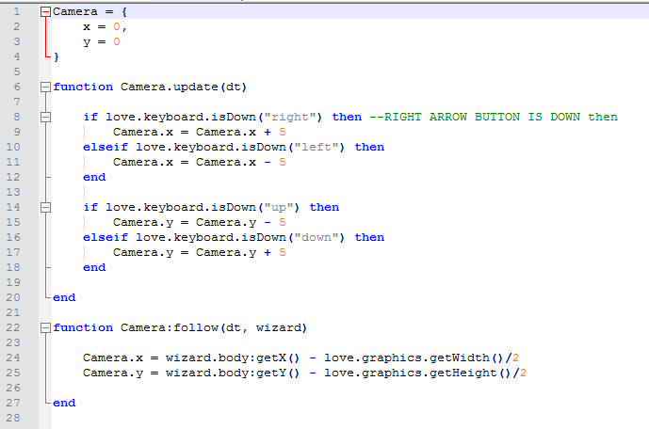

**Love.update Template**

The kids must edit the code so that a force is applied on the wizard to move right, up and down with the right, up and down arrow keys. The wizard will only move when the game is not paused.

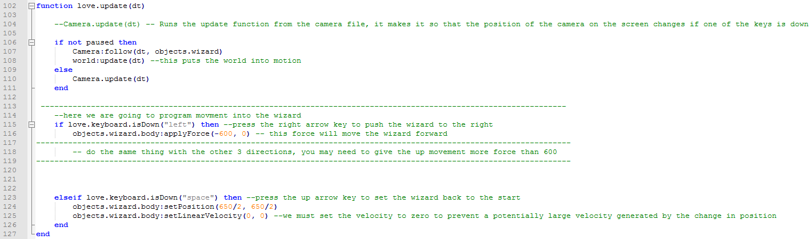

**Love.update completed code**

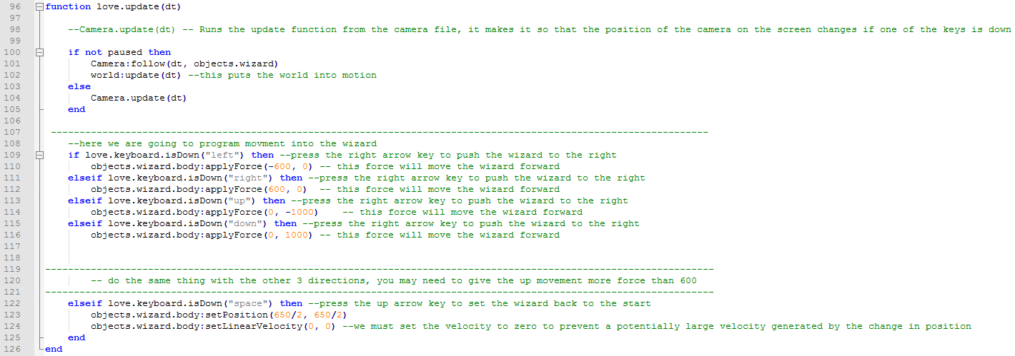

**Love.draw template**

The kids must subtract Camera.x from all the objects x coordinates, and subtract Camera.y from all the objects y coordinates. The objects include the ramps, the ground, the wizard, and the hoops. Have them test out the code after each subtraction and let them see what happens.

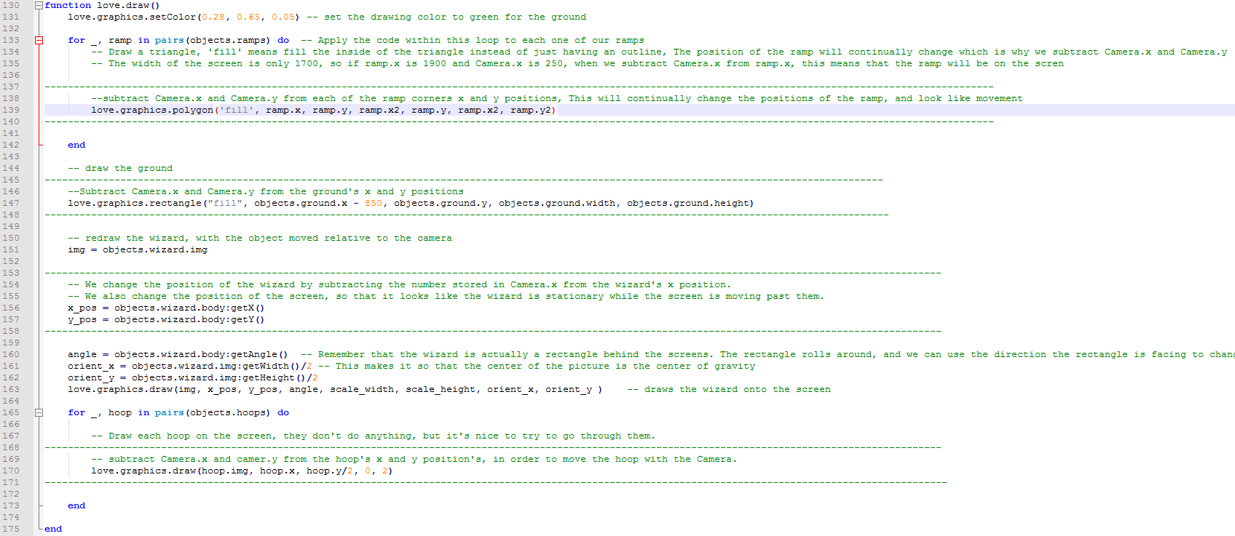

**Love.draw completed code**

