**Putting Your Games onto a USB stick**

1. Plug the USB stick into the computer

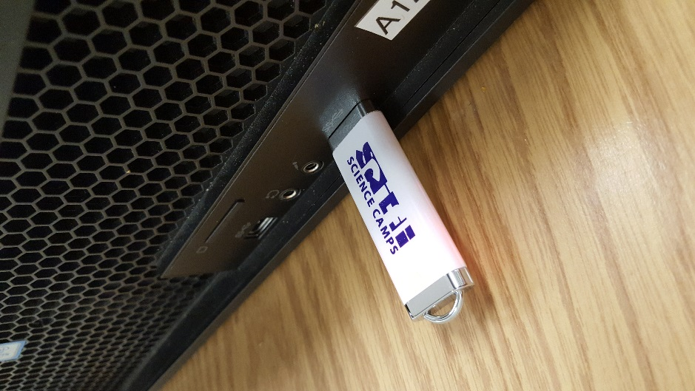

1. Click this icon on your computer

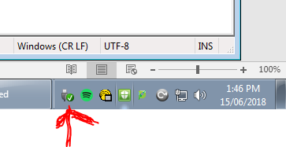

1. Click Open Devices and Printers

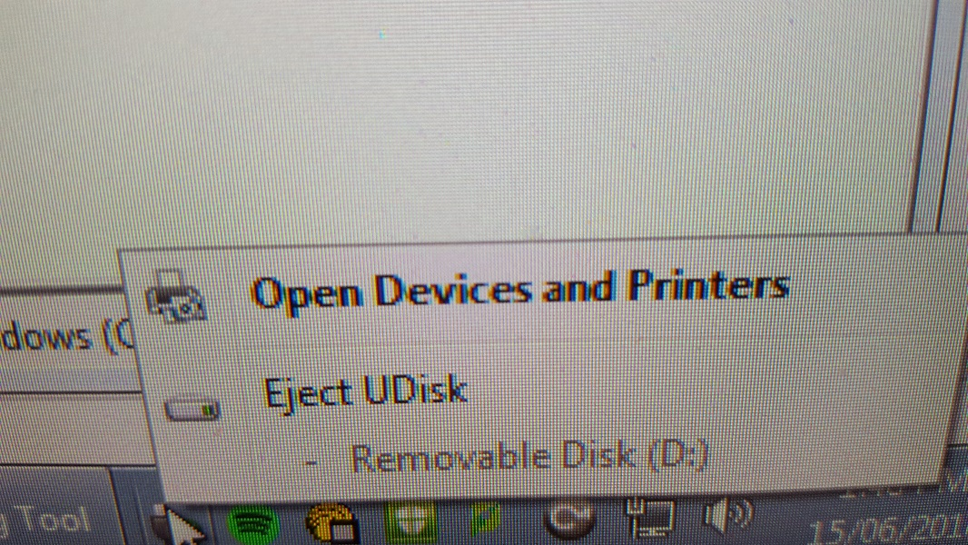

1. A window will open up. In the window, right click UDisk and select Browse Files -> Removable Disk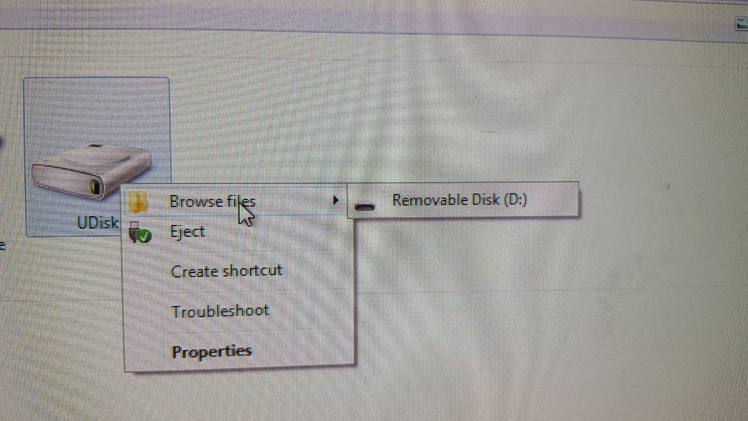
2. This will open up an empty folder which shows the contents saved on your usb stick(currently empty)

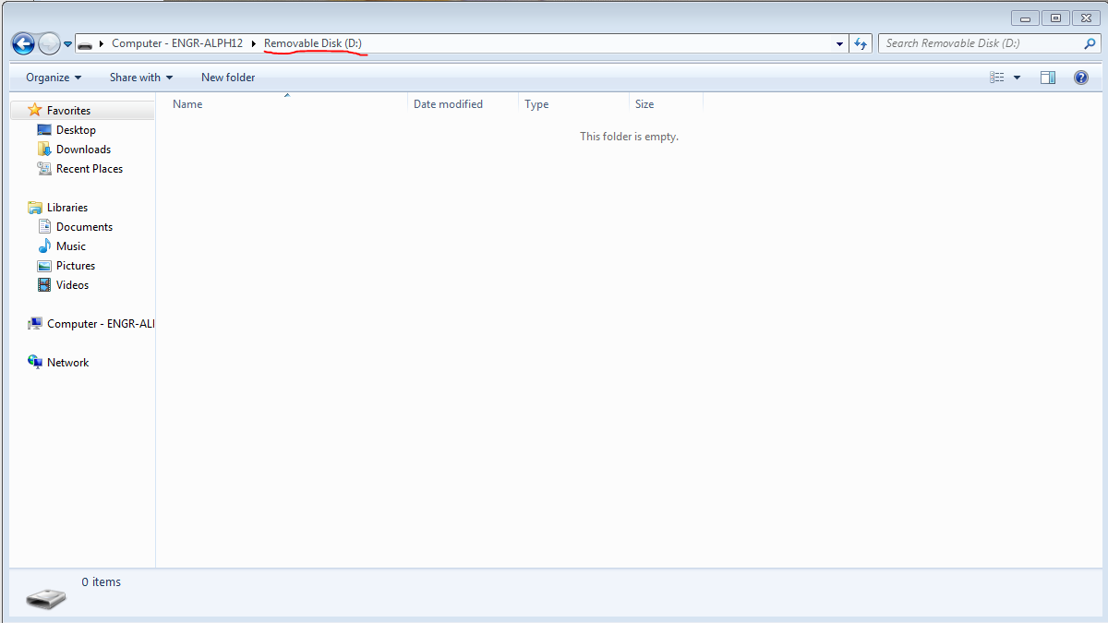

1. Drag your game

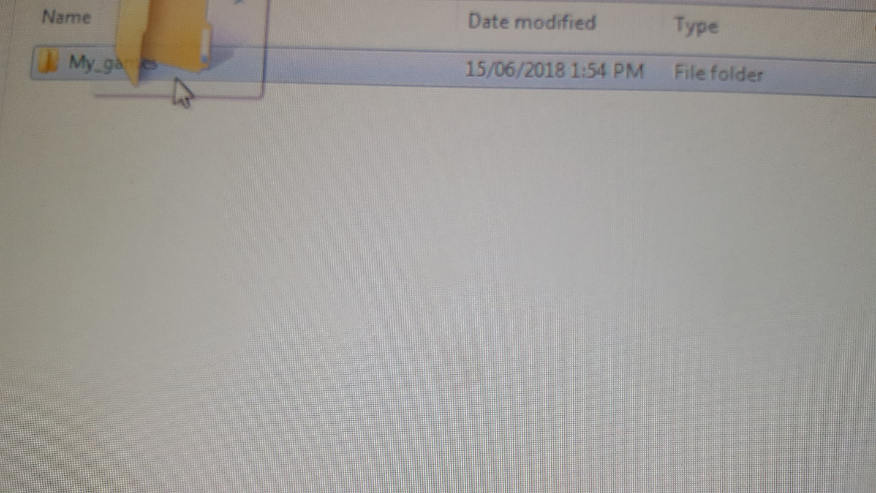

Onto the empty folder you just opened

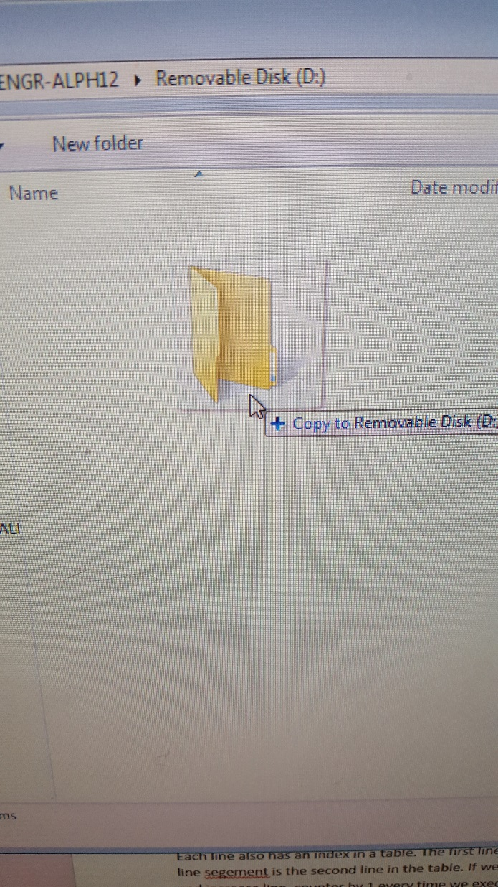

1. Click Back

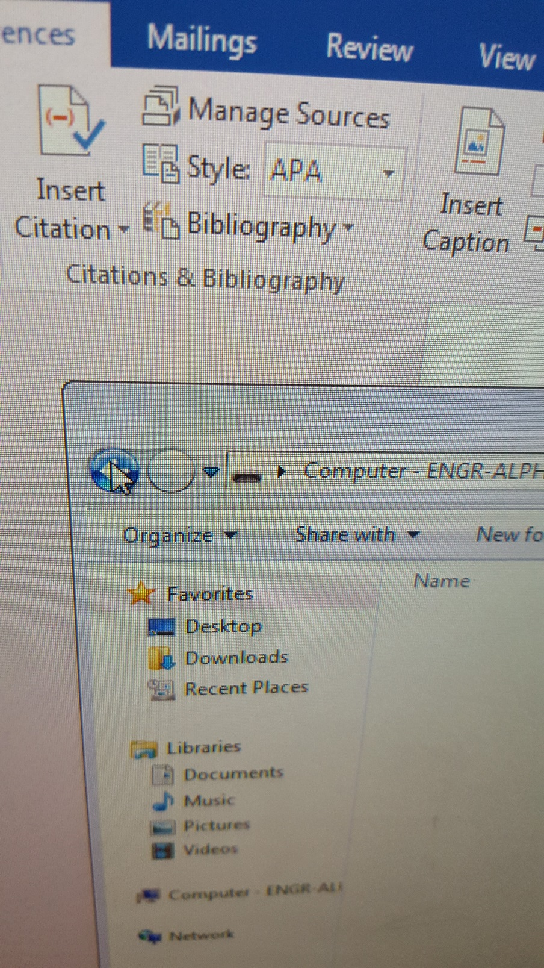

1. Right Click UDisk and select Eject

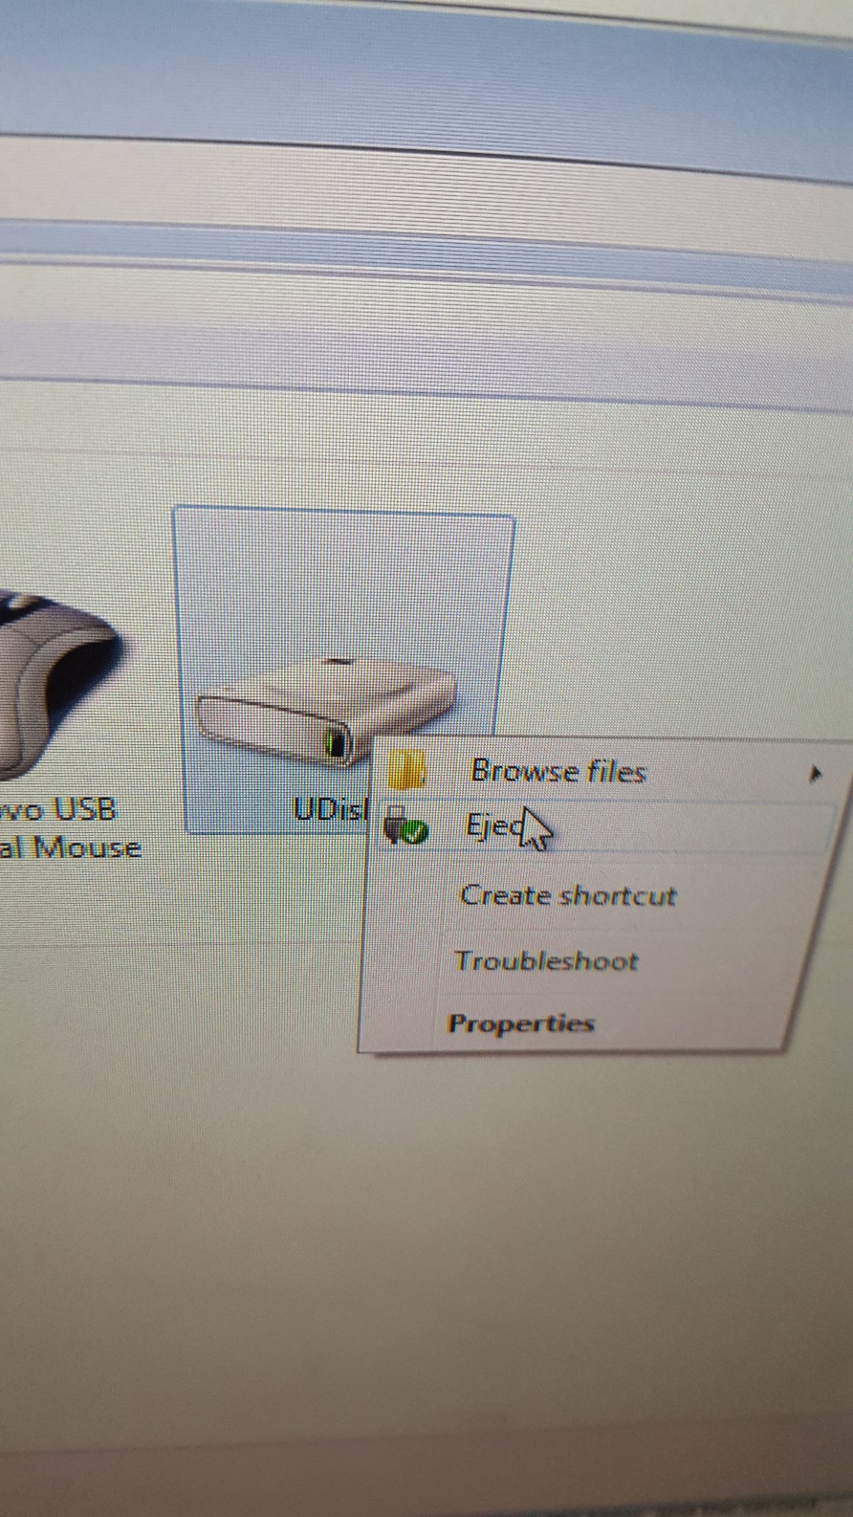

1. Wait until you receive the notification Safe to Remove Hardware

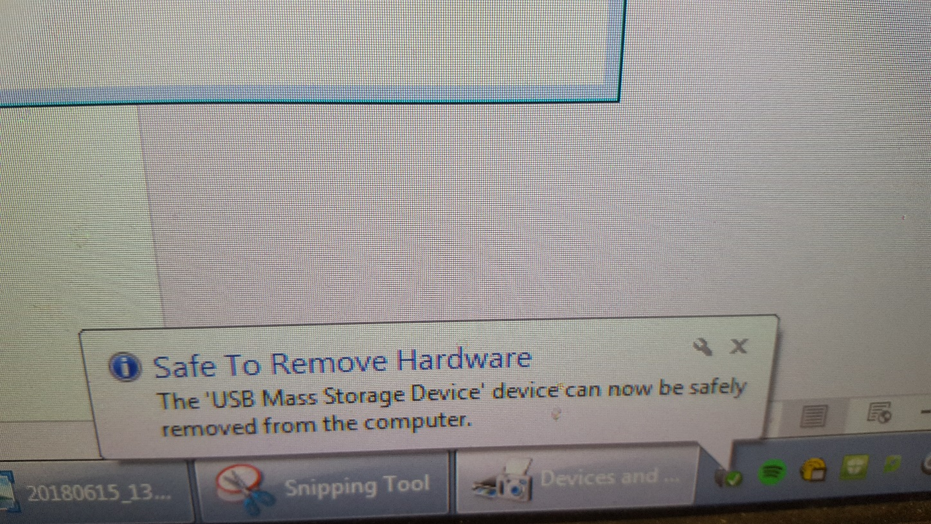

1. Remove the usb stick from the computer

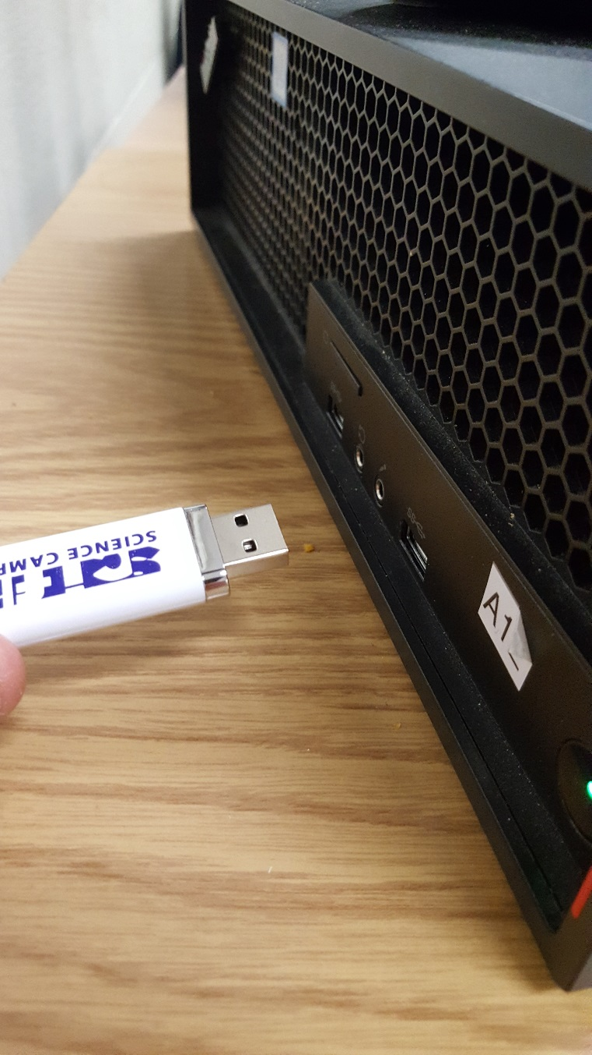

1. Put the cap back on the usb

