**Program Window**

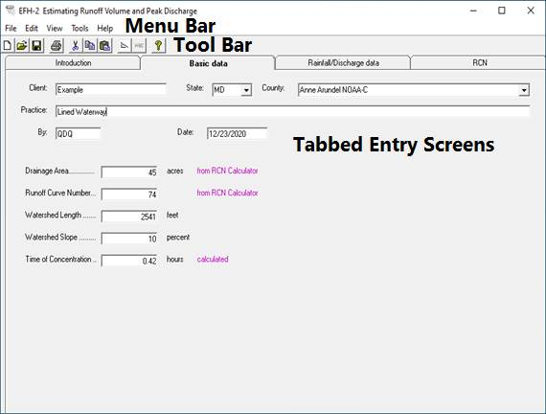

The Program Window consists of the Menu Bar, Tool Bar, and Tabbed Entry Screens.

The program initiates to the Introduction tab. It details the limits of the program.

To begin data entry, click the Basic data tab to enter the watershed data.

Click the Rainfall/ Discharge data tab to enter precipitation data and to view discharge calculations.

Click the RCN tab to calculate a Runoff Curve Number from land use and soils data.