**Rainfall/Discharge Data**

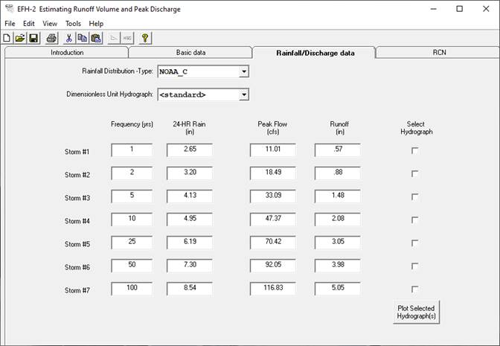

The Rainfall/Discharge data tab screen is automatically populated with the rainfall data for the State and County selected on the Basic data tab. Users can select a difference Rainfall Distribution – Type or Dimensionless Unit Hydrograph depending on their requirements. With each change in input, Peak Flow (cfs) and Runoff (in) are automatically recomputed. User can select output hydrograph(s) to be plotted by clicking on the checkboxes under the Select Hydrograph. Then, the Plot Selected Hydrograph(s) button is clicked to display the plotted output for the selected hydrographs:

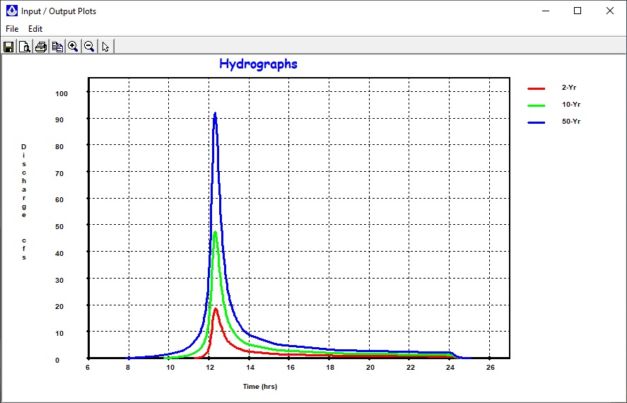

On the Input/Output Plots screen, users can save, open, print, copy to clipboard, zoom in, zoom out, or identify the coordinates of the nearest point using the toolbar or menu options.

To zoon in, users click on the zoom-in icon (+) and either click on the location to zoom in 50% or specify a range to zoom to by selecting a bounding rectangle by clicking and holding down on the left mouse button and moving to the opposite point in the bounding rectangle. Users can return to the original extent, by clicking on the zoom-out icon (-).

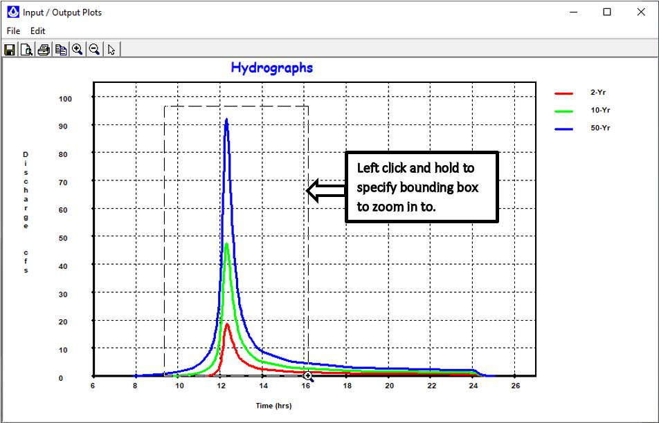

Finally, to display the points use to generate the graph, select Edit + Plot Points:

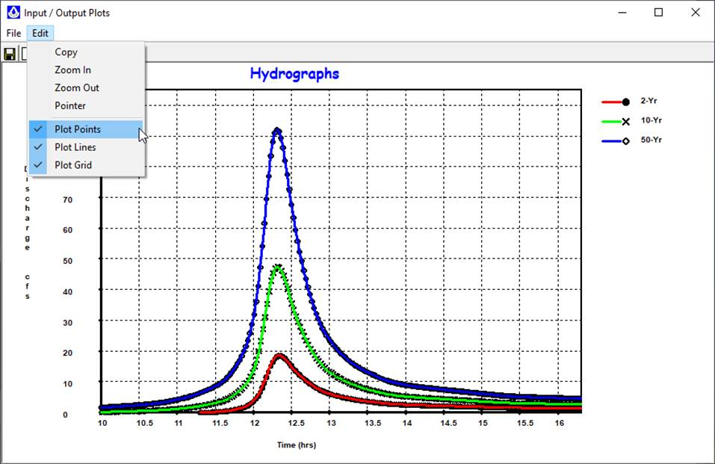

The pointer icon can be selected to display the (time, discharge) coordinates associated with each point.