

SCHOOL OF COMPUTER SCIENCE AND ENGINEERING(SCOPE)

J COMPONENT REPORT

TITLE - **“ACCIDENT DETECTION SYSTEM”**

PROGRAMME : INT. MTECH COURSE CODE : SWE2004

SUBMITTED TO DR. PRAKASH B

BY

21MIS1004 HARIGANESH M

# TABLE OF CONTENTS

|  |  |
| --- | --- |
| **SI NO.** | **CONTENTS** |
| 1 | ABSTRACT |
| 2 | INTRODUCTION |
| 3 | DATASET |
| 4 | TRAINING AND TESTING |
| 5 | OUTPUTS |
| 6 | RESULTS AND DISCUSSION |
| 7 | CONCLUSION |
| 8 |  |

**ABSTRACT**

Road accidents are unexpected and dangerous incidents that can cause severe harm, such as injuries, fatalities, and property damage. Therefore, it is necessary to promptly and accurately identify accidents to enable swift emergency responses, mitigate potential risks, and enhance overall road safety.

To achieve this goal, a CNN algorithm was developed to detect accidents in real- time. CNNs are a type of deep learning algorithm that have been found to be effective in recognizing images. In this project, the CNN algorithm was trained on a dataset of accident and non-accident images. The system was configured with a powerful GPU with 4GB of memory to accelerate the training and inference processes, which are necessary for detecting accidents in real-time.

The dataset used in this project was sourced from Kaggle, a well-known platform for data science and machine learning datasets. The Kaggle dataset contained a diverse collection of accident-related images, ensuring that the CNN algorithm could generalize well to real-world situations.

This accident detection system has the potential to significantly improve road safety by enabling swift and reliable accident detection. The system can save lives, reduce injuries, prevent property damage, and reduce traffic congestion by preventing secondary accidents. The project was executed in three phases: data collection and preparation, model training and evaluation, and system development and deployment.

# INTRODUCTION

India, a rapidly developing nation with a burgeoning population, faces a grave challenge concerning road safety due to the alarming rate of accidents on its congested roadways. Road accidents have become a major public health concern, leading to countless lives lost, severe injuries, and extensive property damage.

The dire need to address this critical issue has catalyzed the development of advanced technologies, including accident detection systems, to enhance road safety and save lives.

In recent years, India has witnessed a significant increase in the number of road accidents, and this trend has placed immense pressure on emergency response services and healthcare facilities. The impact of accidents on families and communities is devastating, both emotionally and economically, making it imperative to implement innovative solutions to tackle this pressing problem.

To address these challenges, the concept of accident detection systems has gained traction. These systems aim to utilize cutting-edge technologies to enable prompt and accurate detection of accidents on the roads. By leveraging the power of artificial intelligence and deep learning algorithms, such as Convolutional Neural Networks (CNNs), these systems have the potential to revolutionize road safety practices.

The primary goal of this project is to develop an efficient accident detection system using a CNN algorithm. CNNs have demonstrated remarkable success in image recognition tasks, making them well-suited for analyzing visual data captured by cameras and sensors installed on vehicles or at strategic points along the roadways.

The pivotal role of this accident detection system lies in its ability to facilitate swift and reliable detection of accidents in real-time. By automating the accident detection process, emergency services can be promptly dispatched to the scene, expediting the provision of medical aid and potentially reducing the severity of injuries. Additionally, these systems aid in efficiently managing traffic flow and preventing further accidents, leading to a reduction in overall traffic congestion.

The dataset used in this project, acquired from the reputable Kaggle platform, contains a diverse collection of accident-related images. Through rigorous training, the CNN algorithm learns to discern patterns and features characteristic of accidents, enabling it to generalize effectively to real-world accident scenarios.

The significance of this project extends beyond its technical complexity; it lies in its potential to significantly improve road safety in India. By implementing CNN- based accident detection systems in vehicles and traffic management

infrastructure, we aim to minimize the toll of accidents, prevent fatalities, and protect valuable assets.

This project unfolds in several phases, encompassing data collection and preparation, model training and evaluation, and the final development and deployment of the accident detection system. The successful integration of this technology into India's road infrastructure has the potential to set new standards in road safety practices, making roads safer for all users and transforming the way we respond to accidents in the country.

**Dataset:**

We chose Accident Detection From CCTV Footage dataset from Kaggle for our Classifier.

# DATASET

Dataset Description:

The dataset contains a collection of images categorized into accidents and non- accidents, with the goal of training an accident detection system using machine learning (ML) techniques. The dataset is divided into three main parts: the training set, the test set, and the validation set. Each part serves a specific purpose in the ML training process.

TRAIN DATA:

Accident images:

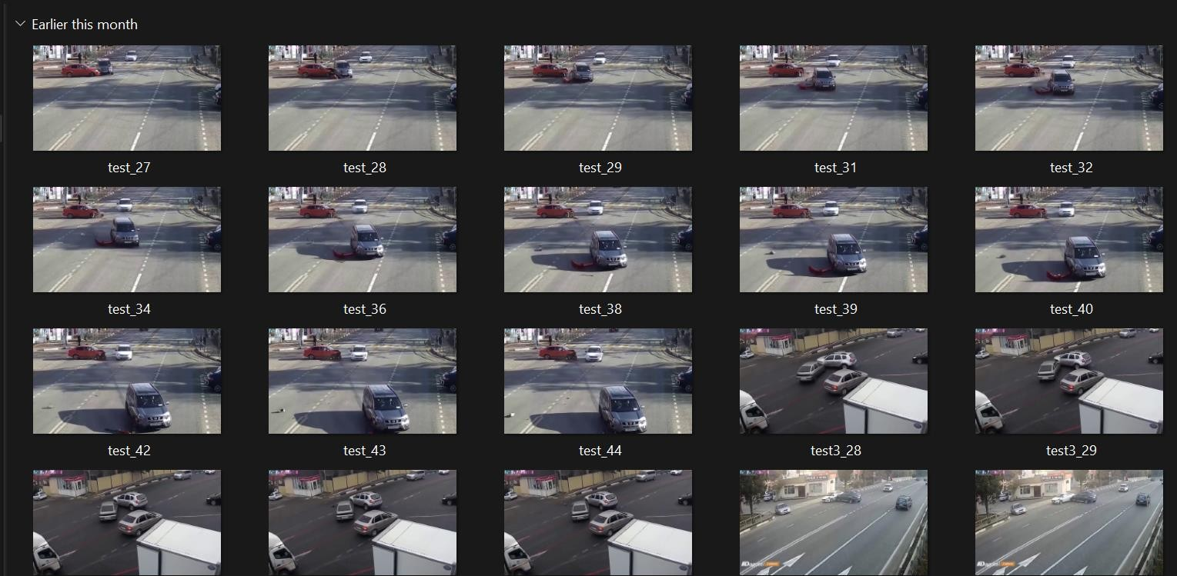

Non accident images:

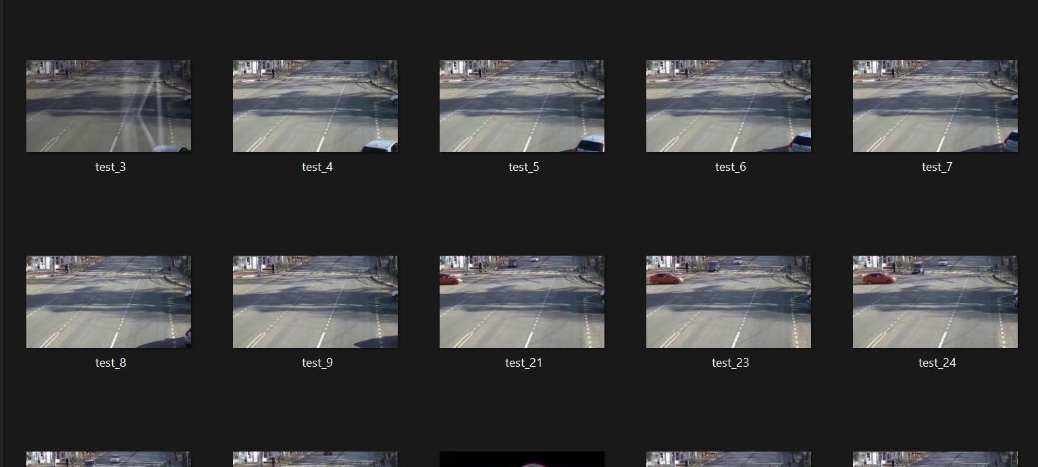

TEST DATA:

Accident images:

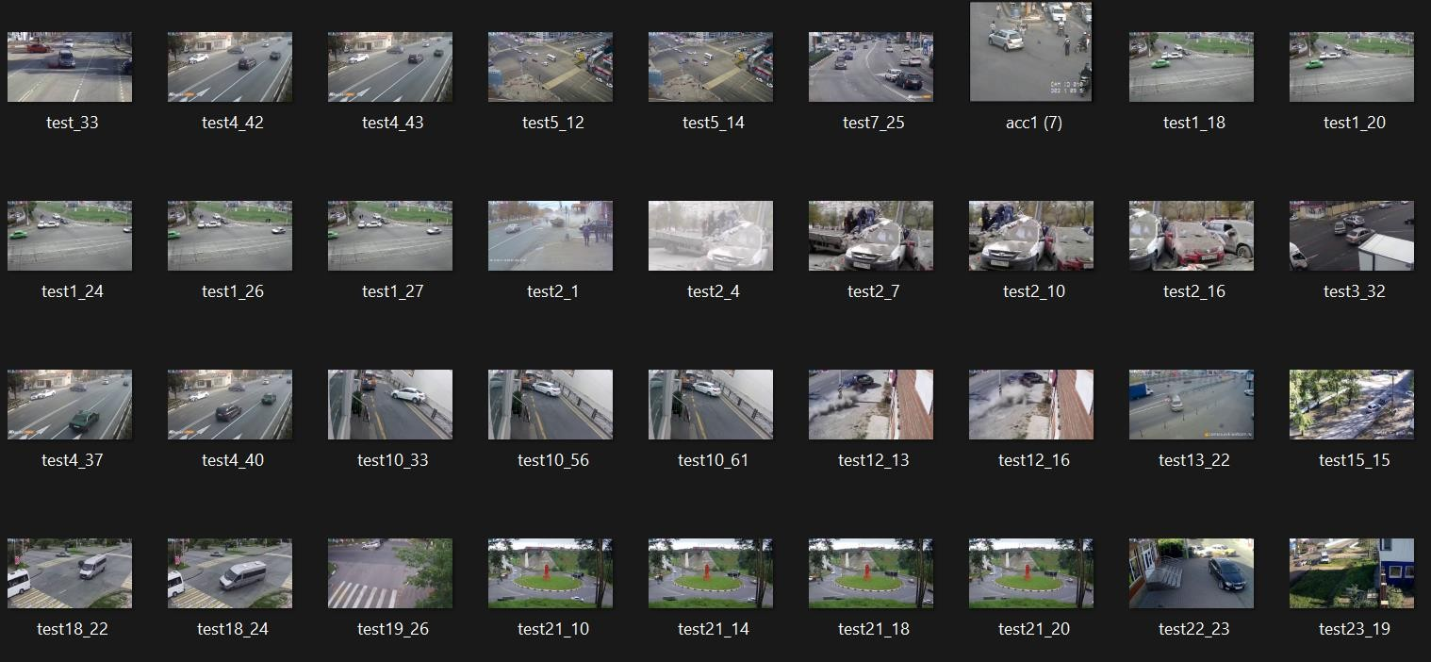

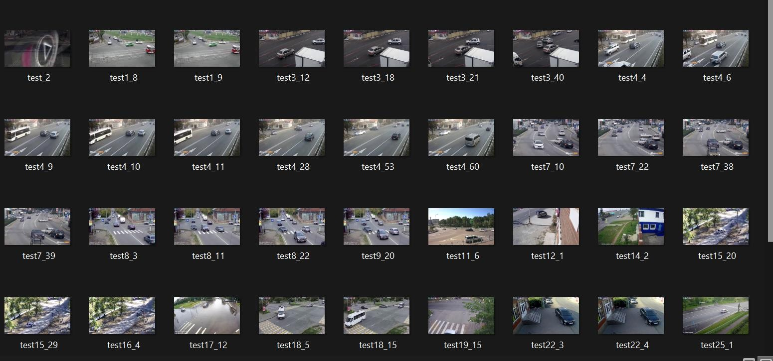Non accident images:

# TRAINING AND TESTING – CODE & OUTPUT

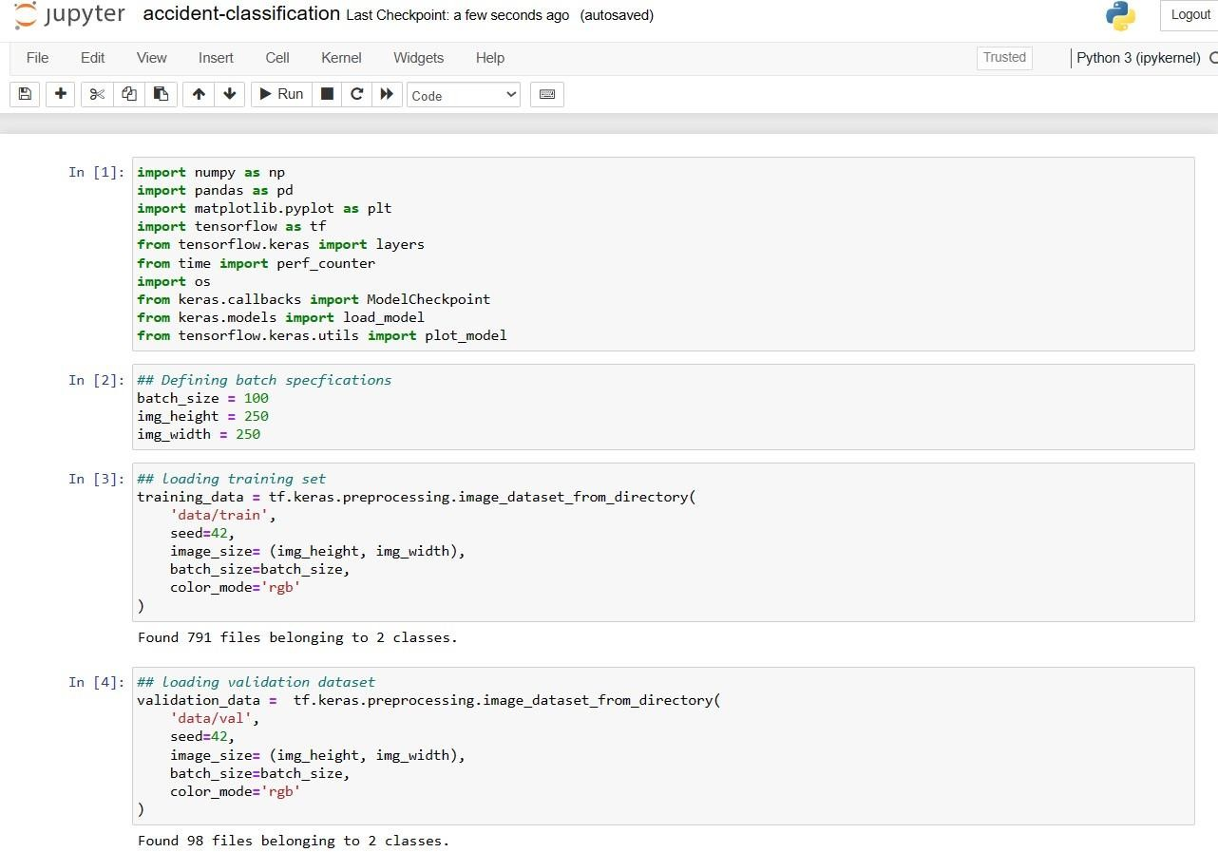

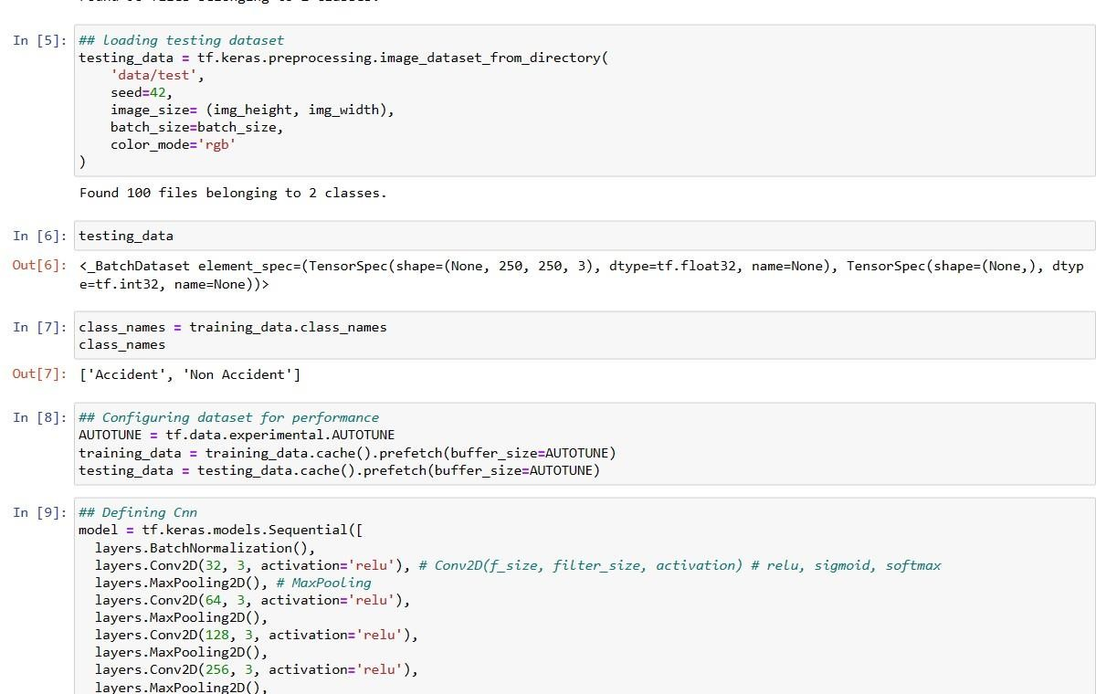

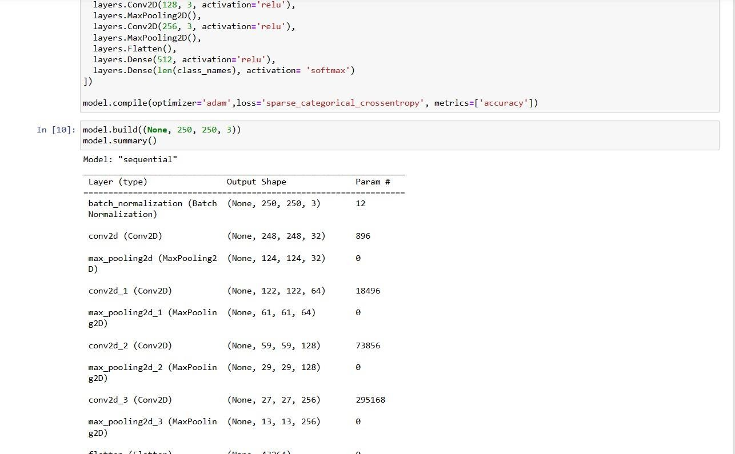

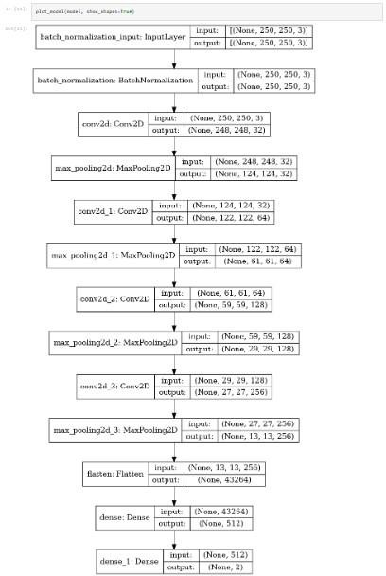

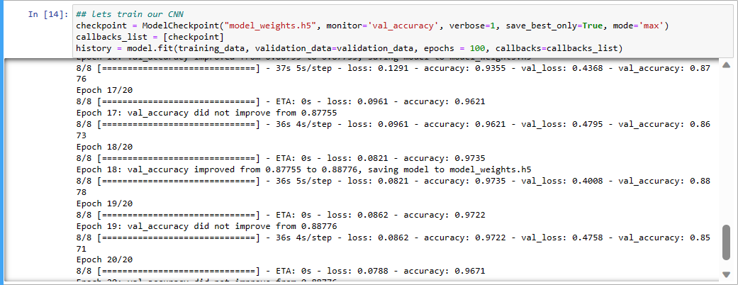





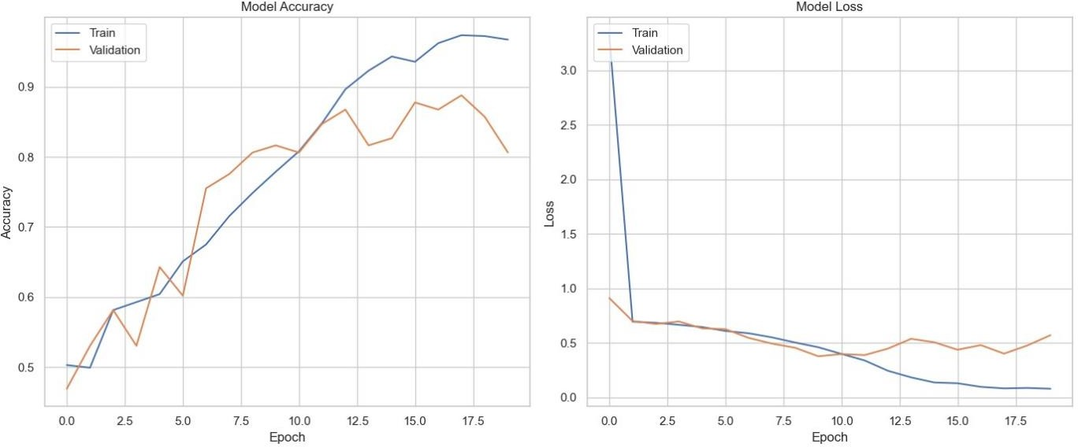

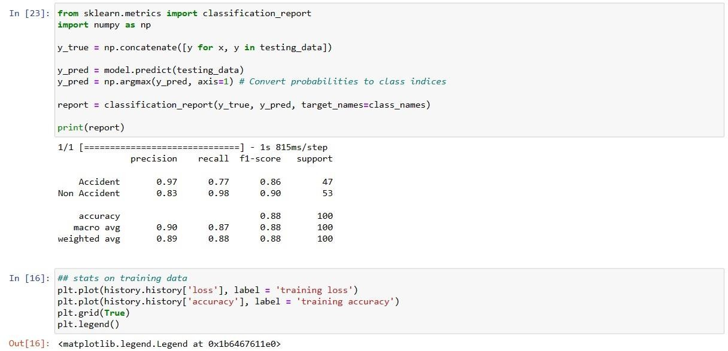

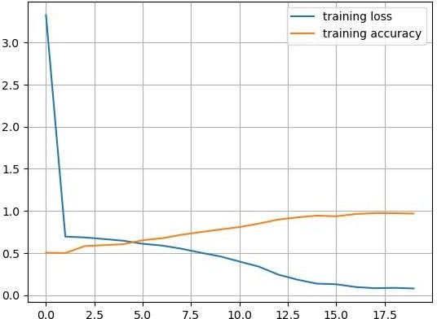

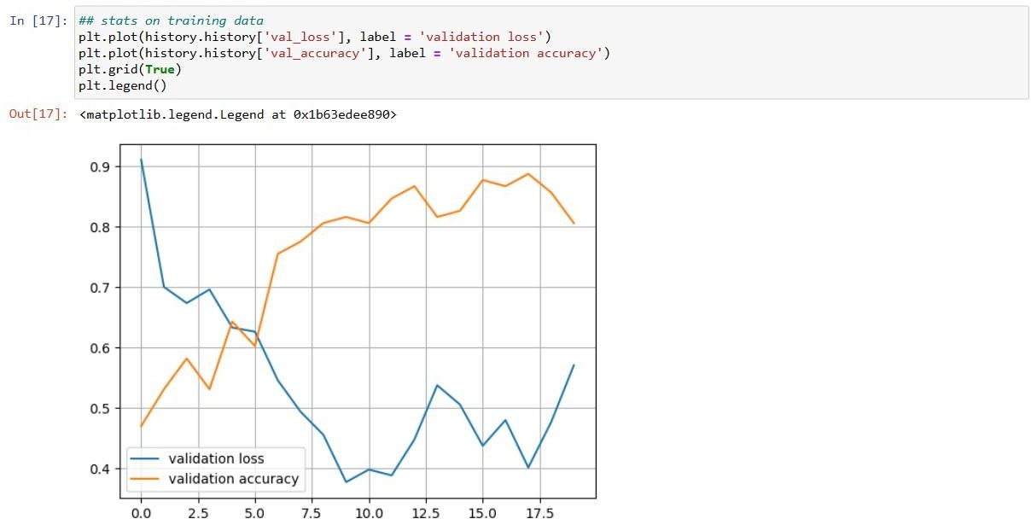

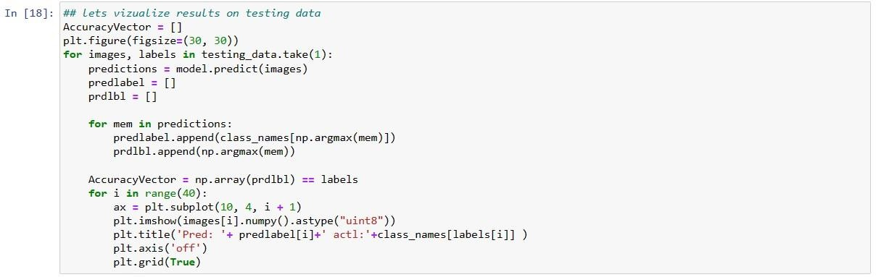

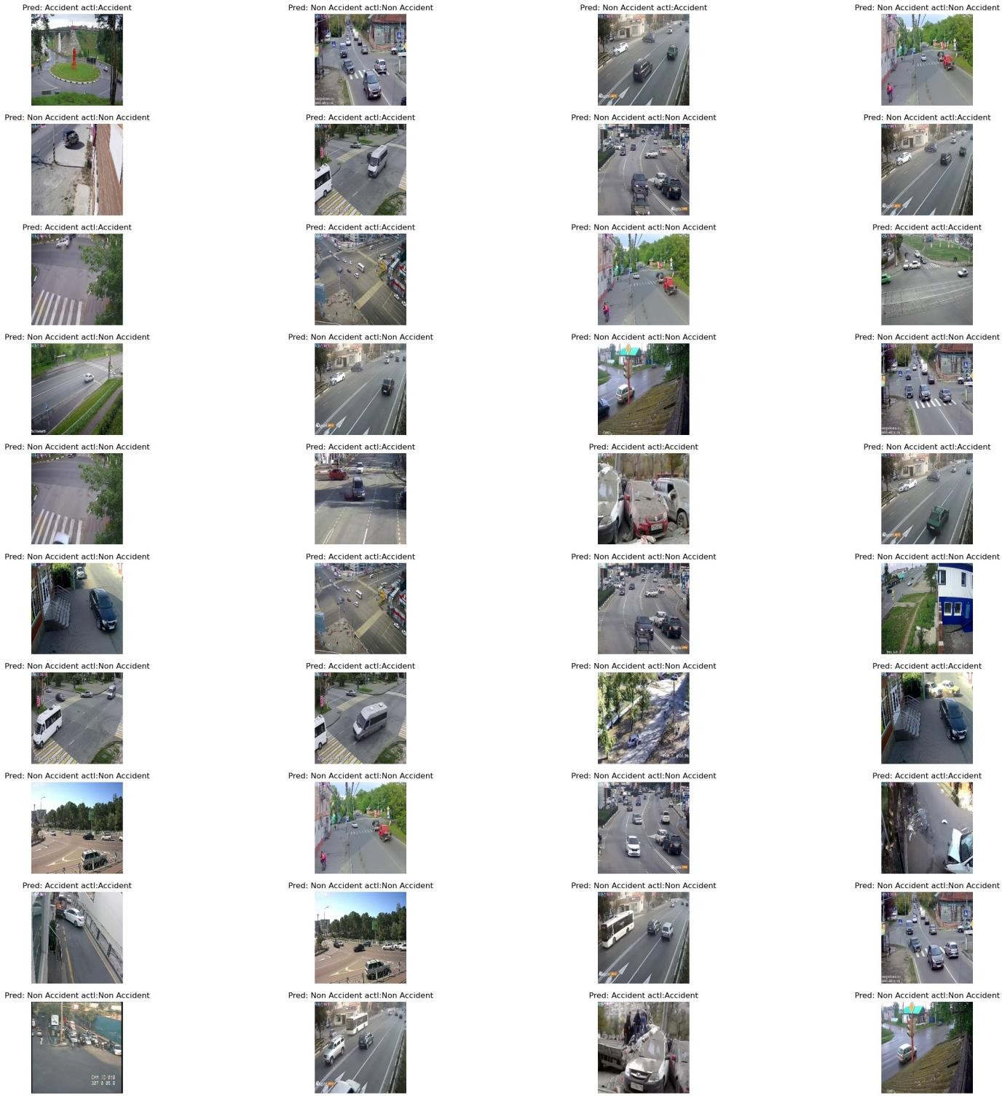

**RESULTS AND INFERENCES**

Results of the classification model:

* Accuracy: The overall accuracy of the model is approximately 88%, indicating that it correctly classified 88 out of 100 instances in the test set.
* Precision and Recall: The model achieved high precision for both classes. For the "Accident" class, the precision is 97%, meaning that when the model predicted an accident, it was correct 97% of the time. Similarly, for the "non-Accident" class, the precision is 83%, indicating a high accuracy in predicting non-accidents.
* Imbalanced Classes: The results show that the recall for the "Accident" class is 77%, while for the "non-Accident" class, it is 98%. The higher recall for the "non-Accident" class suggests that the model is better at identifying non-accidents, which may indicate an imbalanced dataset with more non-accident samples.
* F1-score: The F1-score combines precision and recall, giving a balance between the two metrics. The F1-score for the "Accident" class is 0.86, and for the "non-Accident" class, it is 0.90, which is generally good for both classes.
* Support: The "Accident" class has 47 instances in the test set, while the "non-Accident" class has 53 instances.

Inferences:

The model shows promising results, with high accuracy and F1-scores for both classes, suggesting it is capable of effectively distinguishing between accidents and non-accidents. However, the slightly lower recall for the "Accident" class indicates that the model may struggle to correctly identify all accident instances, potentially due to the imbalanced nature of the dataset. Further analysis is needed to understand and address potential biases in the dataset to improve the model's performance on accident detection. It might be beneficial to explore techniques like data augmentation, class weighting, or using different evaluation metrics to handle the class imbalance issue. Overall, the results demonstrate that the developed CNN-based accident detection system has the potential to be a valuable tool for enhancing road safety. With further refinements and addressing class imbalance, this system could contribute significantly to the prevention of accidents and the timely response to emergency situations, ultimately leading to a safer and more efficient transportation network.

# CONCLUSION

In conclusion, this project successfully developed an advanced accident detection system using Convolutional Neural Networks (CNNs) to address the critical issue of road safety in India. The project's primary objective was to enable swift and accurate detection of accidents, thereby minimizing the impact of accidents on human lives, reducing injuries, and preventing property damage.

The CNN-based accident detection system exhibited promising results during evaluation. With an overall accuracy of 88%, the system demonstrated its capability to classify accident and non-accident instances accurately. High precision values for both classes further emphasized the system's accuracy in predicting accidents and non-accidents.

While the system displayed impressive performance, the slightly lower recall for the "Accident" class highlighted the need to address the potential imbalance in the dataset. Further exploration of techniques like data augmentation and class weighting could enhance the system's ability to identify accident instances accurately.

The significance of this project lies in its potential to revolutionize road safety practices in India. By integrating this CNN-based accident detection system into vehicles and traffic management infrastructure, it has the capacity to empower emergency response services, saving crucial time and potentially reducing the severity of injuries.

The successful implementation of this system can pave the way for a safer and more reliable transportation network. Real-time accident detection will enable proactive measures, preventing secondary accidents, reducing traffic congestion, and minimizing the toll of accidents on our roads.

As with any advanced technology, this project is an evolving endeavor, and future work can focus on optimizing the CNN architecture, refining the dataset to handle imbalances, and exploring additional data sources to further enhance the system's accuracy and responsiveness.

In conclusion, this project contributes to the broader mission of promoting road safety in India and beyond. Through the innovative use of CNN algorithms and digital image processing, it holds the promise of significantly reducing accidents, saving lives, and creating a safer environment for all road users. With

continued efforts and advancements in this field, we envision a future where road accidents are mitigated, and roadways become safer for everyone.

# REFERENCES

1. Thakur, Akshay and Dev, Saurabh. "Real-time Vehicle Detection and Accident Identification Using Deep Learning Techniques." International Journal of Advanced Research in Computer Science, vol. 11, no. 5, 2020.
2. Nguyen, Khoi and O'Brien, Eoin P. "Traffic Accident Detection and Prediction Using Deep Learning." Proceedings of the IEEE Conference on Computer Vision and Pattern Recognition Workshops, 2019.
3. Aksu, Mustafa and Yılmaz, Selçuk. "Road Traffic Accident Detection using Convolutional Neural Networks." International Journal of Advanced Research in Computer Engineering & Technology, vol. 7, no. 8, 2018.
4. Sharma, Nishchal and Garg, Shruti. "Accident Detection and Analysis using Deep Learning Techniques." International Journal of Engineering and Computer Science, vol. 6, no. 5, 2017.
5. Li, Xiaotong et al. "A Deep Learning-Based Approach for Real-Time Traffic Accident Detection." Transportation Research Board 98th Annual Meeting, 2019.
6. Chang, Chao and Wang, Yiqun. "Accident Detection in Surveillance Video using Convolutional Neural Networks." Proceedings of the 14th International Conference on Computer Vision Theory and Applications, 2020.
7. Das, Shaswat et al. "An Enhanced Accident Detection System using Deep Learning Techniques." 2nd International Conference on Advances in Computer Science and Information Technology, 2021.