# River object methods

## Routing (for water)

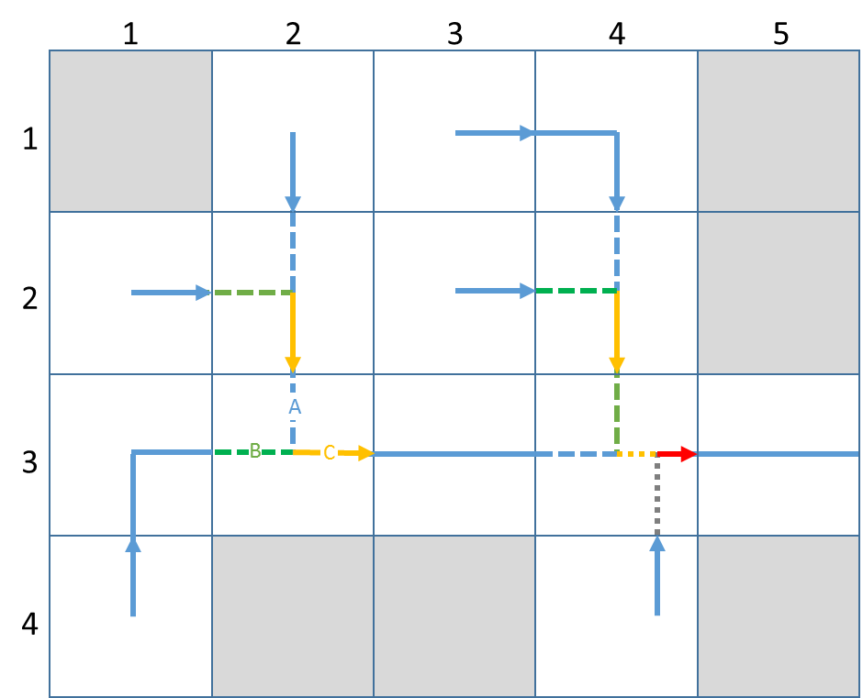

Each Grid Cell object contains one River object. The River object contains a collection of SubRiver objects, each representing a contiguous stretch of river, either from source or grid entry to grid exit (e.g. cells 1,2, 1,3, 2,1, 2,3, 3,1, 3,3, 3,5, 4,1, 4,4), grid entry to confluence (e.g. cells 2,2. 2,4, 3,2, 3,4), confluence to confluence (e.g. cell 3,4) or confluence to grid exit (e.g. cells 2,2, 2,4, 3,2, 3,4).

User defined types in River:

|  |  |  |  |
| --- | --- | --- | --- |
| Type name | Elements | Element Type | Description |
| RiverReachElement |  |  | Wrapper for collection of polymorphic RiverReach objects; can contain objects of any type implementing spcRiverReach superclass |
|  | item(:) | allocatable RiverReach class |  |

|  |  |  |  |
| --- | --- | --- | --- |
| Type name | Elements | Element Type | Description |
| RoutingRef |  |  |  |
|  | GridRow | integer | row reference to a grid cell |
|  | GridCol | integer | column reference to a grid cell |
|  | SubRiverRef | integer | integer reference to a SubRiver |

SubRiver properties:

|  |  |  |
| --- | --- | --- |
| Property name | Property type | Description |
| Reach(:) | RiverReachElement | allocatable array of RiverReach objects |
| inflow_ref(:) | character(len=*) | array of references to source SubRiver objects |
| outflow_ref | character(len=*) | reference to destination SubRiver object |
| nReaches | integer | number of RiverReach objects in the SubRiver |