Hypothesis [N]: Crashes involving vehicles using Automated Driving Systems (ADS) are more frequent in rain than the vehicles' exposure to rain would predict. The share of reported ADS crashes that happen in rain is higher than the share of time it rains in the cities where the vehicles operate.
Context: Python (pandas and Altair, in Colab) was used to explore this hypothesis. The two public NHTSA Standing General Order ADS files (the 2021 to 2025 archive and the current amended order file) were merged, keeping the latest version of each report and one row per incident, which gives 2,945 crashes from July 2021 to August 2026. Weather is reported as tick boxes that differ between the two schemas, so they were collapsed into a single field by taking the worst condition ticked; injury severity labels were mapped to one scale. Within the dataset 77 percent of crashes are in clear weather, 18 percent cloudy and 3.9 percent (114 crashes) in rain; snow, fog and wind together are under half a percent, so the hypothesis is in practice about rain. Crash counts alone cannot test it, because it rains far more often in Austin than in Phoenix, so a derived exposure variable was built: hourly precipitation from the Open-Meteo historical archive for the six largest metros, aggregated to the share of hours with rain over the months each city had reports. Latitude and longitude are redacted in the dataset, which limits the analysis to the city level, and lighting was dropped from the reporting order in 2025, so night and day cannot be separated for the newer crashes.
Visualization 1: Normalized stacked bar of ADS crashes by weather and metro area.
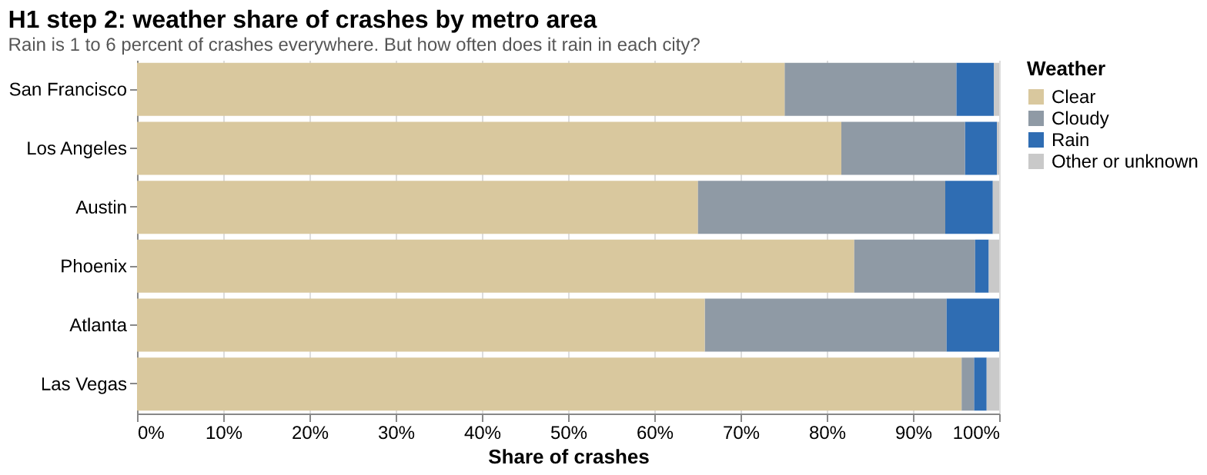
What's informative about this view: A first attempt plotted raw counts across all eight weather codes and was not readable, so weather was collapsed to Clear, Cloudy, Rain and Other and shown as a share of each metro's crashes. Rain is between 1 and 6 percent of crashes in every metro. The ordering is the interesting part: Austin and Atlanta are highest and Phoenix and Las Vegas lowest, which is exactly the order of how rainy those cities are.
What could be improved about this view: The chart shows where rain crashes occur but has no denominator, so it cannot say whether rain crashes are more or less common than expected. Next, the share of hours with rain in each metro was added as a baseline.
Visualization 2.1: Dumbbell chart of crash share in rain against rain exposure, by metro.
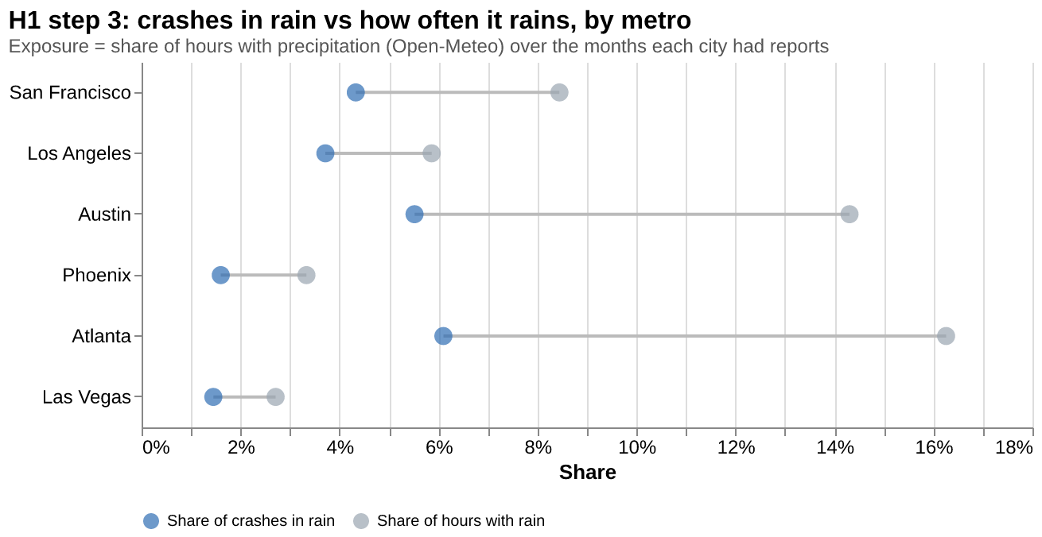
The share of crashes in rain (blue) is placed next to the share of hours with rain (gray) for each metro. In all six metros the blue dot sits well to the left of the gray one. This is the point where the hypothesis flipped: ADS crashes are under represented in rain, not over represented. The view does not, however, show how certain each gap is, and Las Vegas rests on a single rain crash.
Visualization 2.2: Ratio of crash share to rain exposure with 95 percent intervals.
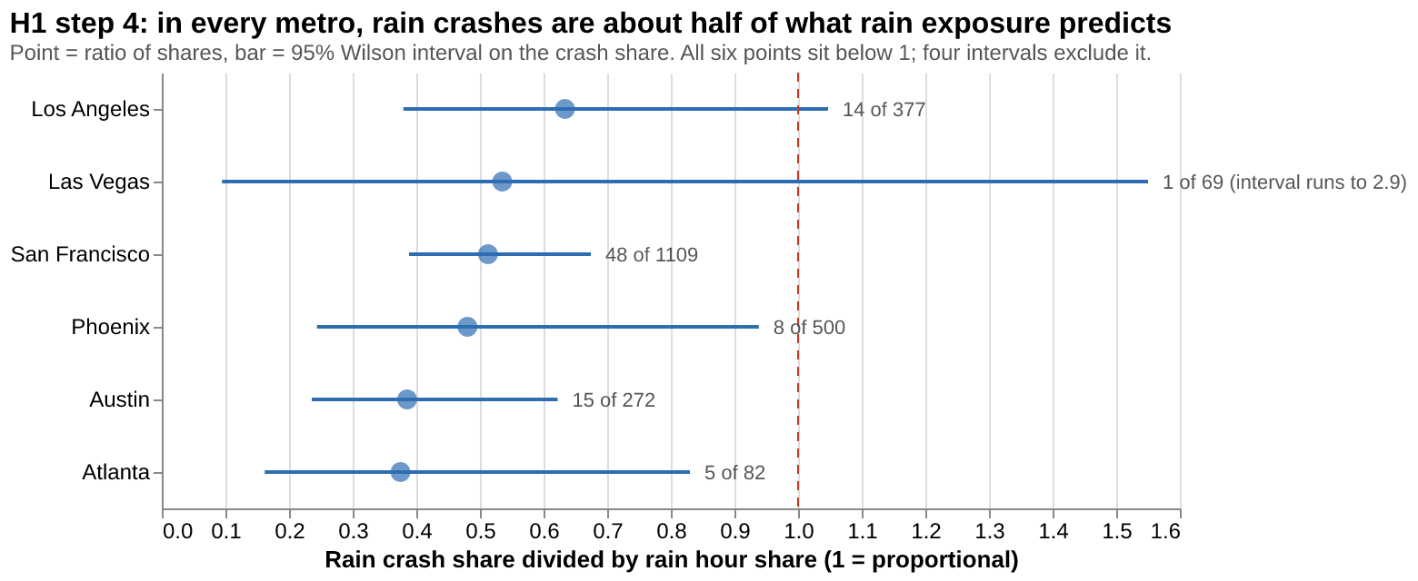
What's informative about this view: Each metro is reduced to one number, the rain crash share divided by the rain hour share, with a 95 percent Wilson interval and a reference line at 1 (crashes happen in rain exactly as often as it rains). Every point lies between 0.38 and 0.63, and in the four metros with the most data (San Francisco, Austin, Phoenix, Atlanta) the interval excludes 1. Las Vegas is visibly uninformative. A month by month view of San Francisco in the notebook confirms the pattern holds over time: rain crashes track the rainy season (r = 0.56 with hours of rain) while total crashes track fleet size and ignore the weather.
What could be improved about this view: The exposure baseline is hours of rain, not miles driven in rain. If fleets drive fewer miles when it rains, a ratio of 0.5 could mean safer driving or simply less driving, and this chart cannot tell them apart. The remaining question was whether rain crashes, though rarer, are more severe.
Visualization 3: Injury rate by weather and road surface, with 95 percent intervals.
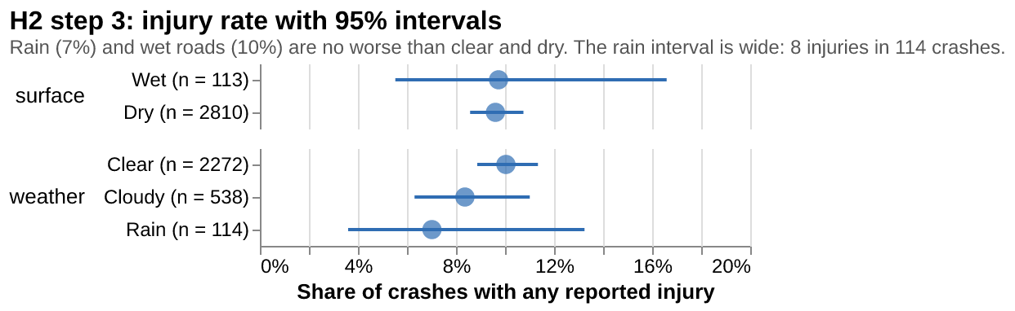
What's informative about this view: A stacked bar of severity counts was tried first and failed, because rain is a sliver next to clear. Normalizing helped but gave no sense of uncertainty, so the final view shows the share of crashes with any reported injury as a point with an interval. Clear 10.0 percent, cloudy 8.4, rain 7.0; dry roads 9.6, wet 9.7. There is no sign that rain or wet roads make crashes worse. A further check in the notebook, rain share by operator inside each metro, shows that operators who look rain prone when pooled (Avride, Aurora) simply operate in Texas; inside any one city all operators sit below that city's exposure line.
What could be improved about this view: The rain interval is wide (8 injuries in 114 crashes), so a modest difference in either direction cannot be ruled out. Severity in the reports is the highest injury alleged, which depends on the operator's reporting; police report severity would be a better measure where available.
Conclusion
The hypothesis is not supported, and the data points the other way. In every metro with enough reports, the share of ADS crashes that happen in rain is about half the share of time it rains, the pattern holds month by month, rain crashes are no more severe than others, and no operator or season breaks it. The most likely explanation is exposure rather than skill: operators pull vehicles back or demand falls when it rains, so fewer miles are driven in rain. The Standing General Order does not report miles by weather, so this dataset cannot separate "safer in rain" from "mostly absent in rain." The one hint of a vehicle effect is in crash type: in rain the ADS more often strikes fixed objects such as curbs and poles (6 percent of rain crashes against 4 percent in clear weather). For the final visualization, weather should be offered as a filter and seasonal context rather than as a headline risk number, since a prominent "crashes in rain" figure would tell a general audience the opposite of what the reports support. Combining this with ADS miles driven by city and month, which Waymo publishes, would turn the exposure ratio into a true crash rate and is the natural next step.

