CS 361  
Computer

Networks Lab

Assignment 6

Samanway Maji

Student ID – 202151136

Date – 26/10/2023

**Questions:**

**1. Make a network and transfer messages from one PC to another as demonstrated in the lab.**

The objective is to have two different networks, and do router configurations, such that the end devices can communicate with each other, as well as with the routers.

Components used:

Connection diagram:  
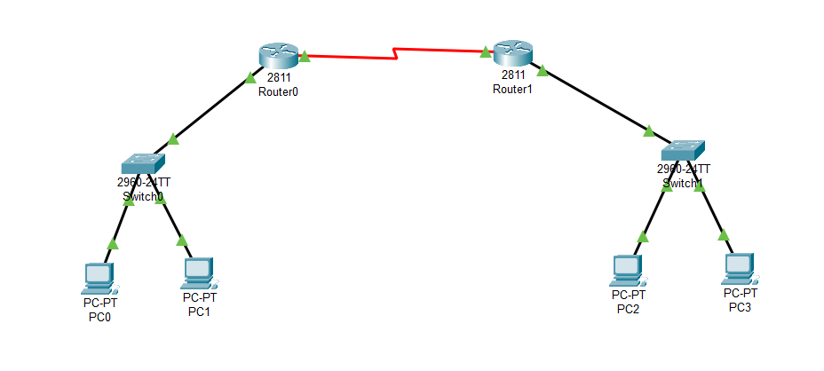

For Connections: Copper Straight Through Wire used for connection PCs with switch, and switches with routers, and serial DCE wires used for connecting routers with each other.

Setting up PC IPV4 and default gateway for all the PCs: (PC0 and PC2 configurations showed as an example of PCs connected to the separate networks.

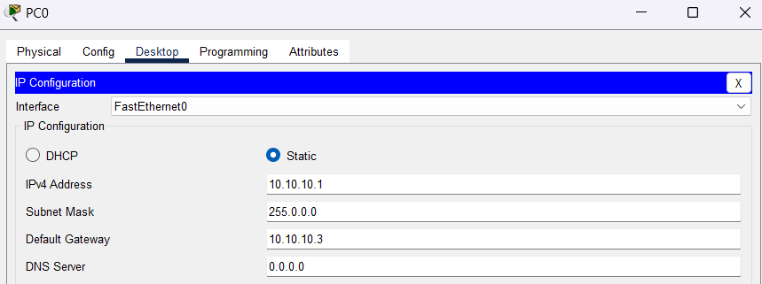

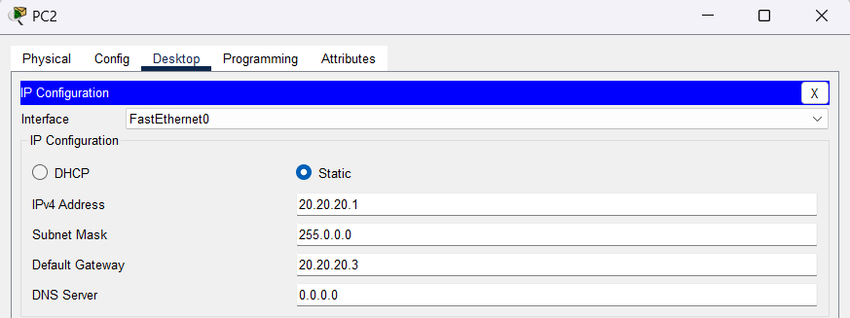

Setting up both router’s Fast-Ethernet ports to serve as a gateway:

Router 0:  
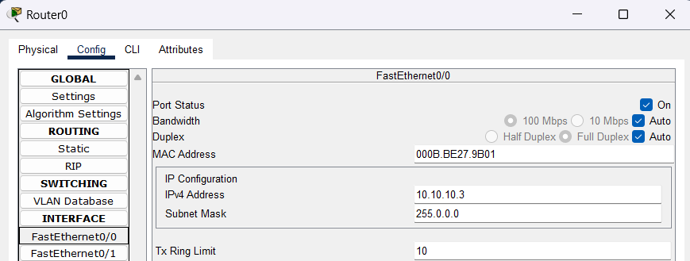

Router 1:  
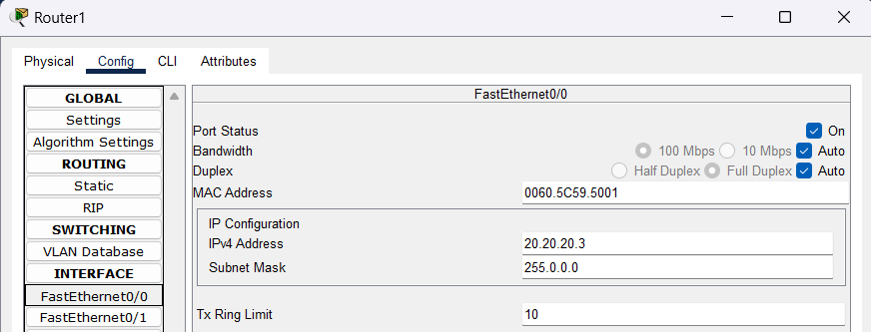

As a next step we need to connect the routers with each other. For that we need to add the WIC-2T module in both the routers. Four slots are available, and any one can be used for the same.

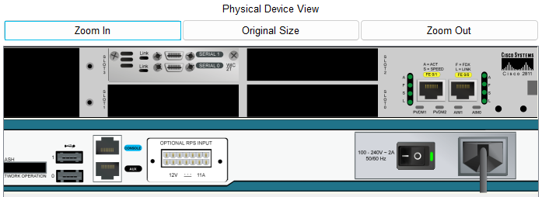

Module should be added only when the router is switched off, done by clicking on the switch button. The module contains 2 serial ports which will be used for connecting.

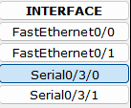

Next, the serial DCE wires is used to connect the two routers. The port needs to be selected as per user choice, where the connection is to be made.

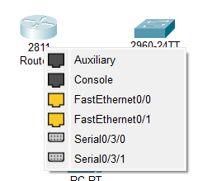

Connection done:

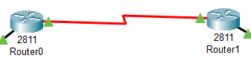

The green flags are achieved after giving an IPV4 to the serial ports, along with providing the specified details.

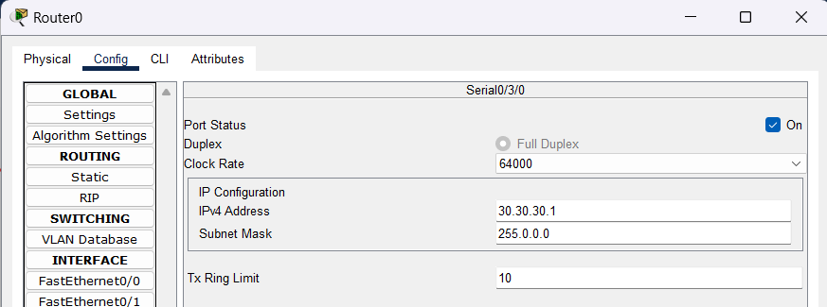

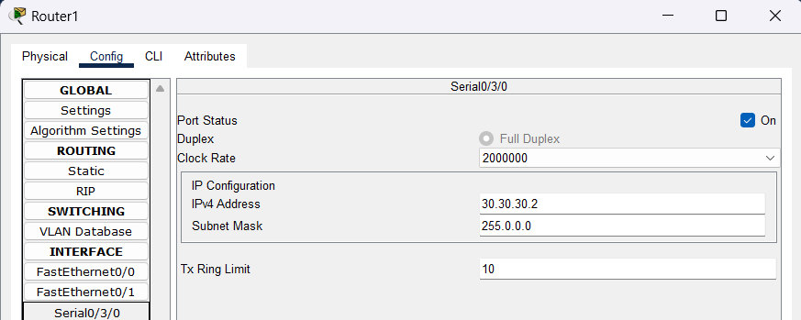

After this, a few commands are to be typed in the CLI (Command Line Interface) of both the routers.

From Router 1 (IPV4: 30.30.30.1) to connect to Router 2 (IPV4: 30.30.30.2)

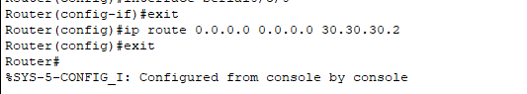

From Router 2 (IPV4: 30.30.30.2) to connect to Router 1 (IPV4: 30.30.30.1)

After this, the connections are ready to be experimented upon.

All message passing is successfully done.

**2. Connect a server to the network designed in the previous problem and transfer mail between pcs or open a web page.**

Components used:

Connection Diagram after connecting server:

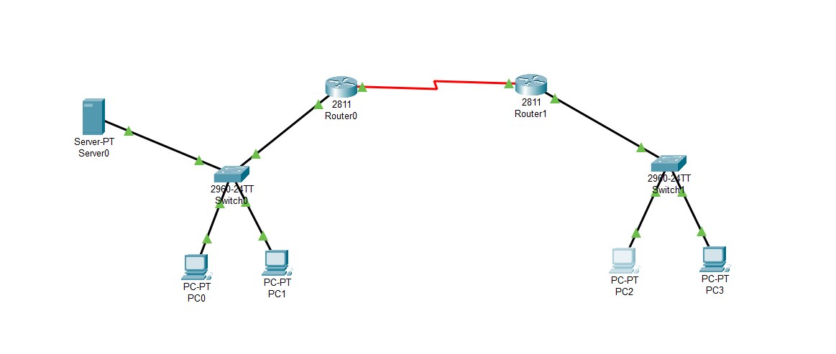Setting server configurations:

We can see from the connection diagram that the server is connected to the router0 side of the connection diagram. So, we will try to access the webpage from PC2 which is at a different network.

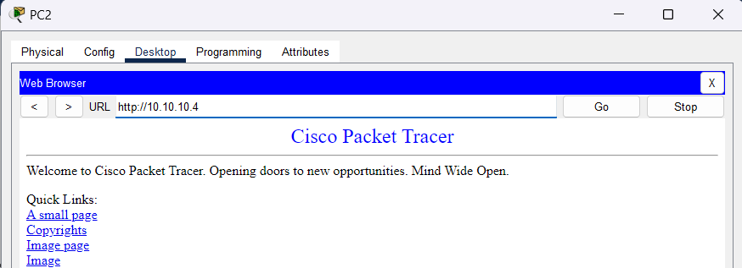

**For Sending email:**Email services need to be configured in the server:  
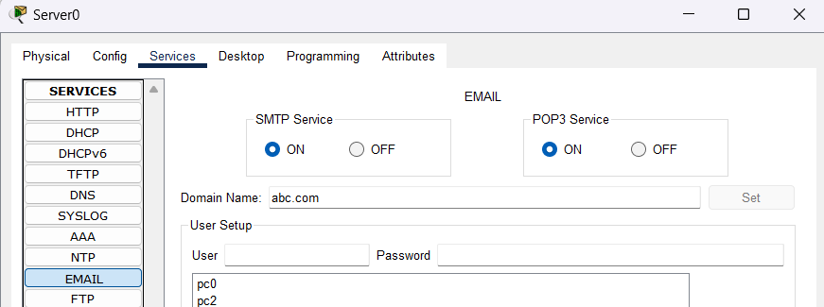

PC0 and PC2 are in separate networks. Their mails need to be configured as well.

Sending mail from PC2 to PC0

Mail successfully received by PC0 from PC2

Both webpage access, and email sending was successful.

**3. Create a complex network using three or more routers and transfer messages from one network to another.**

Components used:

Connection Diagram:  
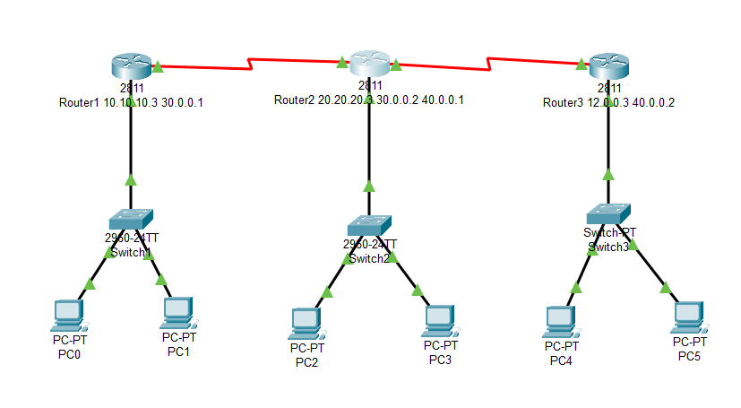

From the diagram, we can see that each of the routers have been given an IPV4 for the Fast-Ethernet, that serves as a default gateway for the end devices or the PCs. The other important thing to notice is that IPV4 is also assigned to the Serial ports of the WIC-2T module.

Serial Port configuration for Router 1.

Serial Port configuration for Router 2. Note both the serial ports of the WIC-2T module have been used, due to double connections.

Serial Port configuration for Router 3.

After this command is given to the respective CLIs of the routers, to recognize the routers that it needs to connect to.

Note the IPV4s are:

* Router 1: Serial 0/0/0 – 30.0.0.1
* Router 1: Serial 0/0/0 – 30.0.0.2 & Serial 0/0/1 – 40.0.0.1
* Router 1: Serial 0/0/0 – 40.0.0.2

Router 1 needs to recognize Router 2, so command is:

Router 2 needs to recognize both Router 1 & Router 3, so command is:

Router 2 needs to recognize Router 3, so command is:

**Observations:**

Sending msg from PC0 to all routers:  
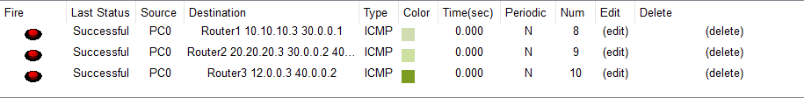

Sending msg from PC0 to different PCs in different networks:  
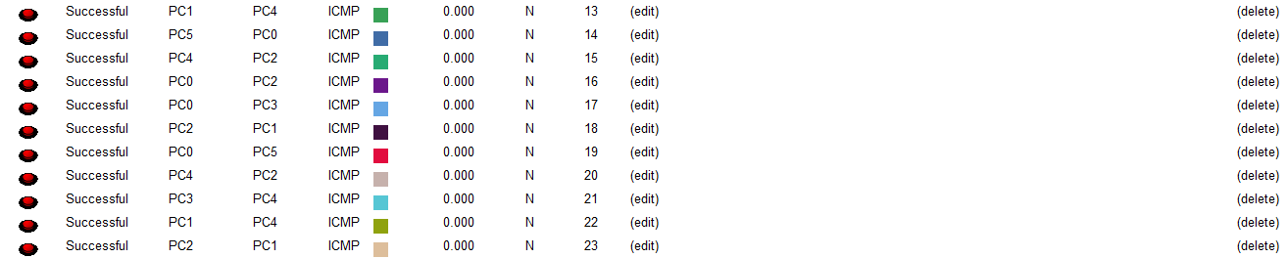

Since connections are successful everywhere, the connection has been established successfully, between all three routers.