An Internship Report
on
CUSTOMER CHURN PREDICTION USING MACHINE LEARNING
submitted in partial fulfillment of the requirements for the award of the degree of

BACHELOR OF TECHNOLOGY

IN

COMPUTER SCIENCE AND ENGINEERING (DATA SCIENCE)

by

MUPPIDI SAMHITA REDDY
24R11A67H4

Under the esteemed guidance of

Name of the Guide
Designation of the Guide


DEPARTMENT OF COMPUTER SCIENCE AND ENGINEERING( DATA SCIENCE)

GEETHANJALI COLLEGE OF ENGINEERING AND TECHNOLOGY

Appoved by AICTE, New Delhi, Affiliated to JNTUH University, Hyderabad and Accredited by NAAC & NBA.

Cheeryal(V), Keesara(M), Medchal(Dist.), Telangana – 501 301.

(An Autonomous Institution)

July, 2026
Academic Year: 2025-26

GEETHANJALI COLLEGE OF ENGINEERING AND TECHNOLOGY (Autonomous)
Accredited by NAAC with A⁺ Grade; B.Tech. CSE, EEE, ECE Accredited by NBA
Sy. No: 33 & 34, Cheeryal (V), Keesara (M), Medchal District, Telangana – 501301

DEPARTMENT OF COMPUTER SCIENCE AND ENGINEERING( DATA SCIENCE)



Certificate

This is to certify that the Internship Report entitled “CUSTOMER CHURN PREDICTION USING MACHINE LEARNING” is a bonafide work done by MUPPIDI SAMHITA REDDY bearing Roll No. 24R11A67H4 in partial fulfillment of the requirements for the award of the degree of Bachelor of Technology in “Computer Science and Engineering (Data Science)” from Jawaharlal Nehru Technological University, Hyderabad during the academic year 2025-2026.

Signature of the Guide

Name of the Guide

Designation of the Guide

Signature of the Head

Dr. D. Sujatha

Professor

Internship Certificate on the Letter Head of the Organization to be kept here

DECLARATION BY THE CANDIDATE

I, MUPPIDI SAMHITA REDDY, bearing Roll No. 24R11A67H4 hereby declare that the Internship Report entitled “CUSTOMER CHURN PREDICTION USING MACHINE LEARNING” is submitted in partial fulfillment of the requirements for the award of the degree of Bachelor of Technology in Computer Science and Engineering (Data Science).

This is a record of bonafide work carried out by me during the internship. The work presented in this report is based on the Customer Churn Prediction project developed using the provided customer dataset and Jupyter Notebook workflow. The results embodied in this Internship Report have not been submitted to any other University or Institute for the award of any other degree or diploma.

Signature of the Student
MUPPIDI SAMHITA REDDY
24R11A67H4

ACKNOWLEDGEMENTS

I would like to express my sincere gratitude to everyone who supported me during my internship and helped me complete this project successfully. I am grateful to the management, faculty members, and Department of Computer Science and Engineering (Data Science), Geethanjali College of Engineering and Technology, for providing the academic environment and resources required for my learning.
I am especially thankful to my internship guide and coordinator for their guidance, feedback, and encouragement throughout the internship. I also appreciate the support of my classmates and everyone who contributed directly or indirectly to my learning. This internship gave me an opportunity to apply concepts of Python, data analysis, and machine learning to a practical customer churn prediction problem.
The internship helped me connect classroom concepts with a practical machine learning workflow and gave me valuable experience in working with data, models, evaluation methods, and model persistence.

MUPPIDI SAMHITA REDDY,
24R11A67H4.

INTRODUCTION ABOUT THE INTERNSHIP ORGANIZATION
The official name and profile of the internship organization were not included in the supplied files. This section should contain the organization’s official introduction, area of operation, major activities, and the department or role in which the internship was completed.
The project work documented in this report focused on applying data science and machine learning techniques to customer churn prediction. The work covered data inspection, cleaning, exploratory data analysis, feature engineering, preprocessing, model development, model comparison, cross-validation, hyperparameter tuning, feature-importance analysis, and saving the trained model for future deployment.

INTERNSHIP SCHEDULE

WEEK-1 | Understanding the churn problem; loading churn.csv; inspecting columns, data types, missing values, duplicates, and dirty values.
WEEK-2 | Data cleaning, type conversion, identifier removal, referral and date-based feature engineering, customer tenure and last-visit features, and EDA.
WEEK-3 | Building preprocessing pipelines; training Logistic Regression, Decision Tree, Random Forest, Extra Trees, Gradient Boosting, and AdaBoost; evaluating model performance.
WEEK-4 | Five-fold stratified cross-validation; GridSearchCV tuning of Random Forest and Extra Trees; final model evaluation, feature importance, and Joblib model saving.

TABLE OF CONTENTS

S. No. | CONTENTS | PAGE. No.
a. | List of Figures | i
b. | List of Tables | ii
c. | List of Symbols/ Abbreviations | iii
1. | Abstract | 1
2. | Introduction | 2
3. | Related work/ Technologies Used | 3
4. | Work done/ Observation/ Duties performed | 5
5. | Learning after Project | 11
6. | Summary / Conclusion | 12

LIST OF FIGURES

S. No. | Fig. No. | Titles of Figures | Page. No.
1 | 4.1 | Architecture of Customer Churn Prediction System | 5
2 | 4.2 | Data Flow of Customer Churn Prediction System | 6
3 | 4.3.1 | Dataset Preparation and Feature Engineering | 7
4 | 4.3.2 | Feature Engineering Summary | 7
5 | 4.4.1 | Exploratory Data Analysis Workflow | 8
6 | 4.4.2 | Classification Models Compared | 8
7 | 4.4.3 | Five-Fold Stratified Cross-Validation | 9
8 | 4.4.4 | Hyperparameter Tuning Workflow | 9
9 | 4.4.5 | Final Model Evaluation Outputs | 10
10 | 4.4.6 | Feature Importance and Sample Prediction | 10

LIST OF TABLES

S. No. | Table. No. | Titles of The Table | Page. No.
1 | Schedule | Internship Schedule | 7

LIST OF SYMBOLS/ABBREVATIONS

- EDA - Exploratory Data Analysis
- ML - Machine Learning

ABSTRACT

The project follows an end-to-end machine learning workflow. The dataset is first inspected and cleaned by handling missing values, placeholder symbols such as “?”, invalid “Error” entries, incorrect numeric values, and unnecessary identifier columns. Feature engineering is performed using referral information, joining dates, customer tenure, last visit time, and visit period. Exploratory Data Analysis is then used to understand the distribution of the target and relationships between customer attributes and churn risk.
A preprocessing pipeline is built using imputation, scaling, and one-hot encoding. Multiple classification algorithms are trained and compared, including Logistic Regression, Decision Tree, Random Forest, Extra Trees, Gradient Boosting, and AdaBoost. The models are evaluated using Accuracy, Precision, Recall, F1-score, and ROC-AUC. Five-fold stratified cross-validation is used for additional validation, while GridSearchCV is used to tune Random Forest and Extra Trees. The final pipeline is saved using Joblib and prepared for future Streamlit deployment.

INTRODUCTION

Machine learning provides a practical way to study customer data and identify patterns associated with churn. Information such as customer activity, frequency of visits, referrals, complaints, account-related details, and other behavioral attributes can be used as input features for a predictive model. In this project, the target variable is churn_risk_score, where the notebook treats 1 as churn or high churn risk and 0 as not churn.
The project was developed as a complete machine learning workflow using Python and Scikit-learn. It includes data inspection, cleaning, type conversion, feature engineering, exploratory data analysis, train-test splitting, preprocessing, model training, evaluation, cross-validation, hyperparameter tuning, feature-importance analysis, and model saving. The workflow is designed so that preprocessing and prediction can be reused consistently for new customer records.
After training, the final pipeline is saved as customer_churn_pipeline.pkl using Joblib. The saved pipeline can be loaded to produce both a predicted churn class and a churn probability for a new customer record. The project therefore provides a practical foundation for further integration into an interactive Streamlit application.

2

RELATED WORK / TECHNOLOGIES USED

Google Colab & Browser-Based Development Tools:
Google Colab was used as the primary browser-based development environment for the project. The Jupyter Notebook workflow was used to write and execute Python code, inspect the dataset, perform exploratory data analysis, build preprocessing and machine learning pipelines, compare models, tune hyperparameters, evaluate the final model, and save the trained pipeline.

Technologies Used

      - Python: Primary programming language for data processing, analysis, visualization, and machine learning.
      - Google Colab / Jupyter Notebook: Development and execution environment.

Pandas and NumPy: Data manipulation, cleaning, type conversion, and numerical operations.
Matplotlib and Seaborn: Exploratory data analysis and visualization.

WORK DONE / OBSERVATION / DUTIES PERFORMED
Joblib: Saving and loading the trained machine learning pipeline.

System Architecture of Proposed System

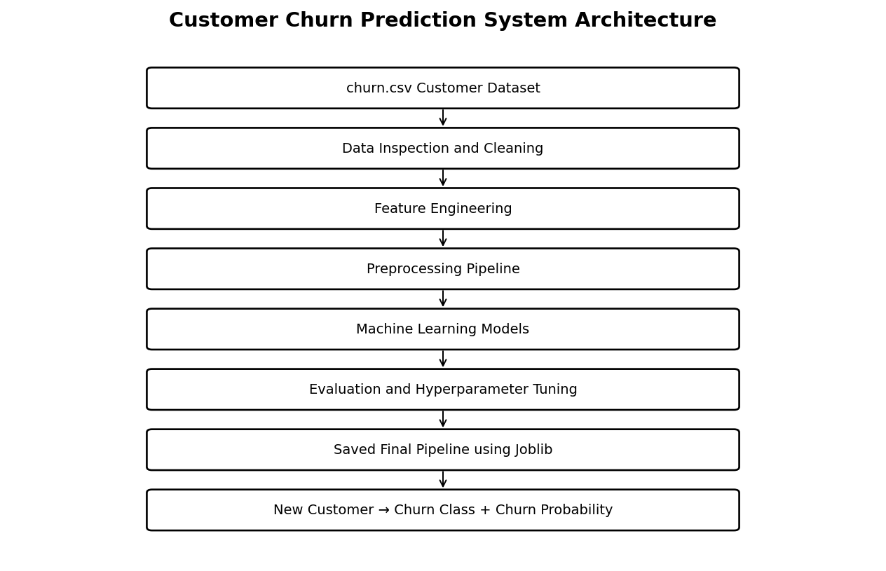

Fig 4.1: Architecture of Customer Churn Prediction System

  - Data Flow
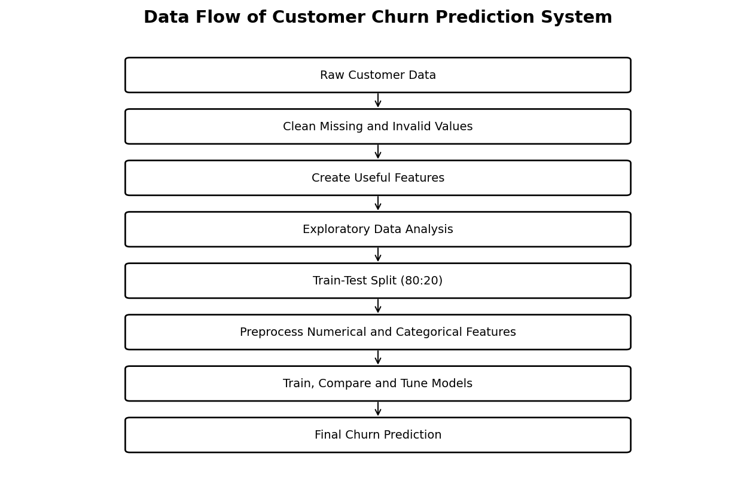
The data flow begins with the churn.csv customer dataset. The data is inspected and cleaned, followed by feature engineering and exploratory analysis. The prepared data is divided into training and testing sets. A preprocessing pipeline handles numerical and categorical features before the machine learning models are trained. Model performance is compared using multiple evaluation metrics and cross-validation. The better-performing ensemble models are tuned, after which the final model is selected, evaluated, and saved. For a new customer, the saved pipeline processes the input and returns a predicted churn class and churn probability.
Fig 4.2: Data Flow of Customer Churn Prediction System

Data Sets
The project uses the provided churn.csv dataset. The target column is churn_risk_score, treated as a binary target in the notebook. The dataset contains customer attributes related to activity, visits, referrals, complaints, feedback, joining date, last visit time, and other account-related information. The notebook performs cleaning and transformation before these attributes are used for modeling.

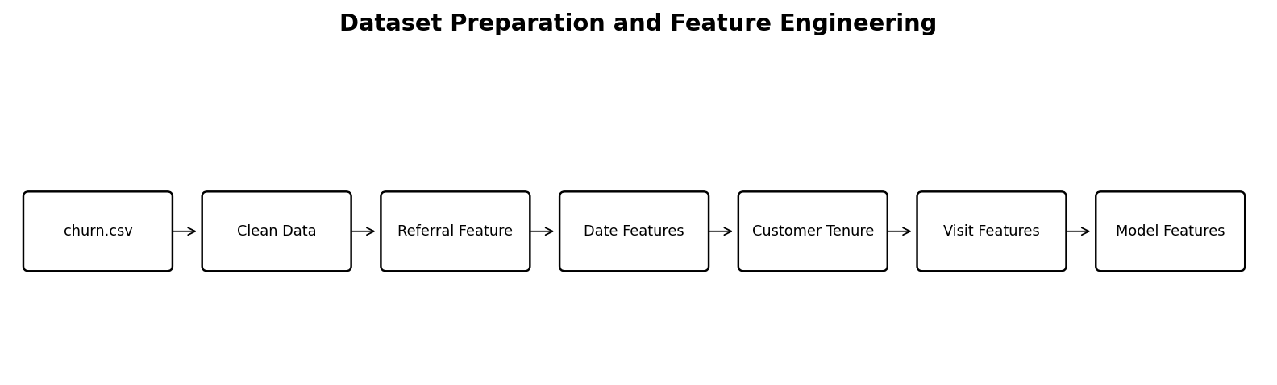
Fig 4.3.1 – Dataset Preparation and Feature Engineering

Key Features Extracted for Functionality
The feature-engineering stage creates has_referral_id, joining_year, joining_month, joining_day, joining_dayofweek, customer_tenure_days, last_visit_hour, and visit_period. The original referral_id, joining_date, and last_visit_time are removed after useful information is extracted. Invalid negative values in days_since_last_login are converted to missing values and later handled by the preprocessing pipeline.

Fig 4.3.2 – Feature Engineering Summary

Project Analysis and Model Development

Exploratory Data Analysis
The notebook examines target distribution, numerical feature distributions, possible outliers, categorical distributions, churn rates by categorical variables, and numerical features against churn risk.

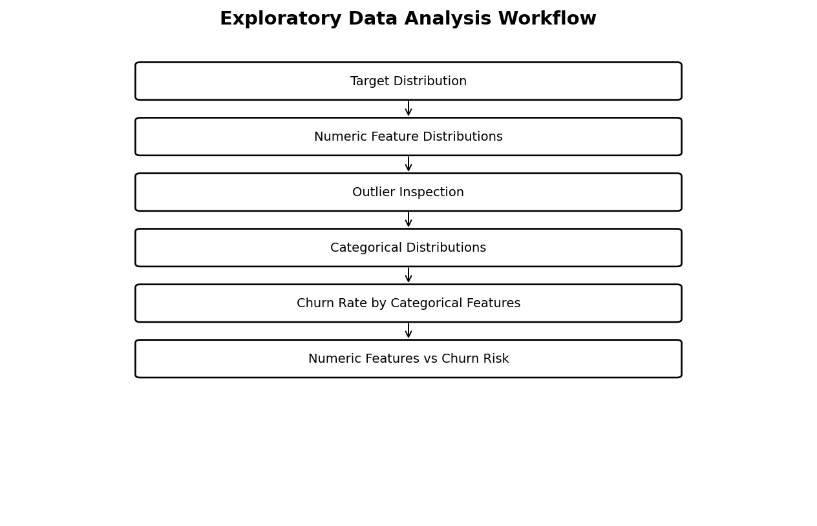
Fig 4.4.1 – Exploratory Data Analysis Workflow

Classification Models Compared
Six classification algorithms are trained through a common preprocessing pipeline: Logistic Regression, Decision Tree, Random Forest, Extra Trees, Gradient Boosting, and AdaBoost.

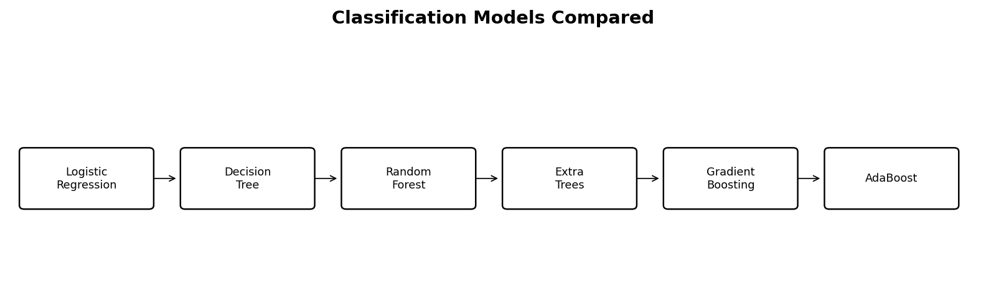
Fig 4.4.2 – Classification Models Compared

Cross-Validation
Five-fold StratifiedKFold cross-validation is used on the training data, with mean F1-score and standard deviation recorded for model comparison.

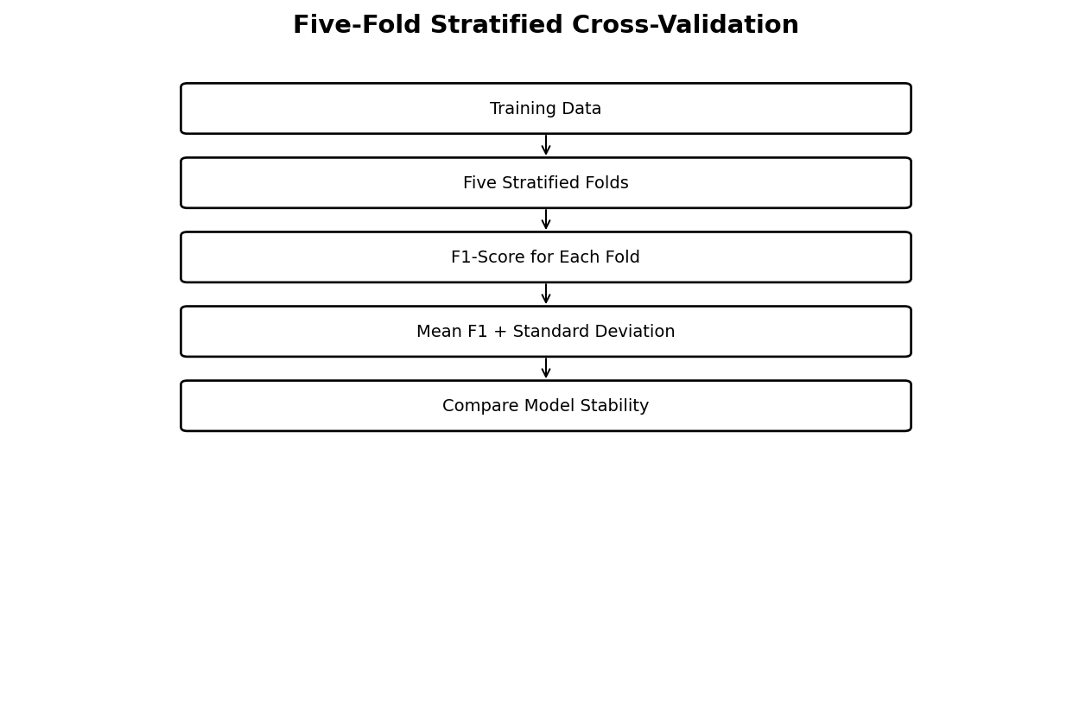
Fig 4.4.3 – Five-Fold Stratified Cross-Validation

Hyperparameter Tuning
Random Forest and Extra Trees are tuned using GridSearchCV. The tuning grid varies tree count, maximum depth, minimum samples for splitting and leaves, and class weighting, with F1-score used as the optimization metric.

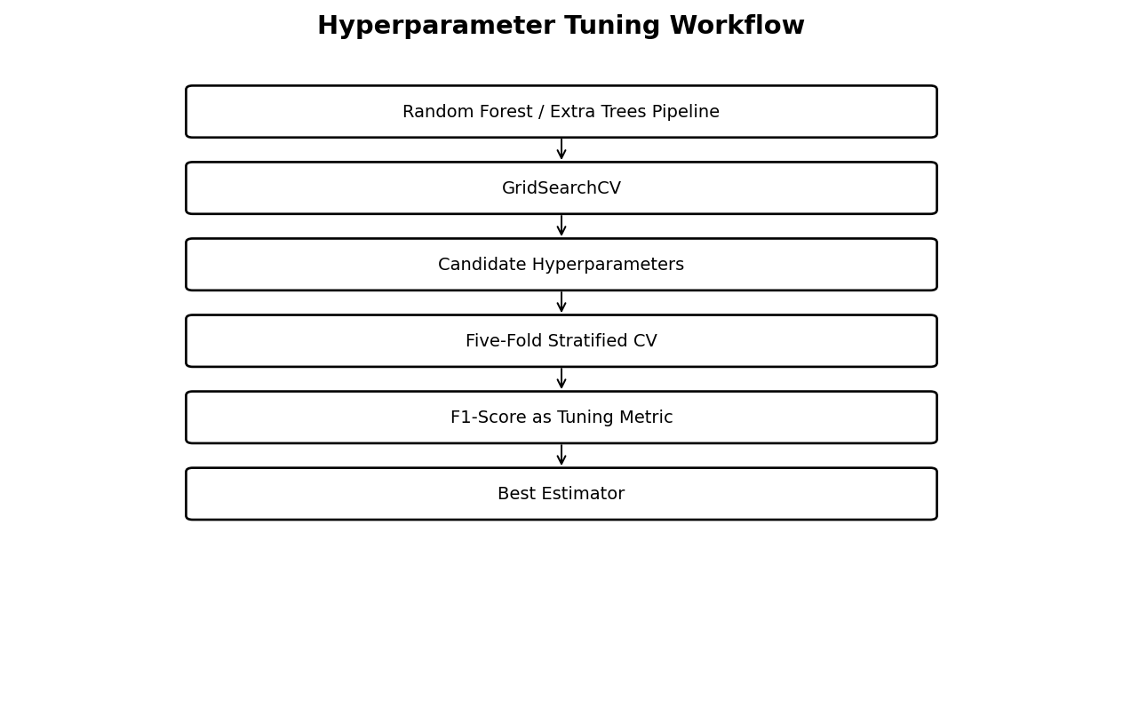
Fig 4.4.4 – Hyperparameter Tuning Workflow

Final Model Evaluation
The selected final model is evaluated on the test set using a confusion matrix, classification report, ROC curve, and ROC-AUC.

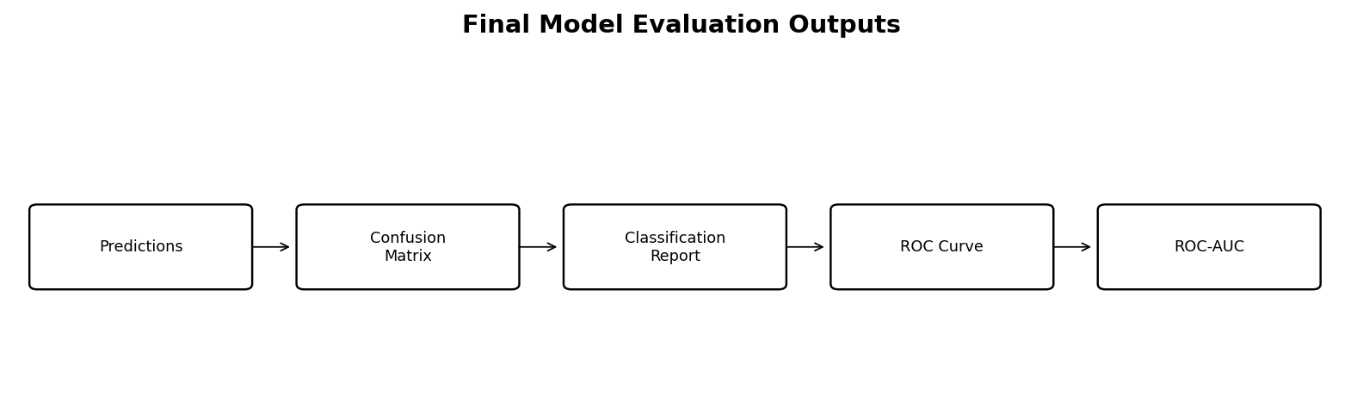
Fig 4.4.5 – Final Model Evaluation Outputs

Feature Importance and Prediction
Feature importance is extracted from the final tree-based model. The saved pipeline is reloaded with Joblib and used to generate a sample prediction and churn probability.

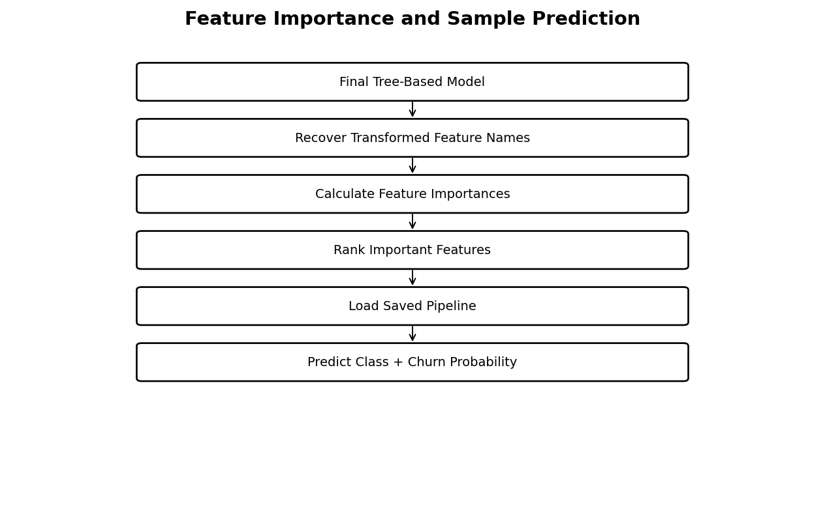
Fig 4.4.6 – Feature Importance and Sample Prediction

LEARNING AFTER INTERNSHIP

I learned how to perform exploratory data analysis using Pandas, Matplotlib, and Seaborn. Creating distributions, boxplots, categorical plots, churn-rate comparisons, and feature-versus-target analyses helped me understand how customer attributes can be examined before model development.
The project improved my understanding of machine learning pipelines. I learned how numerical and categorical preprocessing can be combined with models using Scikit-learn Pipeline and ColumnTransformer. I also learned why classification problems should be evaluated using multiple metrics rather than accuracy alone.

SUMMARY / CONCLUSION
Working with cross-validation and GridSearchCV gave me practical experience in model validation and hyperparameter tuning. I also learned how to examine feature importance, save a trained pipeline using Joblib, reload it, and generate a prediction and probability for a new customer record.

Random Forest and Extra Trees were selected for additional hyperparameter tuning using GridSearchCV, and the notebook sets the tuned Random Forest as the final model unless the run is changed based on the comparison. The final pipeline is evaluated using a confusion matrix, classification report, ROC curve, and ROC-AUC, then saved as customer_churn_pipeline.pkl. The saved pipeline can be loaded for new customer predictions and provides a foundation for a future Streamlit application.

BIBLIOGRAPHY

1. Scikit-learn Documentation, Machine Learning in Python.

