Instacart Customer Analytics Dashboard
End-to-End Data Analytics Project using Python, DuckDB, SQL & Power BI

Introduction
The grocery retail industry generates millions of customer transactions every day, producing vast amounts of data that can be leveraged to improve operational efficiency, customer satisfaction, and business profitability. However, raw transactional data alone provides limited value without proper analysis and visualization.
This project demonstrates an end-to-end data analytics workflow using the Instacart Online Grocery Shopping Dataset, transforming over 3.4 million customer orders into actionable business insights. The project covers the complete analytics pipeline—from importing raw CSV files into a DuckDB database, performing SQL-based business analysis, creating reusable analytical views, and finally developing interactive executive dashboards in Power BI.
The dashboards focus on understanding customer purchasing behavior, identifying high-performing products and departments, measuring customer loyalty and retention, and discovering opportunities for subscription-based services. Rather than simply displaying data, the project emphasizes business storytelling and decision support through clear, executive-focused visualizations.
By combining Python, DuckDB, SQL, and Power BI, this project demonstrates practical skills in data engineering, analytics, business intelligence, and dashboard design that are commonly required in modern Data Analyst roles.

Project Objectives
The primary objectives of this project are to:
- Build an analytical database by importing and managing large-scale Instacart transaction data using DuckDB.
- Analyze customer purchasing behavior to identify shopping trends and patterns.
- Evaluate product and department performance through SQL-based business analysis.
- Measure customer retention and loyalty using customer segmentation and reorder metrics.
- Identify products with high subscription potential based on purchase frequency and reorder rates.
- Develop executive-level Power BI dashboards that communicate business insights through clear and interactive visualizations.
- Demonstrate a complete end-to-end analytics workflow suitable for a professional data analytics portfolio.

Business Problem
Online grocery platforms process millions of transactions every day, making it difficult to extract meaningful insights directly from raw transactional data. Business teams require reliable analytics to understand customer behavior, optimize inventory, improve customer retention, and identify products that contribute most to revenue and customer loyalty.
Without a centralized analytics solution, answering important business questions becomes time-consuming and inefficient.
This project addresses these challenges by answering questions such as:
- When do customers place the most orders?
- Which days require the highest operational capacity?
- Which products and departments generate the highest demand?
- Which customer segments contribute the most to business performance?
- Which departments have the strongest customer loyalty?
- Which products are suitable for subscription or auto-replenishment services?
- How effectively does the platform retain customers over multiple purchases?
The insights generated through this analysis can support data-driven decision-making in areas such as inventory management, marketing campaigns, customer retention strategies, and operational planning.

2. Dataset Description
This project utilizes the Instacart Online Grocery Shopping Dataset, a publicly available dataset containing anonymized customer grocery orders collected over multiple shopping sessions. The dataset represents the purchasing behavior of customers on an online grocery platform and is widely used for customer behavior analysis and business intelligence applications.
The dataset contains transactional information that enables the analysis of shopping patterns, reorder behavior, customer loyalty, product popularity, and department performance. Since the data is organized across multiple related tables, it is well suited for relational database management systems and SQL-based analytics.
The project makes use of five primary tables that together provide a complete view of customer purchasing activities.
Dataset Tables
Table | Description
orders | Stores order-level information including customer ID, order sequence, day of week, hour of day, and time between purchases.
order_products_prior | Contains the products purchased in previous orders along with reorder information and cart position.
products | Provides product names together with their corresponding aisle and department identifiers.
aisles | Contains the list of grocery aisles used to categorize products.
department | Contains the high-level business departments such as Produce, Dairy Eggs, Bakery, and Frozen Foods.

These tables are linked through primary and foreign keys, allowing complex SQL joins to analyze customer purchasing behavior across multiple business dimensions. By combining order information with product, aisle, and department details, the project can generate meaningful business insights that would not be possible from a single table alone.

Dataset Summary
Metric | Value
Total Orders | 3,421,083
Total Customers | 206,209
Total Products | 49,688
Total Aisles | 134
Total Departments | 21

The scale of the dataset closely resembles a real-world retail environment, making it ideal for developing practical analytics solutions. Processing millions of transaction records requires efficient data storage and query execution, which is one of the primary reasons DuckDB was selected as the analytical database for this project. The dataset provides sufficient volume and complexity to perform meaningful customer segmentation, retention analysis, product performance evaluation, and operational reporting.

3. Technology Stack
To build a complete end-to-end analytics solution, multiple technologies were integrated throughout different stages of the project. Each tool was selected based on its strengths in data processing, database management, analysis, or visualization.
Technology Stack
Technology | Purpose
Python | Imported raw CSV files, automated data loading, and managed the database setup process.
DuckDB | Stored and queried millions of transaction records efficiently without requiring a database server.
SQL | Performed business analysis, created reusable SQL views, and generated analytical datasets for reporting.
Power BI | Built interactive dashboards to visualize KPIs and communicate business insights.
Pandas & NumPy | Assisted in data manipulation and preprocessing tasks during development.
Git & GitHub | Used for version control, project management, and portfolio publishing.
VS Code & Jupyter Notebook | Served as the primary development environment for scripting, SQL execution, and experimentation.

Each technology plays a specific role within the analytics pipeline. Python automates the ingestion of raw data into DuckDB, SQL transforms the data into business-ready views, and Power BI converts those analytical outputs into executive dashboards. The use of Git and GitHub ensures that the project remains reproducible, version-controlled, and professionally documented, reflecting industry-standard development practices.

Project Workflow

Raw CSV Files
│
▼
Python (Data Loading)
│
▼
DuckDB Database
│
▼
SQL Business Analysis
│
▼
SQL Views
│
▼
CSV Export
│
▼
Power BI Dashboard
│
▼
Business Insights

The workflow follows a structured analytics pipeline that transforms raw transactional data into actionable business intelligence. Initially, raw CSV files are imported into DuckDB using a Python automation script. SQL queries are then executed to perform business analysis and create reusable views that simplify reporting. These views are exported as CSV files and imported into Power BI, where they are used to build interactive dashboards. The final output provides decision-makers with insights into customer behavior, product performance, operational demand, and retention trends through visually intuitive reports.
4. SQL Business Analysis
Structured Query Language (SQL) was the primary tool used to transform raw transactional data into meaningful business insights. Rather than writing generic database queries, each analysis was designed to answer practical business questions related to customer behavior, operational performance, product demand, and customer loyalty. The SQL queries developed during this project were also used to create reusable database views, which served as the data source for the Power BI dashboards.
The following sections highlight some of the key analyses performed during the project.
4.1 Platform Overview
Business Question
How large is the Instacart platform?
Understanding the overall scale of the business is the first step in evaluating the dataset. This analysis calculates the total number of orders, customers, and products available on the platform.
SQL Query:

SELECT
(SELECT COUNT(DISTINCT order_id) FROM orders) AS total_order,
(SELECT COUNT(DISTINCT user_id) FROM orders) AS total_customers,
(SELECT COUNT(DISTINCT product_id) FROM products) AS total_products;

Result:
Business Insight
The dataset represents a large-scale online grocery platform with millions of transactions and hundreds of thousands of customers. This confirms that the analytical solution is designed to process real-world retail data and generate insights at scale.

4.2 Peak Ordering Hours
Business Question
When do customers place the most orders?
Identifying peak ordering hours helps businesses optimize warehouse operations, staffing levels, and delivery scheduling.
SQL Query:
SELECT
order_hour_of_day,
COUNT(*) AS Total_Orders
FROM orders
GROUP BY order_hour_of_day
ORDER BY Total_Orders DESC;

Result:
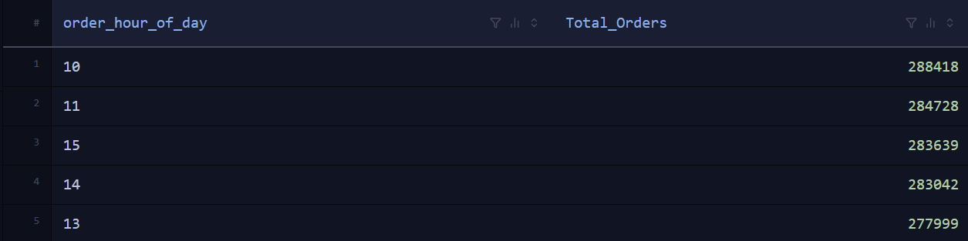

Business Insight
The analysis indicates that customer demand is highest during the late morning and early afternoon. These peak hours require increased staffing, inventory readiness, and delivery capacity to maintain efficient operations and ensure timely order fulfillment.

4.3 Top Purchased Products
Business Question
Which products are purchased most frequently?
This analysis identifies the products that contribute the highest purchase volume across all customer orders.
SQL Query
SELECT
p.product_name,
COUNT(op.product_id) AS Total_Purchases
FROM order_products_prior op
JOIN products p
ON op.product_id = p.product_id
GROUP BY p.product_id, p.product_name
ORDER BY Total_Purchases DESC
LIMIT 10;

Result:
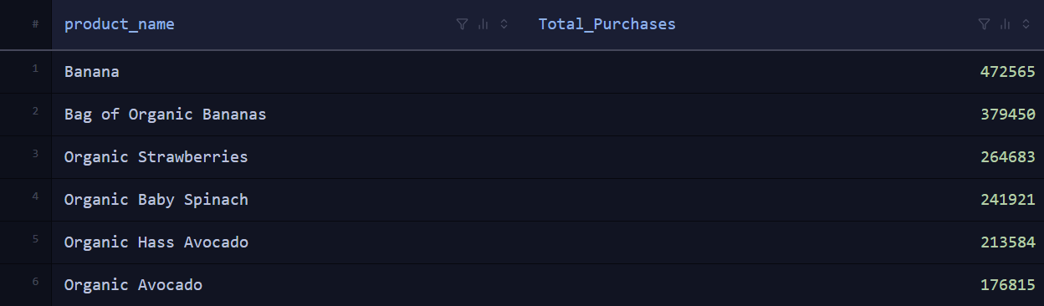

Business Insight
Frequently purchased products such as bananas and other grocery staples consistently drive customer demand. These products should receive priority in inventory management, supplier coordination, and promotional planning to minimize stock shortages and improve customer satisfaction.
4.4 Department Performance
Business Question
Which departments receive the highest number of purchases?
Department-level analysis provides insight into the business categories that generate the greatest customer demand.
SQL Query
SELECT
d.department,
COUNT(op.product_id) AS Total_Purchases
FROM order_products_prior op
JOIN products p
ON op.product_id = p.product_id
JOIN department d
ON p.department_id = d.department_id
GROUP BY d.department
ORDER BY Total_Purchases DESC;

Result
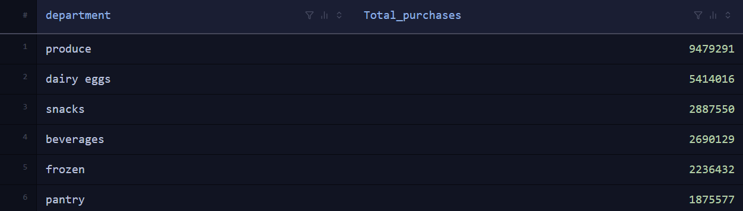

Business Insight
The Produce department records the highest purchase volume, followed by other essential grocery categories. Understanding department performance helps the business allocate inventory, improve supplier relationships, and prioritize high-demand product categories.
4.5 Customer Segmentation
Business Question
How can customers be classified based on their purchasing activity?
Customer segmentation groups shoppers according to the number of orders they have placed, allowing businesses to develop targeted marketing and retention strategies.
SQL Query
CREATE VIEW customer_segments AS
SELECT
user_id,
COUNT(*) AS Total_Orders,
CASE
WHEN COUNT(*) >= 50 THEN 'High Value'
WHEN COUNT(*) >= 20 THEN 'Medium Value'
ELSE 'Low Value'
END AS Customer_Segmentation
FROM orders
GROUP BY user_id;

Result:
Segment | Criteria
High Value | 50 or more orders
Medium Value | 20–49 orders
Low Value | Fewer than 20 orders

Business Insight
Segmenting customers enables businesses to personalize marketing campaigns and loyalty initiatives. High-value customers can be rewarded through exclusive offers and premium benefits, while low-value customers can be encouraged to make repeat purchases through targeted promotions.
4.6 Subscription Opportunity Analysis
Business Question
Which products are suitable for subscription or auto-replenishment services?
Products with consistently high purchase frequency and reorder rates are strong candidates for subscription-based services.
SQL Query
SELECT
p.product_name,
COUNT(*) AS Total_Purchases,
SUM(op.reordered) AS Total_Reorders,
ROUND(SUM(op.reordered) * 100.0 / COUNT(*), 2) AS Reorder_Rate
FROM order_products_prior op
JOIN products p
ON op.product_id = p.product_id
GROUP BY p.product_id, p.product_name
HAVING COUNT(*) >= 1000
ORDER BY Reorder_Rate DESC, Total_Purchases DESC
LIMIT 20;

Result
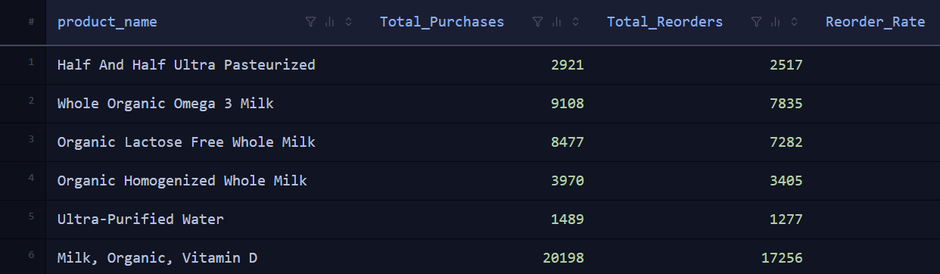

Business Insight
Products that exhibit both high purchase frequency and strong reorder rates are ideal candidates for subscription services. Offering automatic replenishment for these items can increase customer convenience, improve retention, and create a stable source of recurring revenue.

Summary
The SQL analysis performed in this project demonstrates how transactional data can be transformed into actionable business intelligence. By answering key business questions related to customer behavior, demand patterns, product performance, and customer loyalty, the analysis provides valuable insights that support data-driven decision-making. The resulting SQL views were integrated into Power BI to create interactive dashboards that present these findings in a clear and executive-friendly format.

5. Dashboard Development & Analysis
The final stage of the project involved transforming the analytical outputs generated through SQL into interactive dashboards using Power BI. The dashboards were designed with an executive-focused approach, emphasizing clarity, simplicity, and actionable insights rather than displaying excessive information.
To achieve a modern and consistent visual design, the dashboard layout was first created in Microsoft PowerPoint, where custom backgrounds, rounded containers, and visual elements were designed. The completed layout was exported as a PNG image and used as the dashboard background in Power BI. This approach provided greater flexibility over the dashboard's appearance while allowing Power BI to focus solely on data visualization.
The dashboard consists of two pages, each serving a distinct business purpose. The first page provides an overview of business performance, while the second page focuses on customer behavior, product performance, and actionable recommendations.

5.1 Executive Overview Dashboard
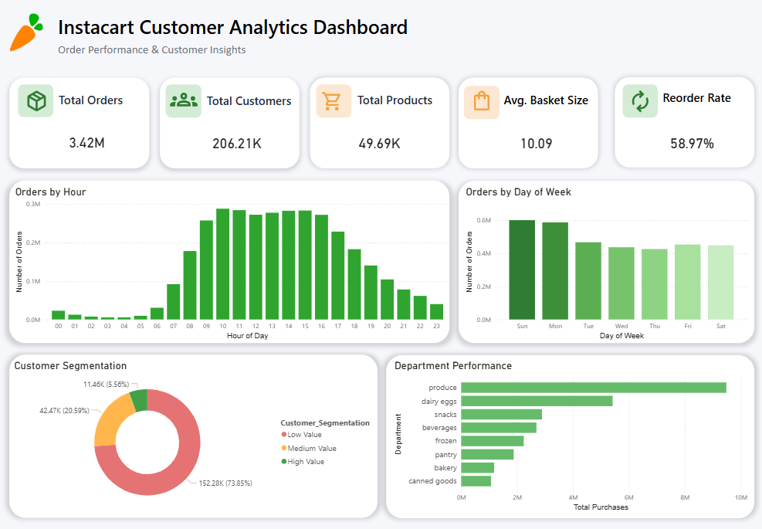
The Executive Overview dashboard provides a high-level summary of the overall performance of the Instacart platform. It enables business stakeholders to quickly assess key performance indicators and identify major operational trends without requiring detailed analysis.
The dashboard includes five KPI cards that summarize the overall scale of the business:
- Total Orders – Displays the total number of customer orders processed.
- Total Customers – Represents the number of unique customers in the dataset.
- Total Products – Shows the total number of products available.
- Average Basket Size – Measures the average number of products purchased per order.
- Overall Reorder Rate – Indicates the percentage of products that customers purchase repeatedly.
In addition to the KPI cards, several visualizations provide further insight into customer purchasing behavior:
- Orders by Hour identifies the busiest shopping hours, helping optimize staffing and delivery operations.
- Orders by Day of Week highlights weekly demand patterns, allowing better inventory and workforce planning.
- Customer Segmentation categorizes customers into High, Medium, and Low Value groups, supporting targeted marketing strategies.
- Department Performance compares purchase volumes across product departments, revealing which categories contribute most to overall sales.
This dashboard answers the business question:
"What is the current overall performance of the business?"
It provides executives with a concise summary of operational performance, customer activity, and product demand, enabling faster and more informed decision-making.

5.2 Customer & Product Insights Dashboard
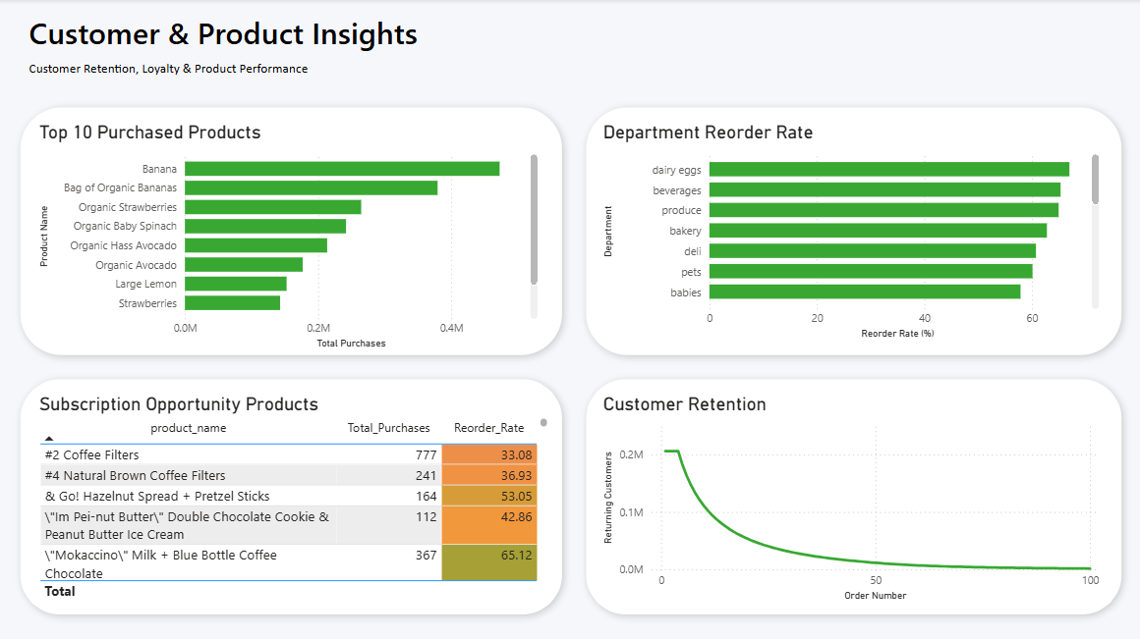
The Customer & Product Insights dashboard focuses on identifying growth opportunities by analyzing customer loyalty, product demand, and purchasing behavior. Unlike the Executive Overview dashboard, which summarizes performance, this page provides deeper insights that support strategic decision-making.
The dashboard includes several business-focused visualizations:
- Top Purchased Products identifies the products with the highest purchase volumes, helping prioritize inventory management and promotional planning.
- Department Reorder Rate measures customer loyalty across different departments by comparing product reorder behavior.
- Subscription Opportunity Products highlights products with consistently high purchase volumes and reorder rates, making them ideal candidates for subscription or auto-replenishment services.
- Customer Retention visualizes how many customers continue placing orders over time, helping evaluate customer engagement and long-term retention.
Together, these visualizations answer the business question:
"What actions can the business take to improve customer retention and increase revenue?"
The dashboard enables stakeholders to identify high-performing products, strengthen customer loyalty initiatives, and discover opportunities for recurring revenue through subscription-based services.

Dashboard Design Approach
The dashboards were designed following modern Business Intelligence principles to ensure readability, consistency, and effective communication of insights.
Key design choices include:
- Minimalist layout with ample white space to reduce visual clutter.
- Rounded cards and soft shadows to improve visual hierarchy.
- Instacart-inspired color palette using green as the primary accent color.
- Consistent typography with clear distinctions between titles, KPI values, and chart labels.
- Logical grouping of visuals to guide users through the dashboard naturally.
- Interactive Power BI visuals that allow users to explore business metrics efficiently.
These design principles improve the overall user experience by making complex analytical information easier to understand and interpret.

6. Key Business Insights
The dashboard analysis produced several valuable insights into customer purchasing behavior and overall business performance:
- The platform processes over 3.4 million customer orders, demonstrating the ability to analyze large-scale retail transaction data.
- Customer demand peaks during the late morning and early afternoon, indicating the need for additional operational resources during these hours.
- Sundays and Mondays experience the highest order volumes, requiring increased inventory availability and staffing.
- The Produce department contributes the largest share of total purchases, making it one of the most important business categories.
- Products such as Bananas consistently rank among the most frequently purchased items, emphasizing the importance of maintaining adequate stock levels.
- High reorder rates in departments like Produce and Dairy Eggs indicate strong customer loyalty and repeat purchasing behavior.
- Products with both high purchase volumes and high reorder rates represent strong opportunities for subscription or auto-replenishment services.
- Customer retention gradually declines as order numbers increase, suggesting opportunities for loyalty programs and personalized marketing campaigns to encourage repeat purchases.
These findings demonstrate how transactional data can be transformed into meaningful business intelligence that supports strategic decision-making, operational planning, and customer engagement initiatives.

7. Conclusion
The Instacart Customer Analytics Dashboard successfully demonstrates a complete end-to-end data analytics workflow, from data ingestion and database creation to SQL analysis and interactive dashboard development. By leveraging Python, DuckDB, SQL, and Power BI, the project transforms over 3.4 million transaction records into meaningful business insights.
Through customer segmentation, product performance analysis, reorder behavior, and retention analysis, the project provides actionable insights that can support inventory planning, customer engagement, and strategic business decisions. Overall, this project showcases practical data analytics and business intelligence skills while demonstrating the ability to convert large-scale transactional data into clear, executive-focused visualizations and insights.

