FOOD NUTRITION & HEALTH RISK ANALYSIS

Project Overview
The Food Nutrition & Health Risk Analytics System is a data analytics project designed to analyze the nutritional composition of various food items and identify potential health risks associated with their consumption.
The project utilizes Python for data cleaning and feature engineering, SQL for analytical querying, and Power BI for interactive dashboard development. The objective is to transform raw nutrition data into meaningful insights that can support healthier food choices and nutrition-based decision-making.

Objectives
The main objectives of this project are:
- Analyze nutritional characteristics of food items.
- Identify foods with high potential health risks.
- Evaluate nutritional quality using a Nutrition Density metric.
- Perform analytical queries using SQL.
- Build an interactive Power BI dashboard for data visualization.
- Generate actionable insights from food nutrition data.

Dataset Description
The dataset contains nutritional information for a variety of food items.
Key Attributes Used
Column | Description
Food Item | Name of the food
Energy (kcal) | Total calories
Carbs | Carbohydrate content
Protein (g) | Protein content
Fat (g) | Fat content
Free Sugar (g) | Sugar content
Fibre (g) | Dietary fibre
Cholesterol (mg) | Cholesterol content
Calcium (mg) | Calcium content
The dataset was processed and transformed to derive additional metrics for health analysis.

Data Cleaning & Feature Engineering
Data Cleaning
The following preprocessing steps were performed:
- Removed duplicate records.
- Handled missing values.
- Standardized column names.
- Verified data types for numerical analysis.
- Checked data consistency across nutritional attributes.
Feature Engineering
Health Risk Score
A custom Health Risk Score was developed to estimate the potential health impact of food items.
The score considers nutritional factors such as:
- Fat Content
- Free Sugar Content
- Cholesterol Content
Higher scores indicate greater potential health risks.
Nutrition Density
Nutrition Density was created to evaluate the nutritional value of food relative to calorie content.
Higher Nutrition Density values indicate foods that provide more nutrients per calorie consumed.
Risk Classification
Food items were categorized into:
- Low Risk
- Moderate Risk
- High Risk
based on their calculated Health Risk Score.

SQL Analysis & Key Findings
To extract meaningful insights from the nutrition dataset, several SQL queries were performed on the processed data stored in MySQL. The analysis focused on identifying healthy foods, high-risk foods, nutrient-rich foods, and overall dietary patterns.

1. Which Foods Are the Most Nutrient-Dense?
Objective
Identify foods that provide the highest nutritional value relative to calorie content.
SQL Query:
SELECT food_item,
nutrition_density
FROM nutrition
WHERE is_spice_condiment = FALSE
ORDER BY nutrition_density DESC
LIMIT 10;
SQL Query Result:
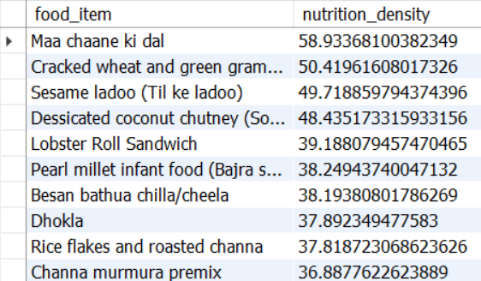
Figure 3: Top 10 Foods Ranked by Nutrition Density
Key Findings
- Maa Chaane Ki Dal achieved the highest nutrition density score in the dataset.
- Cracked Wheat and Green Gram Dal Premix ranked second.
- Traditional foods such as Dhokla and Soya Roti demonstrated excellent nutritional value.
- Foods rich in protein, fibre, and minerals generally achieved higher nutrition density values.

2. Which Foods Have the Highest Health Risk Scores?
Objective
Identify foods that may contribute to adverse health outcomes due to high levels of sugar, fat, or cholesterol.
SQL Query:
SELECT food_item,
health_risk_score
FROM nutrition
ORDER BY health_risk_score DESC
LIMIT 10;
SQL Query Result:
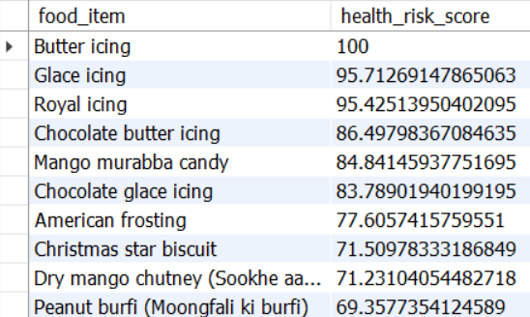
Figure 4: Top 10 Foods with Highest Health Risk Scores

Key Findings
- Butter Icing recorded the highest health risk score.
- Glace Icing and Royal Icing followed closely behind.
- Several frosting and icing products appeared among the highest-risk foods.
- Foods with high sugar content consistently generated elevated risk scores.

3. Which Foods Are Rich in Fibre but Low in Free Sugar?
Objective
Identify foods that support digestive health while maintaining low sugar levels.
SQL Query:
SELECT food_item,
fibre_g,
free_sugar_g
FROM nutrition
WHERE free_sugar_g < (SELECT AVG(free_sugar_g) FROM nutrition)
AND is_spice_condiment = FALSE
ORDER BY fibre_g DESC
LIMIT 10;
SQL Query Result:
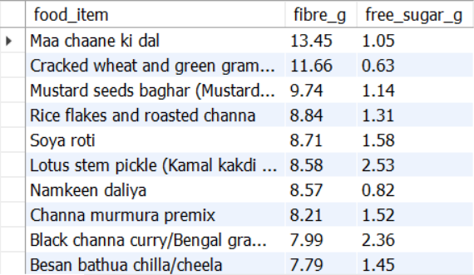
Figure 5: High-Fibre and Low-Sugar Foods

Key Findings
- Maa Chaane Ki Dal ranked first with the highest fibre content.
- Cracked Wheat and Green Gram Dal Premix also demonstrated excellent fibre levels.
- Soya Roti and Black Channa Curry emerged as strong choices for digestive health.
- Most top-performing foods were based on pulses, legumes, or whole grains.

4. Which Foods Have High Protein Content While Maintaining a Low Health Risk Score?
Objective
Identify healthier protein sources suitable for fitness and balanced nutrition.
SQL Query:
SELECT food_item,
protein_g,
health_risk_score
FROM nutrition
WHERE health_risk_score < 40
AND is_spice_condiment = FALSE
ORDER BY protein_g DESC
LIMIT 10;
SQL Query Result:
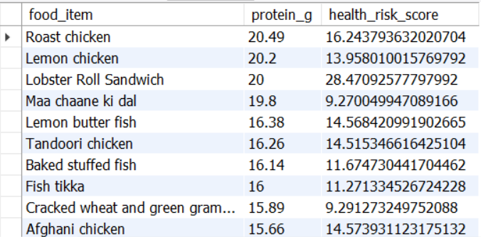
Figure 6: High-Protein Foods with Low Health Risk

Key Findings
- Roast Chicken achieved the highest protein content among low-risk foods.
- Lemon Chicken, Tandoori Chicken, and Fish Tikka ranked among the best animal-based protein sources.
- Maa Chaane Ki Dal and Cracked Wheat with Green Gram Premix emerged as strong plant-based alternatives.
- Both animal and plant-based foods demonstrated the ability to provide high-quality protein while maintaining relatively low health risk scores.

5. What Percentage of Foods Fall into Low, Medium, and High Health-Risk Categories?
Objective
Analyze the overall health profile of foods within the dataset.
SQL Query:
SELECT CASE
WHEN health_risk_score <= 33 THEN 'Low Risk'
WHEN health_risk_score <= 66 THEN 'Medium Risk'
ELSE 'High Risk'
END AS risk_category,
COUNT(*)
FROM nutrition
WHERE is_spice_condiment = FALSE
GROUP BY risk_category;
SQL Query Result:
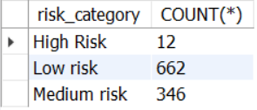
Figure 7: Health Risk Category Distribution

Key Findings
- The majority of foods belong to the Low-Risk category.
- Only a small percentage of foods were classified as High Risk.
- Most High-Risk foods consisted of desserts, confectionery products, and sugar-rich preparations.

6. What Are the Top 10 Healthiest Foods Overall?
Objective
Rank foods by combining Nutrition Density and Health Risk Score into a single overall health metric.
SQL Query:
SELECT food_item,
nutrition_density,
health_risk_score,
(nutrition_density - health_risk_score) AS overall_health_score
FROM nutrition
WHERE is_spice_condiment = FALSE
ORDER BY overall_health_score DESC
LIMIT 10;
SQL Query Result:
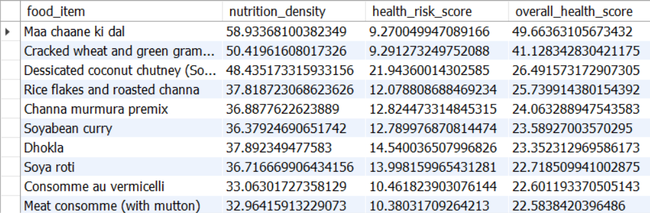
Figure 8: Top 10 Healthiest Foods Overall

Key Findings
- Maa Chaane Ki Dal ranked as the healthiest food in the dataset.
- Cracked Wheat and Green Gram Dal Premix secured the second position.
- Dhokla, Soya Roti, and Soyabean Curry consistently appeared among the healthiest options.
- Foods with high nutrition density and low health risk scores dominated the rankings.

Overall SQL Insights
The SQL analysis revealed several important trends:
- Foods with high nutrition density generally provide superior nutritional value per calorie consumed.
- High health risk scores are strongly associated with foods rich in sugar and unhealthy fats.
- Pulse-based, grain-based, and legume-based foods consistently appeared among the healthiest options.
- Several protein-rich foods maintained low health risk scores, making them suitable for balanced dietary planning.
- Combining Nutrition Density and Health Risk Score proved effective in identifying foods that maximize nutritional benefits while minimizing potential health concerns.
These findings formed the foundation for the Power BI dashboard and support data-driven food health assessment and dietary decision-making.

Power BI Dashboard
An interactive Power BI dashboard was developed to visualize nutritional trends and health indicators.
Dashboard Features
- KPI Cards
  - Total Foods
  - Average Health Risk Score
  - Average Nutrition Density
  - Percentage of Low-Risk Foods
- Risk Category Distribution
- Top Healthy Foods
- Top High-Risk Foods
- Nutrition Analysis
- Interactive Filtering using Slicers
Dashboard Benefits
The dashboard enables users to:
- Quickly identify healthy food options.
- Compare nutritional profiles.
- Explore health risks associated with food consumption.
- Make data-driven dietary decisions.
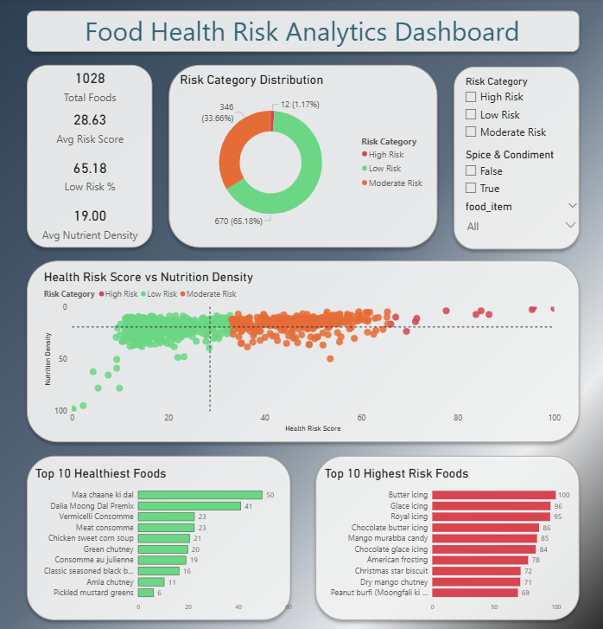

Key Insights
The analysis revealed several important findings:
- Foods with high free sugar and fat content contribute significantly to health risk scores.
- Nutrient-dense foods often contain higher levels of protein and fibre.
- Many foods with moderate calorie values differ substantially in nutritional quality.
- Risk categorization provides a simple method for evaluating food healthiness.

Business Impact
This project demonstrates how data analytics can be applied in the health and nutrition domain.
Potential applications include:
- Consumer nutrition awareness.
- Healthy food recommendation systems.
- Nutritional benchmarking.
- Decision support for diet planning.

Tools & Technologies
- Python
- Pandas
- NumPy
- MySQL
- SQLAlchemy
- Power BI
- Git & GitHub

Conclusion
The Food Nutrition & Health Risk Analytics System successfully analyzed 1,028 food items to evaluate their nutritional quality and potential health risks. By developing custom metrics such as Nutrition Density and Health Risk Score, the project provided a more comprehensive assessment of food healthiness than individual nutritional values alone.
The analysis identified foods such as Maa Chaane Ki Dal, Cracked Wheat and Green Gram Dal Premix, and Dhokla as some of the healthiest options in the dataset, while products like Butter Icing and Glace Icing were found to have the highest health risk scores. Additionally, the majority of foods were classified as low risk, indicating a generally favorable nutritional profile within the dataset.
Overall, this project demonstrates how data analytics, SQL, and Power BI can be used to transform raw nutritional data into meaningful insights that support healthier food choices and nutrition-focused decision-making.

Future Enhancements
- Include additional nutritional factors such as sodium and saturated fats in the risk assessment model.
- Develop machine learning models for automated health risk prediction.
- Build a personalized food recommendation system based on nutritional goals.
- Integrate real-time nutrition data from external APIs.
- Deploy the dashboard as a web application for broader accessibility.

