**San Francisco Bay University**

**EE461 - Digital Design and HDL**

**Quiz #1**

**Student Name: Simon Gezae Student ID: 19830**

1. **Design 4-to-1 mux by using *cmos switch* and *not* primitives, and then write the testbench to verify it by showing the waveforms.**

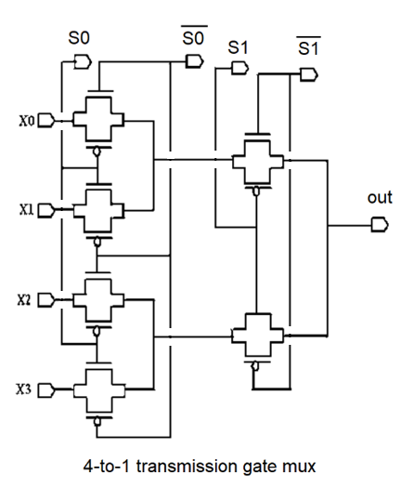**w1**

**W2**

