Lab_1 assignment

1. Result after running the Verilog program in EDA playground.

1. Based on the module *gates*, draw the digital circuit schematic

3)

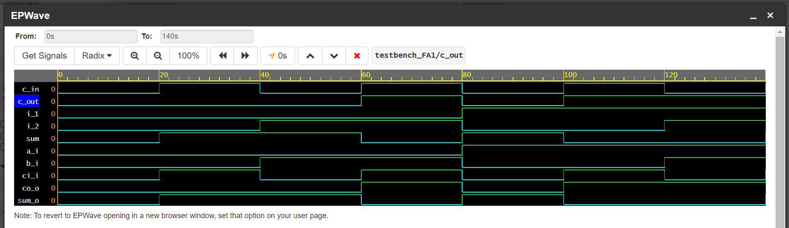

Testbench

