

**SEG 3101 PROJECT - DELIVERABLE 3**

Submitted

to

Wassim El Ahmar

By:

Group 22

Sami Hassan 3001691285

Uyen Nguyen, 300173303

Yi Yau Wong, 300241845

Tiana Ye, 300189296

Kristen Duong, 300240425

December 3, 2023

University of Ottawa

Software Requirements Specification

for

Graduate Admission Management System (GAMS)

Sami Hassan, 3001691285

Uyen Nguyen, 300173303

Yi Yau Wong, 300241845

Tiana Ye, 300189296

Kristen Duong, 300240425

December 3, 2023



Faculty of Engineering

**TABLE OF CONTENTS**

**1.0 Introduction** **1**

**1.1 Purpose 1**

**1.2 Scope 1**

**1.3 Product Overview 1**

**1.3.1 Product perspective 1**

**1.3.2 Product functions 2**

**1.3.3 User characteristics 3**

**1.3.4 Limitations 5**

**1.4 Definitions 5**

**2.0 References** **6**

**3.0 Requirements** **6**

**3.1 Functions 6**

**3.2 Performance requirements 8**

**3.3 Usability requirements 8**

**3.4 Interface requirements 8**

**3.5 Logical database requirements 9**

**3.6 Design constraints 9**

**3.7 Chosen validation techniques 10**

**4.0 Traceability** **10**

**5.0 Verification** **10**

**5.1 Preparation and Prototyping 11**

**5.2 Issues and Clarifications 13**

**6.0 Work Distribution** **13**

**7.0 Appendices** **14**

**7.1 Acronyms and abbreviations 14**

# 

**LIST OF FIGURES**

**Figure 1 Updated G.R.L. model describing the relationship between**

**actors and their goals 4**

**Figure 2 Prototype of GAMS login page 11**

**Figure 3 Prototype of two-factor authentication popup when a user**

**attempts to log in to their account 12**

**Figure 4 Prototype of the GAMS student application page 12**

**Figure 5 Prototype of an academic committee member’s application**

**page to review student applications 12**

**LIST OF TABLES**

**Table 1 General characteristics of stakeholders 3**

**Table 2 System function requirements 6**

**Table 3 System performance requirements 8**

**Table 4 System usability requirements 8**

**Table 5 System interface requirements 8**

**Table 6 System database requirements 9**

**Table 7 System design constraints 9**

**Table 8 Team members and their contributions 13**

# 

# 1.0 INTRODUCTION

## 1.1 Purpose

One of the purposes of the GAMS software is to allow aspiring graduate students a place to upload their application(s) and apply to the University of Ottawa. Its other purpose relates to academic assistants, associate directors as well as their committees, and professors. The software grants them access to and viewing permission to review student applications. Thus, creating a centralized system where GAMS simplifies the way for these groups to perform various tasks. Altogether, GAMS elevates current issues within various faculties by addressing inconsistencies in the existing process(es) and standardizing them. Therefore resulting in an efficient, transparent, and fair admission process.

## 1.2 Scope

The software product to be produced is called the Graduate Admission Management System (GAMS). This software will give students interested in graduate studies at the University of Ottawa the opportunity to search and apply to master/doctorate programs in the faculty of their choosing. It will also let academic assistants view and calculate the student’s CGPA and communicate eligible students to the Associate Director and its committee, who in turn, decide the admissibility of a student. If admissible, the faculty manager will contact the student with a letter of offer. From there, it automatically identifies students without a supervisor and attempts to match the student with a professor through automated emails.

That being said, GAMS effectively eliminates unsuccessful students and sends admissible applications to the correct person for further examination under the respective criteria (according to thesis/non-thesis programs). It also provides constant notifications/updates to students, enabling communication between the school and its potential graduate students. Overall, GAMS automates these repetitive and extensive processes for the university’s employees and bestows on them more time and resources that can be spent elsewhere. Thus, improving the process each stakeholder goes through and efficiently meeting the goals/reasons for using GAMS for each group.

## 1.3 Product Overview

### 1.3.1 Product perspective

The Graduate Admission Management System is a new and improved way of handling graduate admission at the University of Ottawa. GAMS is a centralized and automated system that has revolutionized the admission experience. It replaces the current manual process, which will make the entire admission workflow more efficient. GAMS has a user-friendly interface that caters to multiple user roles such as academic assistants, committee members, professors, and faculty managers. It can handle applicant information, evaluations, and decision-making processes with ease, while also providing evaluation templates and automated application allocation. This system also provides streamlined communication channels that facilitate efficient information sharing and collaboration across faculties and programs. With its innovative features and dynamic capabilities, GAMS aligns perfectly with the institution’s commitment to excellence and efficiency, ensuring that the graduate admission process is a smooth and successful experience for everyone involved.

### 1.3.2 Product functions

GAMS functions can be divided into four main processes:

1. The first process, **Applying to Program(s)**, contains one actor: the Student. This process takes place at the start of the application period and consists of 3 steps.
   1. The Student finds a graduate program they are interested in applying for in GAMS.
   2. The Student can apply for a thesis- or non-thesis-based graduate program by filling out the required application on GAMS.
   3. When the application is submitted, the Student will receive a confirmation message by email that their application has been received.
2. The second process, **Application Evaluation**, contains three actors: the Academic Assistant, the Associate Director, and the Admissions Committee Members. This process takes place during the application processing period and consists of 7 steps.
   1. The Academic Assistant will receive the list of applicants, containing information of applicants that meet the admissions average requirement from GAMS.
   2. The Academic Assistant will quickly review the applications for any problems or missing information.
      1. If a problem is found or there is any missing information, the application will be rejected by the Academic Assistant, providing a reason.
   3. The Academic Assistant sends the completed applications to the Associate Director to distribute among the committee.
   4. The Associate Director divides the applications equally among the Admissions Committee Members using GAMS.
   5. The Academic Committee Members each receive the applications they are assigned to evaluate from GAMS.
      1. If the evaluation is successful, the application is sent to another Academic Committee Member for peer review.
      2. If the evaluation is unsuccessful, the application is rejected and the reason for rejection is sent.
   6. The Academic Committee Members review another member’s evaluation and send the application and decision to the Associate Director.
   7. Using GAMS, the Associate Director moves evaluated applications into different Dropbox folders depending on the decision made to keep a record of applications.
3. The third process, **Recommendation**, contains two actors, the Student and the Professor. This process takes place once the student receives their application result and consists of 4 steps.
   1. The Student is notified whether they are admissible or not for the graduate program through an email message.
   2. Students admitted to a thesis-based graduate program must provide the name and information of the Professor who agreed to supervise their thesis in GAMS.
      1. If the supervising Professor is unknown, the Student will be put on a list of eligible Students to be sent to Professors of their program.
   3. Professors will receive a list of eligible Students who have yet to find a supervisor. The Professor has access to their application and contact information so they can communicate with them if interested.
      1. Students who fail to find a supervisor may be considered for an alternative offer.
   4. When a supervisor is known, the Professor communicates the amount of funding they are willing to give to the Student by email and sends a recommendation of admission for the student through GAMS.
4. The fourth process, **Admissions**, contains two actors, the Student, and the Faculty Manager. This process takes place when the Faculty Manager receives a recommendation and consists of 4 steps.
   1. The Faculty Manager receives a list of recommendations of admissible Students in GAMS.
   2. The Faculty Manager will verify a recommendation and decide whether or not the Student should receive an offer to the program.
   3. Students whose recommendation is verified will receive an offer and confirmation documents by email.
   4. The Student will accept or reject the offer within ten working days.

### 1.3.3 User characteristics and their goals

The GAMS project stakeholders include students, academic assistants, associate directors and their committee, faculty managers, and professors.

Upon completion of the project, GAMS will provide the following features for the respective user. Also included in the table are characteristics that may influence the usability of GAMS based on the stakeholder.

Table 1. General characteristics of stakeholders.

| Stakeholder | Features/Goals | Characteristic(s) influencing usability |
| --- | --- | --- |
| Student | - uploading application  - searching/applying to programs  - receiving application updates | - which graduate study a student applies to will determine their available searches and programs |
| Academic Assistant | - calculating CGPAs and uploading it to GAMS  - allocating accepted applications to the correct user  - rejecting inadmissible applicants | - user will need knowledge in who to direct applications to depending on faculty/program  - technical expertise and experience and how to calculate CGPA depending on the program is needed |
| Associate Director and Committee | - to be able to use evaluation templates designed for the corresponding faculty for evaluating admissibility | - experience in using the evaluation template will be required |
| Faculty Manager | - upholding the integrity and accuracy of admission decisions  - communicating these decisions to the student | - knowledge in admission protocol is essential |
| Professor | - having access to review an applicant’s application | - experience in the applicant’s field of study is necessary  - requires a Masters or Doctorate degree |

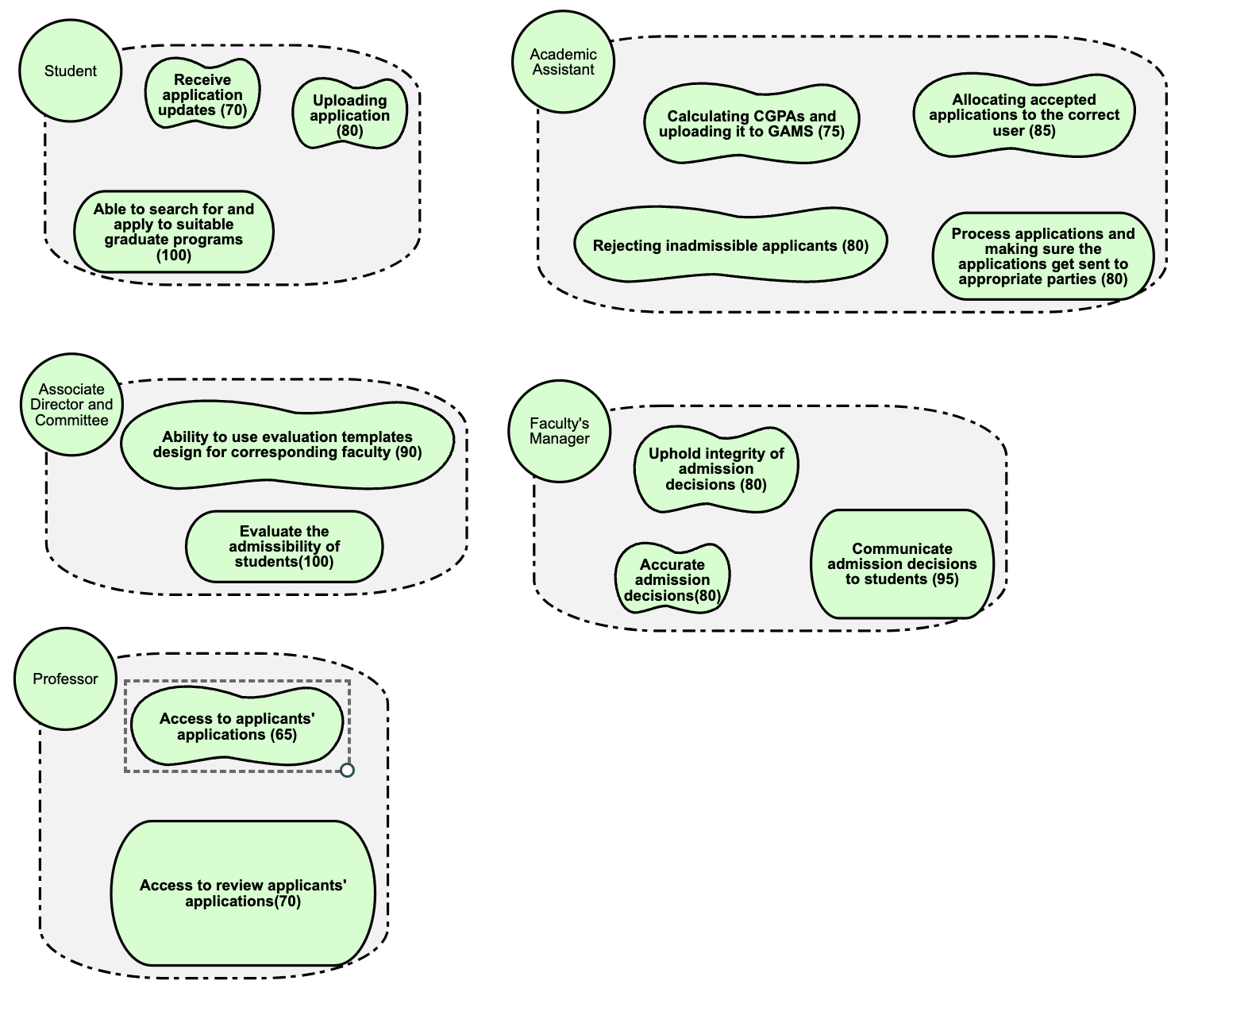

Figure 1. Updated G.R.L. model describing the relationship between actors and their goals.

### 1.3.4 Limitations

* GAMS shall not be published for universities outside of the province of Ontario.
* GAMS shall not have a mobile application for Apple or Android devices.
* GAMS shall only show information from the last twenty courses of a Student’s undergraduate years in their academic details if applying for a master’s program.
* GAMS shall only show information from the last ten courses of a Student’s graduate years in their academic details if applying for a doctorate program.
* GAMS shall not support a platform for direct messaging.
* GAMS shall only show the complete list of applicants to the Associate Director and the Academic Assistant.
* GAMS shall not support the Microsoft Authenticator application for two-factor authentication.
* GAMS will not have any connection to a university’s student portal.
* GAMS will not allow more than twenty applications per Student.

**1.4 Definitions**

**Admissions Committee**

The group responsible for evaluating and deciding on the admissibility of

applicants.

**Alternative Offer**

An offer extended to students in the absence of a confirmed supervisor.

**Course/Project-based Program**

A graduate program without a thesis requirement involving coursework or project work.

**Faculty**

Academic divisions within the University offer various graduate programs.

**Supervisor**

A faculty member responsible for guiding and mentoring a student in a thesis-based

program.

**Thesis-based Program**

A graduate program requiring students to complete a thesis as part of their academic

requirements.

**uoCampus**

The University of Ottawa’s internal administrative platform.

**Xtender**

A web-based tool used for digitizing and storing student admission files and related

documents.

# 2.0 REFERENCES

"ISO/IEC/IEEE International Standard - Systems and software engineering -- Life cycle processes -- Requirements engineering," in ISO/IEC/IEEE 29148:2018(E), vol., no., pp.1-104, 30 Nov. 2018, doi: 10.1109/IEEESTD.2018.8559686.

# 3.0 REQUIREMENTS

## 3.1 Functions

Table 2. System function requirements.

| Description | Importance | Verification method |
| --- | --- | --- |
| The system shall allocate incoming applications to the respective academic advisors based on the program specified by the applicant. | Must | Test |
| The system shall allow the academic assistant to perform calculations for the admission average of students. | Must | Test |
| The system must be able to accept or refuse applications based on a student’s average. | Must | Analysis |
| The system must update an application’s status when a decision has been made. | Must | Test |
| The system must generate and send an email containing details of eligible students, that are without a supervisor, to all professors in their program. | Must | Test |
| The system must allow Student Services to produce and send a set of documents to students confirming their acceptance/admission. | Must | Analysis |
| The system shall automatically reject an offer if the student does not accept it within ten working days. | Must | Analysis |
| The system must allow the user to search and filter programs offered at the University of Ottawa. | Must | Test |
| The system shall send an email receipt to a student once their payment has been processed. | Must | Test |
| The system must allow students to submit their applications online (in pdf). | Must | Test |
| The system must limit the number of applications received from a student to 20. | Must | Analysis |
| The system must divide all student applications evenly among members of the committee. | May | Analysis |
| The system shall make an offer invalid after one semester from the issue date. | Should | Analysis |
| The system must notify the student when a supervisor has been assigned to them. | Should | Analysis |
| The system should automatically admit a student that is admissible to a course/project-based program | Should | Test |

## 3.2 Performance requirements

Table 3. System performance requirements.

| Description | Importance | Verification method |
| --- | --- | --- |
| The system must load all data within 1.5 seconds. | Must | Demonstration |
| The system must log a user in within 1 second. | Must | Demonstration |
| The system must log a user out within 1 second. | Must | Demonstration |

## 3.3 Usability requirements

Table 4. System usability requirements.

| Description | Importance | Verification method |
| --- | --- | --- |
| The system shall automatically save any application drafts. | Should | Test |
| The system shall return the user to the home page when they click the GAMS logo. | Should | Test |
| The system must log the user in according to their role once they click the 'Login' button. | Must | Test |
| The system shall log out the user once they click the Logout button (top right corner). | Must | Test |

## 

## 3.4 Interface requirements

Table 5. System interface requirements.

| Description | Importance | Verification method |
| --- | --- | --- |
| The system must have the GAMS logo at the top left corner for every page. | Must | Inspection |
| The system shall be available in English. | Must | Inspection |
| The system shall be available in French. | Must | Inspection |

## 3.5 Logical database requirements

Table 6. System database requirements.

| Description | Importance | Verification method |
| --- | --- | --- |
| The system should allow access to data across multiple devices. | Should | Analysis |

**3.6 Design constraints**

Table 7. System design constraints.

| Description | Importance | Verification method |
| --- | --- | --- |
| The system must follow a colour scheme for borders/footers consisting of garnet and grey. | Must | Inspection |
| The colour scheme for text will be white for text in coloured boxes and black elsewhere. | Must | Inspection |
| The system shall have a uniform Arial font throughout. Text may be bolded in body paragraphs when needed.  Font sizes:  Headers: 14pt  Body: 12pt | Must | Inspection |

## **3.7 Chosen validation techniques**

Four methods, namely inspection, demonstration, test, and analysis, are used to test the validity of the requirements. Inspection is chosen when checking whether the requirement is fulfilled can be simply conducted by looking at the product. Therefore, requirements like colour schemes can be validated using inspection.

Demonstration is used mostly with performance requirements or those that produce a statistical result. Thus, requirements like processing time can be checked via demonstration.

While it was desired to test all the requirements, it is unrealistic as it will result in a great cost concerning the development of the system. So, requirements with a similar nature that have been validated using tests are checked by analysis. For instance, the requirement “The system shall allocate incoming applications to the respective academic advisors based on the program specified by the applicant” is being tested, and “The system must divide all student applications evenly among members of the committee” is validated by analysis. As both requirements concern distributing applications, it is not needed to test for both to save cost.

# 4.0 TRACEABILITY

Linked below is a detailed requirement forward traceability and a test case backward traceability which

were created using HelixALM.

Forward: <https://uottawa.helixalm.cloud/ttweb/#default/359/previewReport/72>

Backward: <https://uottawa.helixalm.cloud/ttweb/#default/359/previewReport/73>

# 

# 5.0 VALIDATION

Previously, an interview with two stakeholders: an academic assistant and a past graduate student was held. Through this, the team was able to determine what each user prioritized most within GAMS. Two weeks later, a validation meeting was held with both of these two customers again. With this second meeting, prototypes of the system were shown to each stakeholder for their feedback. From this, the team was able to clarify any design issues the stakeholders may have had and wrote notes to improve the prototypes for the final GAMS product.

All team members listened closely to the stakeholders' comments and if required, asked questions for clarification. They were polite and respected the stakeholders’ remarks without cutting anyone off or disrespecting their constructive criticism. Each party was also on time for the meeting and it was able to start and end as scheduled. Learning from the past interview, 30 extra minutes were allocated for this meeting, totaling 1 ½ hours.

To begin the meeting, one team member (the author/expert of the work) showed the prototypes to the stakeholders. The pre-assigned moderator then asked each stakeholder for their feedback of the GAMS webpage prototype. From this, the other 3 team members were able to take note of each stakeholder’s response and address/discuss any problems they may have had with the stakeholder’s answer. These details are noted in section 5.2. At the end of the meeting, all team members and stakeholders read and signed off on the prototypes and software requirements specification document to indicate it has been carefully analyzed and that both parties are responsible for their actions.

## 5.1 Preparation and Prototyping

Shown to the stakeholders during the meeting are digitized paper prototypes. The following figures demonstrate the GAMS login process from the perspective of a Student and an Academic Committee member. The process starts with the login screen that any user will use to access GAMS. When any account logs in, they must confirm their identity using two-factor authentication. A six-digit code is sent to the user’s email and will need to enter it to have access to their account on GAMS. Figure 3 below is the main Student dashboard when they log in, showing off their applications made with some details. Figure 4 shows the Academic Committee Member’s dashboard when they log in, showing them all the applications they are tasked to evaluate.

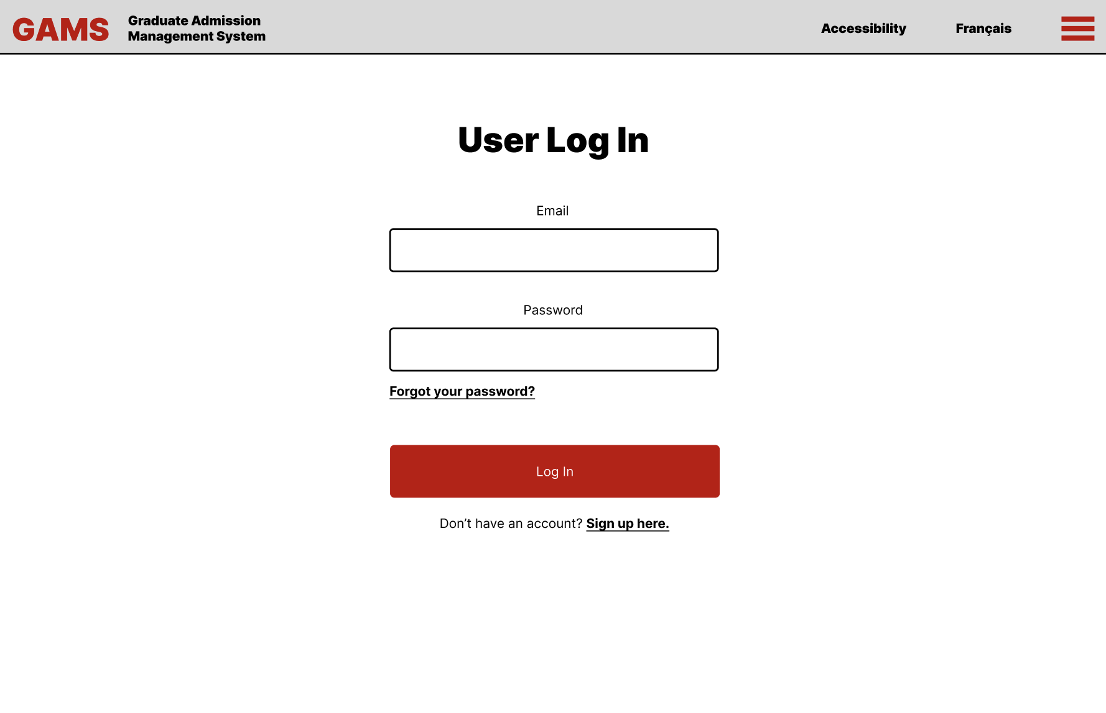

Figure 2: Prototype of GAMS login page.

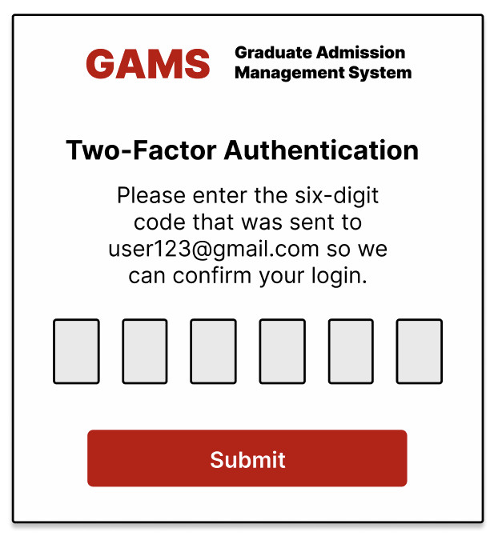

Figure 3: Prototype of two-factor authentication popup when a user attempts to log in to their account.

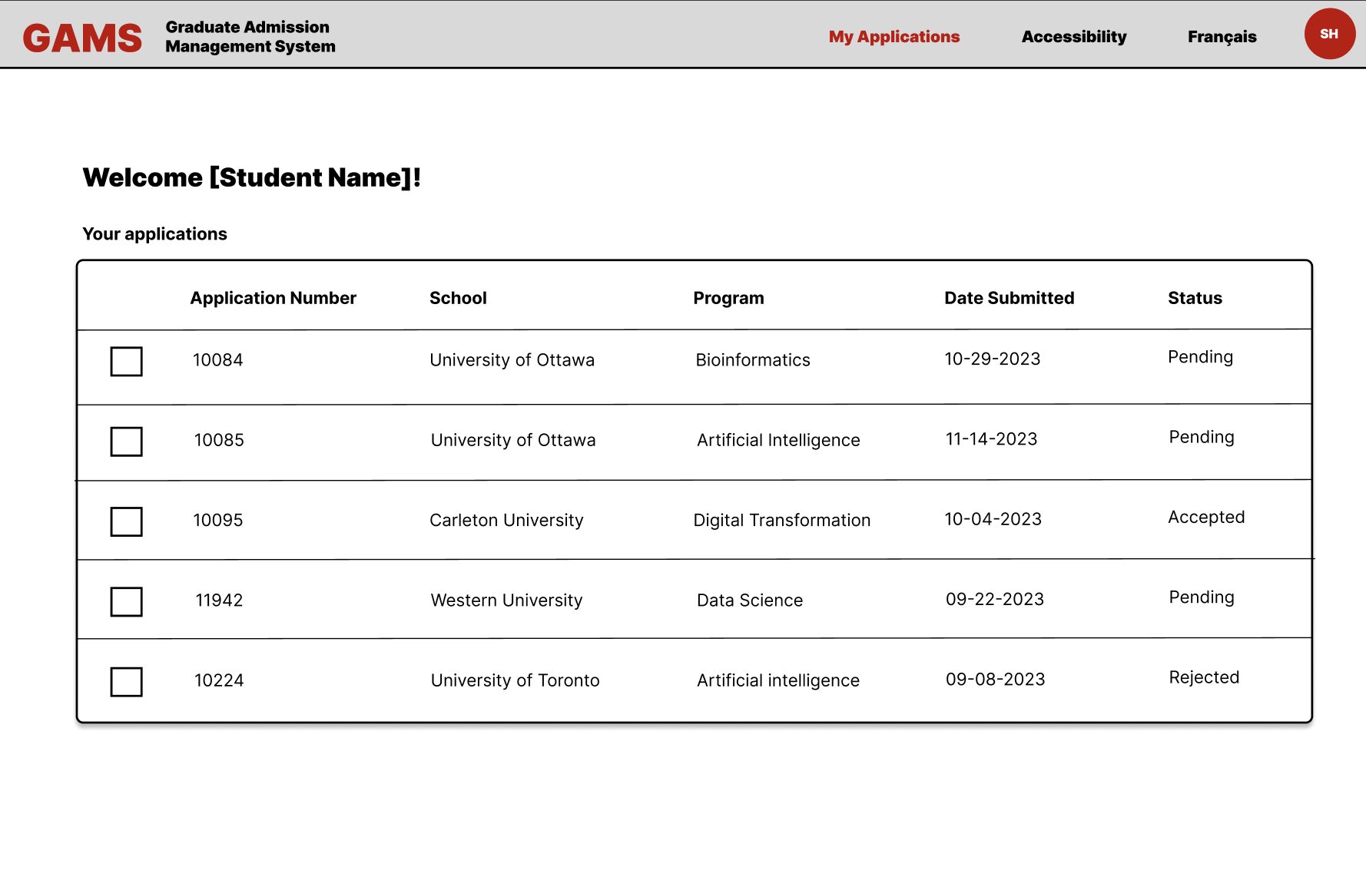

Figure 4: Prototype of the GAMS student applications page.

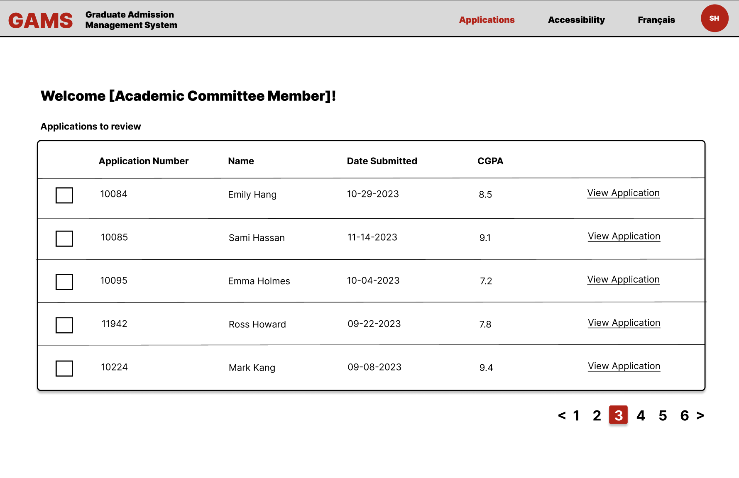

Figure 5: Prototype of an academic committee member’s application page to review student applications.

## 5.2 Issues and Clarifications

One issue noted by both stakeholders was that they wanted the two-factor authentication to be done through the Microsoft Authenticator app as it was already linked to their school emails. However, the team discussed before the meeting that they chose to use email verification as the database already had the user’s email and could easily send a verification email to it. Through negotiation with both parties, it was decided that it would be done through email and not an Authenticator app as not all users will have the app (i.e. students applying). Thus, to make GAMS universal, the final product will send 2FA through the registered email.

Another problem they had with the prototypes was the lack of images on the screen. As this was an abstract point, team members asked the stakeholders to explain what type of images they were hoping to see on the screen. The academic assistant mentioned an image of students smiling in the background for the home page. In contrast, the student suggested a more eye-catching logo and symbols, such as a page or check-mark/x-mark to be visually appealing. Now clarified, the team members took note of these recommended changes are plan to implement these ideas in the final design.

# 

# 6.0 WORK DISTRIBUTION

In the table shown below are the tasks performed by each team member. Each member was in charge of a specific section/sub-section.

Table 8. Team members and their contributions.

| **Team Member** | **Tasks Contribution** |
| --- | --- |
| **Kristen Duong** | **1.1, 1.2, 1.3.3, 4.0, 5.0, 5.2** |
| **Sami Hassan** | **1.3.2, 1.3.4, 5.1** |
| **Tiana Ye** | **1.3.4, 1.4, 4.0** |
| **Uyen Nguyen** | **1.3.1, 4.0** |
| **Yi Yau Wong** | **3.1-3.7, 4.0** |

# 7.0 APPENDICES

**7.1 Acronyms and abbreviations**

**2FA**

Two-factor-authentication

**GAMS**

Graduate Admission Management System

**OUAC**

Ontario Universities’ Application Centre