Kubernetes Course Submission – k8s-course-app
This report documents the deployment and verification of the k8s-course-app. The image was published to GHCR and tested on a Kubernetes cluster. The application exposes /, /healthz, and /readyz endpoints. Screenshots below serve as evidence of the completed steps.

Project Summary
Repository: https://github.com/sami0100/kubernates
Image: ghcr.io/sami0100/k8s-course-app:latest
Service: ClusterIP on port 80 (targetPort 3000); accessed via port-forward 8080

Screenshots

Cluster Nodes

Kubernetes Resources
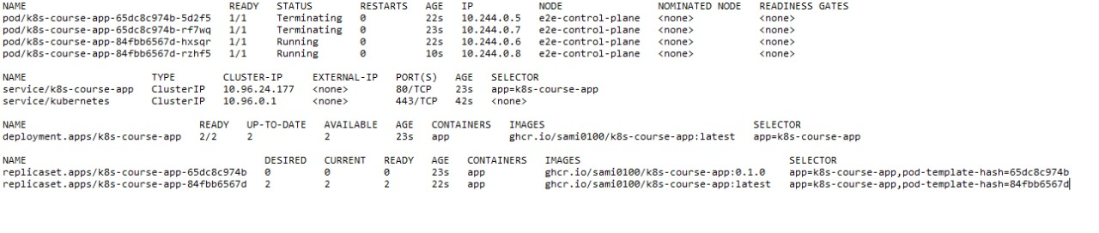

Deployment Description
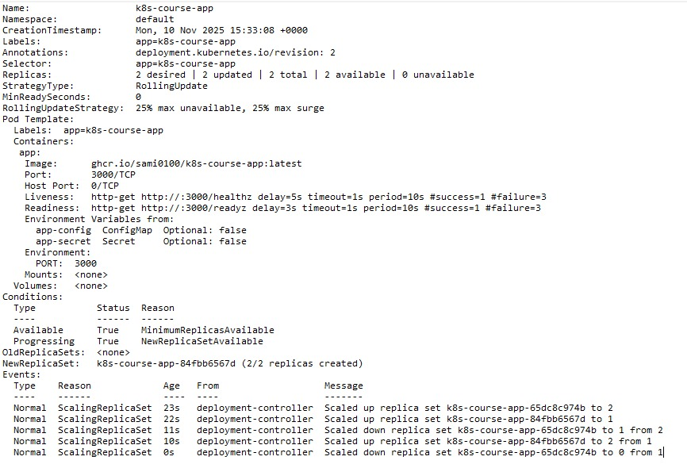

Service Description
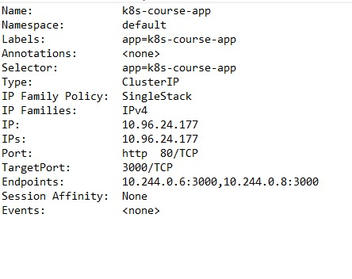

05_app_response.jpg

06_healthz.jpg
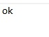

07_readyz.jpg
