1)Watch ansible-01 video and write down notes.
2)Setup one master and two worker nodes in ansible.
1.Launch EC2 Instances
Go to AWS EC2 console.
Launch 3 Ubuntu AMI instances (latest Ubuntu 22.04 ).
1 for master (controller)
2 for workers (managed nodes)
Use the same key pair (e.g., ansible.pem) for all three.
Security Group: Allow at least SSH (port 22) between them
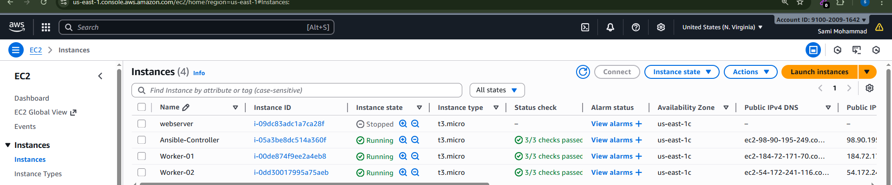
Step-2
By default python3 installed

Connect to Master (Control Node)
sudo apt update -y
sudo apt install ansible –y
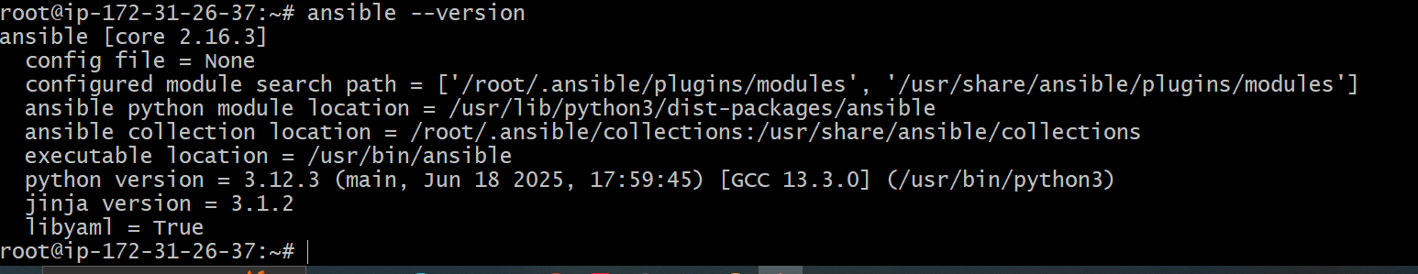
Here we have no cfg file by default
By default, Ubuntu does not create /etc/ansible/ansible.cfg or /etc/ansible/hosts
anymore — instead, you’re expected to create your own config and inventory in your project directory.
sudo mkdir -p /etc/ansible
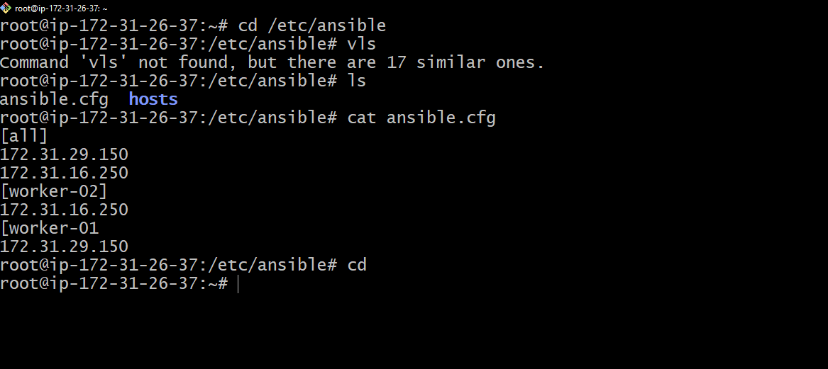

Password less authentication
From ansible controller ec2 → go to root → ssh-keygen → copy
the public key.
Go to worker1 → cd .ssh → vi authorized_keys → paste the
public key of the controller.
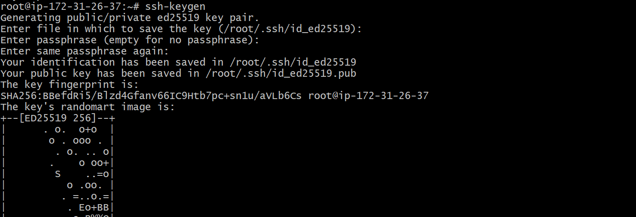

Check ping
ansible all -m ping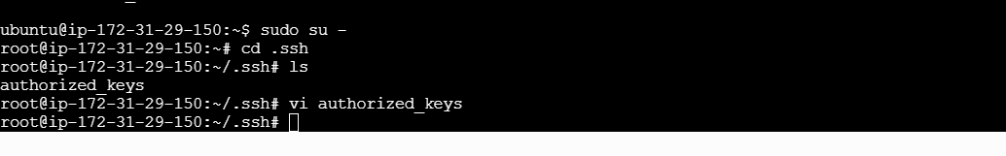
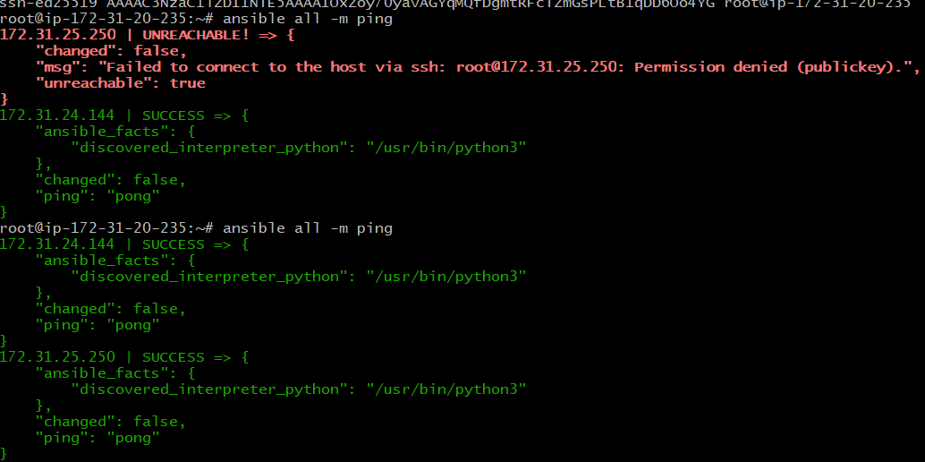
Same paste in worker2 also
3)Execute the adhoc command shared in #dvps-cloud-documents-14 Channel.
Ansible all –m ping
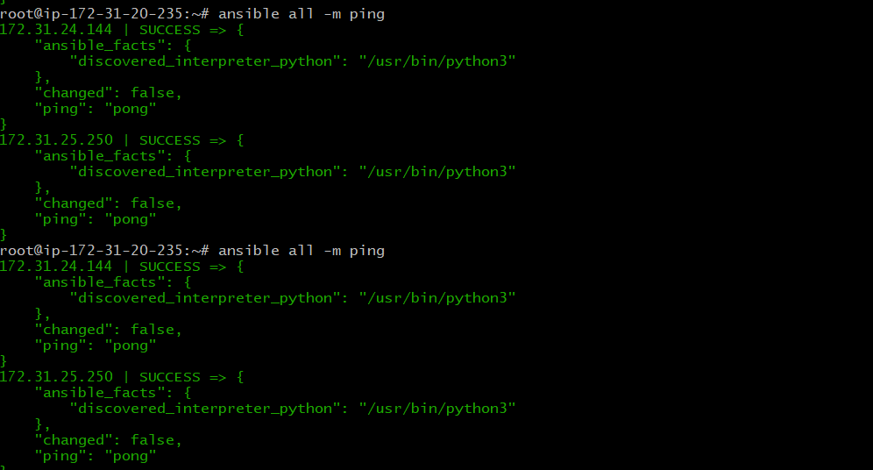
Ansible work1 –m ping

Ansible work2 –m ping
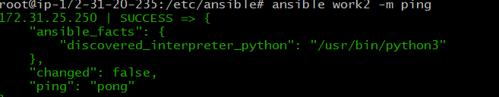
ansible all -m uptime
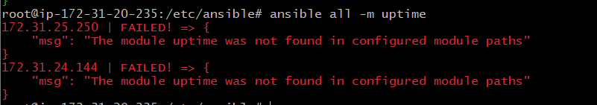
ansible all -m shell -a uptime
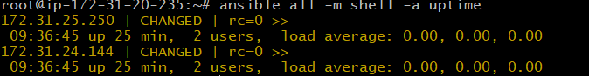
ansible all -m shell -a "mkdir Ansible-controller"


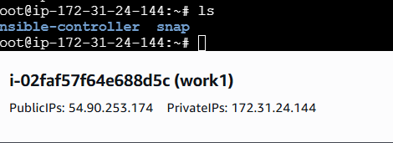
ansible all -m shell -a "ps -ef"



Create inventory
Vi sami_inventory
Ansible –I /root/sami_inventory sami –m ping
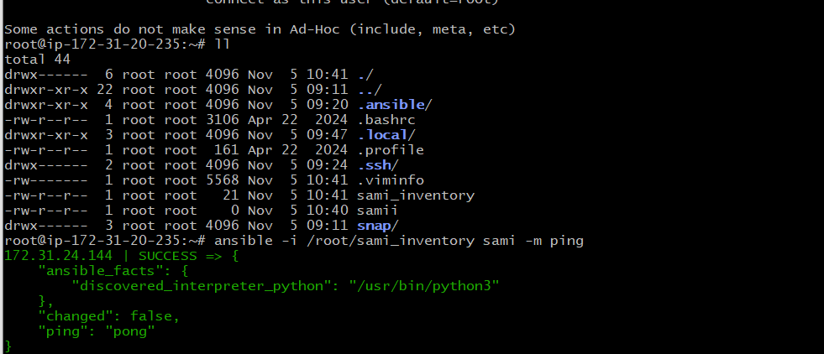
How to gather facts of slave machine
ansible all -m setup
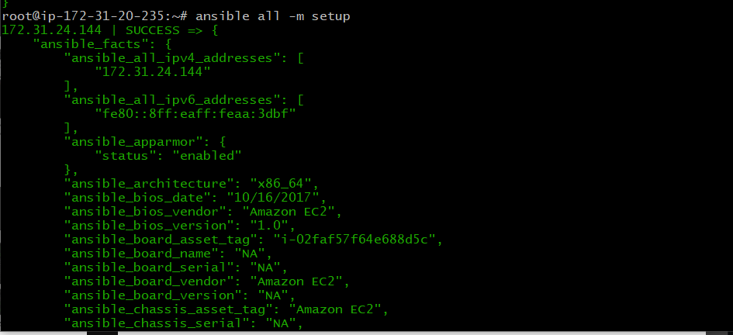

Install a package using apt command
ansible all -m apt -a "name=httpd state=latest"
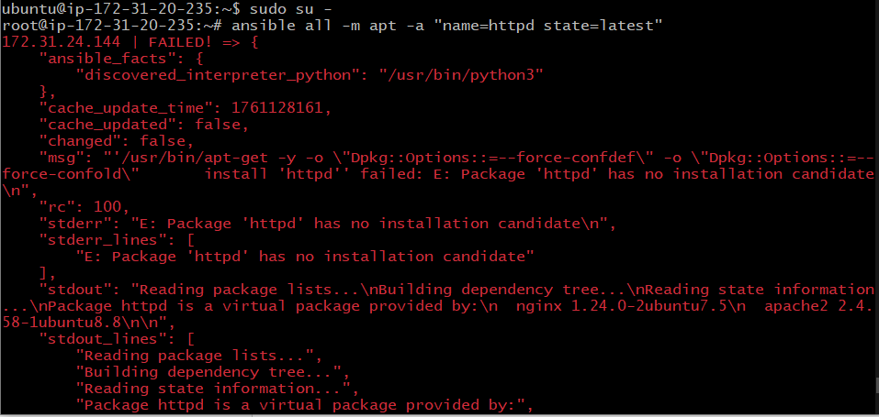

Install apache2
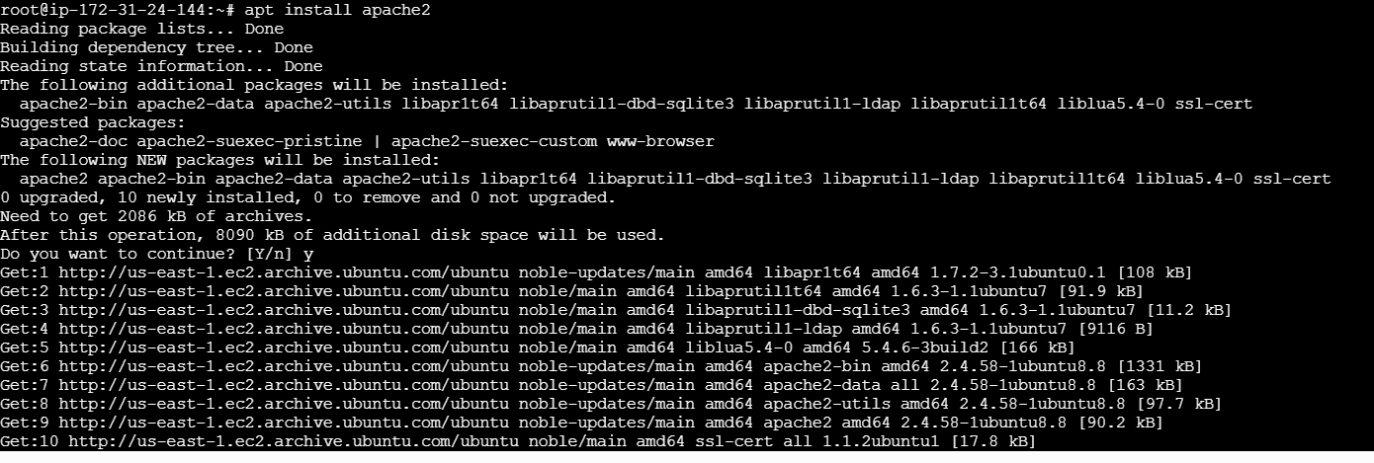
Ansible all –m apt –a “name=apache2 state=latest”


