- Watch the Terraform-05 video.
- Execute the script shown in the video.
Create the S3 bucket
Resource “aws_s3_bucket” “s3_bucket” {
Bucket = “s3backendterraform0908”
Acl = “private”
}
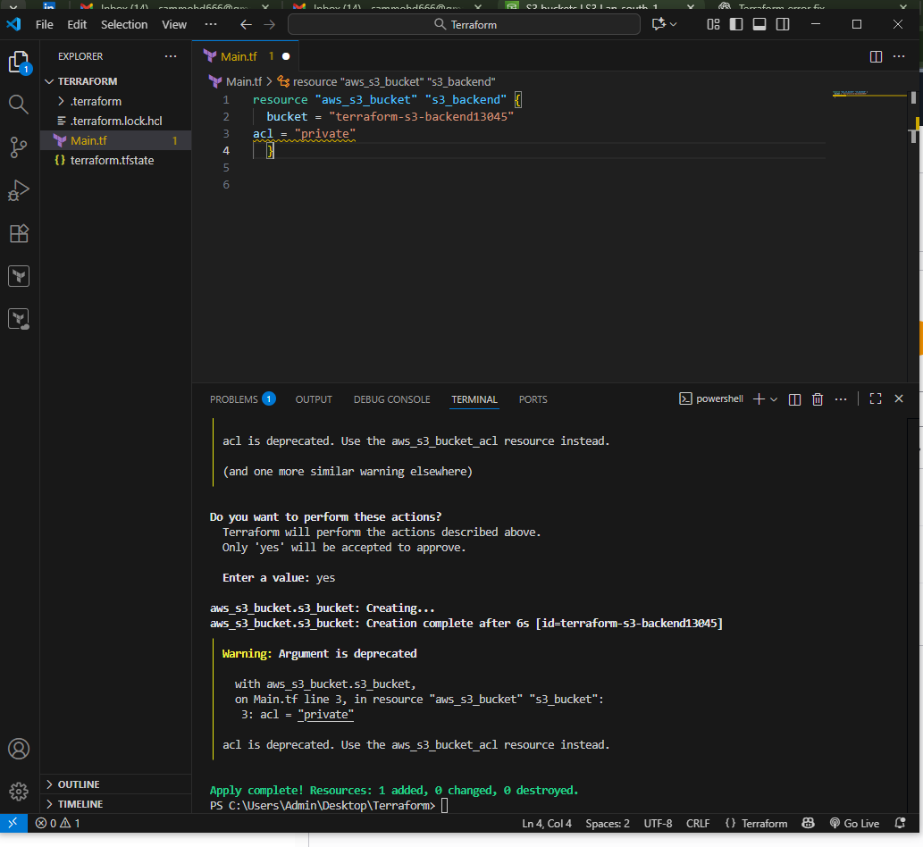
And check in AWS accountS3
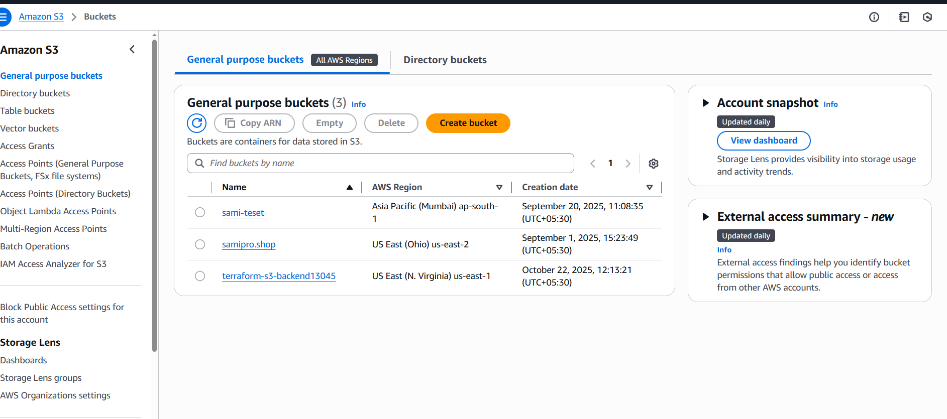
Create dynamo db
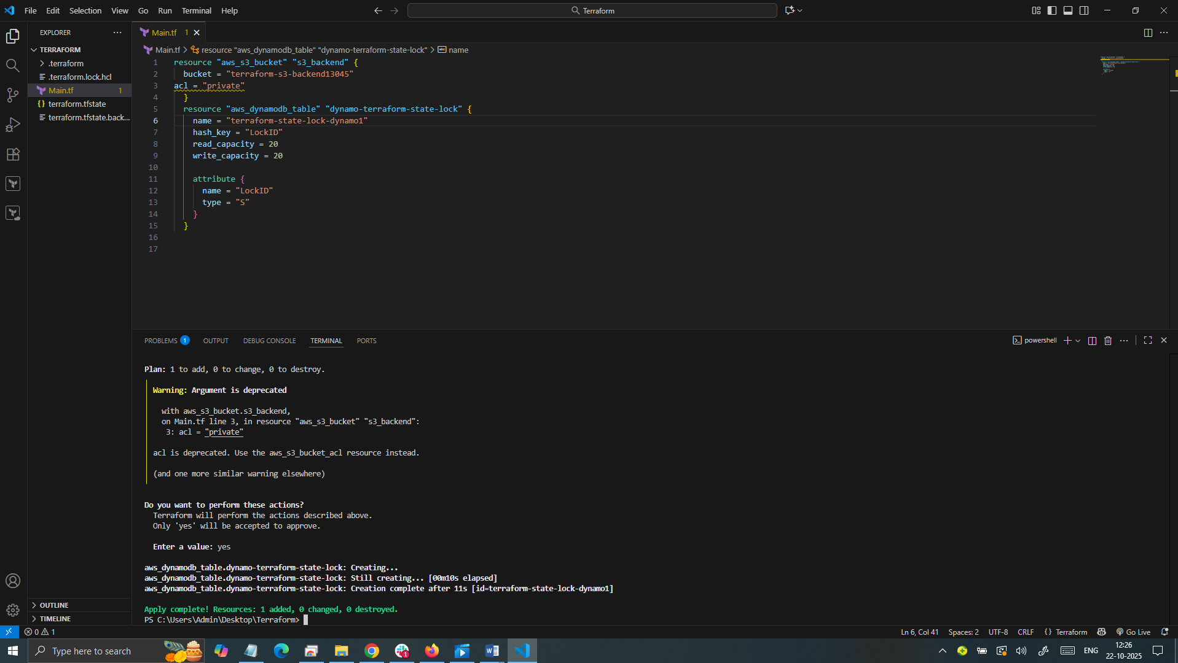
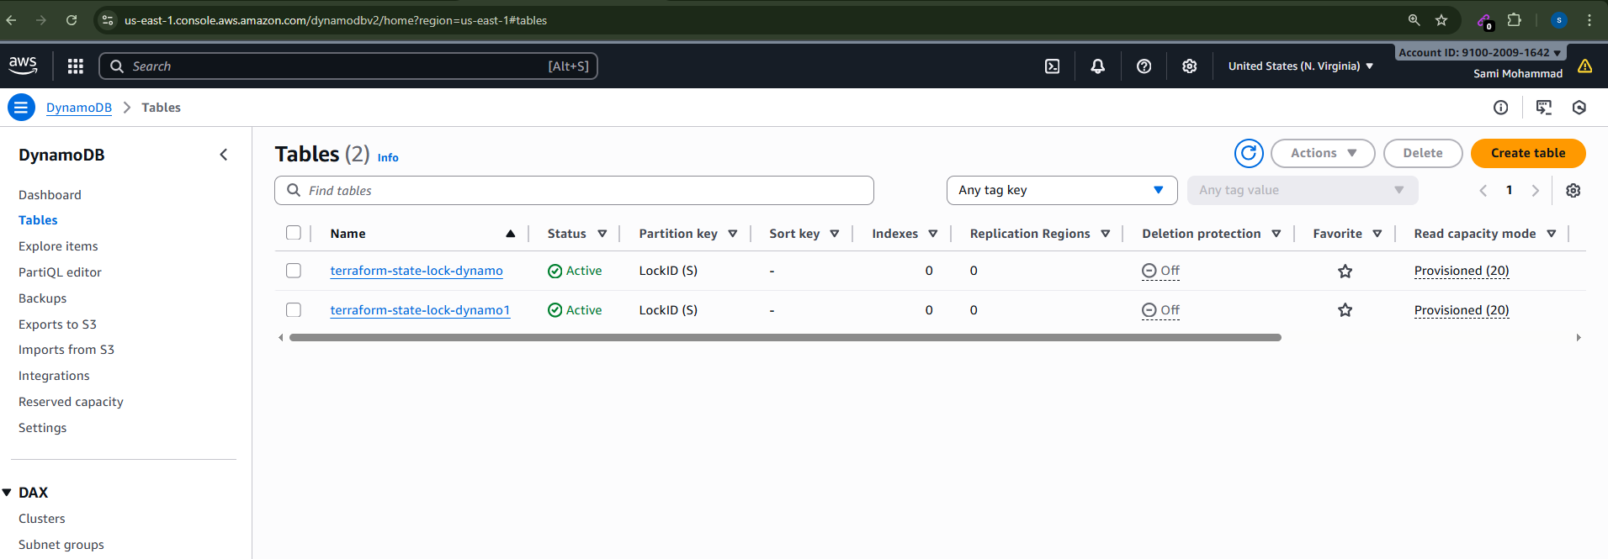

Store Tfstate file in s3 (S3 as backend for terraform.tfstate file)
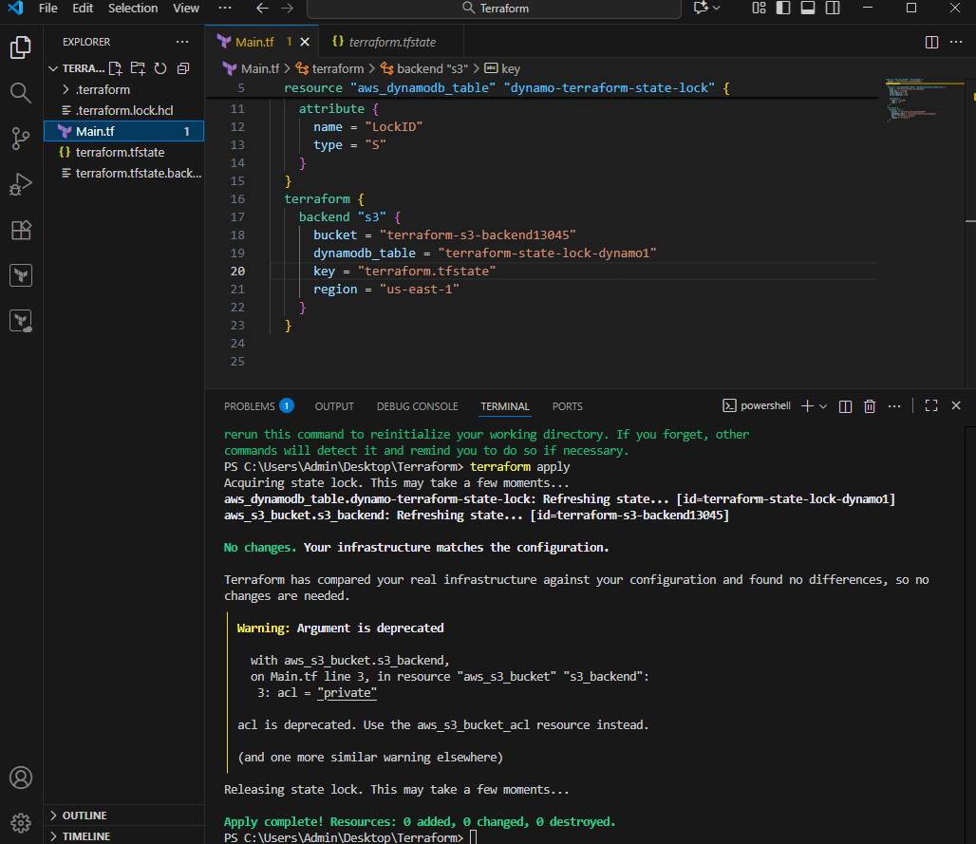
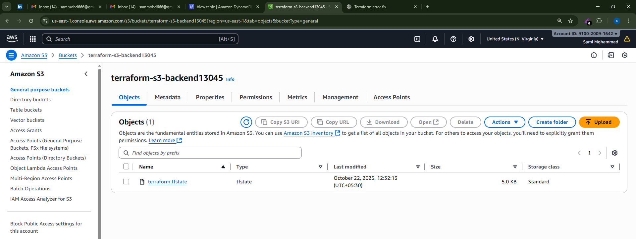
Go to dynamo DB
It will create a table
It will create LockID
DynamodbExplore Items
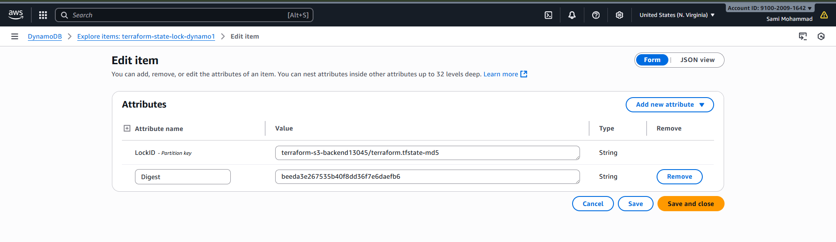

Terraform Provisioners:
=======================
Terraform provisioners allow us to execute command, scripts on remote
machines or local place were terraform is installed.
Provisioners will be written inside the resource blocks
We have two type povisioners
Remote Provisioner
This is used to execute commands at the run time on remote machines.
We can use user data
Local Provisioner :
This is used to execute commands at the run time on local machine. (means where terraform
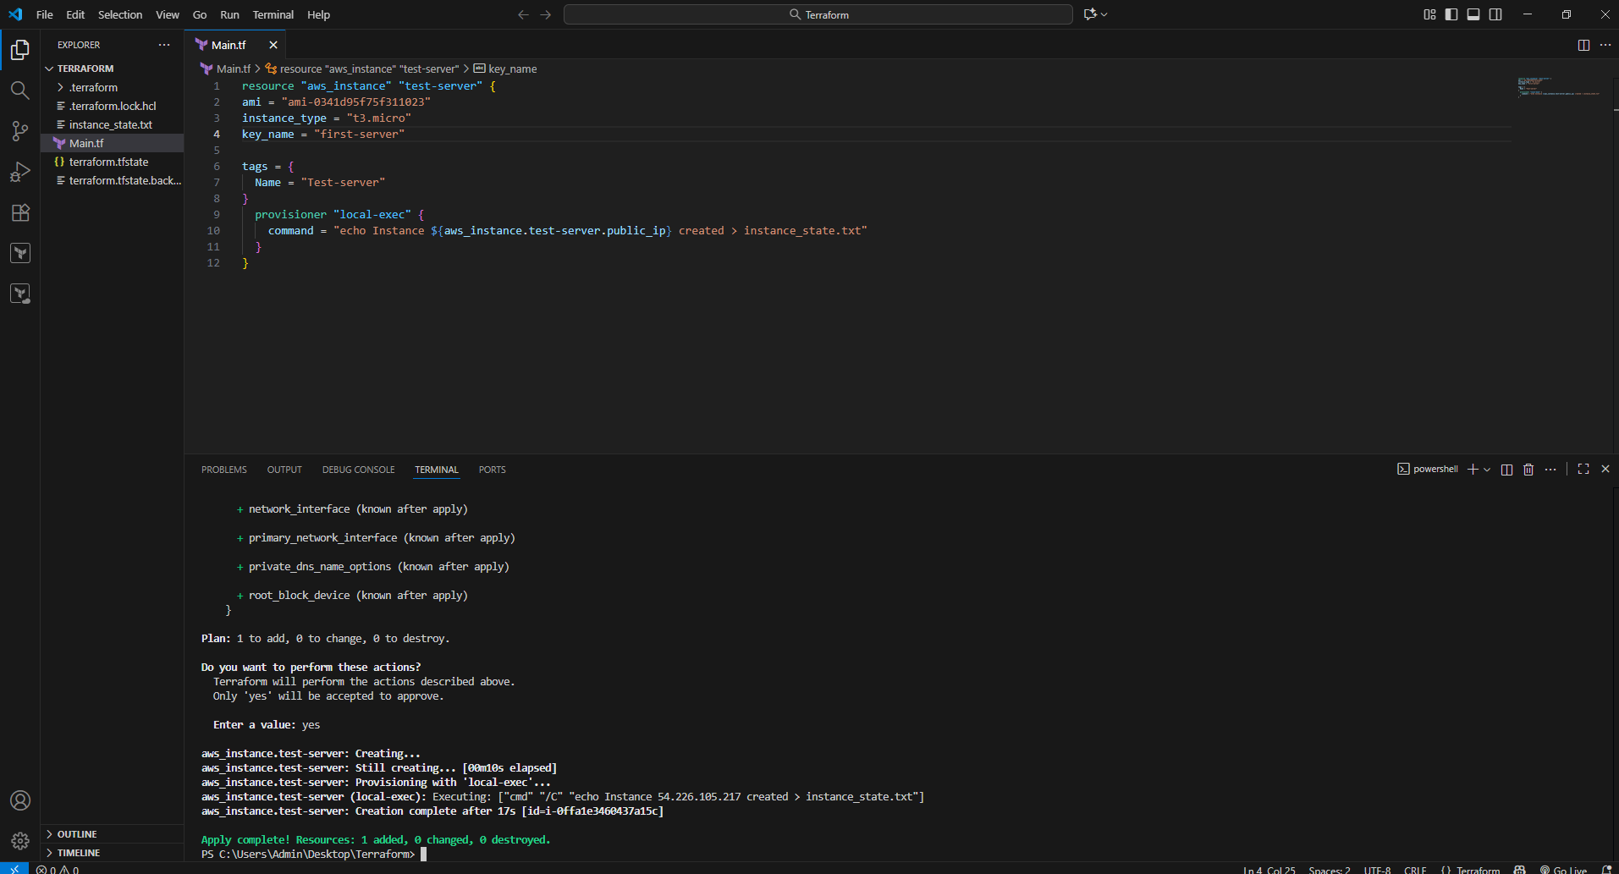
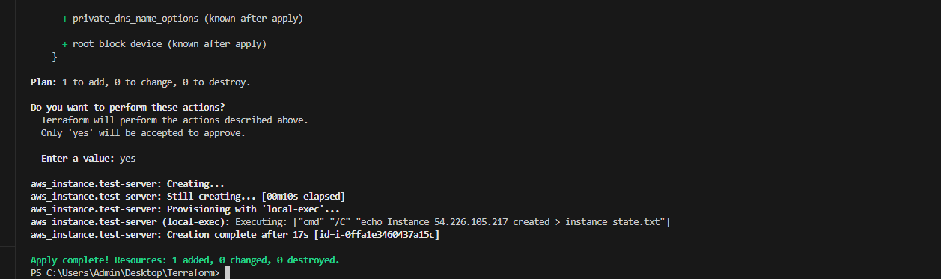

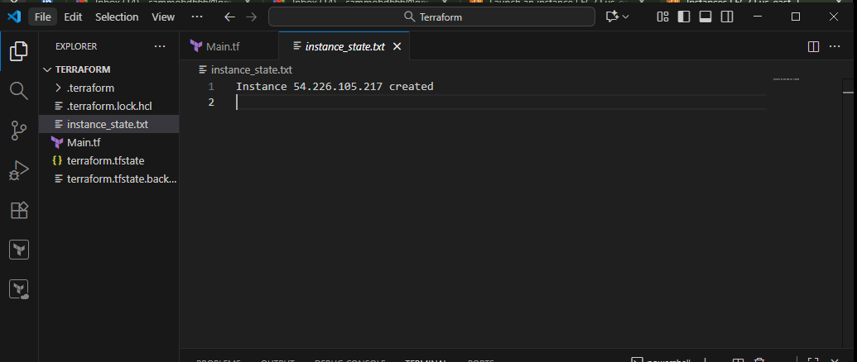
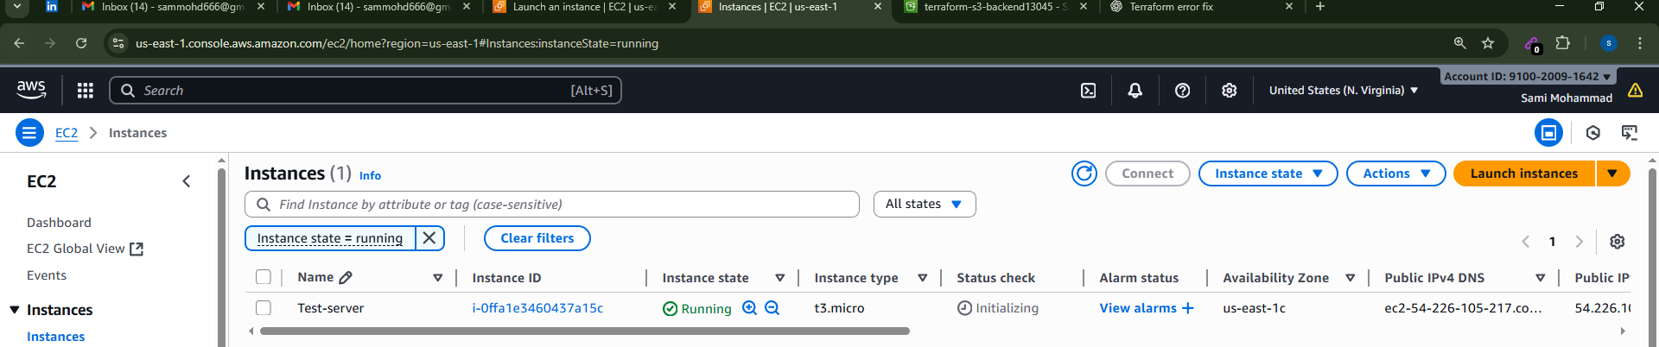

Terraform provisioner behaviours:
=================================
1) Create at the time creating resource (Default)
2) create at the time of destroyin resource (when = destroy)
3) on_failure = fail --> to create the resource if the script gets failed.(But terraform will mark the reource as tainted)
4) On_fail = continue --> to create the resource and ignore the changes

Create at the time creating resource (Default)
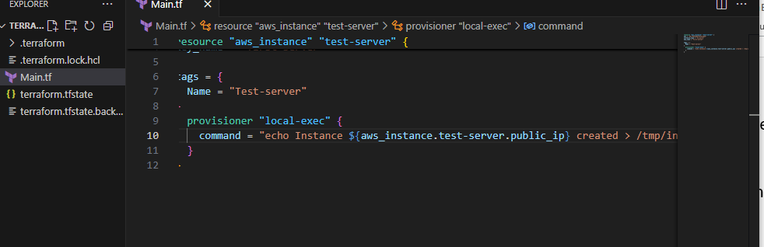
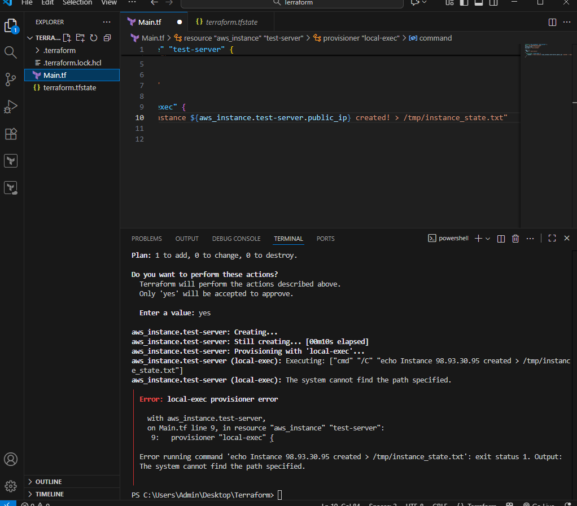
create at the time of destroyin resource (when = destroy)

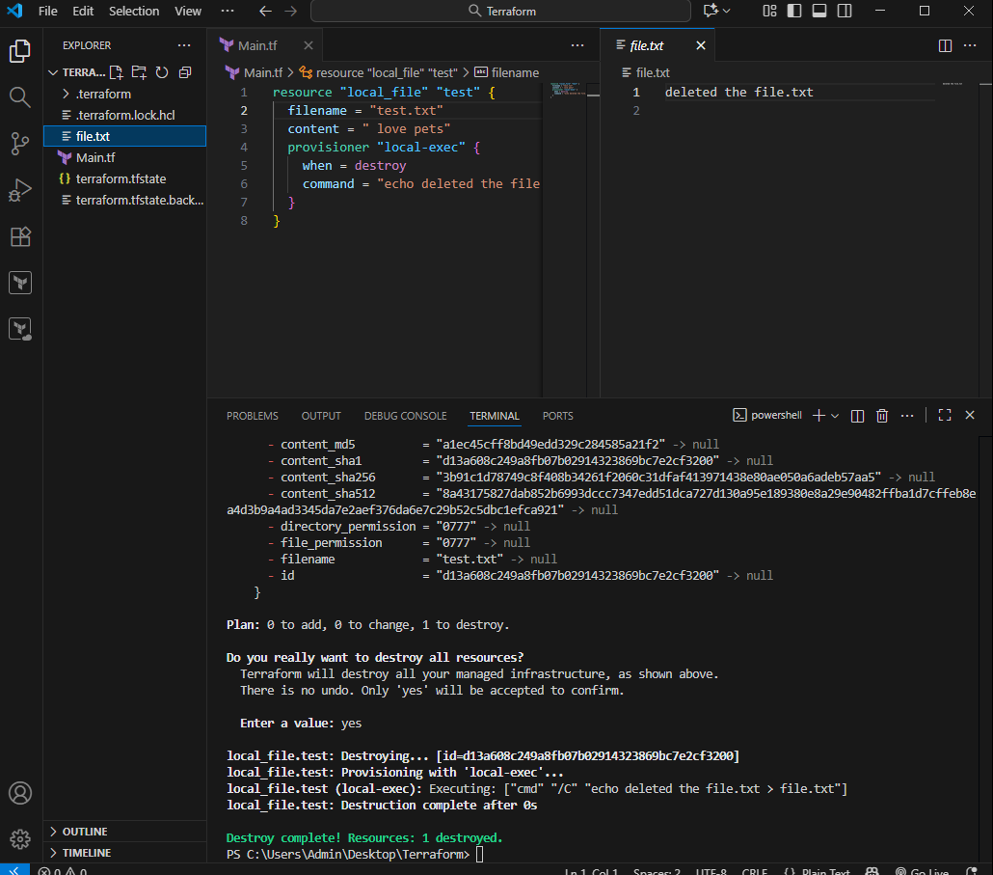
Tainted terraform will replace that file
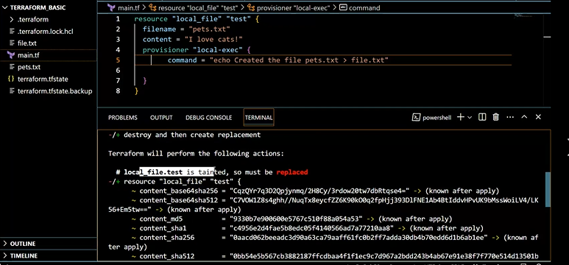
Untaint : There will be no changes
Debugging

terraform apply will provide us the logs/cause of the issue,
but still if we want to dig deeper then we need to export a variable
Set-Item -Path env:TF_LOG -value "TRACE"
Terraform apply
Terraform provides 5 levels of logs:
1) INFO
2) WARNING
3) ERROR
4) DEBUG
5) TRACE
Trace will get the complete details

Terraform import
Terraform import is used to import the existing infrastructure in terraform state file.
Once import is done then we can be able to create/delete and manage the infrastructure.
I order to import any resource we need to write the resource details in configuration file.

Terraform import aws_instance.<name> instance_id
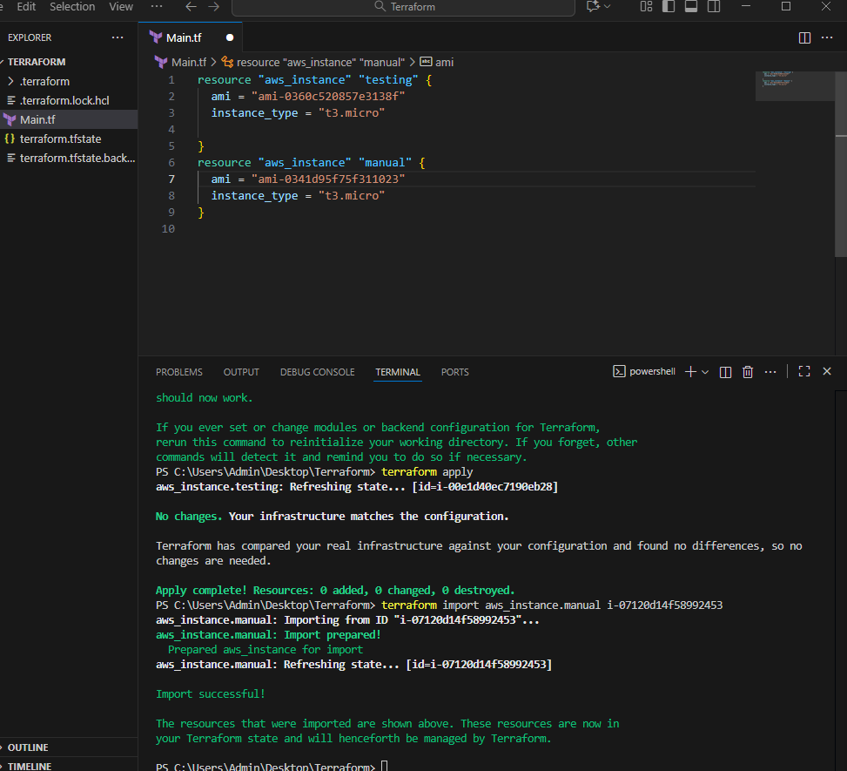

- Create one EC2 instance with httpd installed using a Terraform script.
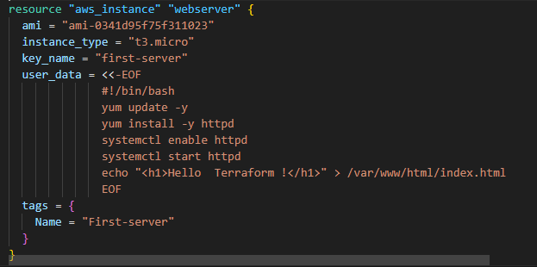
Terraform init
Terraform apply

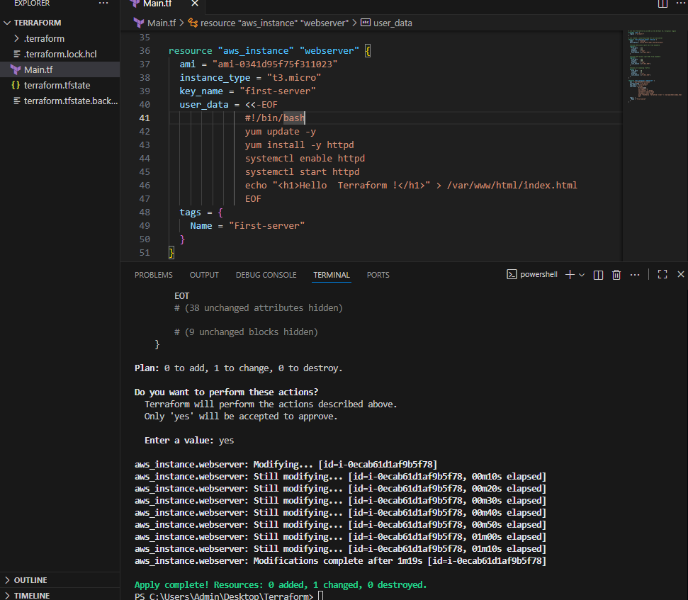
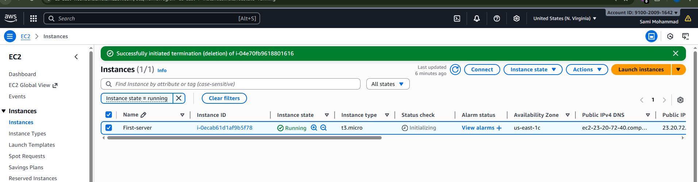
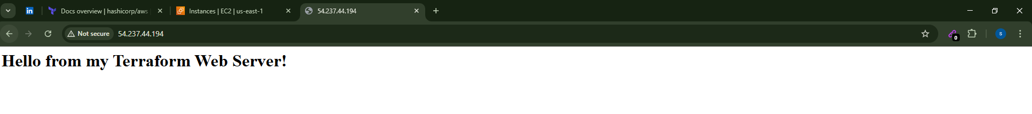
4 Set up S3 as backend for task 3.
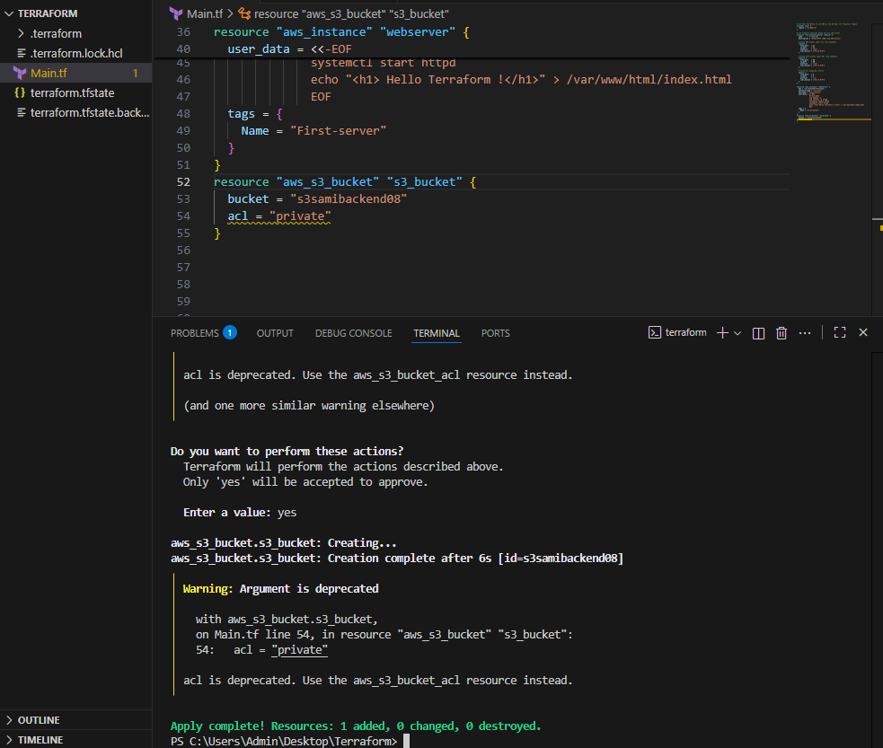
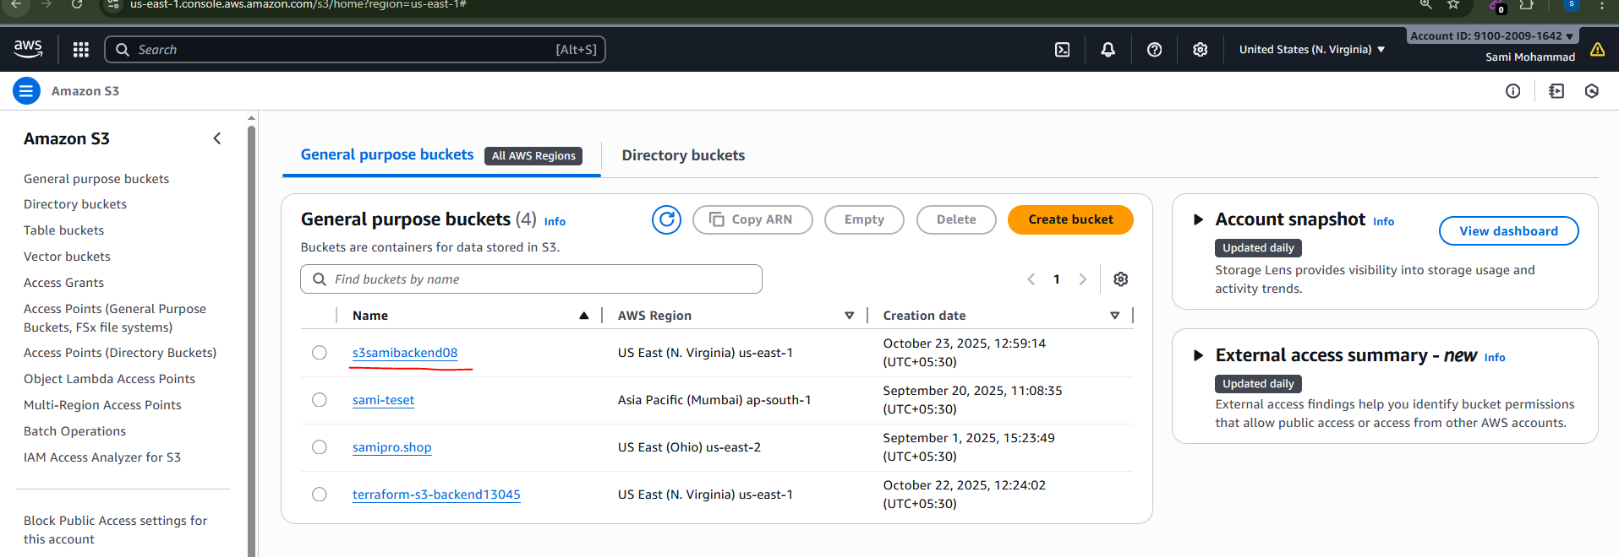
- Set up DynamoDB locking for task 3.

