1 Watch the Terraform-06 video.
2 Execute the script shown in the video.
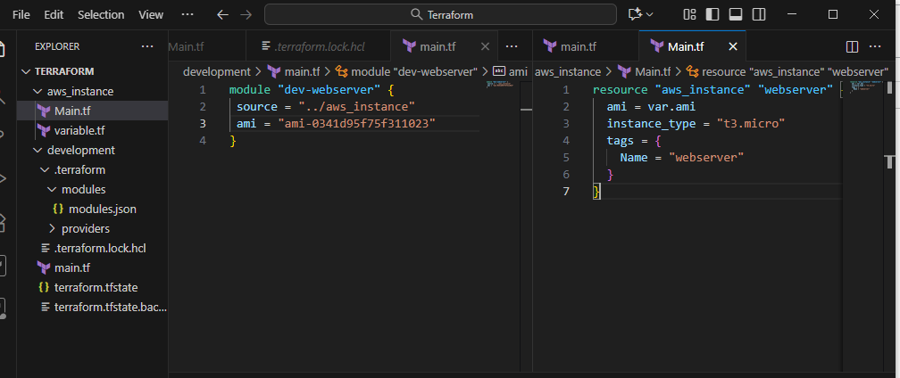
Terraform init
Terraform apply
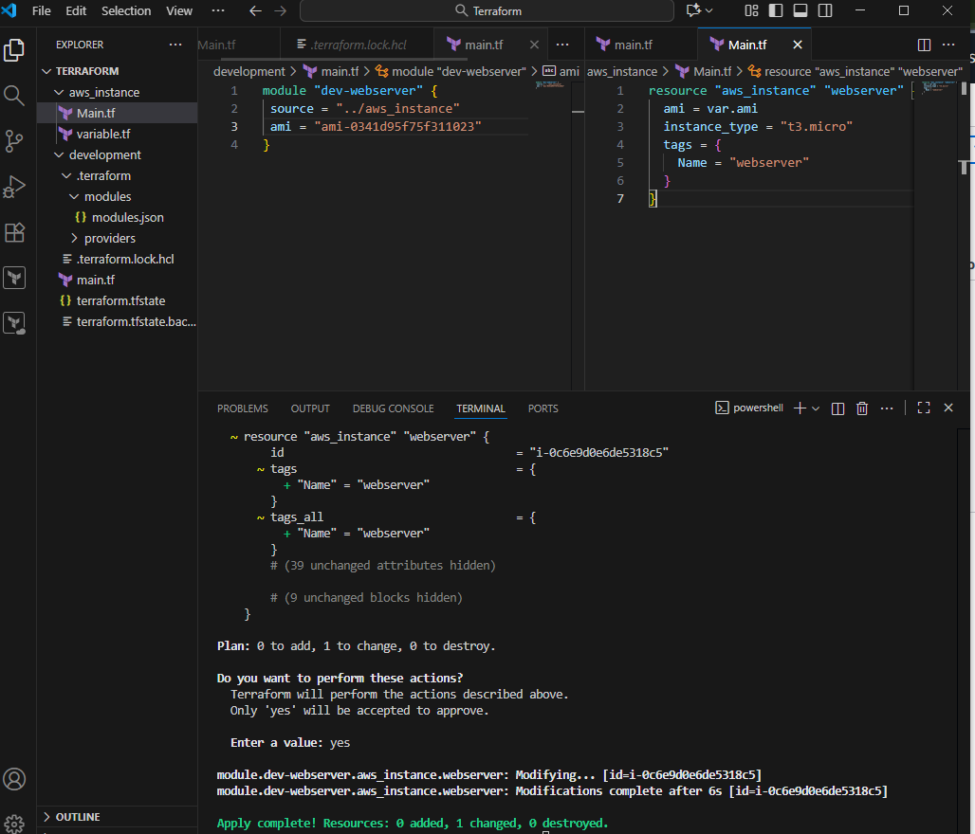
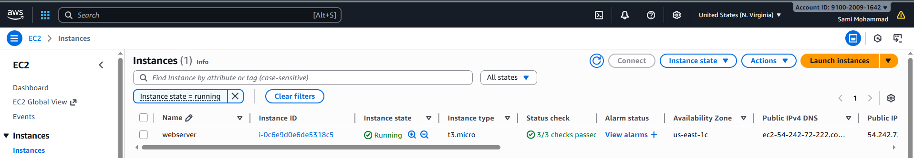
Terraform workspaces:
Workspace can be used if we have multiple project/environments using the same configuration
Workspace commands:
terraform workspace new projectA --> to create a workspace names projectA
terraform workspace list --> to list the workspaces available
terraform workspace select projectA --> to swtich to specific workspace
when using workspaces state files will be created in the main directory
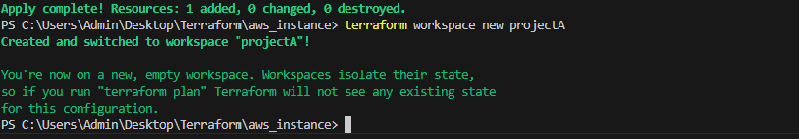
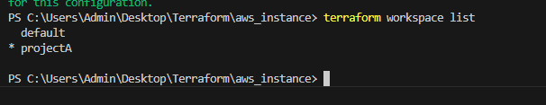
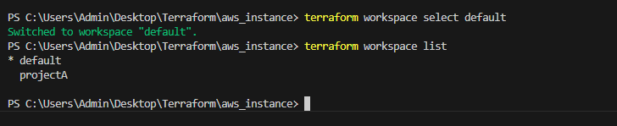
when using workspaces state files will be created in the main directory
under a folder "terraform.tfstate.d"
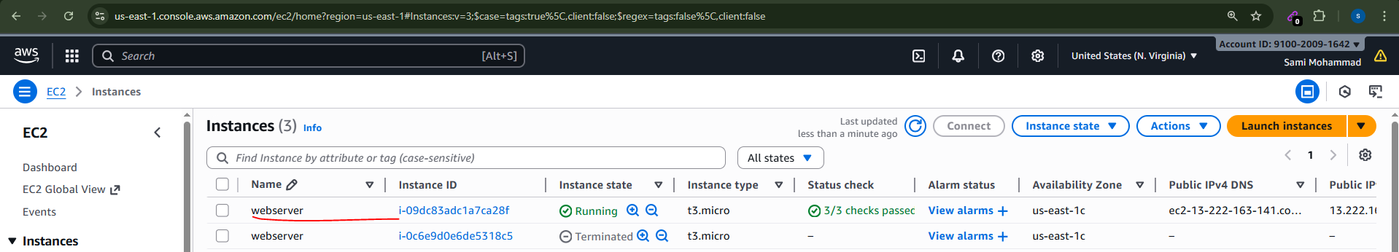
3 Provision EC2, S3, and VPC using Terraform modules.
We'll create three Terraform modules:
- EC2 module → creates an instance
- S3 module → creates a bucket
- VPC module → creates a simple VPC with subnets

4 Provision EC2 for 3 different environments (Dev, Staging, and Prod) using Terraform workspaces.
First create 3 workspaces:
terraform workspace new dev
terraform workspace new staging
terraform workspace new prod
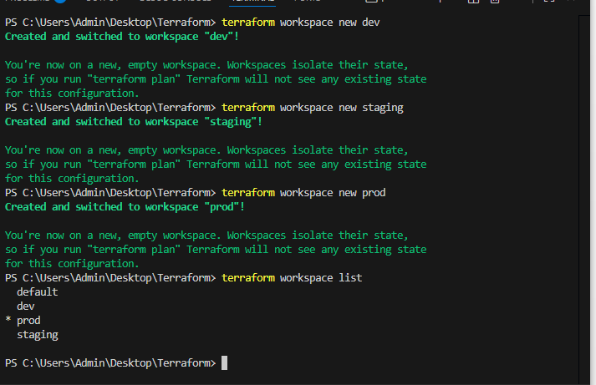

Terraform apply
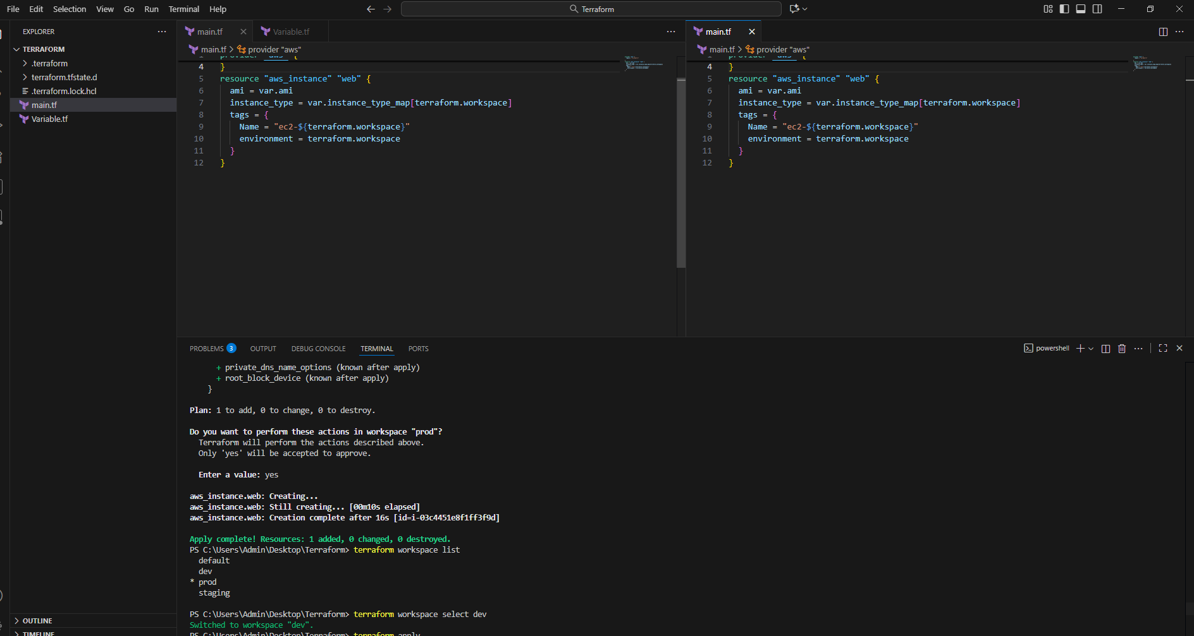
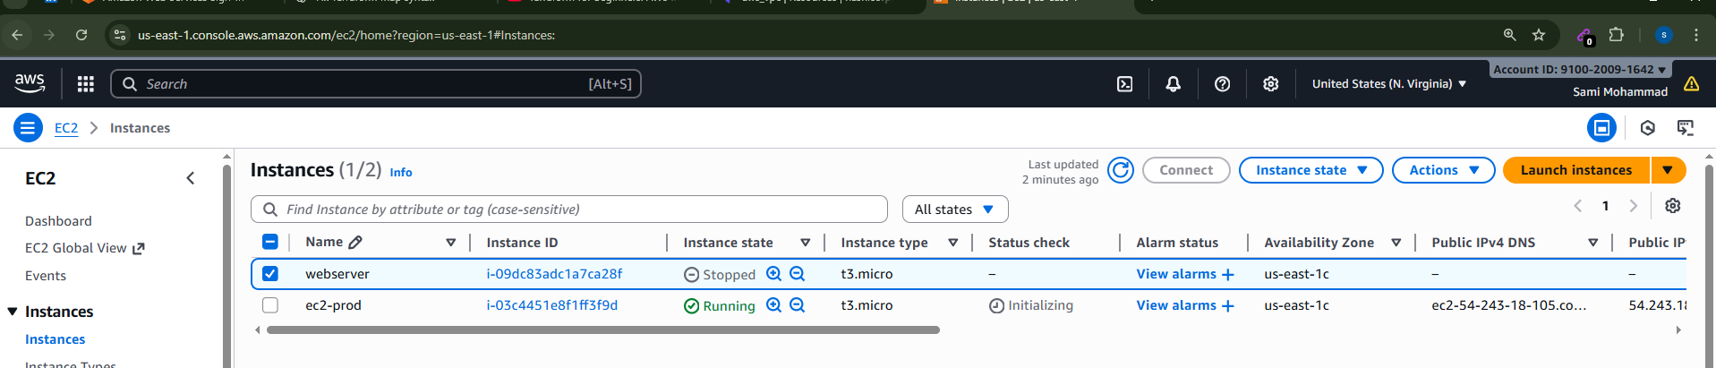

Terraform workspace select dev
Terraform apply
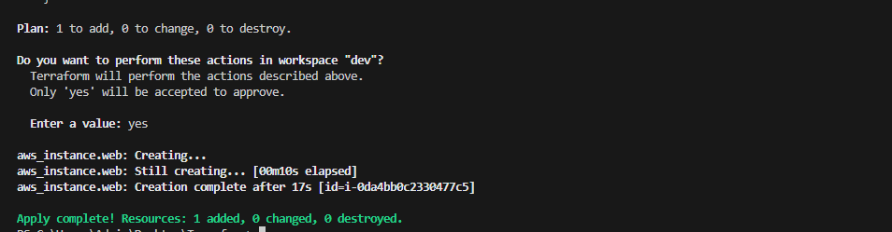
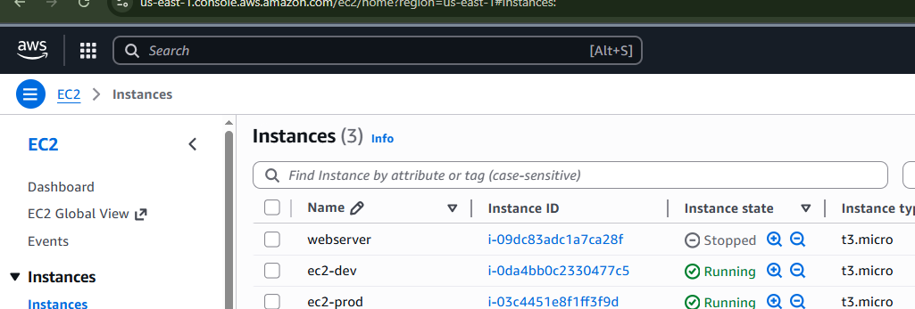
terraform workspace select staging
terraform apply
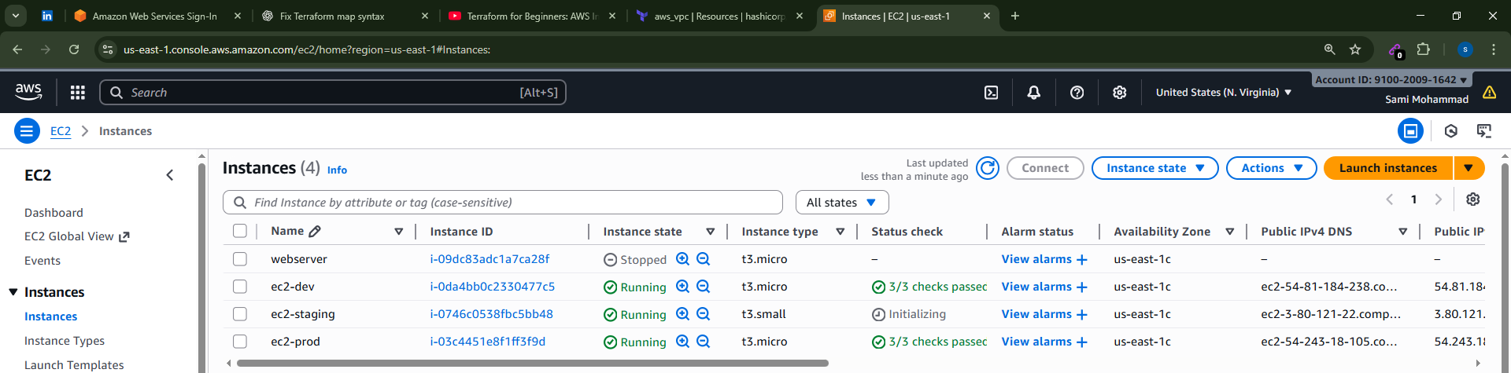

Terraform destroy –auto-approve
