- Create one IAM user and assign ec2,s3 full access role.
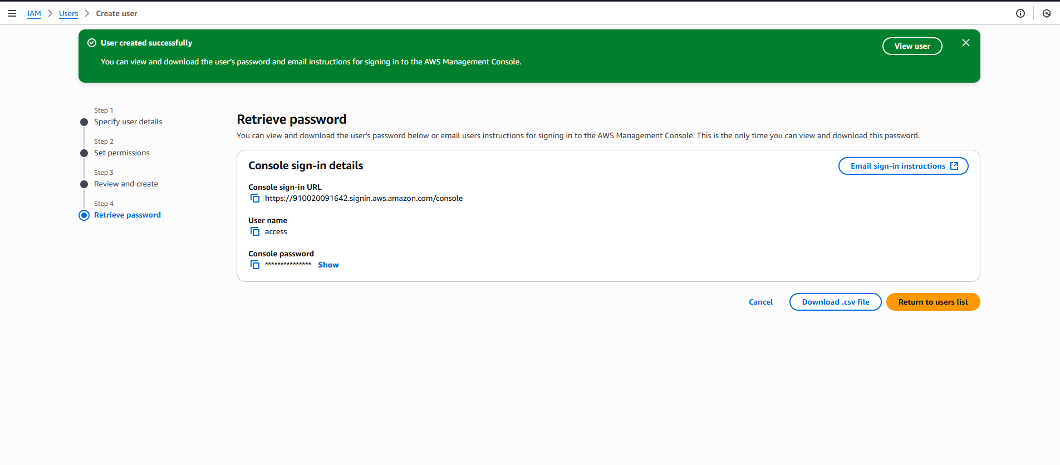

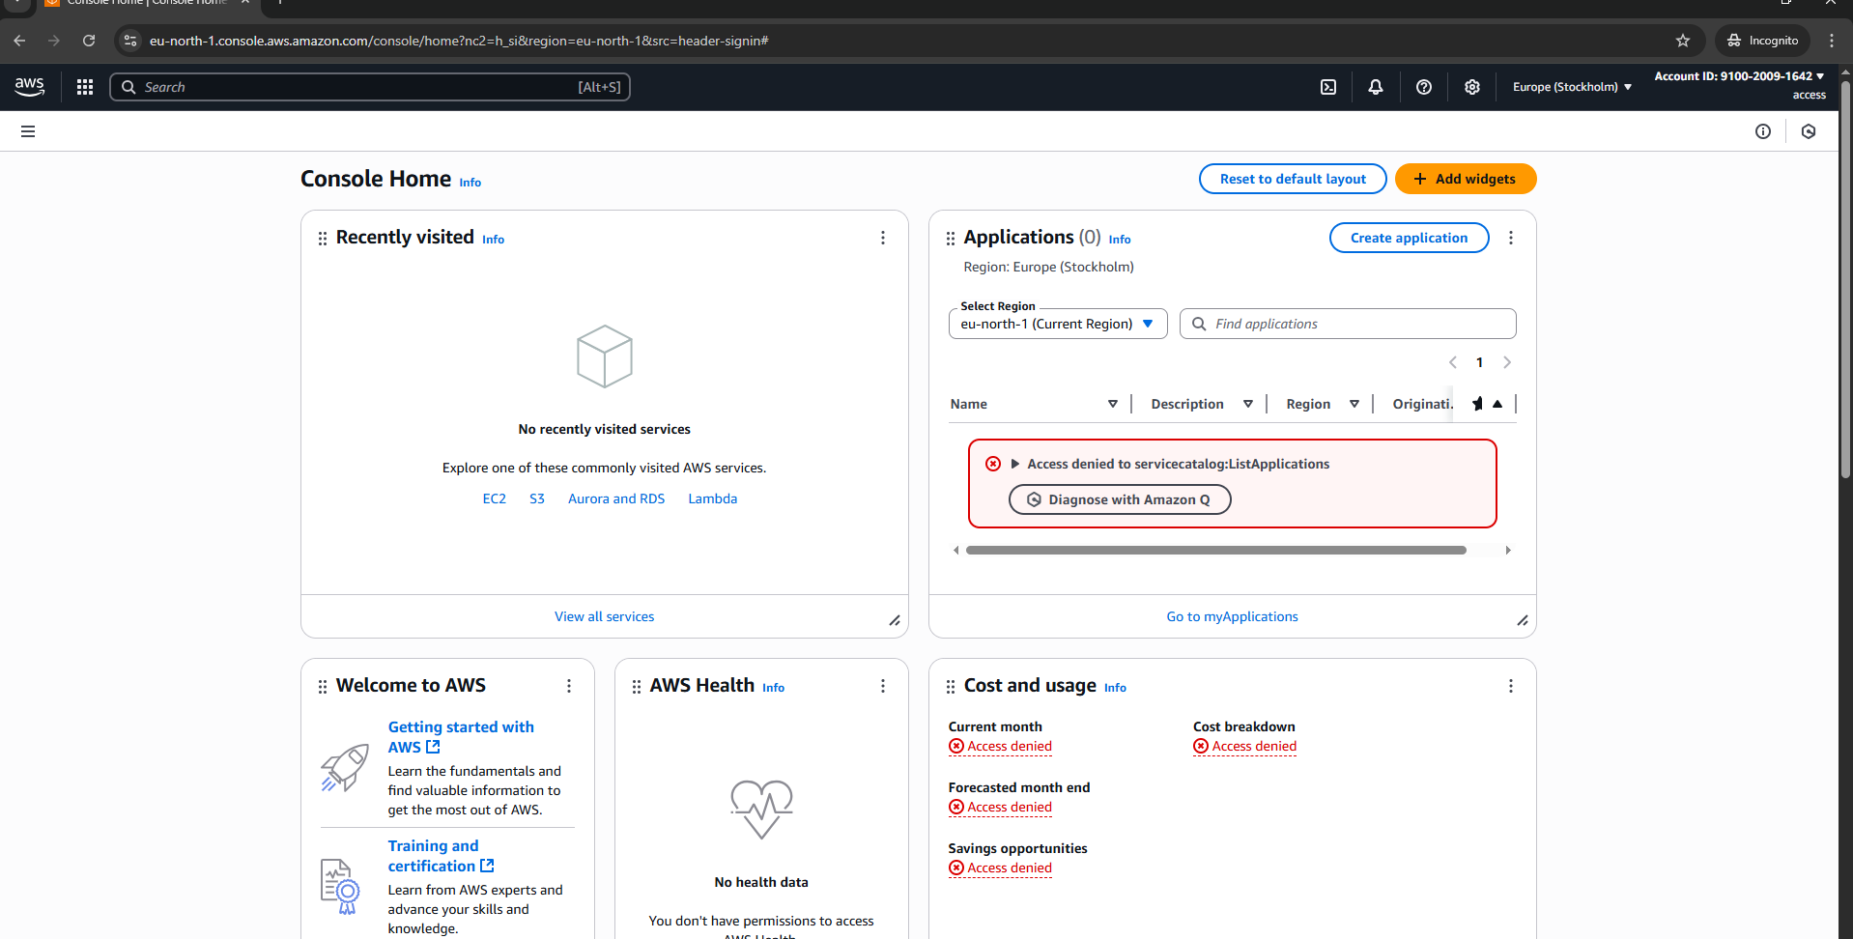
- Create one Group in IAM and Assign Read access for ec2.
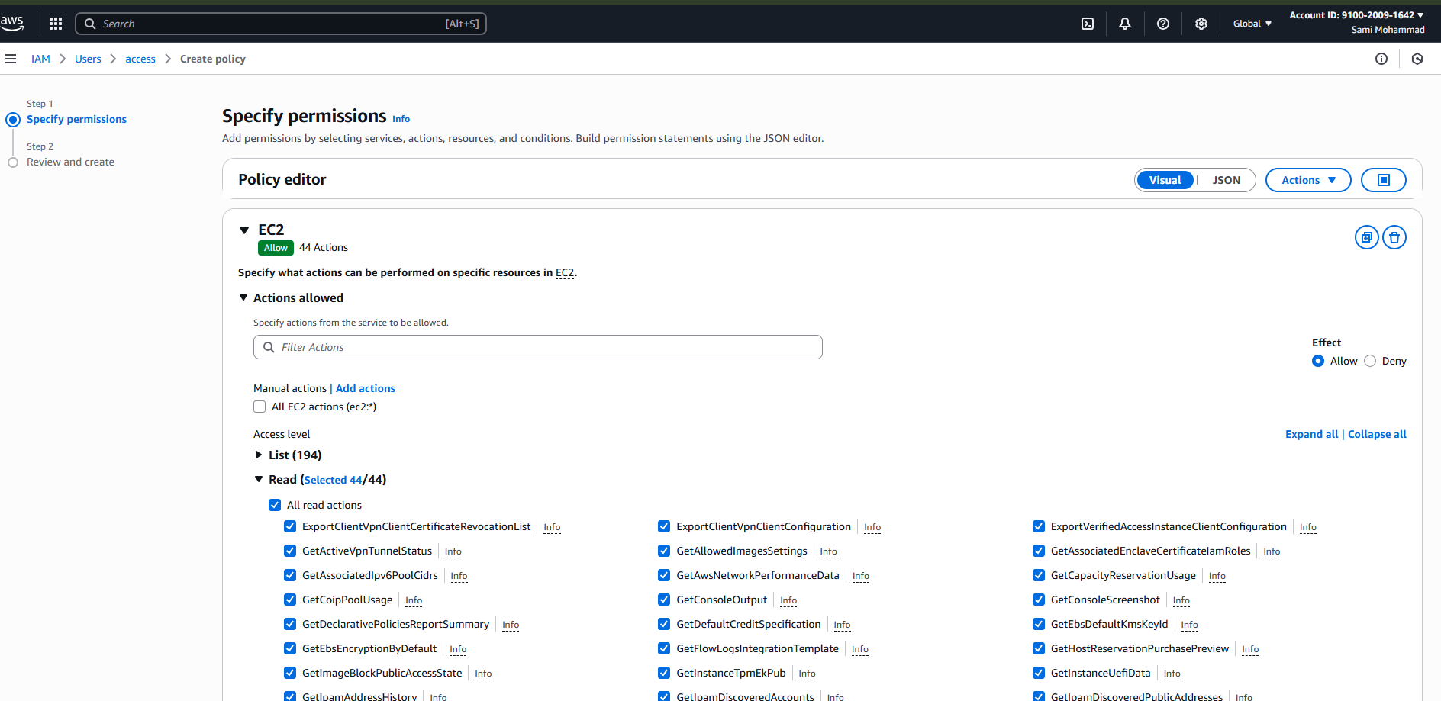
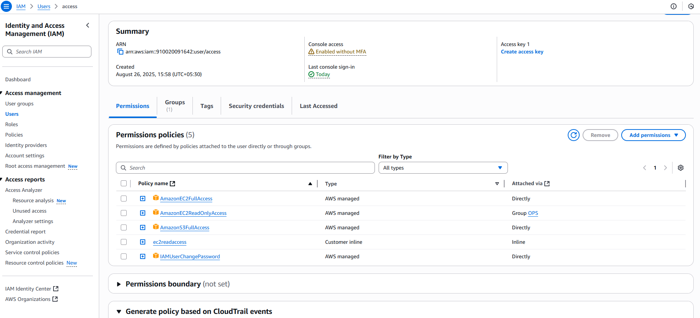
- Create a new user with name Devops and add to the group created in task2.
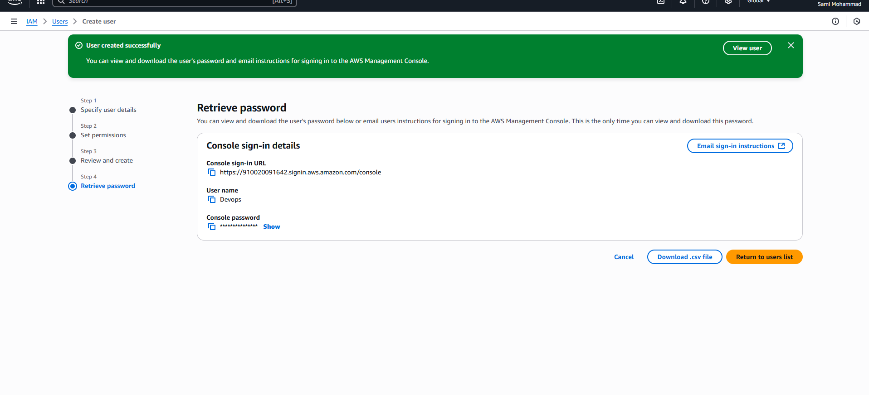
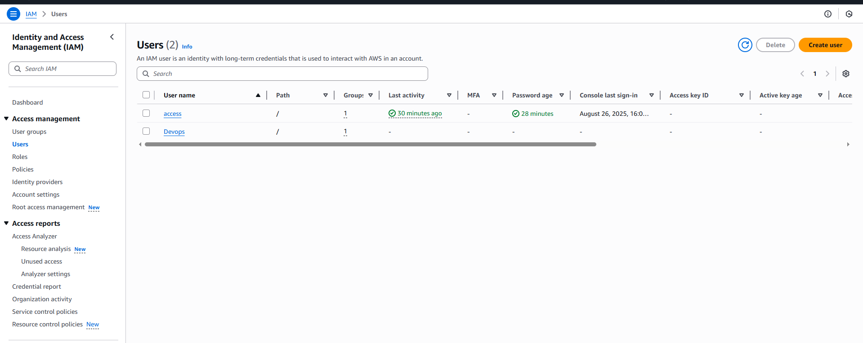
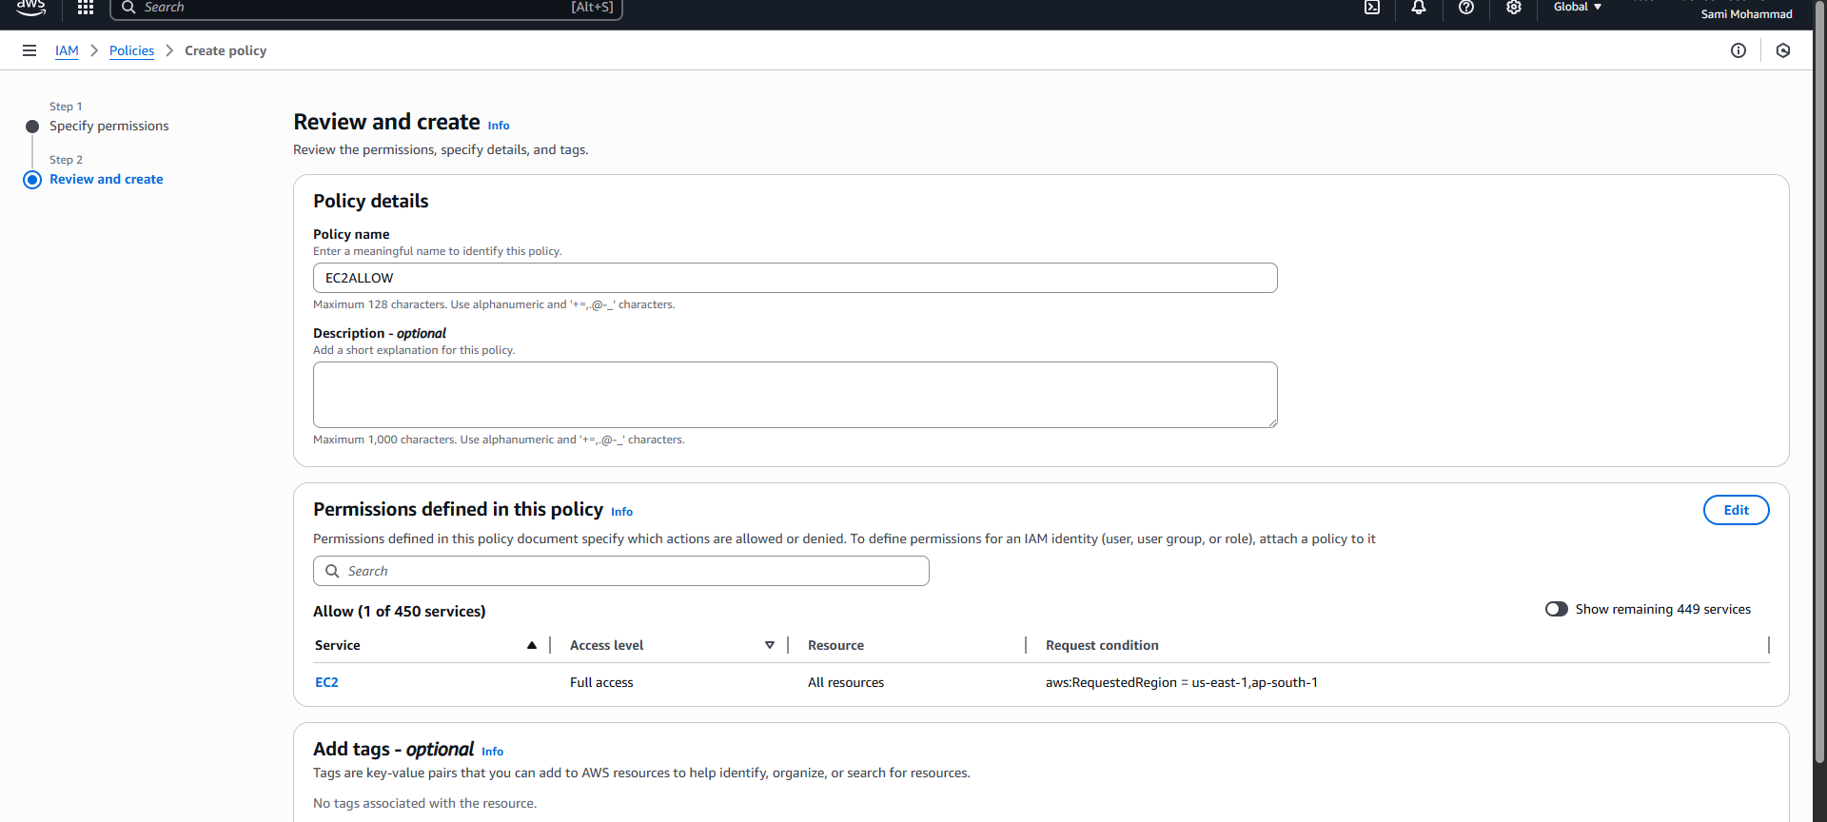

- Write a bash script to create a IAM user with VPC full access.
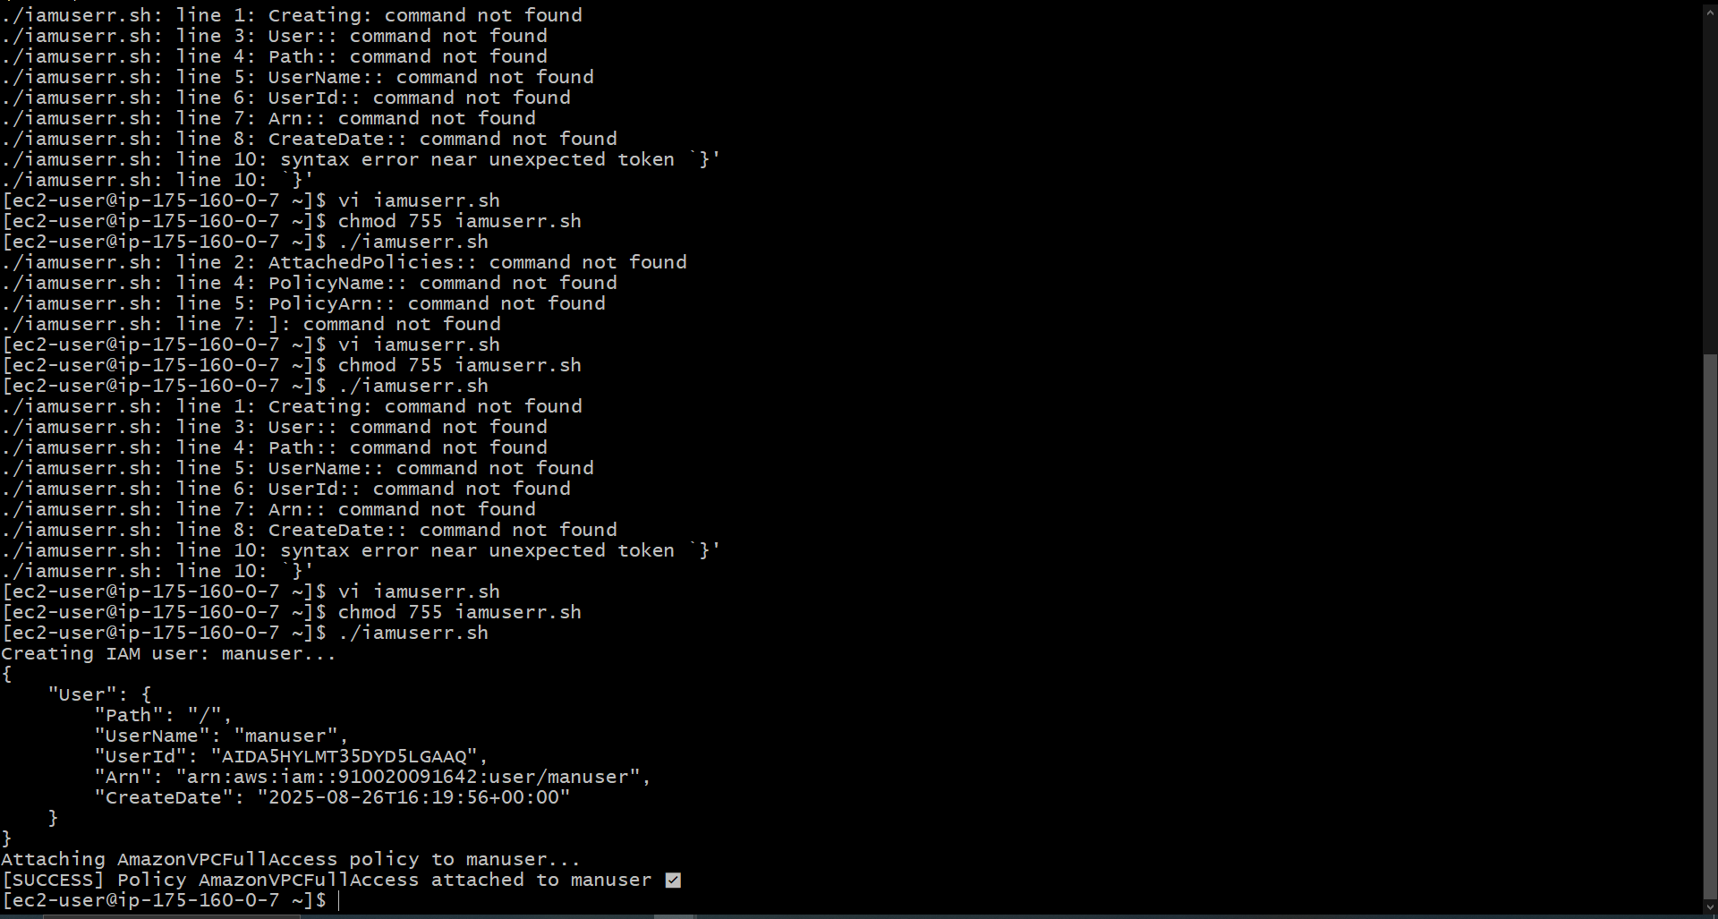

- Create a IAM policy to access ec2 for a specific user in specific regions only.
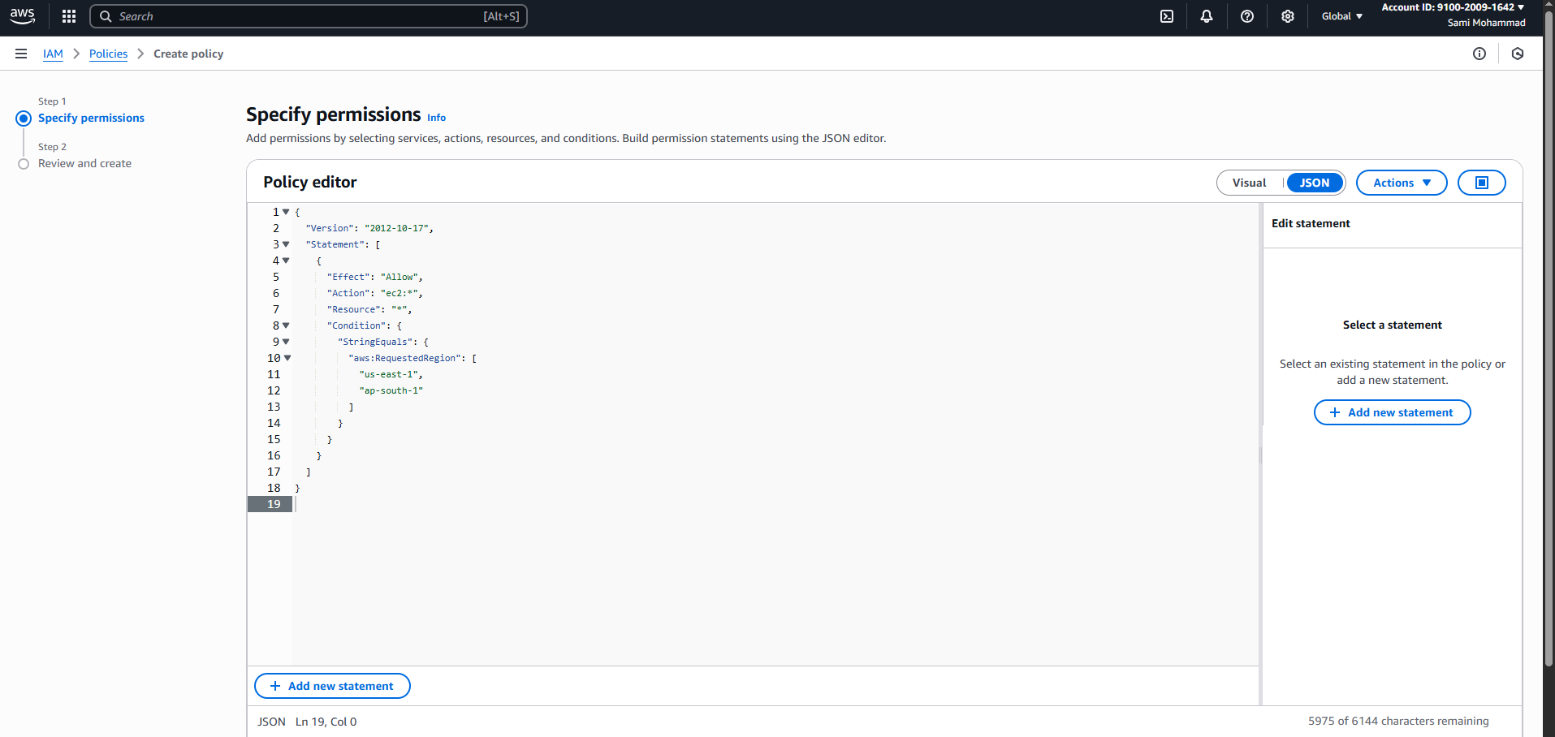

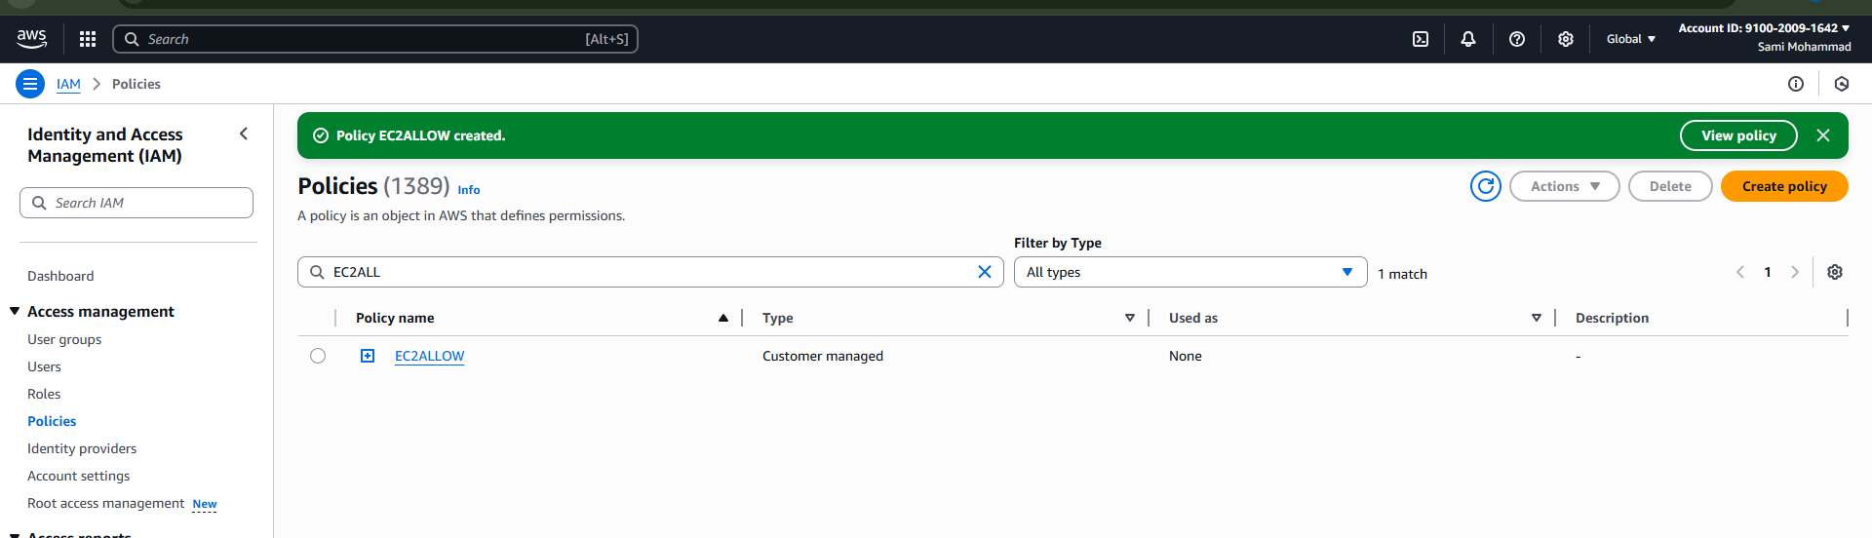

Now attach policy to user
Go to add permission
Attach policy
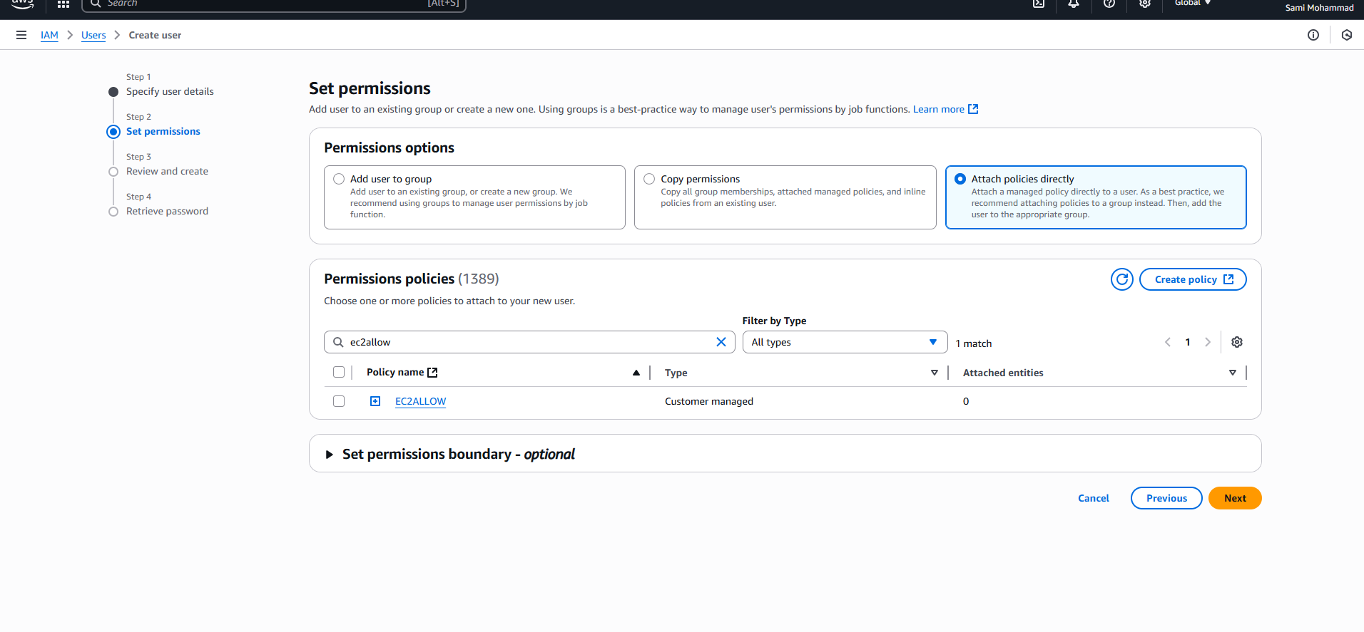

6) We have two accounts Account A and Account B, Account A user should access s3 bucket in Account B.
(Collaborate with team member and execute this.Mostly asked in every interview)

